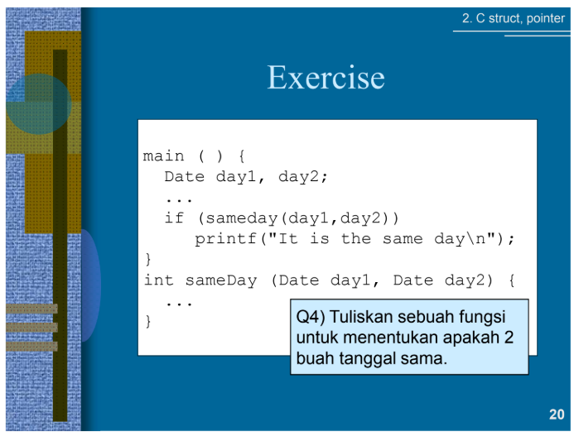

#include <stdio.h>

#include <stdlib.h>

typedef struct {

    int d, m, y;

} Date;

main(){

    Date day1, day2;

    printf("Masukkan day1 : ");

    scanf("%d-%d-%d", &day1.d, &day1.m, &day1.y);

    printf("Masukkan day2 : ");

    scanf("%d-%d-%d", &day2.d, &day2.m, &day2.y);

    if (sameday(day1, day2))

        printf("\nIt is the same day\n");

    else

        printf("\nIt is not the same day\n");

}

int sameday(Date day1, Date day2){

    if (day1.d == day2.d && day1.m == day2.m && day1.y == day2.y)

        return 1;

    else

        return 0;

}



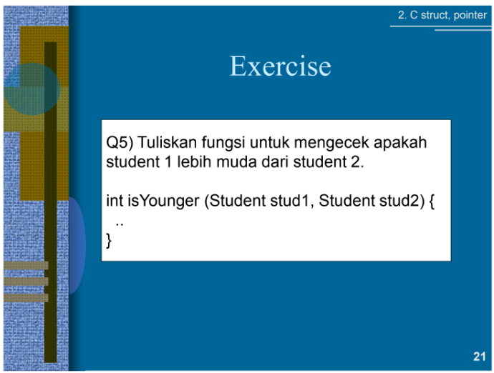

#include <stdio.h>

#include <stdlib.h>

typedef struct {

    int d, m, y;

} Date;

typedef struct {

    char name[50];

    Date bday;

} Student;

int isYounger(Student stud1, Student stud2) {

    if (stud1.bday.y > stud2.bday.y) {

        printf("%s lebih muda dari %s\n", stud1.name, stud2.name);

    } else if (stud1.bday.y < stud2.bday.y) {

        printf("%s lebih muda dari %s\n", stud2.name, stud1.name);

    } else {

        if (stud1.bday.m > stud2.bday.m) {

            printf("%s lebih muda dari %s\n", stud1.name, stud2.name);

        } else if (stud1.bday.m < stud2.bday.m) {

            printf("%s lebih muda dari %s\n", stud2.name, stud1.name);

        } else {

            if (stud1.bday.d > stud2.bday.d) {

                printf("%s lebih muda dari %s\n", stud1.name, stud2.name);

            } else if (stud1.bday.d < stud2.bday.d) {

                printf("%s lebih muda dari %s\n", stud2.name, stud1.name);

            } else {

                printf("%s dan %s memiliki tanggal lahir yang sama\n", stud1.name, stud2.name);

            }

        }

    }

}

int main() {

    Student stud1, stud2;

    Date bday1, bday2;

    printf("Masukkan nama stud 1: ");

    scanf("%s", stud1.name);

    printf("Masukkan ultah stud 1 : ");

    scanf("%d-%d-%d", &stud1.bday.d, &stud1.bday.m, &stud1.bday.y);

    printf("Masukkan nama stud2 : ");

    scanf("%s", stud2.name);

    printf("Masukkan ultah stud 2 : ");

    scanf("%d-%d-%d", &stud2.bday.d, &stud2.bday.m, &stud2.bday.y);

    isYounger(stud1, stud2);

    return 0;

}



