Git Repo Link: https://github.com/shintjoo/repo759

Task 1:

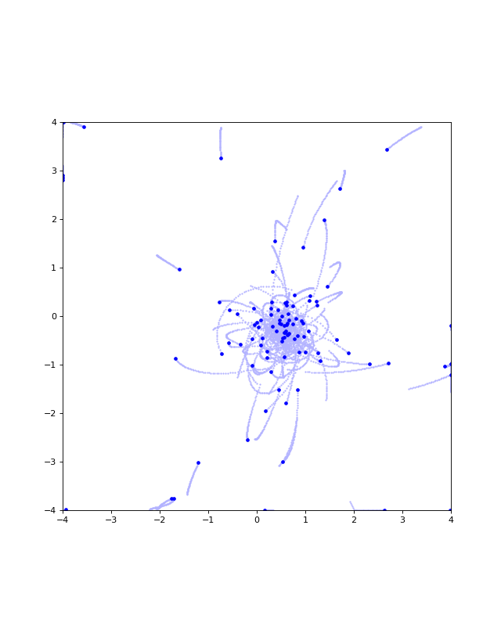

Task4: 