**Module -1: Understanding of Hardware and Its Components**

Section 1: **Multiple Choice**

1.Which of the following is NOT a component of the CPU

3-CU

2. What is the function of RAM in a computer?

A- Random Access Memory (RAM) is a type of computer memory used to store data temporarily while the computer is running. It is termed "random access" because the system can quickly and directly access any memory location, enabling fast data retrieval and processing.

3. Which of the following is a primary storage device?

4-HDD and SSD both

4. What is the purpose of a GPU?

A- Graphics Processing Unit (GPU), commonly referred to as a graphics card or video card, is a hardware component designed to render and display images, videos, and animations on a computer monitor. It enhances your computer's performance by accelerating graphics processing tasks.

Section 2: **True or False**

5. True or False: The motherboard is the main circuit board of a computer

where other components are attached.

A-True

6. True or False: A UPS (Uninterruptible Power Supply) is a hardware

device that provides emergency power to a load when the input power

source fails.

A-True

7. True or False: An expansion card is a circuit board that enhances the

functionality of a component.

A-True

Section 3: **Short Answer**

8. Explain the difference between HDD and SSD

A- Solid state drives (SSD) and hard disk drives (HDD) are data storage devices. SSDs store data in flash memory, while HDDs store data in magnetic disks. SSDs are a newer technology

9. Describe the function of BIOS in a computer system.

A-BIOS stands for Basic Input/Output System. It helps in booting up the computer and managing communication between the operating system and hardware components.

10. List and briefly explain three input devices commonly used with

Computers

1. Keyboard- A keyboard is used to input text, numbers, and commands into a computer.  
   Mouse- It allows users to move a cursor, select items, and execute commands through clicks and gestures.   
   Scanner- A scanner is used to convert physical documents or images into digital formats.

Section 4: **Practical Application**

11. Identify and label the following components on a diagram of a motherboard: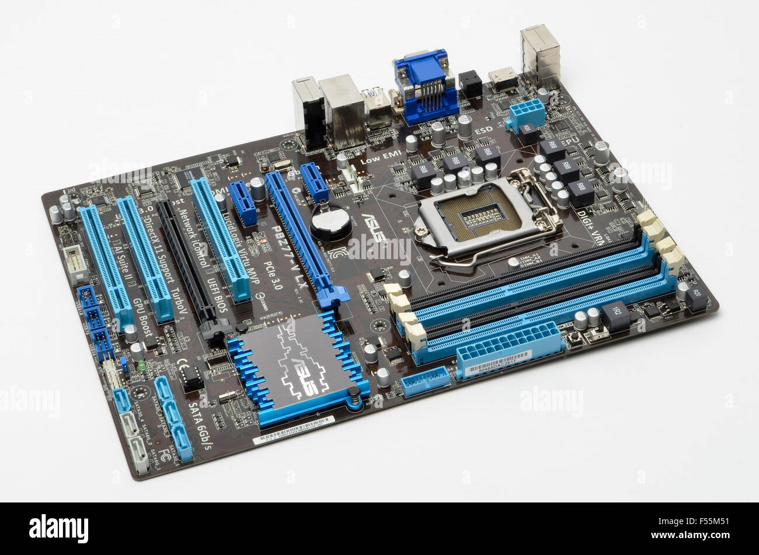

12. Demonstrate how to install a RAM module into a computer.

A-Open the clips from both the ends of the ram. Then check the slot and insert ram slowly and press it and clip will be closed on its own.

Section 5: **Essay**

13. Discuss the importance of proper cooling mechanisms in a computer system. Include examples of cooling methods and their effectiveness.

A- Heat can degrade the performance and lifespan of internal components. Excess heat can make the system slow, and the application will not behave well and will have to face frequent system turn off. Types of cooling systems are fans, heat sinks, liquid cooling. They work on pushing air out of your PCs and laptops. Fans are used with heat sinks in a computer system wherein a heat sink is first placed on top of it, after which the fan is placed on it.

14. Explain the concept of bus width and its significance in computer architecture.

A- Bus width refers to the number of bits that can be sent to the CPU simultaneously. It is one of the most vital features of a data bus. It indicates the number of electric wires or bits that build up the data bus.

**Assignment module 2: Installation and Maintenance of Hardware and Its components**

Section 1: **Multiple Choice**

1.Which of the following precautions should be taken before working on

computer hardware?

B-Wear an anti-static wrist strap to prevent damage from electrostatic

discharge.

2. What is the purpose of thermal paste during CPU installation?

C- To improve thermal conductivity between the CPU and the heat sink.

3. Which tool is used to measure the output voltage of a power supply

unit (PSU)?

1. Multimeter

**4**. Which component is responsible for storing BIOS settings, such as date

and time, even when the computer is powered off?

1. CMOS battery

Section 2: **True or False**

5.When installing a new hard drive, it is essential to format it before use.

A-True

6. A POST (Power-On Self-Test) error indicates a problem with the CPU.

A-True

7. It is safe to remove a USB flash drive from a computer without ejecting it first.

A-False

Section 3: **Short Answer**

8. Describe the steps involved in installing a new graphics card in a desktop computer.

A-Place the graphics card into the slot, aligning it carefully. Press down gently until it clicks securely into place. Attach the necessary power cables to the graphics card, ensuring a firm connection. Finish by closing the PC case and securing it properly.

9. What is RAID, and what are some common RAID configurations?

A-

Section 4: **Practical Application**

10. Demonstrate how to replace a CPU fan in a desktop computer.

Section 5: **Essay**

11. Discuss the importance of regular maintenance for computer hardware

and provide examples of maintenance tasks.

A-If we do not perform regular maintenance then dust will be filled in, also face system slowness issue and hardware failure.

**Assignment module 3 : Understanding and maintenance of Networks**

**Section 1: Multiple Choice**