TalentMatch AI
Phase 6 — Database Design
ER Diagram, Schema, Relationships, Constraints, and Indexes

1. Overview
This document defines the relational database schema for TalentMatch AI, targeting Azure SQL Database. The design covers the six core entities named in the project roadmap (Users, Recruiters, Candidates, Jobs, Applications, Skills) plus supporting tables needed to represent the candidate profile data and platform activity already present in the Phase 3 frontend (education, experience, certifications, projects, languages, notifications, and audit logs).
Design principle: entities that can legitimately repeat per candidate (education, experience, certifications, projects, languages, skills) are normalized into their own tables rather than flattened into columns or stored as unstructured text — this is what allows future reporting and search queries (e.g. 'candidates with an AZ-104 certification', 'average years of experience by skill') without parsing text at query time. Simple ordered lists with no independent identity, like a job's list of responsibilities or benefits, are stored as JSON in a single column instead — normalizing those would add joins with no real query benefit.

2. Entity-Relationship Diagram
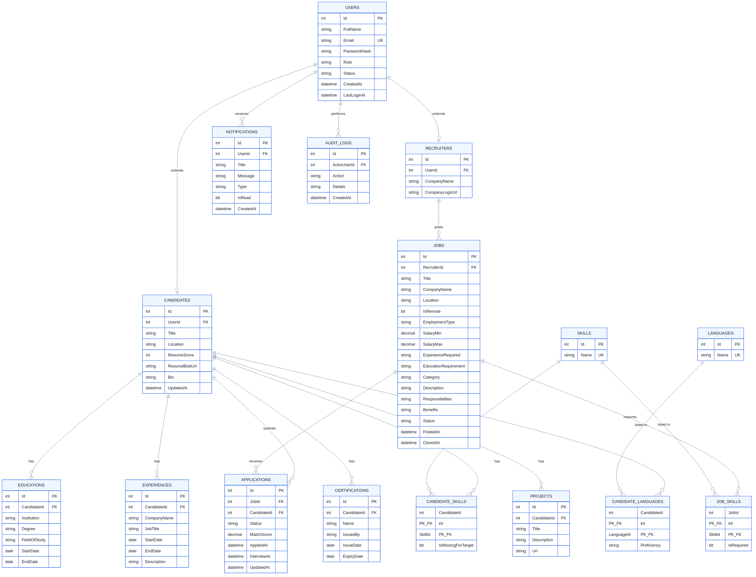

3. Table Definitions
Users
Base identity table shared by all three roles. Candidates and Recruiters extend this table 1:1; Admins exist only here.
Column | Type | Constraints | Notes
Id | INT (PK) | Identity, auto-increment | Primary key
FullName | NVARCHAR(150) | NOT NULL
Email | NVARCHAR(255) | NOT NULL, UNIQUE | Login identifier
PasswordHash | NVARCHAR(255) | NOT NULL | Never store plain text passwords
Role | NVARCHAR(20) | CHECK IN ('Candidate','Recruiter','Admin')
Status | NVARCHAR(20) | CHECK IN ('Active','Suspended') | Default 'Active'
CreatedAt | DATETIME2 | NOT NULL, default now (UTC)
LastLoginAt | DATETIME2 | NULL
Candidates
1:1 extension of Users for candidate-specific profile data.
Column | Type | Constraints | Notes
Id | INT (PK) | Identity, auto-increment
UserId | INT (FK → Users.Id) | NOT NULL, UNIQUE, ON DELETE CASCADE | Enforces 1:1
Title | NVARCHAR(150) | NULL | e.g. 'Frontend Developer'
Location | NVARCHAR(150) | NULL
ResumeScore | INT | CHECK BETWEEN 0 AND 100 | AI-generated resume score
ResumeBlobUrl | NVARCHAR(500) | NULL | Points to Blob Storage
Bio | NVARCHAR(MAX) | NULL
UpdatedAt | DATETIME2 | NOT NULL, default now (UTC)
Recruiters
1:1 extension of Users for recruiter-specific profile data.
Column | Type | Constraints | Notes
Id | INT (PK) | Identity, auto-increment
UserId | INT (FK → Users.Id) | NOT NULL, UNIQUE, ON DELETE CASCADE | Enforces 1:1
CompanyName | NVARCHAR(200) | NOT NULL
CompanyLogoUrl | NVARCHAR(500) | NULL
Jobs
Job postings created by recruiters. Responsibilities and Benefits are stored as JSON arrays in text columns since they're simple ordered lists without independent identity — not normalized into their own tables.
Column | Type | Constraints | Notes
Id | INT (PK) | Identity, auto-increment
RecruiterId | INT (FK → Recruiters.Id) | NOT NULL, ON DELETE CASCADE
Title | NVARCHAR(200) | NOT NULL
CompanyName | NVARCHAR(200) | NOT NULL | Denormalized for display speed
Location | NVARCHAR(150) | NOT NULL
IsRemote | BIT | NOT NULL, default 0
EmploymentType | NVARCHAR(50) | NOT NULL, default 'Full-time'
SalaryMin / SalaryMax | DECIMAL(10,2) | CHECK Min <= Max
ExperienceRequired | NVARCHAR(50) | NULL | e.g. '3-5 yrs'
EducationRequirement | NVARCHAR(300) | NULL
Category | NVARCHAR(100) | NULL | Used for Browse Jobs filtering
Description | NVARCHAR(MAX) | NOT NULL
Responsibilities / Benefits | NVARCHAR(MAX) | NULL | JSON array
Status | NVARCHAR(20) | CHECK IN ('Open','Closed','Draft')
PostedAt / ClosedAt | DATETIME2 | PostedAt NOT NULL
Applications
The many-to-many join between Candidates and Jobs, carrying application-specific state (status, match score, interview time).
Column | Type | Constraints | Notes
Id | INT (PK) | Identity, auto-increment
JobId | INT (FK → Jobs.Id) | NOT NULL, NO ACTION on delete | See constraints note below
CandidateId | INT (FK → Candidates.Id) | NOT NULL, ON DELETE CASCADE
 |  | UNIQUE (JobId, CandidateId) | A candidate can apply to a job only once
Status | NVARCHAR(20) | CHECK IN ('Applied','Under Review','Interview','Offer','Rejected')
MatchScore | DECIMAL(5,2) | CHECK BETWEEN 0 AND 100 | AI-calculated
AppliedAt | DATETIME2 | NOT NULL, default now (UTC)
InterviewAt | DATETIME2 | NULL
UpdatedAt | DATETIME2 | NOT NULL, default now (UTC)
Skills, CandidateSkills, JobSkills
Skills is a master list shared across the whole platform. CandidateSkills and JobSkills are junction tables implementing the many-to-many relationships (a skill appears on many candidates and many jobs; a candidate or job has many skills). This normalization is what makes queries like 'all candidates with React' or 'most in-demand skill this month' possible without parsing text.
Column | Type | Constraints | Notes
Skills.Id | INT (PK) | Identity, auto-increment
Skills.Name | NVARCHAR(100) | UNIQUE | e.g. 'React', 'Azure'
CandidateSkills (Candidate, Skill) | composite PK | ON DELETE CASCADE both sides | IsMissingForTarget flags a gap vs. a specific job
JobSkills (Job, Skill) | composite PK | ON DELETE CASCADE both sides | IsRequired vs. nice-to-have
Educations, Experiences, Certifications, Projects
Each candidate can have multiple of each, so each gets its own table (1:many from Candidates) rather than being flattened into repeated columns or an unstructured blob — this is what allows future queries like 'candidates with an AZ-104 certification' or reporting on average years of experience.
Column | Type | Constraints | Notes
Educations | Institution, Degree, FieldOfStudy, StartDate, EndDate | FK → Candidates.Id, ON DELETE CASCADE
Experiences | CompanyName, JobTitle, StartDate, EndDate, Description | FK → Candidates.Id, ON DELETE CASCADE
Certifications | Name, IssuedBy, IssueDate, ExpiryDate | FK → Candidates.Id, ON DELETE CASCADE
Projects | Title, Description, Url | FK → Candidates.Id, ON DELETE CASCADE
Languages, CandidateLanguages
Same many-to-many pattern as Skills — a master Languages list plus a junction table, so proficiency level can be tracked per candidate per language.
Column | Type | Constraints | Notes
Languages.Id / Name | INT (PK) / NVARCHAR(100) UNIQUE
CandidateLanguages (Candidate, Language) | composite PK | ON DELETE CASCADE both sides | Proficiency: Native / Fluent / Conversational
Notifications
Per-user notification feed, shared structure across all three roles.
Column | Type | Constraints | Notes
Id | INT (PK) | Identity, auto-increment
UserId | INT (FK → Users.Id) | NOT NULL, ON DELETE CASCADE
Title / Message | NVARCHAR | Title NOT NULL, Message NOT NULL
Type | NVARCHAR(20) | CHECK IN ('info','success','warning','error')
IsRead | BIT | NOT NULL, default 0
CreatedAt | DATETIME2 | NOT NULL, default now (UTC)
AuditLogs
System-wide audit trail for the Admin module. ActorUserId is nullable so system-generated events (e.g. automated resume parsing) can be logged without a human actor.
Column | Type | Constraints | Notes
Id | INT (PK) | Identity, auto-increment
ActorUserId | INT (FK → Users.Id) | NULL, ON DELETE SET NULL | Null = system-generated event
Action | NVARCHAR(300) | NOT NULL | e.g. 'Created job posting X'
Details | NVARCHAR(MAX) | NULL | Optional extra context
CreatedAt | DATETIME2 | NOT NULL, default now (UTC)

4. Relationships
- Users 1:1 Candidates — every Candidate row extends exactly one Users row (enforced by a UNIQUE constraint on Candidates.UserId).
- Users 1:1 Recruiters — same pattern, for the Recruiter role.
- Recruiters 1:many Jobs — one recruiter can post many jobs.
- Candidates 1:many Applications, Jobs 1:many Applications — Applications is the many-to-many join between Candidates and Jobs, with a UNIQUE(JobId, CandidateId) constraint preventing duplicate applications.
- Candidates many:many Skills via CandidateSkills; Jobs many:many Skills via JobSkills — the same master Skills list is reused on both sides so skill names never diverge or duplicate.
- Candidates 1:many Educations, Experiences, Certifications, Projects — a candidate can have zero or many of each.
- Candidates many:many Languages via CandidateLanguages.
- Users 1:many Notifications — any user role can receive notifications.
- Users 1:many AuditLogs (as actor) — nullable, since some audit events are system-generated rather than user-initiated.

5. Constraints
- Every foreign key uses ON DELETE CASCADE except AuditLogs.ActorUserId (ON DELETE SET NULL — deleting a user shouldn't erase the historical record that an action happened, just anonymize who did it) and Applications.JobId (NO ACTION). The latter exists because SQL Server disallows cascading from both Jobs and Candidates into Applications at once — it would create two cascade paths from Users (Users→Candidates→Applications and Users→Recruiters→Jobs→Applications), which SQL Server rejects as ambiguous. Practically, this means a Job with existing applications can't be hard-deleted; it must be Closed instead — already supported in the frontend, and arguably the more correct behavior anyway, since historical applications shouldn't disappear when a posting is removed.
- UNIQUE constraints enforce the 1:1 relationships (Candidates.UserId, Recruiters.UserId) and prevent duplicate applications (Applications: JobId + CandidateId) or duplicate master data (Skills.Name, Languages.Name, Users.Email).
- CHECK constraints keep enums honest at the database layer, not just in application code: Users.Role, Users.Status, Jobs.Status, Applications.Status, Notifications.Type are all constrained to a fixed set of values, and ResumeScore / MatchScore are constrained to 0-100.
- CK_Jobs_SalaryRange prevents a logically invalid job posting where the minimum salary exceeds the maximum.

6. Indexes
- IX_Users_Role — the login flow and admin user-management screens filter by role constantly.
- IX_Jobs_Status_Category and IX_Jobs_Location — Browse Jobs' search/filter panel filters on exactly these three fields.
- IX_Applications_CandidateId / IX_Applications_JobId / IX_Applications_Status — My Applications, recruiter candidate lists, and status-based filtering all hit these.
- IX_CandidateSkills_SkillId / IX_JobSkills_SkillId — supports 'find all candidates with skill X' style queries used by the matching engine.
- IX_Notifications_UserId_IsRead — the notification bell badge count and the Notifications page both filter unread-by-user constantly.
- IX_AuditLogs_CreatedAt DESC — the Admin Audit Logs page always lists most-recent-first.

7. Next Steps
The full T-SQL DDL script (schema.sql) accompanies this document and can be run directly against the talentmatchdb database provisioned in Phase 5. Phase 7 will build the backend API layer that reads and writes against this schema, replacing the mock data currently used in the frontend.

