Project Structure
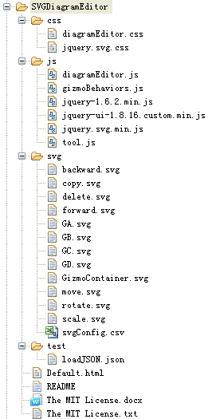
FIGURE 1 Project file structure

css
diagramEditor.css: css styles used for editor, palette, canvas
jquery.svg.css: jquery.svg plugin css

js
diagramEditor.js: Diagram editor plugin. Five widgets are concluded in this plugin. See more details inside the file.
gizmoBehaviors.js: This plugin is to operate mouse behavior on the gizmo. Eight widgets are concluded in this js plugin. See more details inside the file.
tool.js: Utility functions

svg
backward.svg: backward svg file.
copy.svg: copy svg file.
delete.svg: delete svg file.
forward.svg: forward svg.
GizmoContainer.svg: gizmo container svg file.
move.svg: move svg file.
rotate.svg: rotate svg file.
scale.svg: scale svg file.
GA.svg to GD.svg: test shape on palette.

svgConfig.csv: configure for svg files.
CSV format: name,path,centerPosition,group,order
name: shape name.
path: shape svg path.
centerPositon: Used for configure a button origin on gizmo corresponding to gizmo origin.
group: palette or gizmo
order: shape order. Shapes will be displayed on palette in this order.

test
loadJSON.json: json to test load function. Just for test. In fact, a diagram json will be got from backend through a request.

Default.html: HTML structure for diagram editor.

How to use this editor on your own html page?
- Add css/script files to your page.
<link rel="stylesheet" href="css/diagramEditor.css" type="text/css" media="screen" title="no title" charset="utf-8" />
<link rel="stylesheet" href="css/jquery.svg.css" type="text/css" media="screen" title="no title" charset="utf-8" />
<script type="text/javascript" src="js/jquery-1.6.2.min.js"></script>
<script type="text/javascript" src="js/jquery-ui-1.8.16.custom.min.js"></script>
<script type="text/javascript" src="js/jquery.svg.min.js"></script>
<script type="text/javascript" src="js/diagramEditor.js"></script>
<script type="text/javascript" src="js/gizmoBehaviors.js"></script>
<script type="text/javascript" src="js/tool.js"></script>

- Add a div on your page for editor.
<div id="editor"></div>

- Invoke plugin on editor div element.
$("#editor").SVGDiagram();

How to save the diagram?
var json = $("#editor").SVGDiagram(“save”);
Then save json variable to your database.

How to replace or add a shape on palette?
- Create a svg file.
Please specify width, height for the svg file. And wrap all groups in a group, in other words, under svg node should be only one g node.

Correct: <svg width="100" height="100"><g></g></svg>
Not correct: <svg><g></g></svg> or <svg><g></g><g></g></svg>

And there should be no padding for the svg. That’s because padding will also be displayed on the page.

Correct:
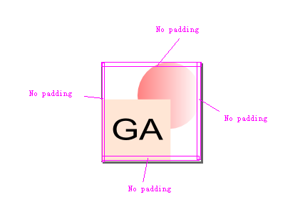
FIGURE 2 No padding svg file.
Not correct:
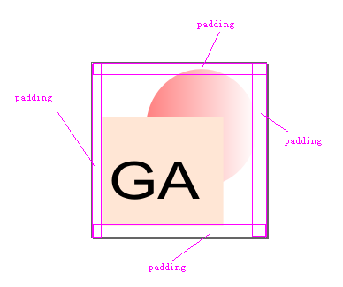
FIGURE 3 A svg file with padding.

- Add and configure.
Add your svg file into svg foler. And then Configure your svg file in svg/svgConfig.csv.
Example: GA,svg/GA.svg,,palette,1

