In the case you guys don’t know how to use Github in a team way.
Honestly, just read the help docs of github online, you will understand how to use Github properly.

Task, commit something to a team repository.
- Fork the repository you want to commit.
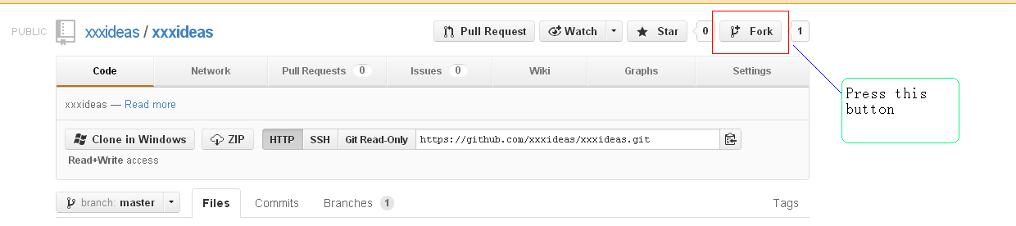
After forked, go to your fork.
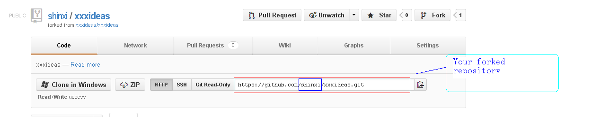
- Setup your account first. https://help.github.com/articles/set-up-git
- Download your fork.
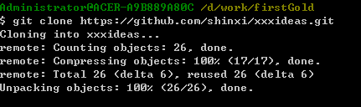
- Setup link to the repository which you forked from.
Why do this?
Before you go to push your commits, you need to do synchronization between your fork and repository you forked from.
Two commands to do this.
git fetch upstream
git merge upstream/master
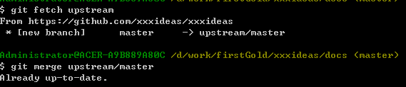
- Commit your files to your forked repository.
Step 1, create a touch.txt at xxxideas/docs.
Step 2, commit using git gui.
About commit message, please follow the https://github.com/blog/926-shiny-new-commit-styles
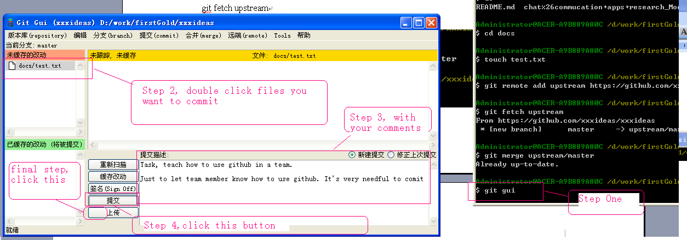

After upload, go to your fork again.
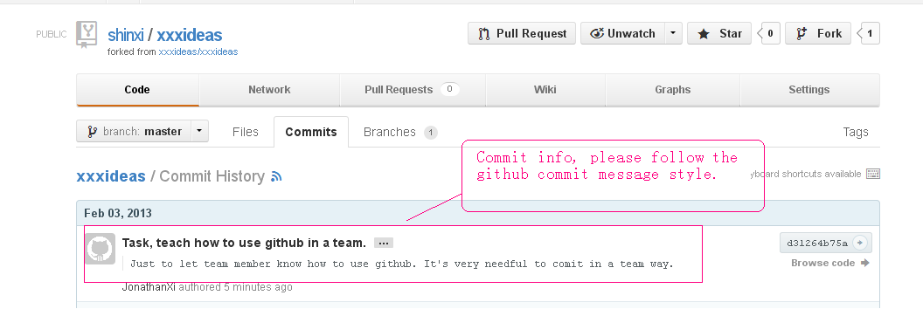
- Send pull request.
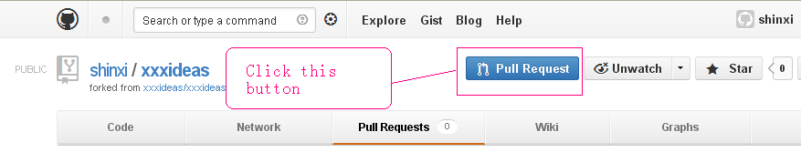
After clicked pull request button.
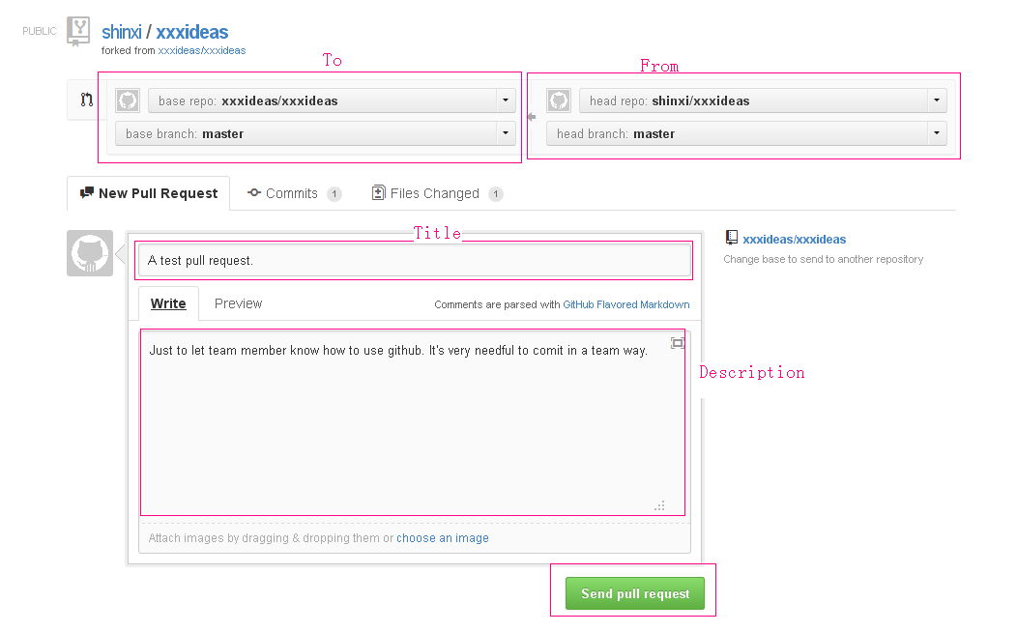

- Merge pull request. (Administrator of your forked repository will do this.)
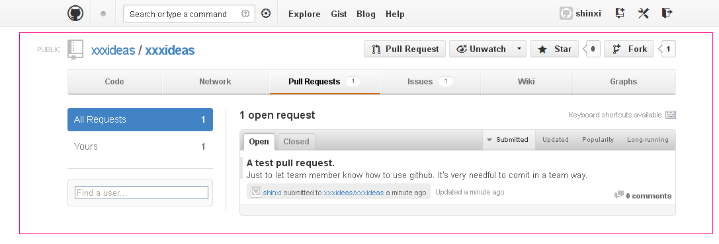
Click the request title “A test pull request”
