**CODING SNIPPET:**

// 1. Create a table with name depart for the following specification.

CREATE TABLE

EMPLOYEES(EMP_ID INTEGER(6) NOT NULL PRIMARY KEY,

EMP_NAME VARCHAR(20) ,

EMAIL CHARACTER(25) ,

PHONE_NUMBER VARCHAR(10) ,

DEPART_ID INTEGER(4) );

// 2. Create a table with name employees for the following specification.

CREATE TABLE

DEPART(DEPART_ID INTEGER(4) NOT NULL PRIMARY KEY,

DEPART_NAME VARCHAR(30)NOT NULL ,

MANAGER_ID INTEGER(6) UNIQUE);

// 3. Using Alter command add a new column in employees table with name salary and with datatype and precision as Number(8,2)

ALTER TABLE EMPLOYEES ADD SALARY DECIMAL(8,2);

// 4. Using Alter command add a new table constraint in employees table with name for key for DEPT_ID column in employees table which refers the primary key of depart table (consider the usage of both foreign key and references constraints)

ALTER TABLE EMPLOYEES

ADD CONSTRAINT FK FOREIGN KEY (DEPART_ID) REFERENCES DEPART(DEPART_ID);

// 5. Using Alter command drop the constraint in employees table with name for key and modify the column DEPT_ID with column constraint references for the primary key in depart table.

ALTER TABLE EMPLOYEES DROP CONSTRAINT FK ;

// 6. Using Alter command drop the column in employees table with name EMAIL.

ALTER TABLE EMPLOYEES

DROP COLUMN EMAIL;

// 7. After adding salary column (Q.3), add a column constraint to the EMPLOYEES table which restricts the addition of those employees who have salaries less than 10000.

ALTER TABLE EMPLOYEES ADD CONSTRAINT CHECK SALARY WHERE SALARY > 9000;

// 8. Using Alter command, rename table employees as empl;

ALTER TABLE EMPLOYEES

RENAME TO EMPL;

// 9. Create a new table with name depart1 as same as depart in structure.

CREATE TABLE

DEPART1(DEPART_ID INTEGER(4) NOT NULL PRIMARY KEY,

DEPART_NAME VARCHAR(30)NOT NULL ,

MANAGER_ID INTEGER(6) UNIQUE);

// 10. After creation, drop table depart1 using drop command.

DROP TABLE DEPART1;

**OUTPUT SCREENSHOTS:**

1. 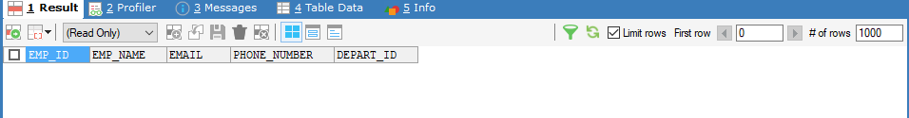
2. 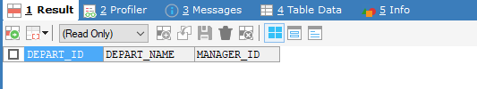
3. 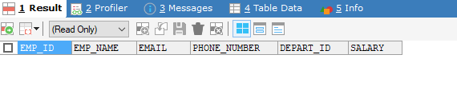
4. 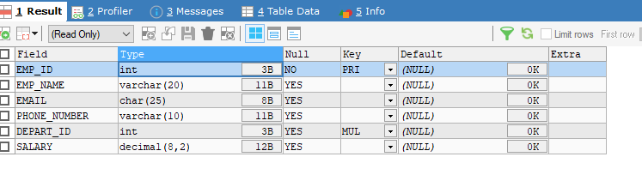

**6.**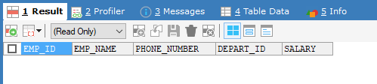

**8.** 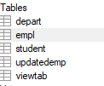

**9.** 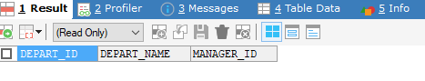

**10.** 