**CODING SNIPPET:**

-- 1. Insert the following 5 rows in depart table using Insert command

INSERT INTO EMPL VALUES(101,'Babu','babu101@gmail.com',9448341201,10 ,12000),

(102,'Somu','somu102@gmail.com',9448534120 ,20 ,10000),

(103,'Ramu','ramu103@gmail.com',9448886634,40 ,15000),

(104,'Gobu','gobu104@gmail.com',9447783412,50 ,11500),

(105,'Anbu','anbu105@gmail.com',9848341200 ,40 ,22000),

(106,'Deepu','deepu106@gmail.com',9448345678,30 ,18000);

-- 2. Insert the following 5 rows in employees table using insert command.

INSERT INTO DEPART VALUES(10,'Purchase ',123),

(20,'Inventory ',345),

(30,'Sales',567),

(40,'Materials ',789),

(50,'Production ',911);

-- 3. (a)Select all employees working in materials department

SELECT * FROM EMPL WHERE DEPART_ID=40;

-- (b)Select the department number and employees’ names who are working in sales

SELECT DEPART_ID,EMP_NAME FROM EMPL WHERE DEPART_ID=30;

-- (c)Select the names of the employees who are working in materials department earning salary more THAN 15000

SELECT EMP_NAME FROM EMPL WHERE DEPART_ID=40 AND SALARY >15000 ;

-- (d) select all employee’s name, salary and 5% of their salary as BONUS

SELECT EMP_NAME,SALARY+SALARY *0.05 AS SALARY FROM EMPL;

-- (e) select all employees details whose name starts with letter ‘R’;

SELECT * FROM EMPL WHERE EMP_NAME LIKE 'R%';

-- 4.(a)Update all employee records in sales department with 10% raise in salary

UPDATE EMPL SET SALARY=SALARY+SALARY *0.1 WHERE DEPART_ID=30;

-- b. Update all employees’ salary with 3% reduction in inventory department.

UPDATE EMPL SET SALARY=SALARY-SALARY *0.03 WHERE DEPART_ID=20;

-- 5. create a table with name updatedemp by selecting columns Emp_ID,Emp_name, email associated with employees table and with dept_id values greater than 20.

CREATE TABLE UPDATEDEMP AS SELECT EMP_ID,EMP_NAME,EMAIL FROM EMPL WHERE DEPART_ID > 20;

-- 6. Delete all employees who are drawing salary less than 12000

DELETE FROM EMPL WHERE SALARY<12000;

-- 7. Create a new table with name view tab by selecting all values from updatedemp

CREATE TABLE VIEWTAB AS SELECT * FROM UPDATEDEMP;

-- 8. Create a view with name my tab with EMP_ID, EMP_NAME, DEPT_ID with salary values greater than or equal to 10000.

CREATE VIEW MYTAB AS SELECT EMP_ID,EMP_NAME,DEPART_ID,SALARY FROM EMPL WHERE SALARY >= 10000;

-- 9. Display all rows in employees in ascending order of salary.

SELECT * FROM EMPL ORDER BY SALARY ASC;

-- 10. Display all rows in employees in descending order of their names

SELECT * FROM EMPL ORDER BY EMP_NAME DESC;

**OUTPUT SCREENSHOTS:**

1. 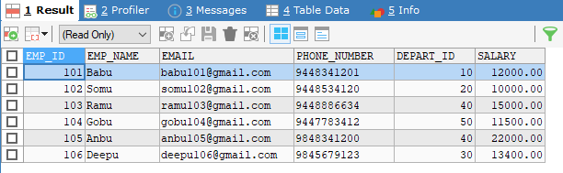
2. 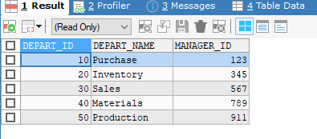
3. **(A)** 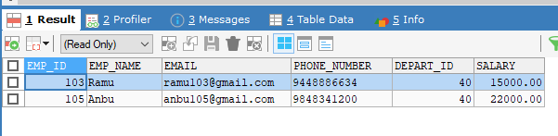

**3.(B)**

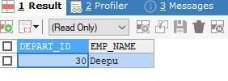

**3.(C)**

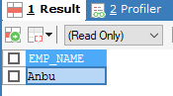

**3.(D)**

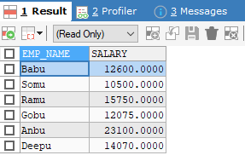

**4.(A)**

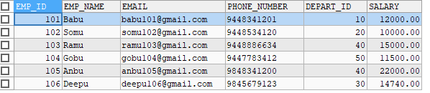

**4.(B)**



**5.**

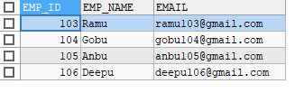

**6.**

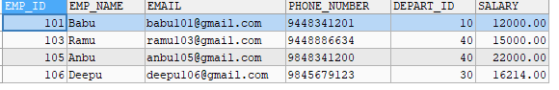

**7**. 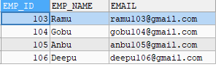

**8**. 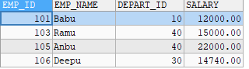

**9**. 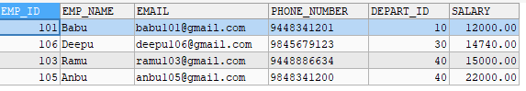

**10**. 