# Deployment of contracts to Ganache:

1. Open up Ganache and create a New Workspace for Etherum.
2. Add project to the workspace.  
   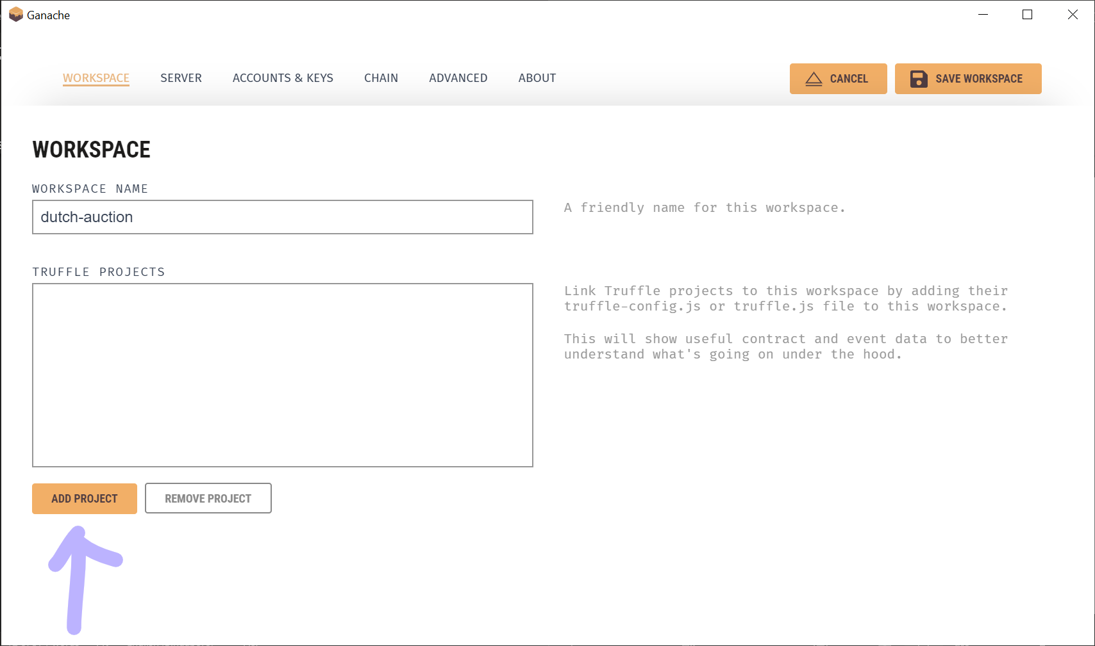
3. Select the “truffle-config.js” file found in “../DutchAuction/src” directory.  
   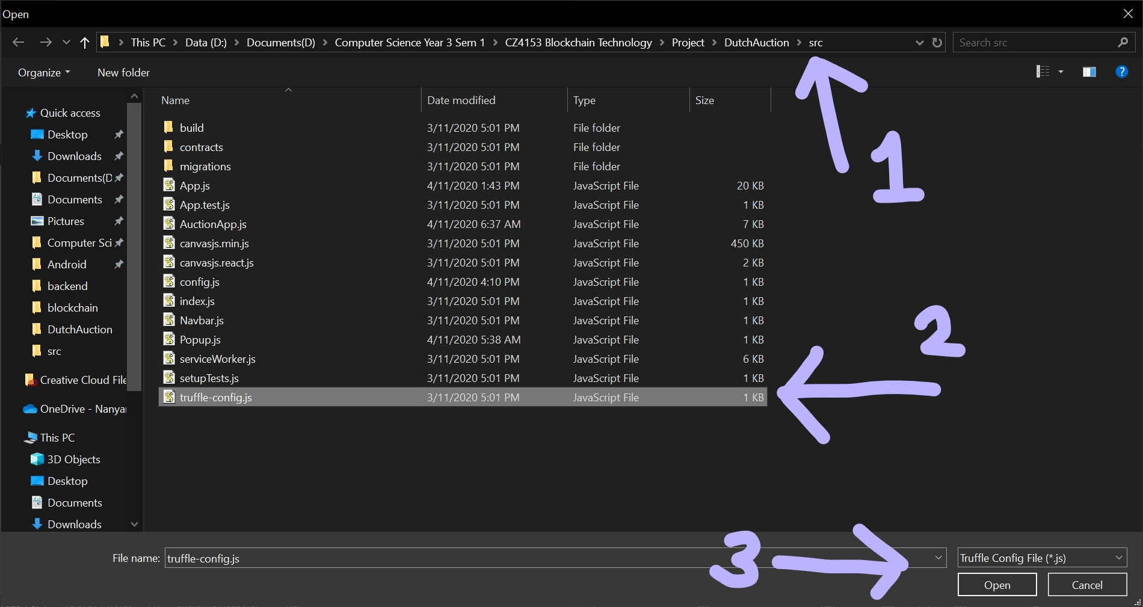
4. After ensuring that there is only one truffle project, proceed by click on “Save Workspace”.  
   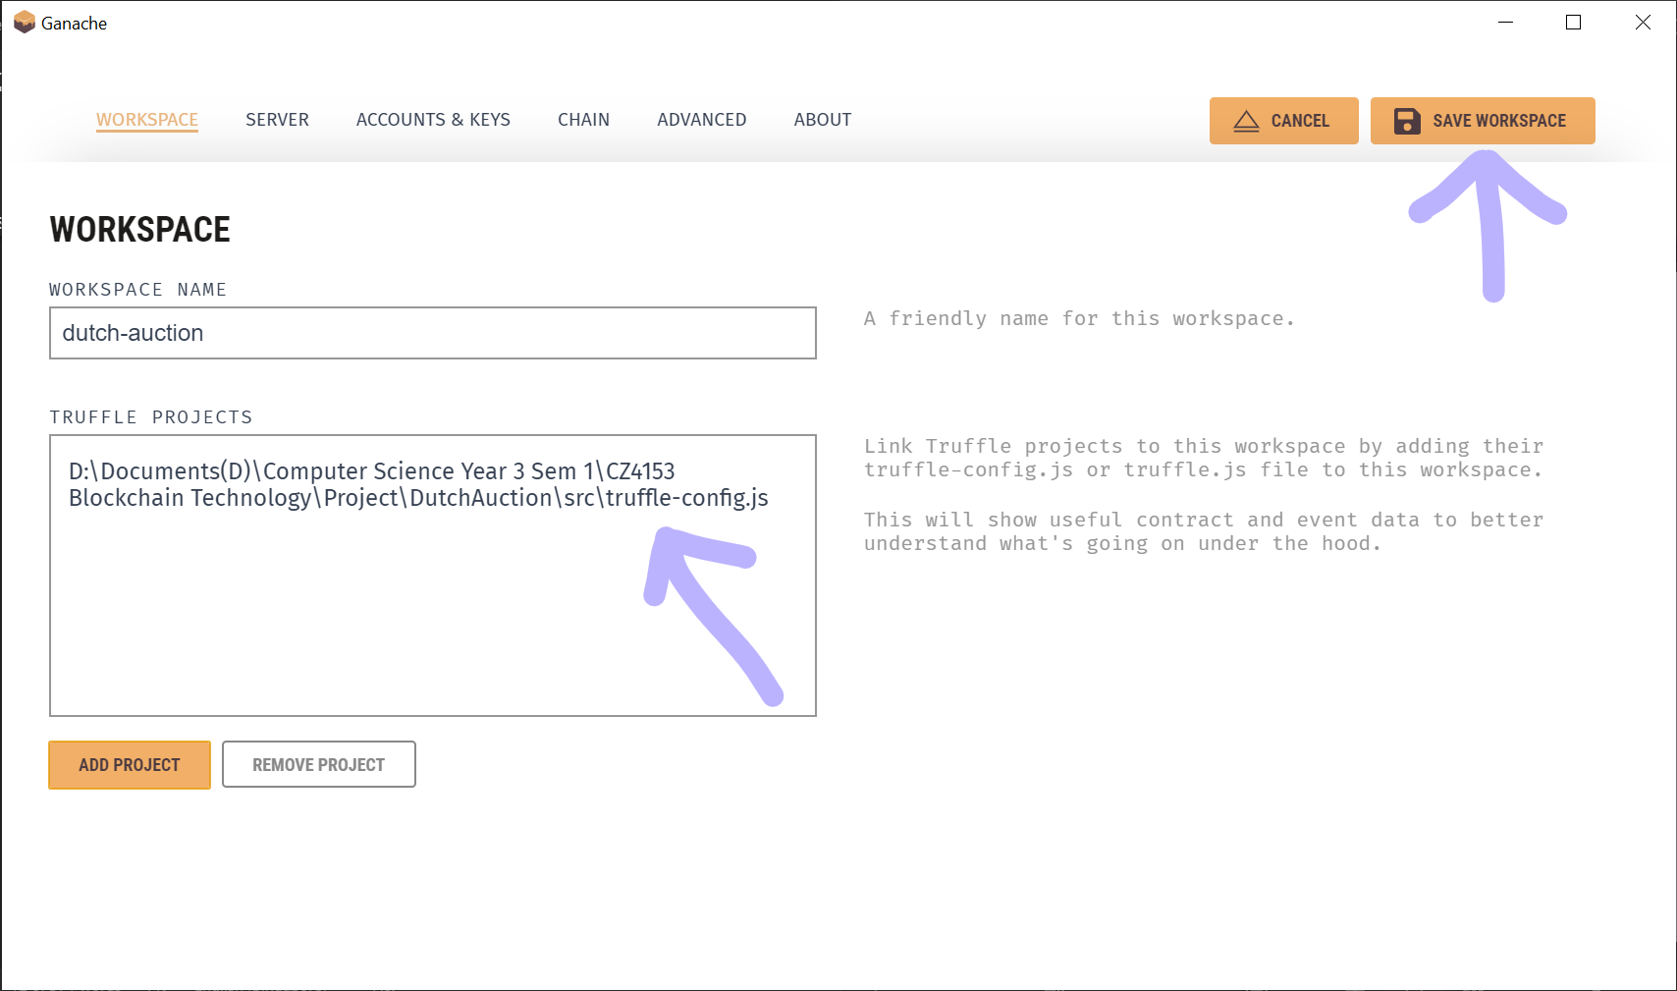
5. Open a terminal and change the directory to the “../DutchAuction/src” folder as this is where the “truffle-config.js” file is at.  
   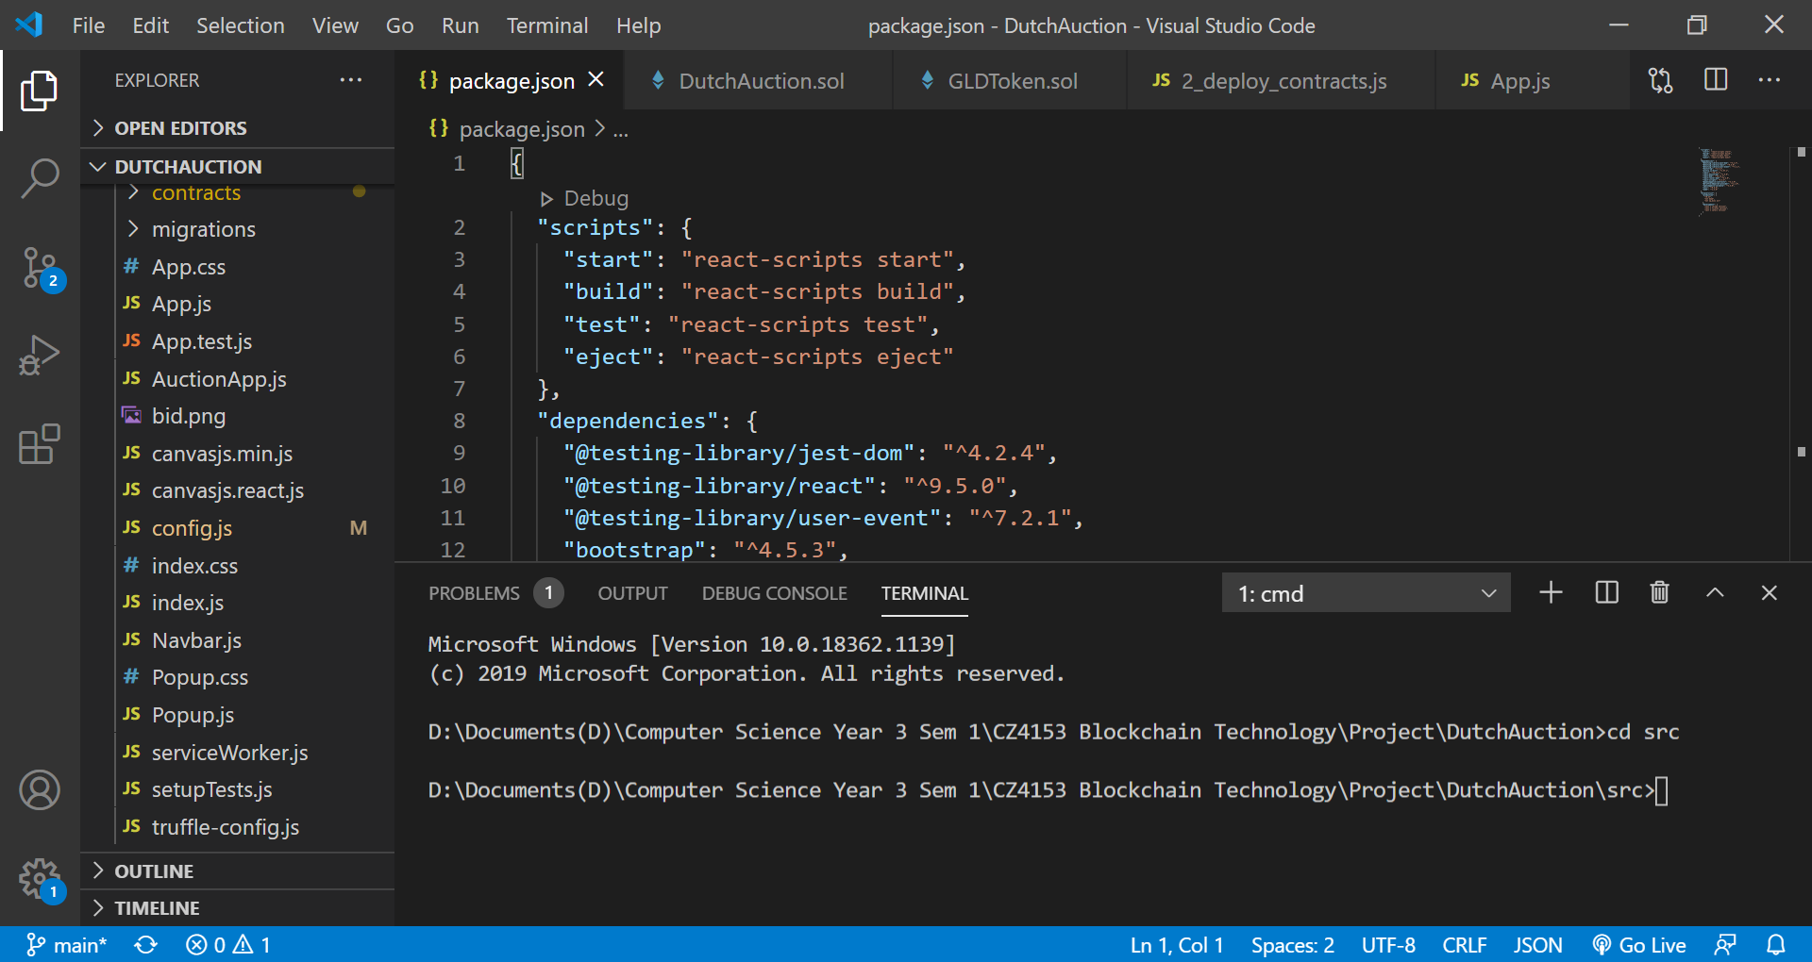  
   If you would like, you may change to token supply, start price and price factor (rate of decrease in price per minute) in the “2_deploy_contracts.js” file that can be found in the “../DutchAuction/src/migrations” directory. This needs to be done before migration.  
   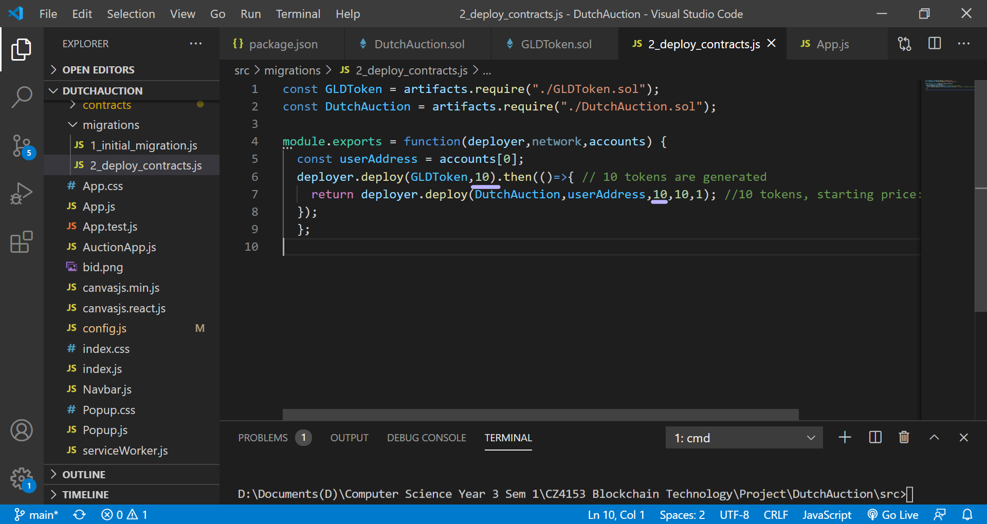
6. Enter “truffle migrate” and wait for the migration to end.  
   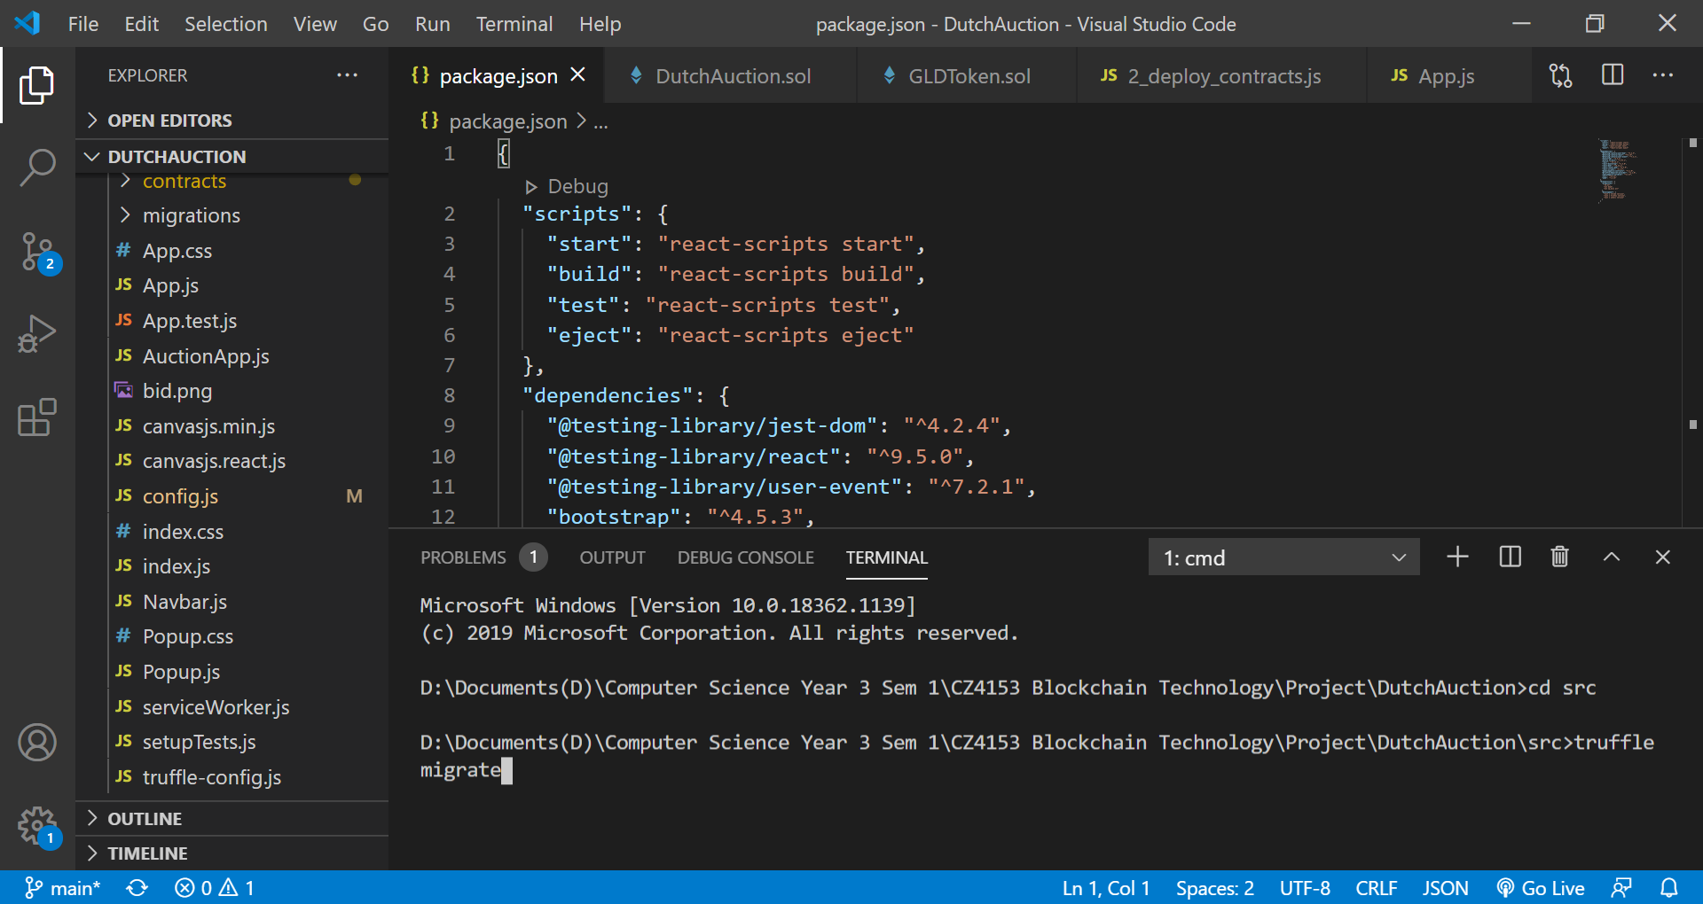
7. Upon successful migration, you will be able to see the contract addresses of “DutchAuction” and “GLDToken” under the contracts tab in Ganache. Take down the two address as these are needed later on.  
   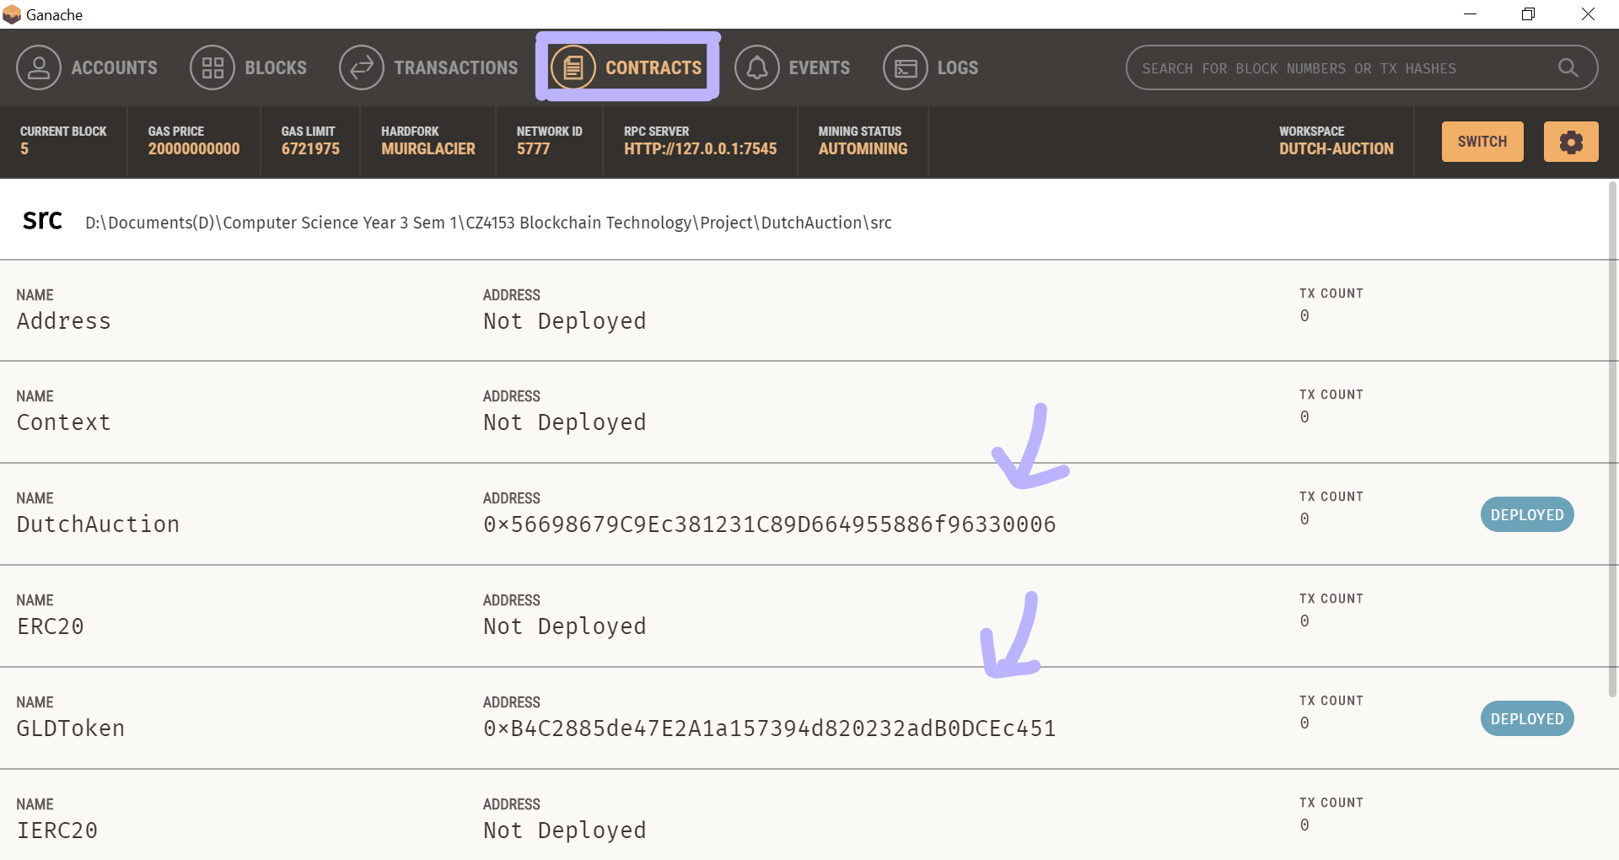

# Connecting to the Ganache RPC Server:

1. We are going to use this RPC URL provided by Ganache. Copy this URL.  
   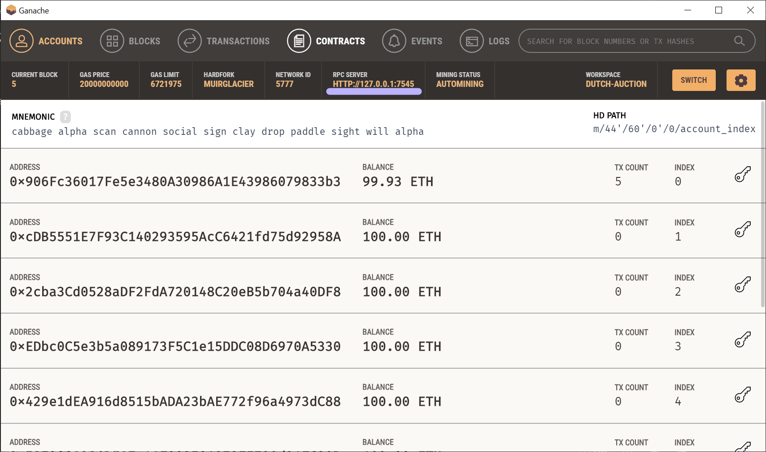  
   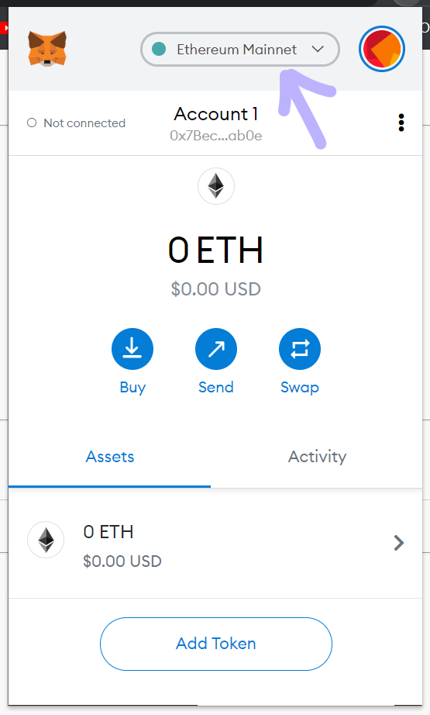 Login to your Metamask and select the drop down on the top.  
   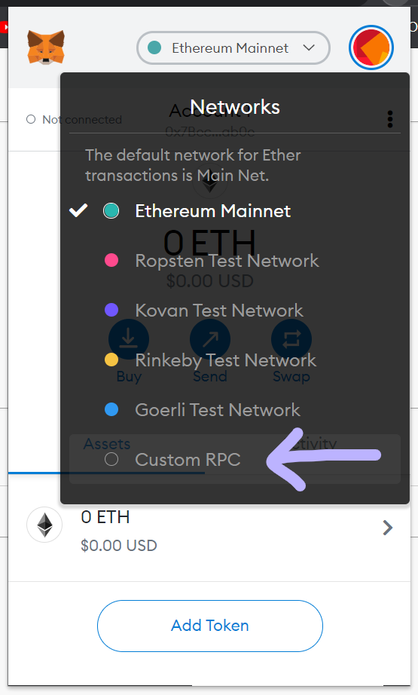 Select Custom RPC.  
   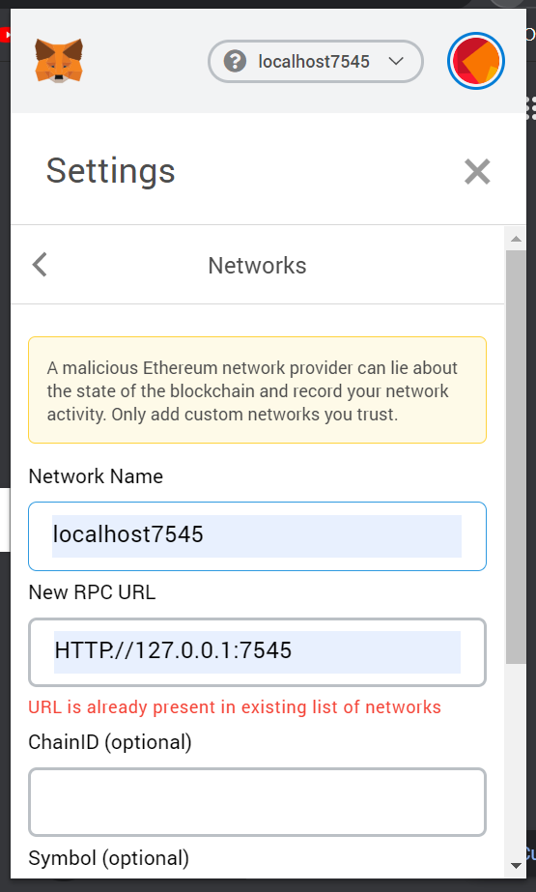  
   Add the RPC URL into “New RPC URL” input field and save the network.  
     
   To note:  
   Ganache and Metamask just recently updated. Hence, ChainID might not be optional anymore. Ganache stated that in the new version there will be the ChainID provided.

# Importing accounts to Metmask:

1. Click on the key icons at the right side.  
   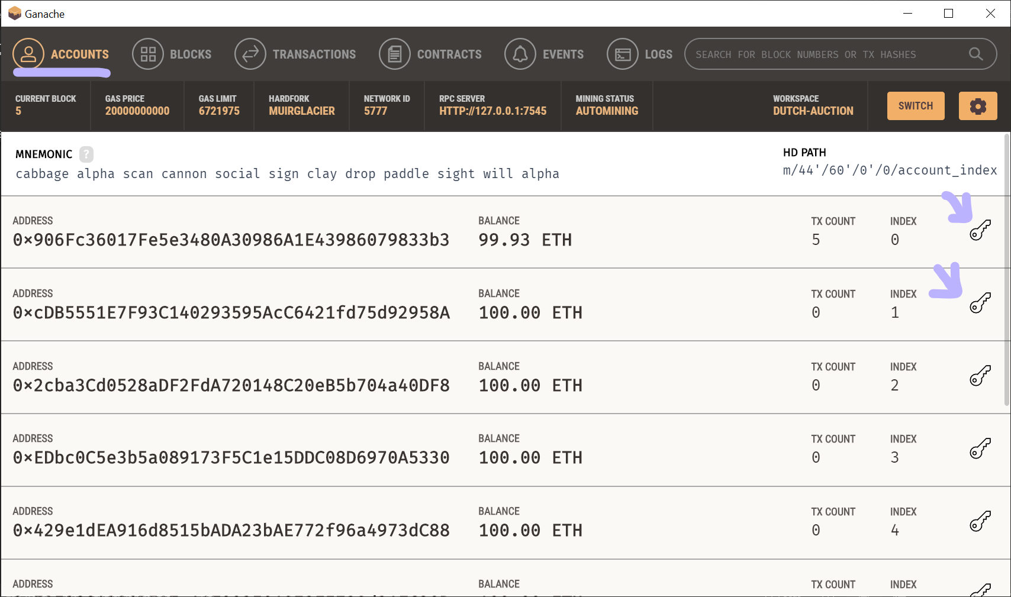
2. Record down the private keys.  
   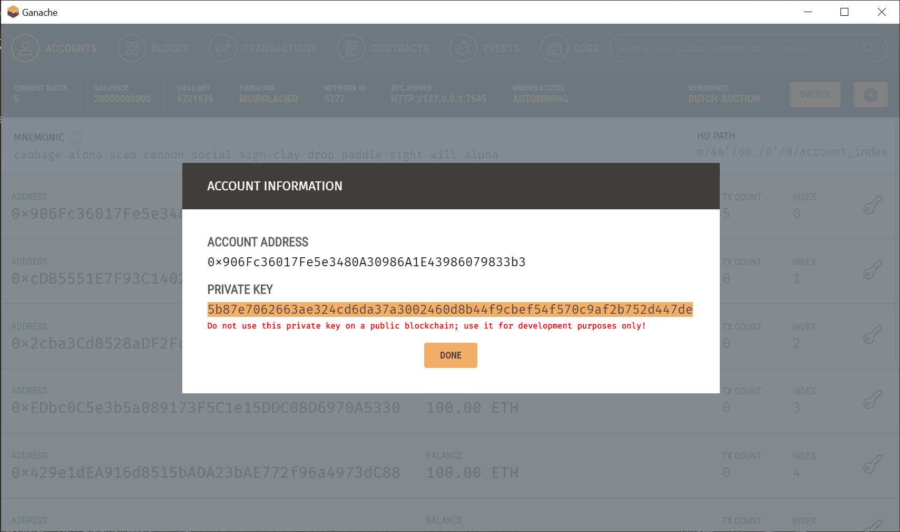
3. Go back to metamask.  
   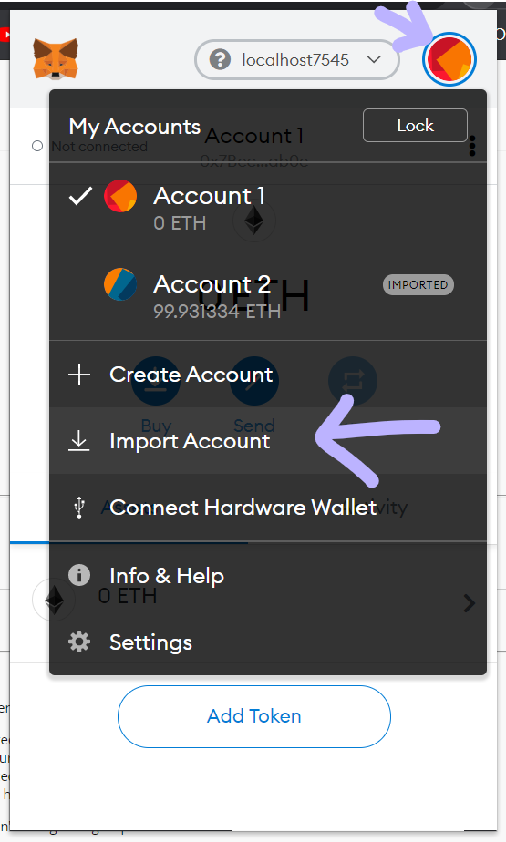Look for Import Account.  
   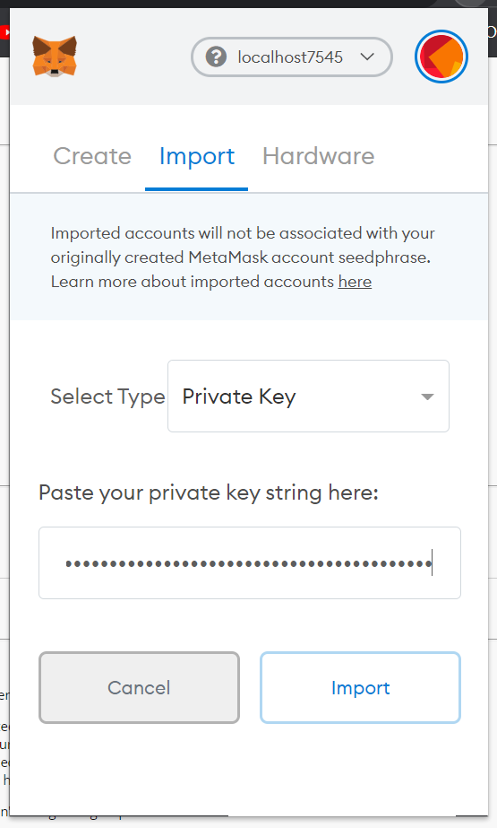  
   Select Type to Private Key and past the Private Key String here. Repeat if you want to import more than 1 account.  
   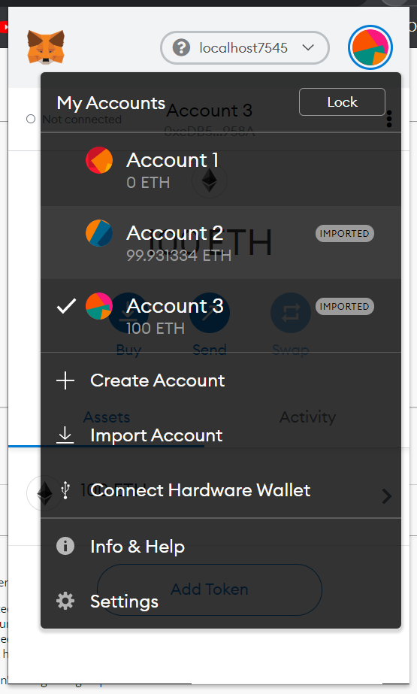  
   The accounts will be reflected in Metamask.

# Starting up and setting up webapp:

1. Open another terminal and change the directory to the “../DutchAuction” where “package.json” is at.  
   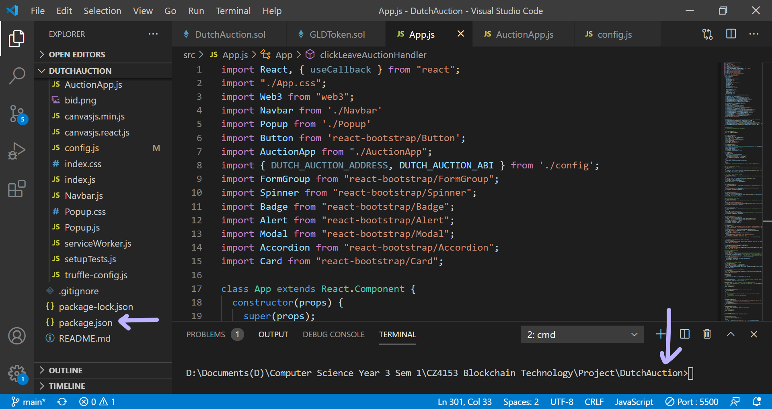
2. Enter “npm start” and let it run until the web application pops up.  
   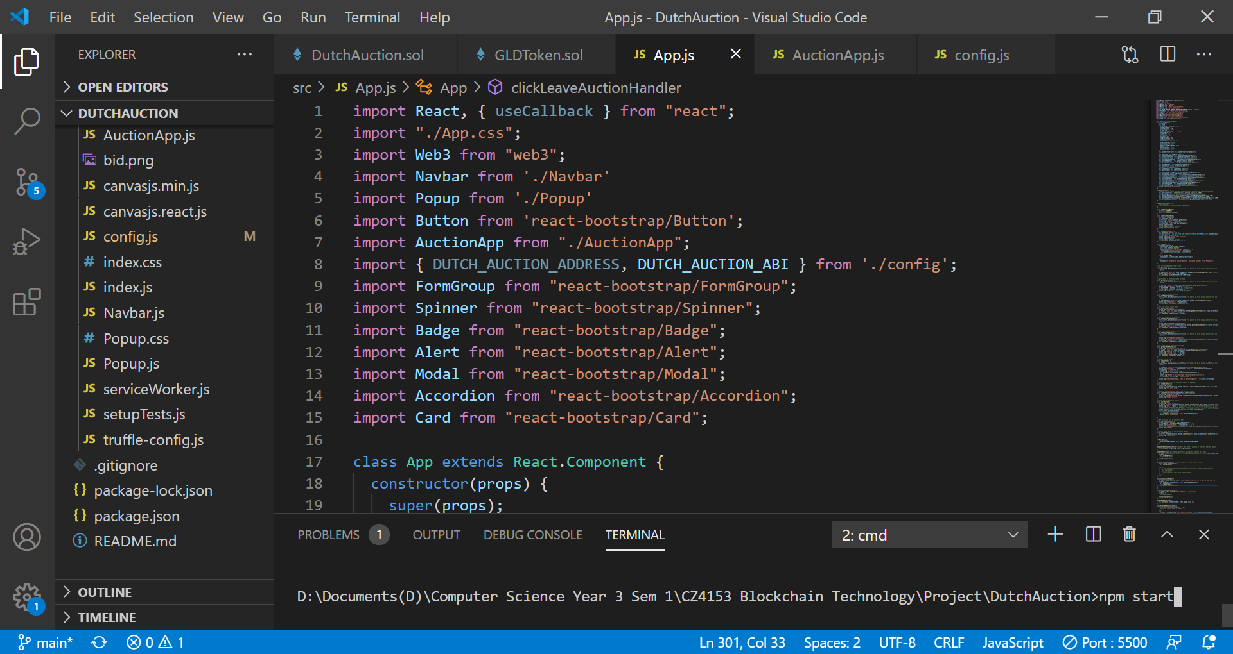  
   It will prompt you to connect your accounts. Select the accounts imported from Ganache  
   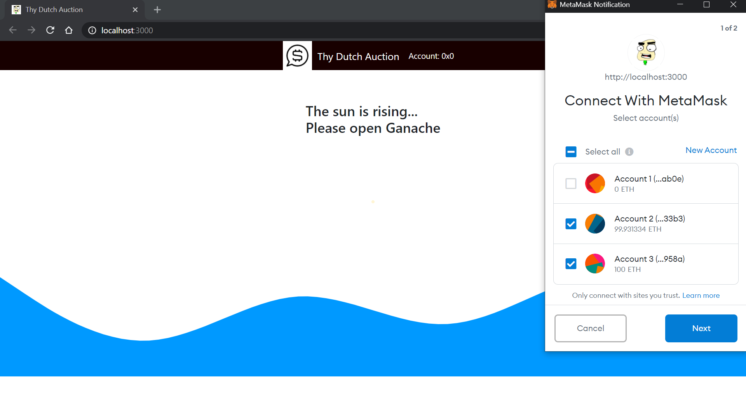  
   The web application is up.  
   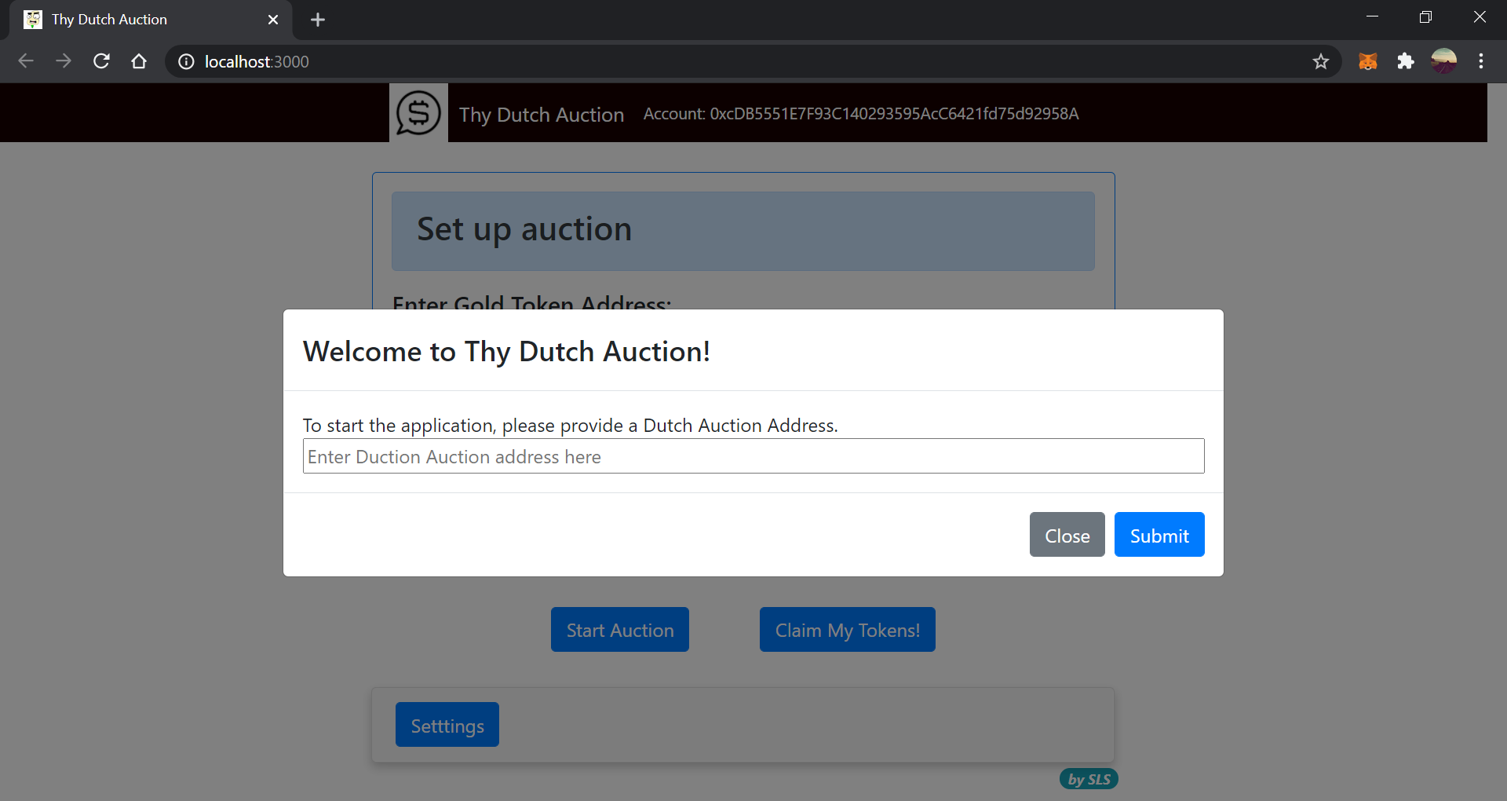

Our demo video will show how the application works. Please ensure the Ganache is open.

# Note

If there is an error when submitting the Dutch Auction Address, try resetting the account.  
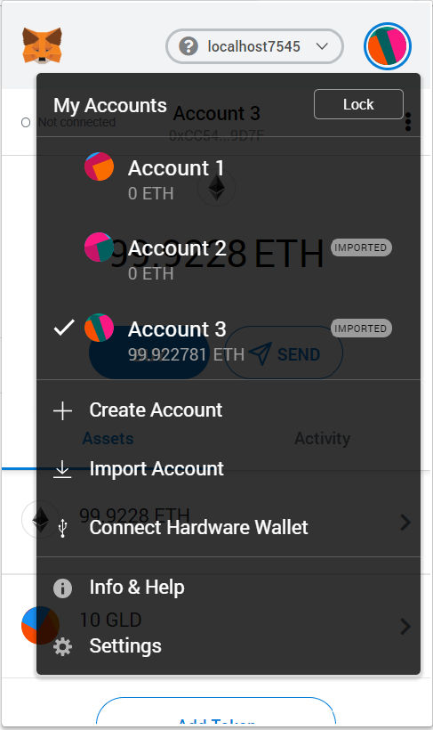Click the account icon on the top right corner of metamask.  
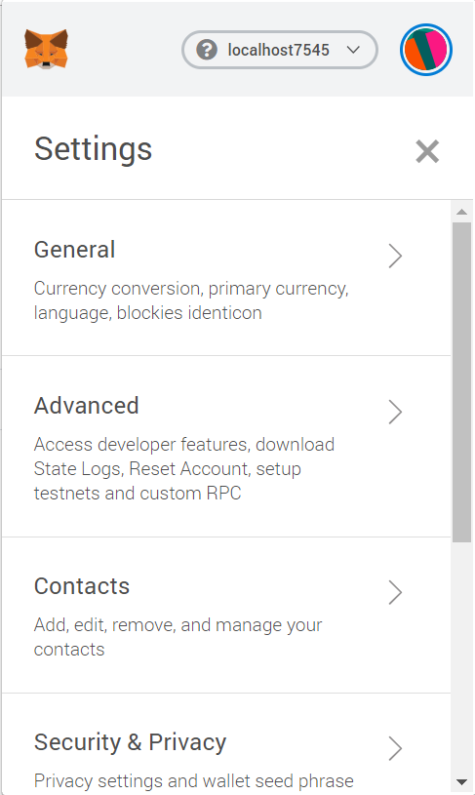Go to settings->Advanced  
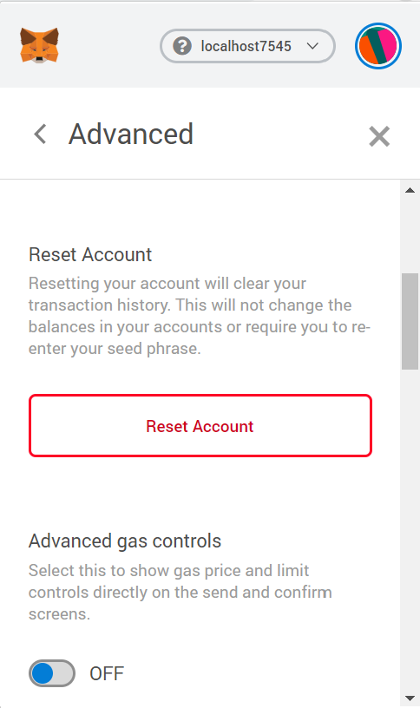Scroll down and click Reset Account.  
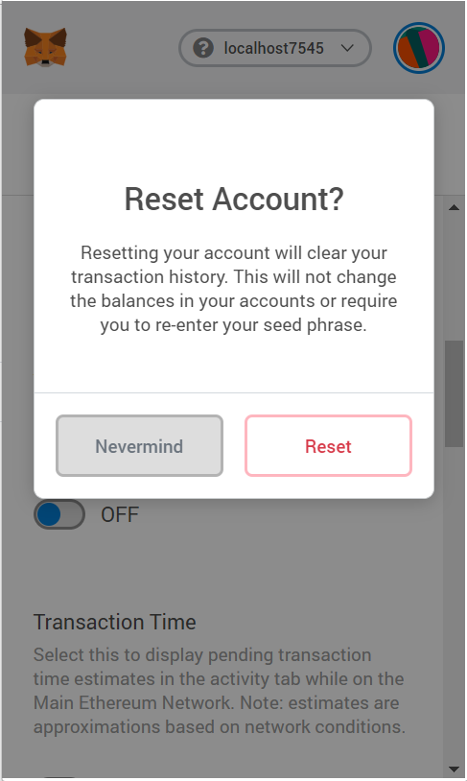Click reset and refresh the app

# Installing of node modules (if needed):

1. Open terminal and ensure the directory is pointing to the folder containing the package.json file.   
   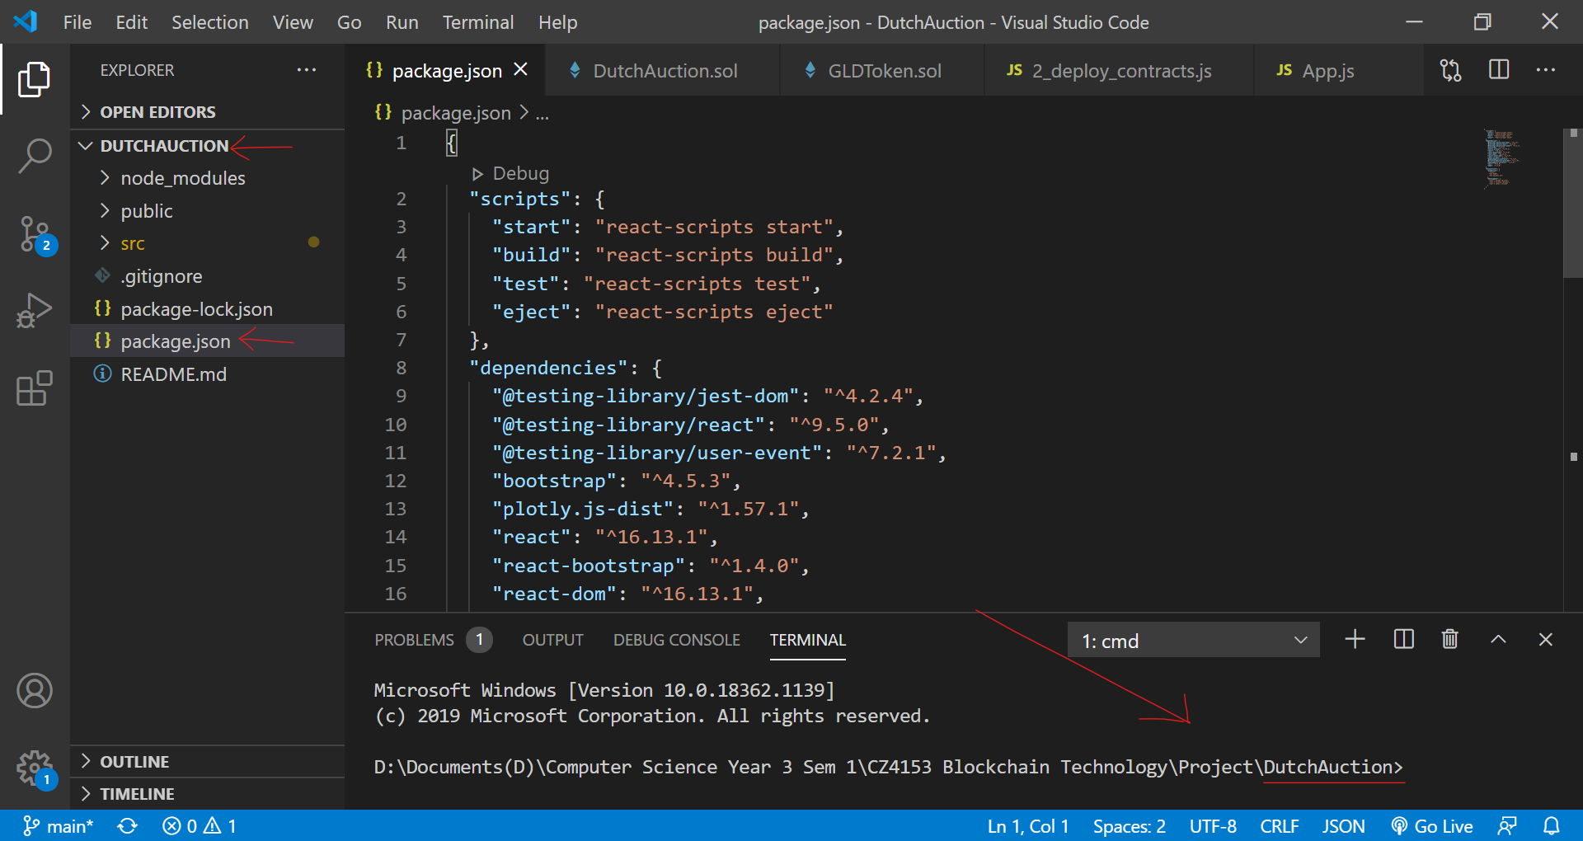
2. Enter npm install into the terminal.  
   