Implementation of Diffie-Hellman Algorithm

R.Shiny
AP25122050012
Diffie-Hellman key exchange:
It is a key exchange algorithm happens between 2 users. This is symmetric key exchange algorithm, means share common secret key.
- Public Parameters: Both parties agree on a large prime number p and a base g (a primitive root modulo p).
- Private Keys: Each party selects a private key — a secret number.
- Public Keys: Each computes a public key using the formula g^{ {private}} \mod p.
- Exchange: They exchange public keys.
- Shared Secret: Each party computes the shared secret using the other’s public key and their own private key.

Code:
# Public parameters (agreed upon by both parties)
P = 23 # A prime number
G = 5 # A primitive root modulo P

# Alice's private key
a = 6
# Bob's private key
b = 15

# Alice computes her public key
A = (G ** a) % P

# Bob computes his public key
B = (G ** b) % P

# Exchange public keys: A and B

# Alice computes shared secret using Bob's public key
shared_secret_alice = (B ** a) % P

# Bob computes shared secret using Alice's public key
shared_secret_bob = (A ** b) % P

print("Alice's public key:", A)
print("Bob's public key:", B)
print("Shared secret (Alice):", shared_secret_alice)
print("Shared secret (Bob):", shared_secret_bob)

Output:
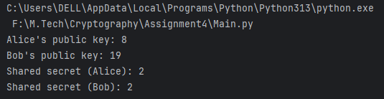

Github link: https://github.com/shinyramanadham-AD/Applied-Cryptography

