**CHAPTER 3**

**METHODOLOGHY**

**A. EXISTING ALGORITHM**

**Statement of the Problems**

1. The existing algorithm is unable to assure recognition accuracy due to various illumination conditions where it strongly affects the face appearance.
2. The existing algorithm is susceptible in producing inaccurate recognition results depending only in facial feature.
3. The existing algorithm’s *Dimension Reduction* produces inefficient *Lower Dimension Covariance Matrix* **(*C = ATA*)**when ***m*** is larger than ***N2*** of the vector.

**B. PROPOSED ALGORITHM**

**Objectives**

1. S
2. S
3. S

**MANUAL SIMULATION**

**A. EXISTING ALGORITHM**

**Problem 1:** Sensitivity to illumination cause inaccurate or inability to recognize a person.

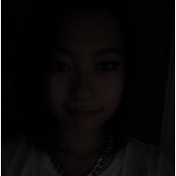 ***Training Face Input Image***

***Figure 1:*** *Images with different illumination conditions. The Input Image has a darker lighting.*

1. Get colored image and convert into greyscale image.

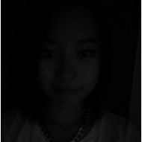 ***Input Image Greyscale Image***

***Figure 2:*** *Converting the Input Image to Greyscale Image.*

1. Get image data in form of a matrix (N x N pixel).

*** Greyscale Image Matrix x***

***N x N Matrix***

***Figure 3:*** *Converting the Greyscale Image to N x N Matrix*

1. Calculate the mean.



*Where* ***M*** *is the number of Training Face and Γ is the vector of size* ***N2***

d

* 1. If image is for Training Face, its data will be stored in the Training Set.
  2. If image is for Recognition, proceed to process number.2

1. Calculate the mean of the Training Set, where *m* is the number of Training Face and Γ as the Training Face.
2. Normalize each input face image by subtracting the mean face.
3. Calculate covariance matrix.
4. Calculate the eigenvalues of the covariance matrix and keep only k largest eigenvalues.
5. Compute the eigenvectors of covariance matrix.
6. Compute eigenfaces containing highest information of face images.
7. Compute the projected image