**Using LMT:**

=== Summary ===

Correctly Classified Instances 940 98.1211 %

Incorrectly Classified Instances 18 1.8789 %

Kappa statistic 0.9582

Mean absolute error 0.1568

Root mean squared error 0.2017

Relative absolute error 34.6131 %

Root relative squared error 42.3868 %

Total Number of Instances 958

=== Detailed Accuracy By Class ===

TP Rate FP Rate Precision Recall F-Measure MCC ROC Area PRC Area Class

0.995 0.045 0.976 0.995 0.986 0.959 0.991 0.995 positive

0.955 0.005 0.991 0.955 0.972 0.959 0.991 0.989 negative

Weighted Avg. 0.981 0.031 0.981 0.981 0.981 0.959 0.991 0.993

=== Confusion Matrix ===

a b <-- classified as

623 3 | a = positive

15 317 | b = negative

**Using NaiveBayes:**

=== Summary ===

Correctly Classified Instances 679 70.8768 %

Incorrectly Classified Instances 279 29.1232 %

Kappa statistic 0.3054

Mean absolute error 0.3677

Root mean squared error 0.4302

Relative absolute error 81.1549 %

Root relative squared error 90.405 %

Total Number of Instances 958

=== Detailed Accuracy By Class ===

TP Rate FP Rate Precision Recall F-Measure MCC ROC Area PRC Area Class

0.861 0.578 0.737 0.861 0.794 0.316 0.747 0.858 positive

0.422 0.139 0.617 0.422 0.501 0.316 0.747 0.647 negative

Weighted Avg. 0.709 0.426 0.696 0.709 0.693 0.316 0.747 0.785

=== Confusion Matrix ===

a b <-- classified as

539 87 | a = positive

192 140 | b = negative

**Using J48:**

=== Summary ===

Correctly Classified Instances 800 83.5073 %

Incorrectly Classified Instances 158 16.4927 %

Kappa statistic 0.618

Mean absolute error 0.1927

Root mean squared error 0.3651

Relative absolute error 42.539 %

Root relative squared error 76.7225 %

Total Number of Instances 958

=== Detailed Accuracy By Class ===

TP Rate FP Rate Precision Recall F-Measure MCC ROC Area PRC Area Class

0.927 0.337 0.838 0.927 0.880 0.626 0.868 0.902 positive

0.663 0.073 0.827 0.663 0.736 0.626 0.868 0.800 negative

Weighted Avg. 0.835 0.246 0.834 0.835 0.830 0.626 0.868 0.866

=== Confusion Matrix ===

a b <-- classified as

580 46 | a = positive

112 220 | b = negative

**Using Logistic:**

=== Summary ===

Correctly Classified Instances 936 97.7035 %

Incorrectly Classified Instances 22 2.2965 %

Kappa statistic 0.9489

Mean absolute error 0.0304

Root mean squared error 0.1342

Relative absolute error 6.7162 %

Root relative squared error 28.1953 %

Total Number of Instances 958

=== Detailed Accuracy By Class ===

TP Rate FP Rate Precision Recall F-Measure MCC ROC Area PRC Area Class

0.990 0.048 0.975 0.990 0.983 0.949 0.997 0.998 positive

0.952 0.010 0.981 0.952 0.966 0.949 0.997 0.995 negative

Weighted Avg. 0.977 0.035 0.977 0.977 0.977 0.949 0.997 0.997

=== Confusion Matrix ===

a b <-- classified as

620 6 | a = positive

16 316 | b = negative

**Using JRip:**

=== Summary ===

Correctly Classified Instances 936 97.7035 %

Incorrectly Classified Instances 22 2.2965 %

Kappa statistic 0.9491

Mean absolute error 0.0298

Root mean squared error 0.1438

Relative absolute error 6.5851 %

Root relative squared error 30.2159 %

Total Number of Instances 958

=== Detailed Accuracy By Class ===

TP Rate FP Rate Precision Recall F-Measure MCC ROC Area PRC Area Class

0.987 0.042 0.978 0.987 0.983 0.949 0.971 0.970 positive

0.958 0.013 0.975 0.958 0.967 0.949 0.971 0.967 negative

Weighted Avg. 0.977 0.032 0.977 0.977 0.977 0.949 0.971 0.969

=== Confusion Matrix ===

a b <-- classified as

618 8 | a = positive

14 318 | b = negative

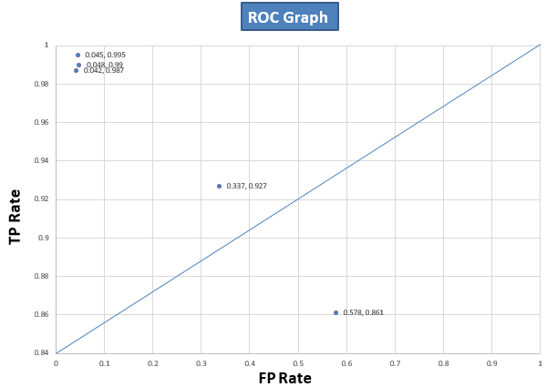

**Report:**

For Classifier 1,

It has a TP Rate of 99.5% and FP rate of 4.5%. In our case the main concern is TP rate, because classifying the positive as positive is the ultimate goal. Though classifier 1 has highest TP rate of 99.5%, it can be said that classifier 1 is the best suitable classifier for this data set.

For Classifier 2,

It has a TP Rate of 86% and FP rate of 57%. It has lower TP rate than classifier 1, which is bad in our case.

For Classifier 3,

It has a TP rate 92% & FP rate 33%. It has lower TP rate than classifier 1, which is bad in our case.

For Classifier 4,

TP rate 99% & FP rate 4%. It has lower TP rate than classifier 1, which is bad in our case.

For Classifier 5,

TP rate 98% & FP rate 4%. It has lower TP rate than classifier 1, which is bad in our case.

Now according to all of the classifier’s Euclidian distance from (0,1) in the ROC Graph it can be said classifier 1 which is LMT Classifier performs best for this data set. Hence it can be said LMT is the best suitable classifier for this data set.