Title: | Door Control Unit  SW Component DCM_App Version 1.1

History
Issue status  (Index) | Maturity/Date  (draft/invalid/valid)  (dd-mmm-yyyy) | Author  Department | Check/Release  Department | Description
1.0 | Draft  04-0ct-20 | Miguel Garcia | Miguel Garcia | Creation of the document
1.1 | Valid  28-Jan-2021 | Shiomar Salazar |  | First release of the SDD Document for DCM_App.

Table of Contents
1 Purpose 3
2 Definitions and abbreviations 3
2.1 Definitions 3
2.2 Abbreviations 3
2.3 References 3
3 Realization, constraints and targets 3
4 SW Conceptual design 4
4.1 Use Case Diagram 4
4.2 Block Definition Diagram 4
5 SW Component internal breakdown 5
5.1 SW Component internal breakdown 5
5.2 Functional Decomposition 5
5.3 Function <Type> <function name> (type par 1, .., type par n) 6
5.4 Function <Type> <function name> (type par 1, .., type par n) 6

Purpose
This document is intended to provide a complete and necessary guide on the Software Detail Design of the DCM Application for the Door Control Module project; this document will provide different diagrams and specifications needed to implement by the DCM_App SWC, in order to fulfil all the customer requirements. In addition, this document will capture and summarize all the significant architectural decision, which have been made for this SWC.

Definitions and abbreviations

Definitions

Abbreviations
DCM | Door Control Module
SWC | Software Component
DD | Driver Door
PD | Passenger Door
RRD | Rear Right Driver
RLD | Rear Left Driver
SW | Software
HAL | Hardware Abstraction Layer

References
N° | Document name | Reference
1 | “Traceability Matrix Template.xls” Version 2 | \V_Project_UDG_Eq4\documentation\V-Cycle Process\1.0 Requirements
2 | “Proyecto_DoorControlModule.docx” | \V_Project_UDG_Eq4\documentation
3 | SWA_DoorControlModule.pdf | \V_Project_UDG_Eq4\documentation\V-Cycle Process\2.0 Architecture\

Realization, constraints and targets

DCM_App is one of the key components of the DCM project, due that this SWC component shall implement the mayority of the customer requirements.
This SWC will be able to get all the inputs form other SWC (like Button Manager or CAN Manager) and be able to perform the necessary algorithm to perform the main 3 functions of the system (Door Locking feature, Window Control Features, HW Diagnostics).
This SWC also communicate with the “output SWC” (i.e. Actuator Manager, Error Manager or Serial Manager) which help the DCM_App to trigger the expected behavior of every input combinanation.

SW Conceptual design

Use Case Diagram

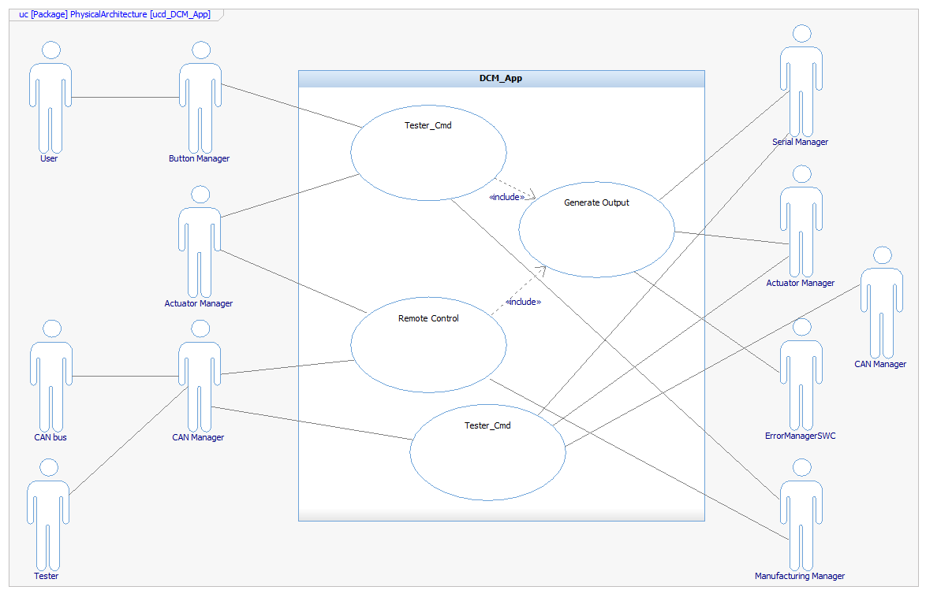

Block Definition Diagram

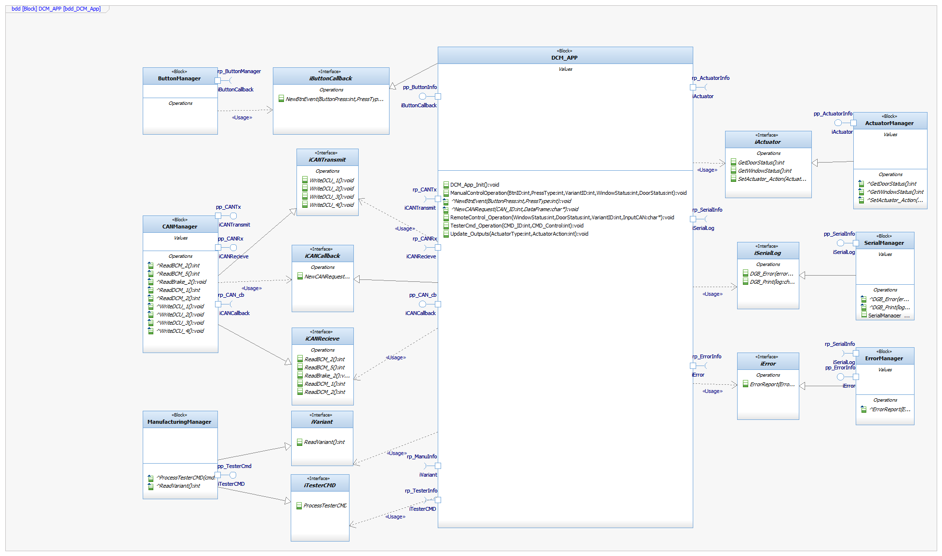

SW Component internal breakdown

Functional Decomposition

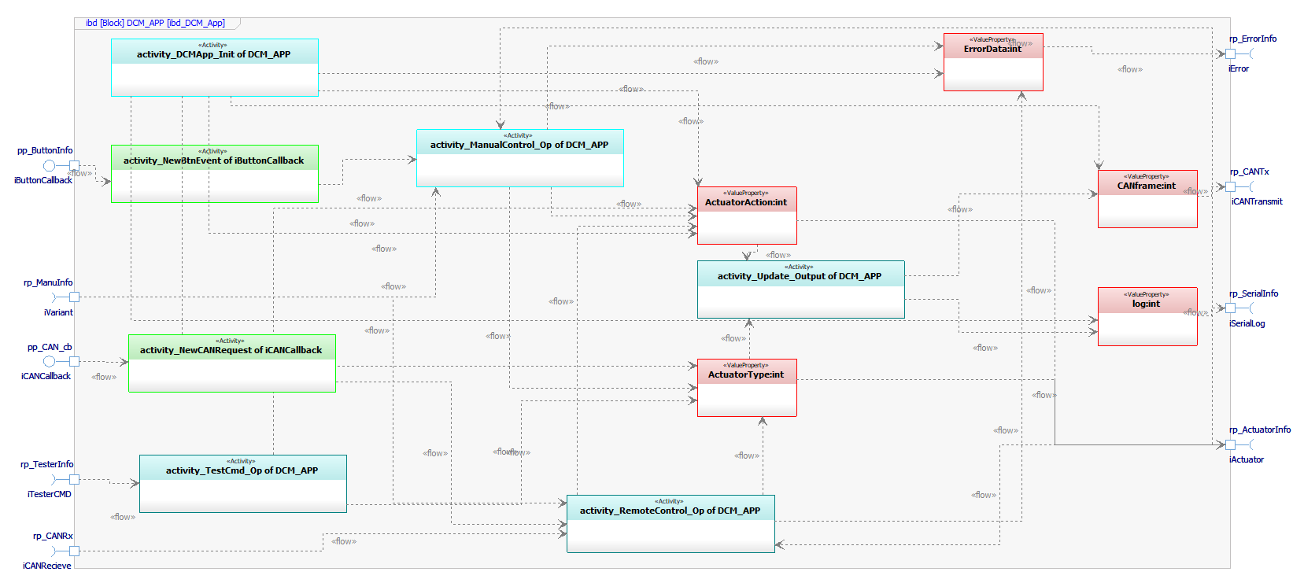

SW Component internal breakdown

Function void DCM_App_Init (void)

Description | This function perform the necessary step (Variable Initialization) to allow the algorithm to be ready to execute.
Parameter 1  void | N/A
Return Value | N/A
Precondition | The OS call this function during the initialization process, hence no preconditions.
Post condition | N/A
Error Conditions | N/A
Requirements | This Function will not implement any requirement.

Dynamic Behavior
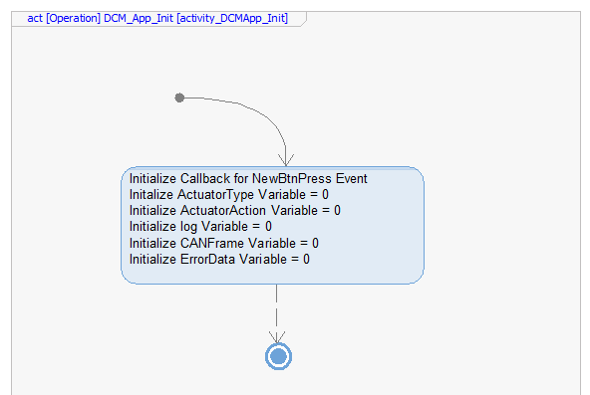

Function void ManualControl_Operation (int BtnId, int PressType, int VariantId, int WindowStatus, int WindowStatus)

Description | This function will process the inputs of the Manual Control of the Module (all the buttons inputs) for the DCM Algorithm and will produce the necessary information for the other functions to execute their tasks.
Parameter 1  input | BtnId: int  This variable will contain the information related to which button was pressed.
Parameter 2  input | PressType: int  This variable will contain the information related to which type of press was present after the debounce algorithm filter it.
Parameter 3  input | VariantId: int  This variable will contain the information related to which variant is the module been configured as.
Parameter 4  input | WindowStatus: int  This variable will contain the information related to which is the status of the WindowPosition.
Parameter 5  input | WindowStatus: int  This variable will contain the information related to which is the status of the Door Locking.
Return Value | N/A
Precondition | This Function shall be executed after the DCM_App_Init  This function need to be execute after a NewButtonEvent_Callback happened.
Post condition | After this function is been, execute, the ActuatorAction, ActuatorType and ErrorData Variable will be populated with the expected information.
Error Conditions | This function will validate all the algorithm inputs, and if it encounter an error (invalid signals or impossible conditions), will connect with ErrorManager SWC to Handle it.
Requirements | For requirement traceability, please refer to traceability matrix file (see reference section).

Dynamic Behavior
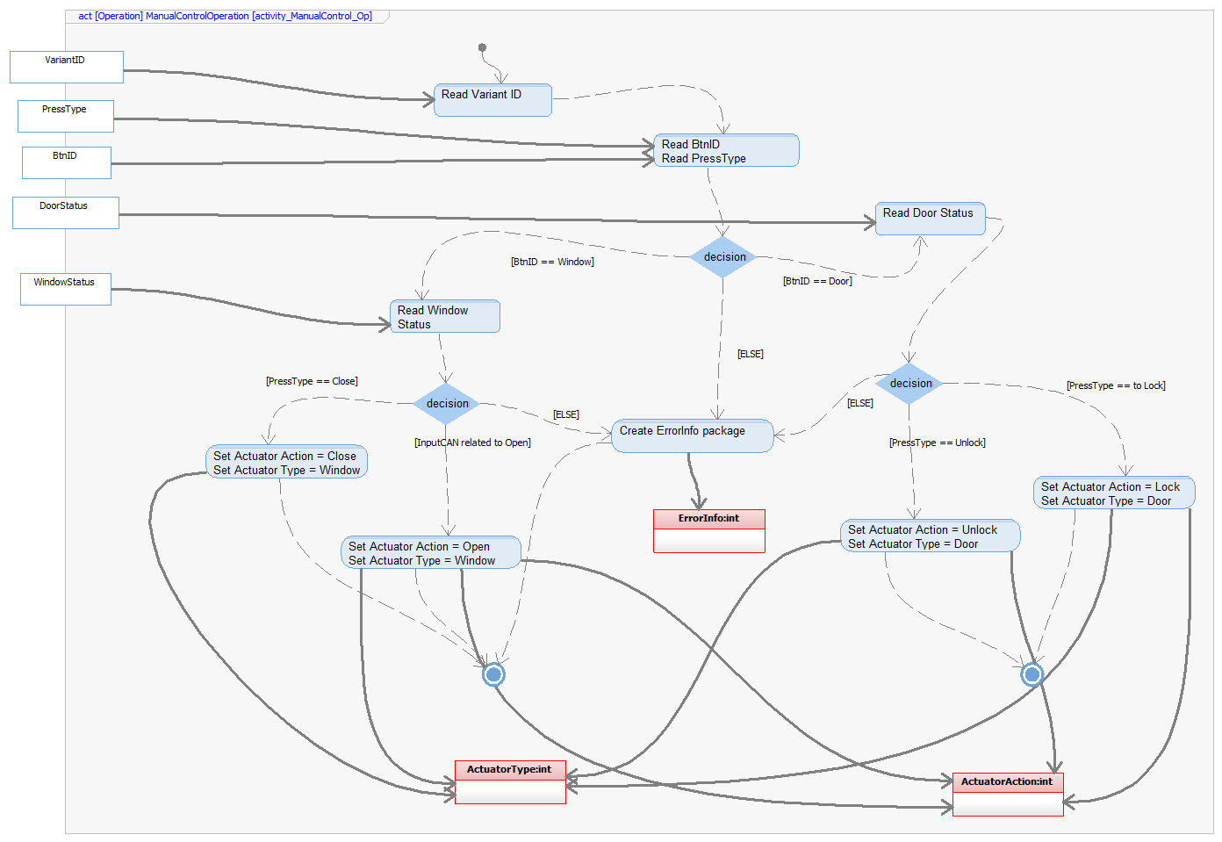

Function void RemoteControl_Operation (char* InputCan, int VariantId, int WindowStatus, int WindowStatus)

Description | This function will process the inputs of the Remote Control (all the CAN signals inputs) for the DCM Algorithm and will produce the necessary information for the other functions to execute their tasks.
Parameter 1  input | InputCan: char*  This variable will contain the information related the input CAN request to be attended.
Parameter 2  Input | VariantId: int  This variable will contain the information related to which variant is the module been configured as.
Parameter 3  Input | WindowStatus: int  This variable will contain the information related to which is the status of the WindowPosition.
Parameter 4  input | WindowStatus: int  This variable will contain the information related to which is the status of the Door Locking.
Return Value | N/A
Precondition | This Function shall be executed after the DCM_App_Init  This function need to be execute after a (previously filtered) valid CAN signal reach to the DCM.
Post condition | After this function is been, execute, the ActuatorAction, ActuatorType and ErrorData Variable will be populated with the expected information.
Error Conditions | This function will validate all the algorithm inputs, and if it encounter an error (invalid signals or impossible conditions), will connect with ErrorManager SWC to Handle it.
Requirements | For requirement traceability, please refer to traceability matrix file (see reference section).

Dynamic Behavior
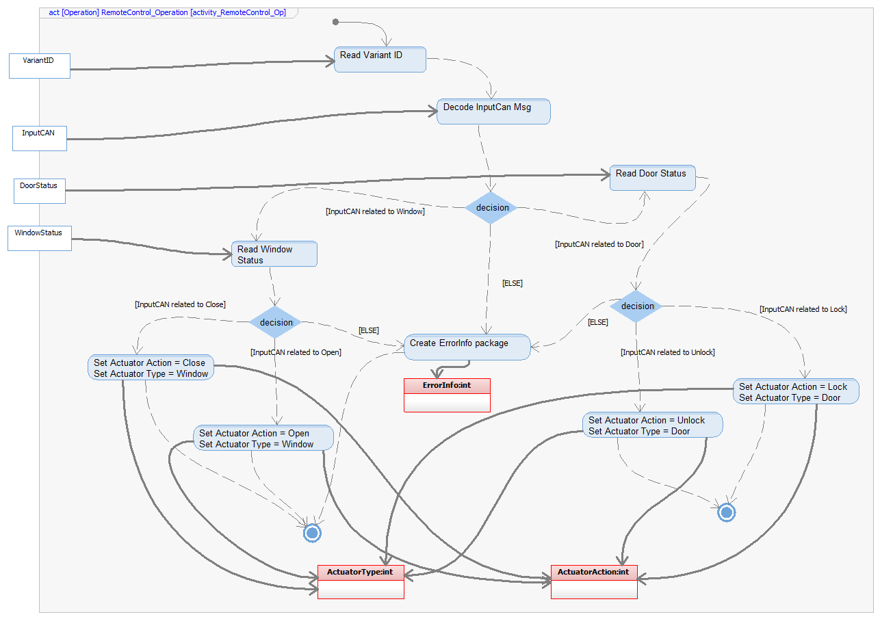

Function void Test_Cmd_Operation (int CMD_ID, int CMD_Control)

Description | This function will process all the requested Command form the Tester inputs.
Parameter 1  input | CMD_ID: int  This variable will contain the information related to the Tester Command to be execute.
Parameter 2  input | CMD_Control: int  This variable will contain the information related to the variant of the Tester Command to be execute.
Return Value | N/A
Precondition | This Function shall be executed after the DCM_App_Init  This function need to be execute after the ManufacturingManager triggers the Tester Command event.
Post condition | After this function is been, execute, the ActuatorAction and ActuatorType Variable will be populated with the expected information.
Error Conditions | Prior this function is been executed the input shall be validated by the Manufacturing Manager, hence no error possible here.
Requirements | For requirement traceability, please refer to traceability matrix file (see reference section).

Dynamic Behavior
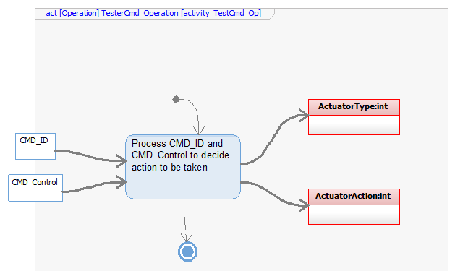

Function void Update_Outputs (int ActuatorType, int ActuatorAction)

Description | This function will be executed periodically to ensure all the changes form the algorithm are properly attend.  This function will collect the information from the Control Function and generated the CANFrame to be send to the CANManager and the Log information to the SerialManager.
Parameter 1  input | ActuatorType: int  This variable will contain the information related to the kind of Actuator (DoorLocking or Window) shall be activated.
Parameter 2  input | ActuatorAction: int  This variable will contain the information related to the kind of Action the Actuator shall perform.
Return Value | N/A
Precondition | This Function shall be executed after the DCM_App_Init  This Function will be executed periodically.
Post condition | After this function is been, execute, the CANFrame and Log Variable will be populated with the expected information.
Error Conditions | Prior this function is been executed the input shall be validated by the Control Function on this SWC, hence no error possible here
Requirements | For requirement traceability, please refer to traceability matrix file (see reference section).

Dynamic Behavior
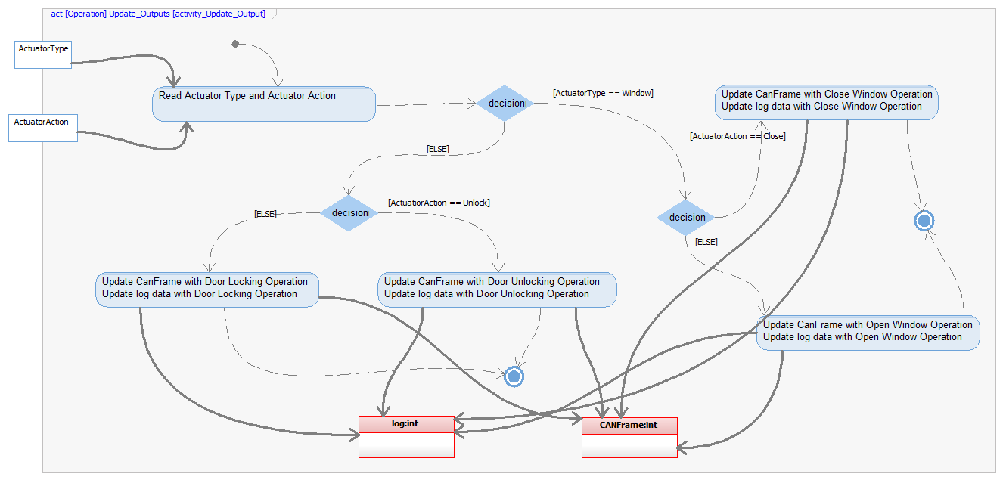

Function void NewBtnEvent (int ButtonPress, int PressType)

Description | This function will be the Entry point for the ManualControl_Operation, providing not only the event to start the processing, but also providing the inputs for that function.
Parameter 1  output | ButtonPress: int  This variable will contain the information related of the debounce button that had been pressed.
Parameter 2  output | PressType: int  This variable will contain the information related to the debounced type of button press read by the DCM.
Return Value | N/A
Precondition | This Function shall be executed after the DCM_App_Init.  This Callback shall be trigger by ButtonManager SWC.
Post condition | After this function execution, the ManualControl_Operation function can start processing the information and has all the necessary information to do so.
Error Conditions | Prior this function is been executed the input shall be validated by the ButtonManager SWC, hence no error possible here
Requirements | For requirement traceability, please refer to traceability matrix file (see reference section).

Dynamic Behavior
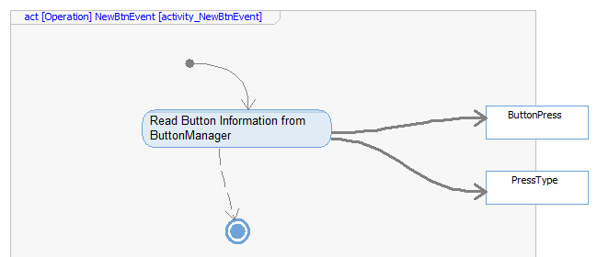

Function void NewCANrequest (int CAN_ID, char* DataFrame)

Description | This function will be the Entry point for the RemoteControl_Operation, providing not only the event to start the processing, but also providing the inputs for that function.
Parameter 1  output | CAN_ID: int  This variable will contain the information related of the filtered CAN Id which is requesting a change.
Parameter 2  output | CANFrame: char*  This variable will contain the information related to the filtered Information from the CAN Request.
Return Value | N/A
Precondition | This Function shall be executed after the DCM_App_Init.  This Callback shall be trigger by CANManager SWC.
Post condition | After this function execution, the RemoteControl_Operation function can start processing the information and has all the necessary information to do so.
Error Conditions | Prior this function is been executed the input shall be validated by the ButtonManager SWC, hence no error possible here
Requirements | For requirement traceability, please refer to traceability matrix file (see reference section).

Dynamic Behavior
