Investigation and analysis of PM2.5 air quality data in Chengdu

Cheng Wang

COSC3570 Data Science

Marquette University

12/12/2019

1. **Introduction**

The rapid development of China's economy in recent years is universally acknowledged. As a Chinese, I am very proud and very proud. However, China's air quality has become extremely worrying because of its efforts to develop industries such as heavy industries and oil that emit large amounts of polluting gases. Many scientists use PM2.5 as a measure of air quality to inform Chinese citizens. What is PM2.5? It is an extremely small particle in the air, with a diameter of 2.5 microns or less. PM2.5 has a small particle size, is rich in a large number of toxic and harmful substances and stays in the atmosphere for a long time and has a long transportation distance, so it has a greater impact on human health and atmospheric environment quality. Although such small particles, when the number of these particles become extremely large, can directly affect People's Daily life and even harm human health. In order to learn more about the influence of PM2.5, I chose this project as reference to find out more relevant information about air pollution to people’s life. I don't want to do any research on pollution in Beijing because it is known for its very poor air quality. Therefore, I chose Chengdu, a well-known Hot-Pot city, as the main target of this project.

1. **Lit Review**

There are two types of PM2.5: natural and man-made. Natural factors are dust blown up by the wind, plant pollen, spores, and airborne bacteria. There are also natural disasters such as volcanic eruptions that release large amounts of ash and dust storms that produce large amounts of fine particles that are transported into the atmosphere. When people see the gray sky, they are already victims. The fine particulate standard, proposed by the United States in 1997, is intended to more effectively monitor the emergence of industrialization of small, harmful particles that had been ignored in the old standards. Fine particulate matter index has become an important index to measure and control the degree of air pollution. By the end of 2010, except for the United States and some countries of the European Union, which included fine particulate matter in national standards and imposed mandatory restrictions, most countries in the world had not yet carried out monitoring of fine particulate matter, and most generally monitored PM10. In order to highlight the harmful impact of air pollution on human beings and society, I found a classic example, Great Smog of 1952 in London, to illustrate. December 5, 1952, solstice 9, a large number of factory production and residential coal heating emissions difficult to diffuse, accumulated in the city above. London was blanketed in thick smog and traffic was at a standstill. People's lives have been disrupted and their health seriously compromised. Many citizens have chest tightness, suffocation and other discomfort, morbidity and mortality increased sharply. The smog killed as many as 4,000 people that month, according to one estimate. The event became known as the "London smog incident" and became one of the top 10 environmental hazards of the 20th century. （more）Furthermore, PM 2.5 has a danger level determined.(…….) Here needs 8 resources!!!

1. **Methods**

我怎么增删/修改数据

1. 1
2. 2
3. 3
4. **Results**
5. 逐一解释为什么要这样形成图形
6. 引出这些关系/对比对我的项目有什么帮助
7. Overview of PM 2.5 in Chengdu and one of its towns from 2010 to 2015

X = day, y = PM 2.5 in town Caotangsi, different colors represent different year

X = day, y = PM 2.5 in town Caotangsi, different colors represent different year

In this part, ……

1. Compare PM 2.5 in two example towns and whole city Chengdu

In this part, ……

1. By cleaning the data, I find something interesting to show

1. To use PM 2.5 in Chengdu as example, to show which month the data changed the most

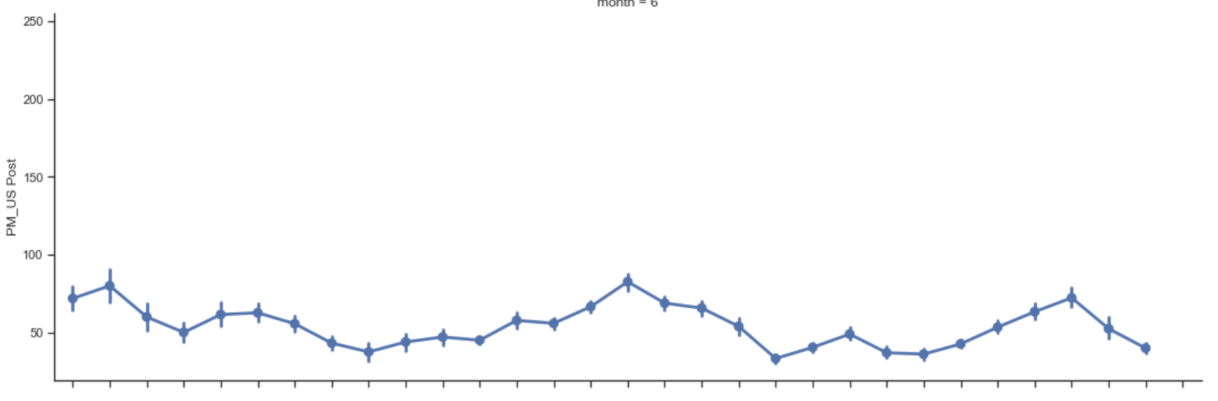

1. To compare PM 2.5 from different years in Chengdu and one of its towns

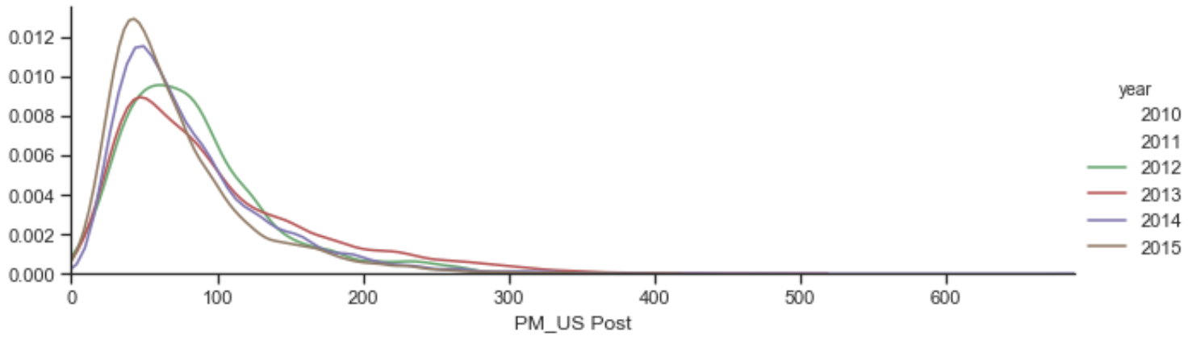

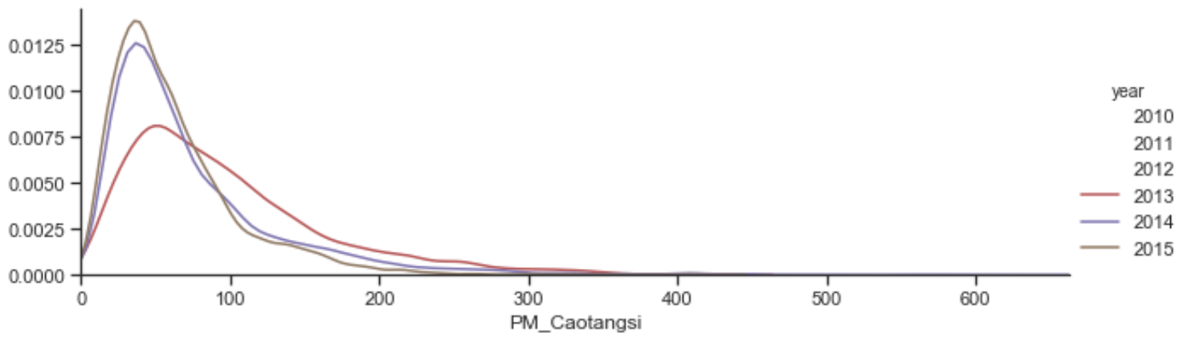

1. **Conclusion**
2. 总结一些已知的信息并加以拓展
3. 说明情况并设想一些长远的影响或者发展策略

In conclusion, PM 2.5

1. **Reference (APA Format)**
2. <https://blissair.com/what-is-pm-2-5.htm>
3. <https://repository.usfca.edu/cgi/viewcontent.cgi?article=1098&context=capstone>
4. <https://www.ncbi.nlm.nih.gov/pmc/articles/PMC4740125/>
5. <https://www.history.com/news/the-killer-fog-that-blanketed-london-60-years-ago>
6. <https://www.chengduliving.com/pollution-questions-answered/>
7. <https://www.nytimes.com/2016/08/18/world/asia/china-coal-health-smog-pollution.html>
8. <https://energy.economictimes.indiatimes.com/news/coal/coal-burning-causes-most-air-pollution-deaths-in-china-study-finds/53756809>
9. <https://www.theguardian.com/environment/2016/jan/19/chinas-coal-burning-in-significant-decline-figures-show>
10. <https://www.kaggle.com/uciml/pm25-data-for-five-chinese-cities>