HR ANALYTICS TO TRACK EMPLOYEE PERFORMANCE

Submitted By:
Shipali Garg (2024010097)
Yogita Mishra (2024010121)
MCA 2nd Year (2025-2026)

Submitted To:
Dr. Anjula Mehto
Assistant Professor


Computer Science and Engineering Department
Thapar Institute of Engineering and Technology, Patiala
November 2025
Table of Contents

S. No | Topic | Page No.
1 | Introduction | 3
2 | Problem Statement | 4
3 | Overview of the Dataset used | 5-6
4 | Project workflow | 7-8
5 | Results | 9-11
6 | Conclusion | 12
7 | GitHub Link | 12

Introduction
The Employee Analytics Dashboard is a data analytics project aimed at understanding and improving workforce performance through data-driven insights. In any organization, employee productivity and performance are key factors that determine overall success. However, manually analysing large volumes of performance data is time-consuming and often inaccurate.
This project uses Numpy, Pandas, and Matplotlib to process and visualize employee performance data efficiently. The dashboard presents key metrics such as training hours, experience level, working hours, and performance scores in the form of interactive charts and trend analyses. By converting raw data into meaningful visual insights, HR departments and management teams can easily identify top performers, analyse the impact of training programs, and track performance trends over time.
Ultimately, the Employee Analytics Dashboard serves as a valuable decision-support tool that helps organizations enhance employee productivity, recognize training needs, and make evidence-based HR decisions.

Problem Statement
Organizations often face challenges in monitoring and evaluating employee performance due to scattered data, lack of visualization tools, and manual analysis processes. Without proper analytical insights, it becomes difficult to identify performance patterns, training impacts, or declining productivity trends.
The problem this project addresses is the absence of an automated, visual, and data-driven system to analyse employee performance effectively.
There is a need for a dashboard that:
- Collects and processes employee performance data.
- Displays visual correlations between training, experience, and performance.
- Tracks monthly or yearly performance trends.
- Helps HR professionals and managers make informed decisions based on real-time insights.
By solving this problem, the Employee Analytics Dashboard provides a clear, data-centric approach to understanding employee efficiency and organizational growth.

Overview of the dataset used
The dataset used in this project: employee_performance_data_categorical.csv contains detailed information about employees and their performance-related attributes. It includes both categorical and numerical variables that help analyze how different factors affect overall performance.
Each record in the dataset represents an individual employee, capturing key metrics such as training hours, experience, and performance scores. The dataset serves as the foundation for generating visual insights in the Employee Analytics Dashboard.

The dataset used for this project originally contains 17 columns. However, for the purpose of this analysis, only the following 14 key columns were used, as they are directly related to evaluating and visualizing employee performance trends. These attributes provide insights into employee productivity, training impact, attendance behaviour, and salary distribution across departments.

Column Name | Description
employee_ID | Unique identification number assigned to each employee.
department | The department where the employee works (e.g., HR, IT, Sales, Finance).
job_role | The specific role or designation of the employee within the department (e.g., Analyst, Manager, Executive).
years_at_company | The total number of years the employee has worked in the current organization.
monthly_hours_worked | The average total number of hours worked by the employee in a month.
attendance_rate | The percentage of days the employee was present during the evaluation period.
training_hours | The total number of hours the employee has spent in professional or skill development training.
tasks_completed | The total number of tasks completed by the employee.
promotions_last_3years | Indicates whether the employee received a promotion within the last three years.
salary_band | The salary category of the employee (e.g., Low, Medium, High).
work_location | Tells the location whether onsite, hybrid or remote.
performance_score | The numerical score assigned to the employee based on their performance evaluation.
performance_class | A categorical representation of performance levels (e.g., Excellent, Good, Average, Poor).
month | The month in which the performance data was recorded, used for time-trend analysis.

Project Workflow

1. Data Collection
The dataset, employee_performance_data_categorical.csv, was collected from Kaggle website.
It contains details such as employee demographics, job roles, attendance, training hours, and performance ratings.
This data forms the foundation for understanding employee behaviour and performance across different departments.

2. Data Pre-processing
Before analysis, the dataset underwent several cleaning and transformation steps:
- Handling Missing Values: Missing or incomplete records were filled or removed to maintain data integrity.
- Categorical Encoding: Text fields such as Department, Job_Role etc were prepared for visualization.

3. Exploratory Data Analysis (EDA)
In this stage, the data was explored to uncover key trends and relationships:
- Calculated descriptive statistics such as average performance, average training hours, and attendance rate.
- Segmented employees by department, job role, and salary level to observe performance variations.

4. Data Visualization
Using Matplotlib, multiple visual charts were created to present insights clearly:
- Donut Charts to display work location and salary band distributions.
- Histogram to display the performance distribution.
- Bar chart to compare promotions last 3 years.
- Bar Charts to compare performance across departments and job roles.
- Line Plots to analyze relationships between attendance rate, training hours, and performance score.
- Line Plot to show monthly performance trends over time.
These visualizations form the basis of the dashboard.
5. Dashboard Development
All the key visualizations were combined into a single Employee Analytics Dashboard using Python.
The dashboard includes:
- Key Performance Indicators (KPIs) such as Average Training Hours, Average Monthly Hours, and Average Performance Score.
- Multiple plots arranged in a clear layout to help HR managers quickly interpret trends.
- Export functionality to save the dashboard as an image (dashboard.png).

6. Insight Generation
After visualizing the data, meaningful insights were derived, such as:
- How training hours influence performance.
- Which departments have higher productivity.
- The relationship between promotions, salary bands, and employee performance.
- Monthly fluctuations in average performance scores.
These insights assist management in making data-driven HR decisions and improving employee engagement.

Results

1. Performance Distribution
The analysis revealed that most employees fall within the Good and Average performance categories, while a smaller portion achieved Excellent ratings. This indicates that overall employee performance is stable but has room for further improvement through training and engagement initiatives.
2. Promotions last 3 years
The promotion analysis shows that the majority of employees did not receive any promotions in the last three years, indicating either limited advancement opportunities or a highly selective promotion process. A smaller portion of employees received one promotion, while only a very small group achieved two promotions, highlighting that frequent upward movement within the organization is rare.

3. Department-Wise Performance
Performance levels differ notably across departments.
- Employees in Technical, HR, and Marketing departments generally perform better.
- Departments such as Finance and Sales show moderate performance levels.
This suggests that performance improvement strategies should be tailored to specific departmental needs.

4. Job-Role wise Performance
The job-wise performance chart shows that the average performance scores across all roles are very similar, with only minor differences between them. This indicates that performance is fairly consistent across job positions, and no specific role stands out as significantly higher or lower than the others.

5. Impact of Training Hours
A clear positive relationship was observed between training hours and performance score.
Employees who participated in more training sessions showed higher productivity and better evaluation results.
This finding emphasizes the importance of continuous learning and skill enhancement programs.

6. Attendance Rate
The attendance rate was found to have a moderate impact on performance.
Employees maintaining attendance above 90% generally achieved higher performance scores, showing that consistent presence positively affects output and efficiency.
7. Salary Bands
The salary band analysis shows that employees are almost evenly distributed between the high and medium salary bands, while a noticeably smaller portion falls into the low salary band. This indicates a generally balanced compensation structure with fewer employees earning at the lower end.
8. Work location
The work location distribution shows a fairly balanced setup, with 35% of employees working in a hybrid mode, 34% working onsite, and 31% working remotely. This indicates that all three work arrangements are well-represented, with hybrid being slightly more common.

9. Monthly Performance Trends
The time-series analysis showed minor monthly fluctuations in average performance.
Certain months demonstrated slightly higher productivity, which may correspond to project deadlines, appraisal cycles, or seasonal workload variations.
DASHBOARD.png
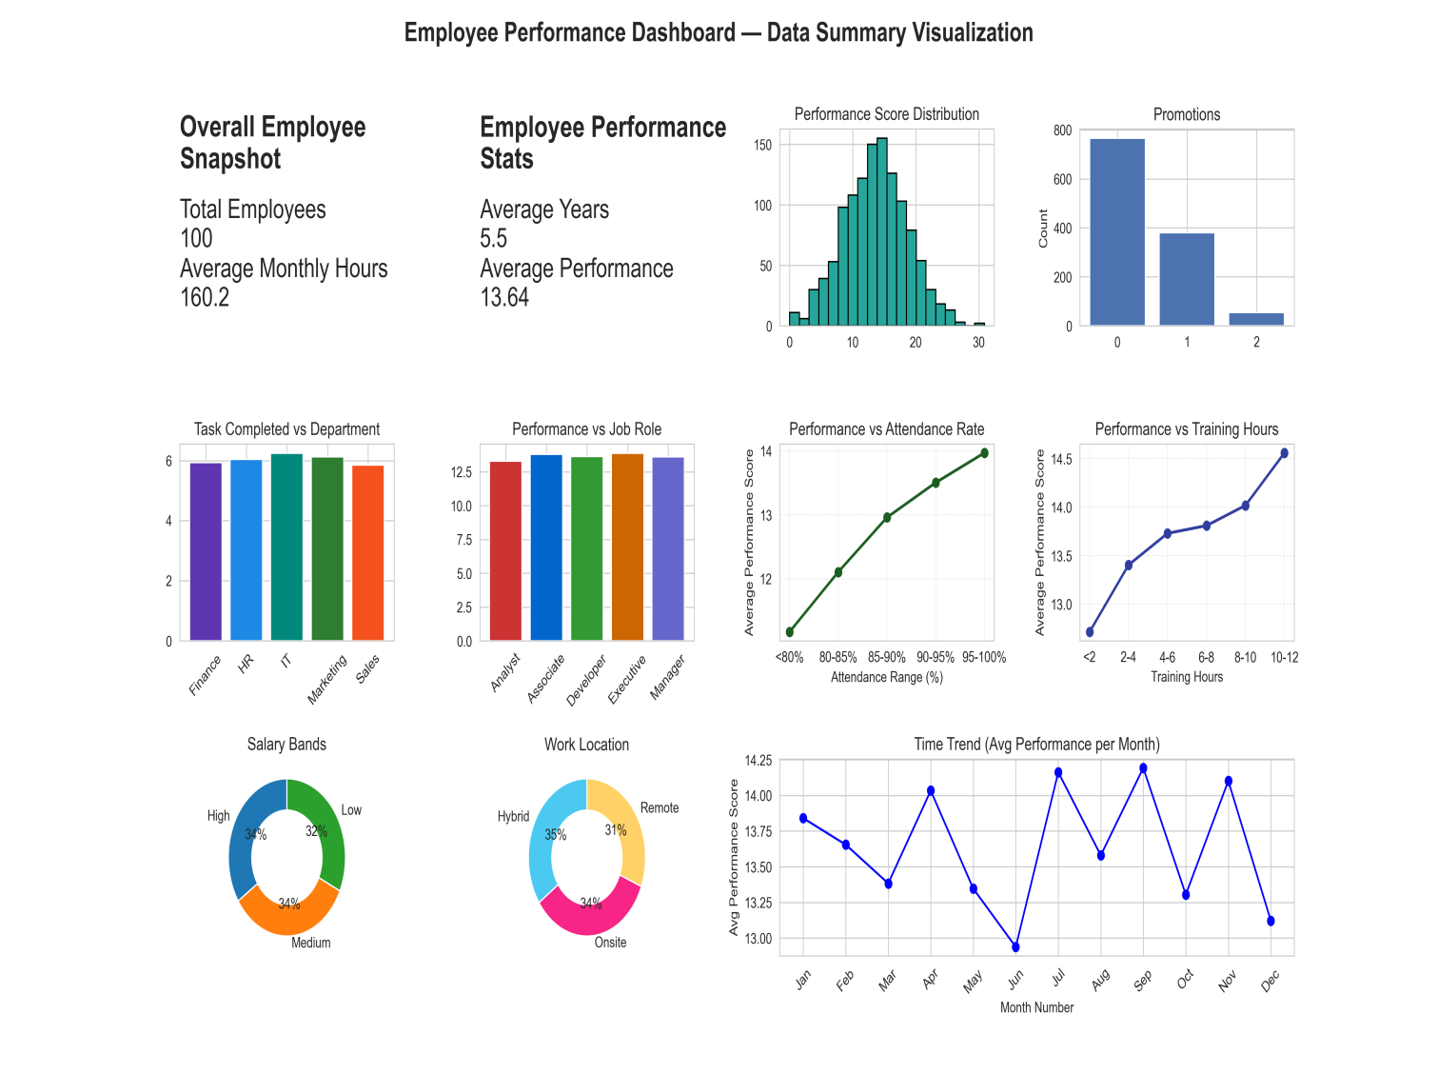

Conclusions
- Training and development are strong drivers of performance improvement.
- Department-specific strategies are needed to balance productivity across different units.
- Experience, tenure, and consistent attendance positively influence overall performance.
- Incentives such as promotions and salary growth enhance motivation and engagement.
- The developed Employee Analytics Dashboard successfully converts raw HR data into meaningful visual insights, helping management make data-driven decisions for workforce optimization.
GITHUB Link
https://github.com/shipali-garg/Data_Analytics_Project

