**Bachelor of Software Engineering**

**Database System**

**BTIS2013**

**SKY Bus Rental System**

**Content**

|  |  |
| --- | --- |
| **Title** | **Pages** |
| 1.0 Introduction | 1-3 |
| 2.0 Entities Relationship Diagram | 4 |
| 3.0 SQL Applied | 5-8 |
| 3.1 | 5 |
| 3.2 | 6 |
| 3.3 | 7 |
| 3.4 | 8 |
| 4.0 User Interface | 9 |
| 1. Conclusion | 10 |

**1.0 Introduction**

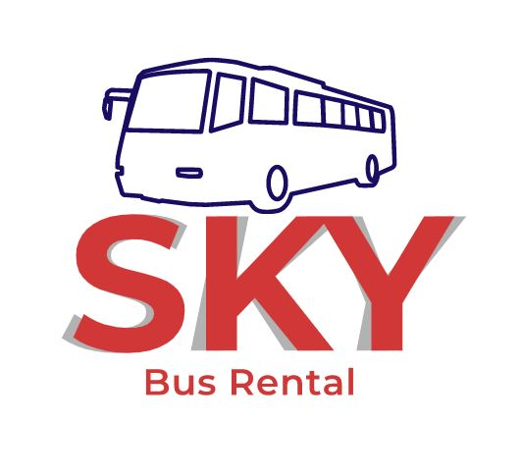

SKY Bus Rental System is a web application system that help customer to rent their bus and let customer rent the bus, so our SKY bus rental system is an intermediary system.

Because many customers have their own bus but currently not in use, and they want to rent out the bus for earn some extra money. But they don’t know how to find the tenants, they can use our system at this time.

Our system can let them input the information of their bus such as brand, type, year of production, color, maximum count of seat, fuel consumption per kilometer, used type of fuel and so on.

Besides that, the tenant customers can use our system to rent a bus for themselves. Nowadays, the bus rental’s market demand is not low such as the neighbors went on a group trip together, this also need of a bus.

Besides that, another example such as many schools no matter primary school, secondary school, college or university, when the school carry on the off-campus activities they will need the bus to transport the students and lectures.

Furthermore, for our company we also need to have the profit and income, so we will charge about 15 percent of the amount in the rental trade. Besides that, the tenant customer no need to worry about the bus’s owners will set a price that is too high.

Why the tenant no need to worry about bus’s owners will set a high price? It is because our company will have an prices evaluation team to evaluate all the bus that rent by bus’s owners’ user and calculate a reasonable price.



Beside the price evaluation team, our company also have the damage assessment team. The job of damage assessment team is evaluating the damage of bus after the tenant customer finish their bus rental before back to the bus’s owner and calculate that whether tenant customer need to make compensation or not.

We said that we will charge 15 percent for the amount of rental trade, the price charge of 15 percent is for the bus that used of normal fuel which is diesel. For the sake of environmental protection, if the type of used fuel is hybrid electric, the price of charge will discount to only charge 12 percent. So, this condition can appeal people for support the hybrid electric vehicle.

According to website MILJOLARE.NO, they do a calculation of the CO2 emissions to the normal size car such as Proto Saga and a normal bus. In their research, the CO2 emissions of a bus that have drive for 1km is 69ml of CO2, and the car is 133ml CO2.

Moreover, we use their research do another example calculation. One day, a neighborhood has 30 people plan to have a travel. They can have two choices, first is go by bus and the second is go by car. If their choice is bus, they just need one bus, else is the car and they need 6 cars.

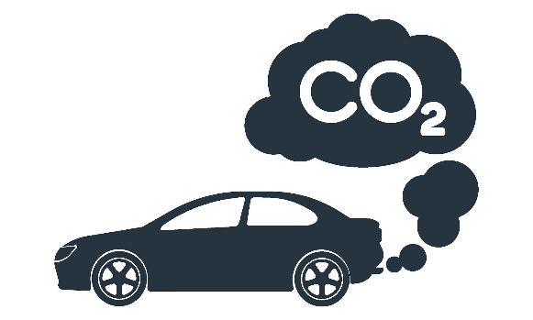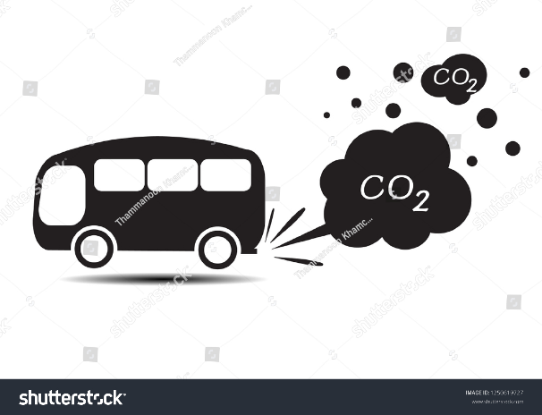Then, if the distance that to the place they want to travel have 100 km, and the calculation CO2 emissions of bus that have driven 100km is 6900 ml. Besides that, the calculation CO2 emissions ofcar that have driven 100km is 13300 ml. But, don’t forget that there have 6 cars, so that, 13300ml times 6 equal 79800ml of CO2. According to our calculation, the CO2 emissions of cars is 11 times the CO2 emissions of bus.

VS

1. **Entity Relationship Diagram**

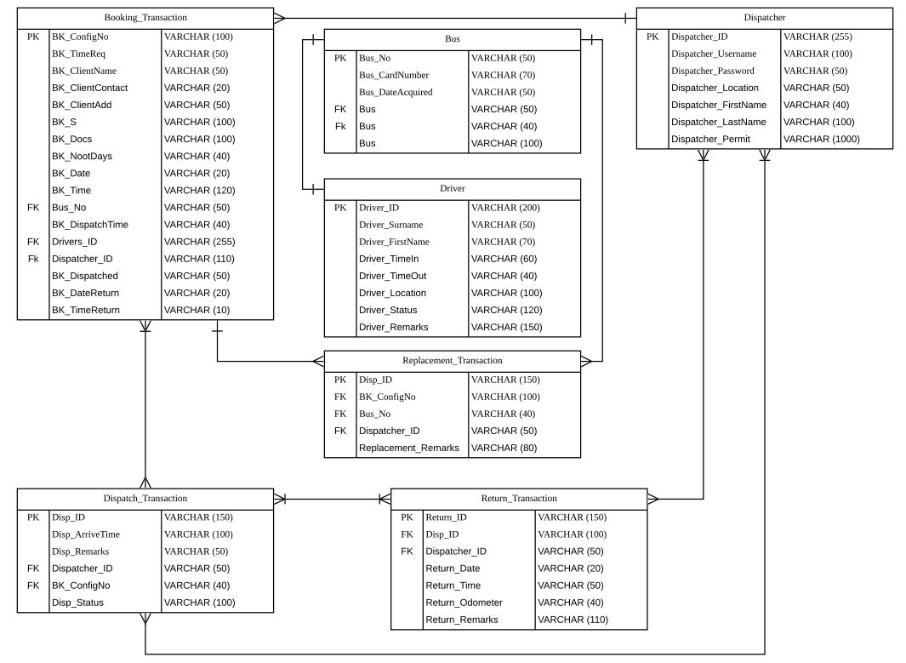

1. **SQL Applied**
   1. **SQL INSERT INTO Statement**

The INSERT INTO statement is used to insert new records in a table.

This is the INSERT INTO syntax:

INSERT INTO table_name (column1, column2, column3, ...)  
VALUES (value1, value2, value3, ...);

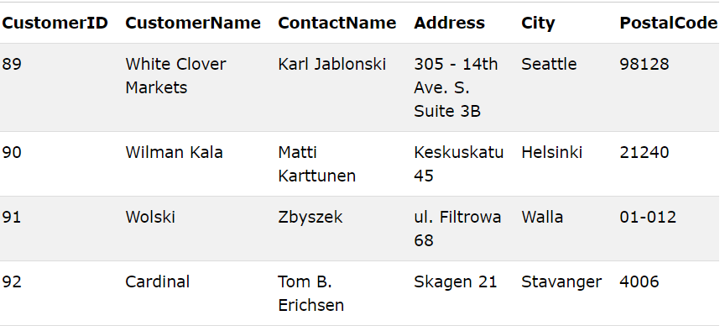Here example database:

So, will like this

INSERT INTO Customers (CustomerName, ContactName, Address, City, PostalCode, Country)  
VALUES ('Cardinal', 'Tom B. Erichsen', 'Skagen 21', 'Stavanger', '4006', 'Norway');

* 1. **SQL DELETE Statement**

The DELETE statement is used to delete existing records in a table.

This is DELETE syntax:

DELETE FROM table_name WHERE condition;

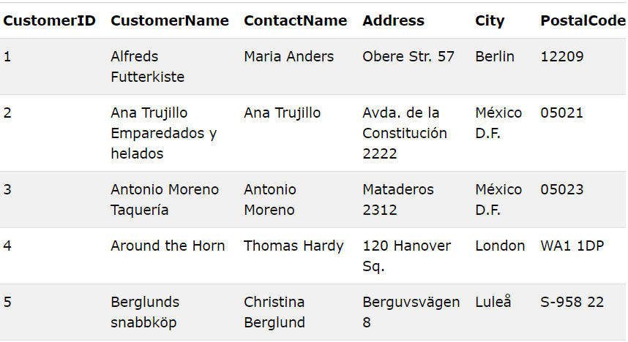Here the sample database:

Example statement,

DELETE FROM Customers WHERE CustomerName='Alfreds Futterkiste';

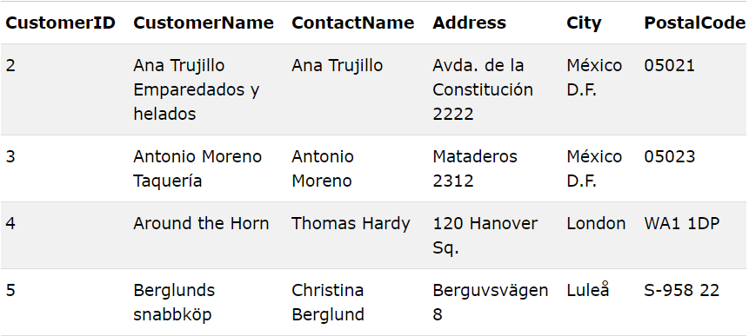The sample database after run the statement:

* 1. **SQL UPDATE Statement**

The UPDATE statement is used to modify the existing records in a table.

This is the UPDATE syntax;

UPDATE table_name  
SET column1 = value1, column2 = value2, ...  
WHERE condition;

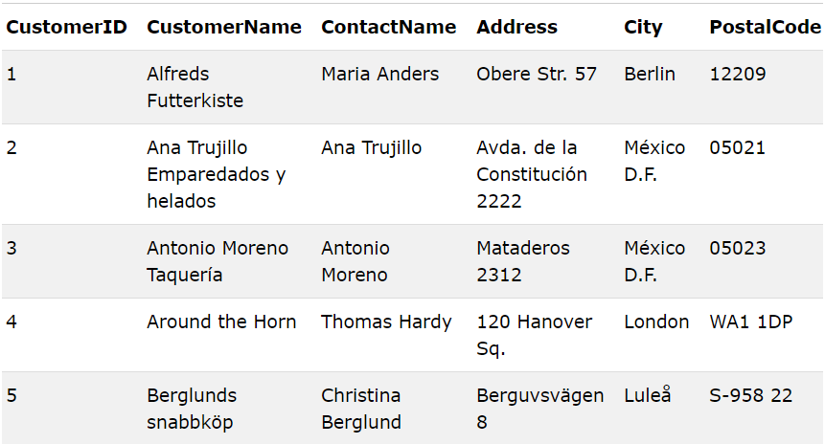This the sample database:

Example statement:

UPDATE Customers  
SET ContactName = 'Alfred Schmidt', City= 'Frankfurt'  
WHERE CustomerID = 1;

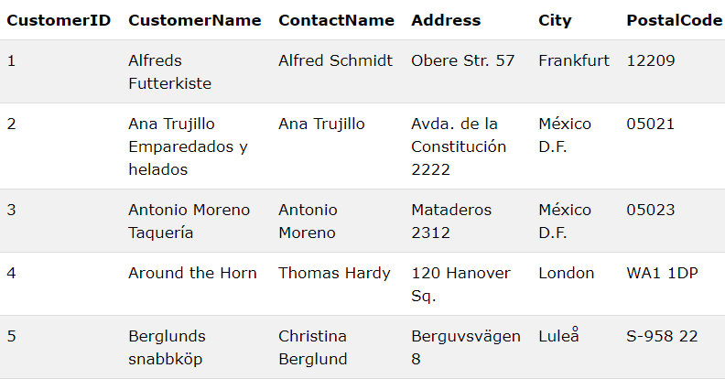The sample database after do the statement:

* 1. **SQL SELECT Statement**

The SELECT statement is used to select data from a database. The data returned is stored in a result table, called the result-set.

There have two type syntax for SELECT, the first one is the field names of the table you want to select data from, the second one is if we want to select all the field available in the table:

SELECT column1, column2, ...  
FROM table_name;

SELECT * FROM table_name;

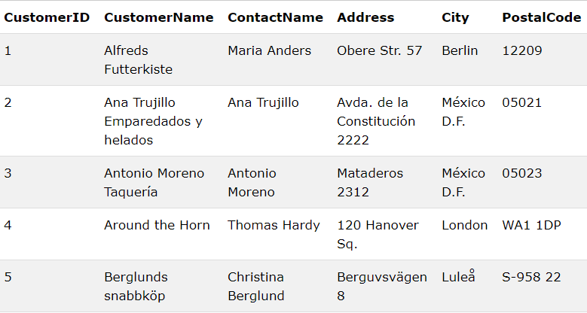Sample database:

The example statement:

SELECT * FROM Customers;

SELECT CustomerName, City FROM Customers;

The first are statement selects the "CustomerName" and "City" columns from the "Customers" table

The second one is selecting all the columns from the "Customers" table

1. **User Interface**

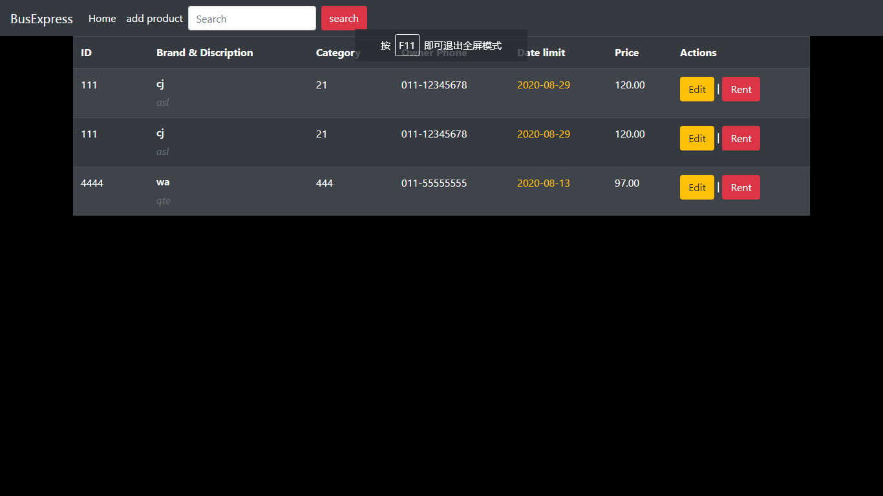

This is the main page of our system, our customer can view the bus information here and choice the one they want to rent.

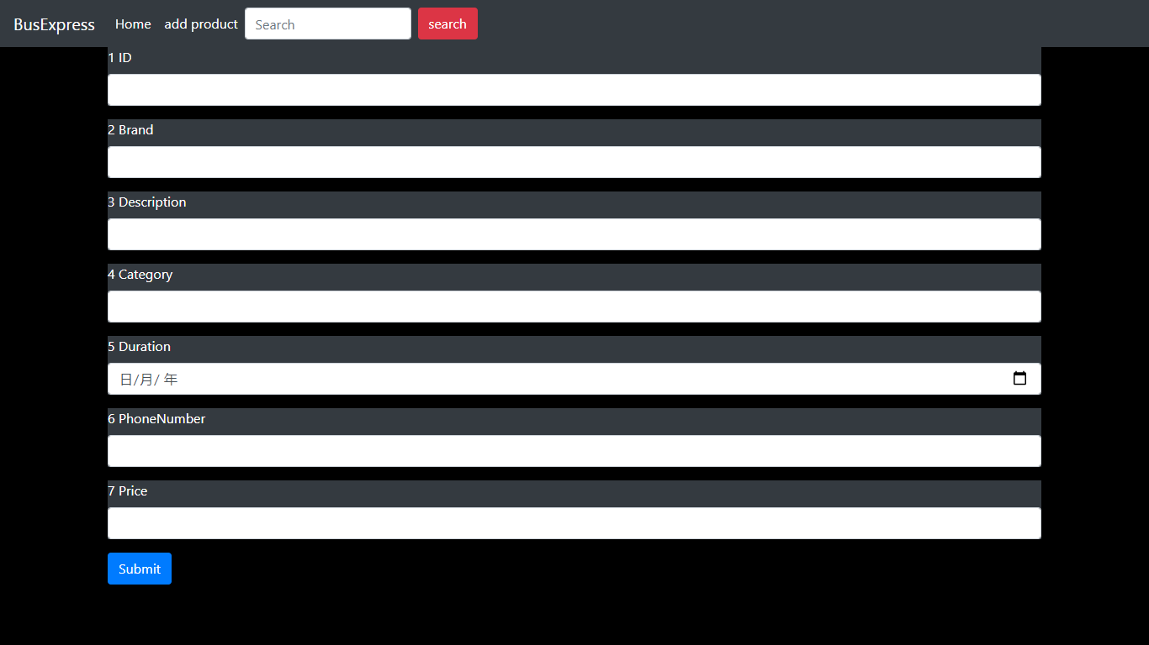

Here can let our user to add their product, and input the bus information and set the price.

**5.0 Conclusion**

In conclusion, our system SKY Bus Rental System is the system that let bus owner user rent their bus and let tenant user to rent the bus. According to our calculate up there, drive a bus will more environment protection and reduce air pollution compare with drive car if there is a group that more than 15 of people.

When you grouping travel by bus, you will be found that it is very happy when travel with a lot of friend and all of them in a same bus, you guys can play together, talk together, take picture together and so on.

But if not travel by bus, and by car, you and your friend will separate to few cars, then you guys cannot play together and talk together, maybe can but not with all friend. Beside that, you cannot take picture with all the friend, if you take picture with all friend then you can keep the memories with them and print it out for keep.