The Title of the Sample Document

Your Organization  
<http://yourdomain.com>

Updated at Jan 9, 2015

A brief introduction for the document. A brief introduction for the document. A brief introduction for the document. A brief introduction for the document. A brief introduction for the document. A brief introduction for the document. A brief introduction for the document. A brief introduction for the document. A brief introduction for the document. A brief introduction for the document. A brief introduction for the document.

# A Level-1 section which is *NOT* listed in ToC

Lists can be nested in Markdown:

* Here it is.
* Don't do evil.
  + Cats are good.
  + Dogs are bad.
* [Link](http://www.google.com) in Markdown is simple. Check <http://www.google.com>.

# A Level-1 section which is listed in ToC

## A Level-2 section

### A Level-3 section

#### A Level-4 section

Markdown has simple syntax to support code display, with inline style rm -rf / or in separate section as follows:

SSH Port: 22  
Username: YOUR_USERNAME  
Password: YOUR_PASSWORD  
Home: /lustre/home/YOUR_HOME

Code can be nested in to the list too:

1. Delete Windows:

* format c

1. Install Linux:

* $ uanme -a

Markdown has limited but yet useful support for image. Please adjust the image to proper size before inserting them into the document.

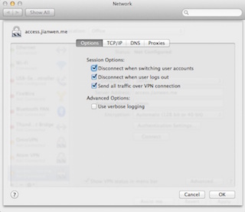

A Image Demo

More Markdown can be viewed on [Pandoc Manual](http://pandoc.org/README.html).

# Reference

* "Pandoc Manual" <http://pandoc.org/README.html>
* "It is nice to add a reference at the end of the document." <http://www.ee.surrey.ac.uk/Teaching/Unix/>