SYSTEM DESIGN · FINAL RELEASE
Asset Intelligence Copilot
A source-grounded assistant for 600 wells across seven areas · calculation date: 15 January 2027
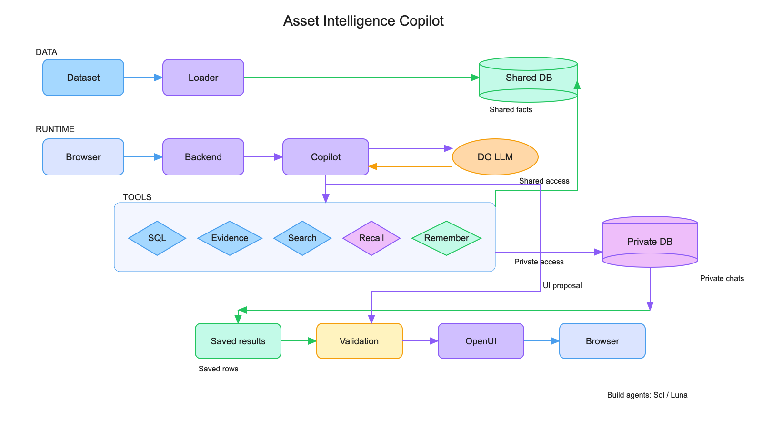
Runtime uses one copilot with five bounded tools; the Sol/Luna labels describe build-time roles, not runtime agents.
Data path
Loader places the released dataset in a shared SQLite database. Private chats live separately in a second SQLite database.
Answer path
SQL queries, evidence lookup, FTS5 manual/SOP search, recall and remember support answers. Saved query rows feed validated OpenUI components.
Safeguards
Original records remain intact; accepted scoped corrections inform later calculations. Private memory access is owner-checked. Demo user selection is not production authentication.
Public source: github.com/shipitdev/hackbase
DO inference router · budget preference enabled · no measured cost claim
EVALUATION · 11 RELEASED QUESTIONS
Saved answers and results
E4 captured 21 turns: 12 HTTP 200 partials and 9 HTTP 502 upstream errors; no 504s. Ten partials hit the context limit. Two turns returned evidence-supported answers (2/21 answer coverage, not an accuracy rate); the other 19 were unverifiable.
Question
Saved answer or failure
Evidence review
Q1 · Pressure
Supported refusal: pressure is unmeasured; no map.
Scanned 125,198 inspections; zero pressure matches; cited equipment inventory.
Q2 · Producer
HTTP 502 upstream error; no answer.
Source has no per-well oil-volume measure; refusal to rank barrels is warranted.
Q3 · Gas reports
HTTP 502; no table.
No answer to assess. Reference oracle only: 26 reports; 17 met deadline, 9 missed.
Q4 · Bypasses
Context-limit partial; no table, citations or results.
No answer to assess. Reference oracle only: 12 intervals, 3 current, 5 violations.
Q5 · Regulator
Context-limit partial; no table or evidence.
Not verifiable.
Q6 · Disagreement
Context-limit partial; no table or evidence.
Not verifiable.
Q7 · Repair risk
Both turns context-limit partial; no ranking.
No crew recommendation or table; no unique oracle ranking.
Q8 · Recall
Turns 1–2: HTTP 502; turns 3–5: context-limit partial.
No recall tables or sourced facts; no shared change saved, persistence not demonstrated.
Q9 · Multi-topic
Turn 2: Nathan Pierce, 150 TEAM-NW wells. T1/T5 partial; T3/T4/T6 HTTP 502.
Turn 2 supported by four saved-query citations. T4 got no answer; no Dec 3 H2S reading, latest documented earlier value 0 ppm on Nov 20.
Q10 · Workload
HTTP 502; no table or stacked bar.
Not verifiable.
Q11 · Region
HTTP 502; no evidence or comparison.
Not verifiable.
Follow-up: Q1 refusal and Q9-2 (Nathan Pierce, 150 wells) were the only supported answers. Q9-2 had four saved-query citations. Q9-4 had no answer: source oracle confirms no Dec 3 H2S reading; latest prior reading is 0 ppm on Nov 20. Oracle counts shown above are reference only, not model output.
Limits: The other 19 turns had no verifiable answer. Usage is a lower bound (1,740,380 tokens across 103 served-model IDs); no cost total is stated. Full prompts/responses stay private and are not included here. Public E4 rerun report · source oracle. Dataset: 125,198 inspections and 17,415 maintenance records.
Full private capture remains in the local evaluation workspace; no conversations or private DBs published.
11 scenarios · 21 turns · no full scenario returned a complete answer

