e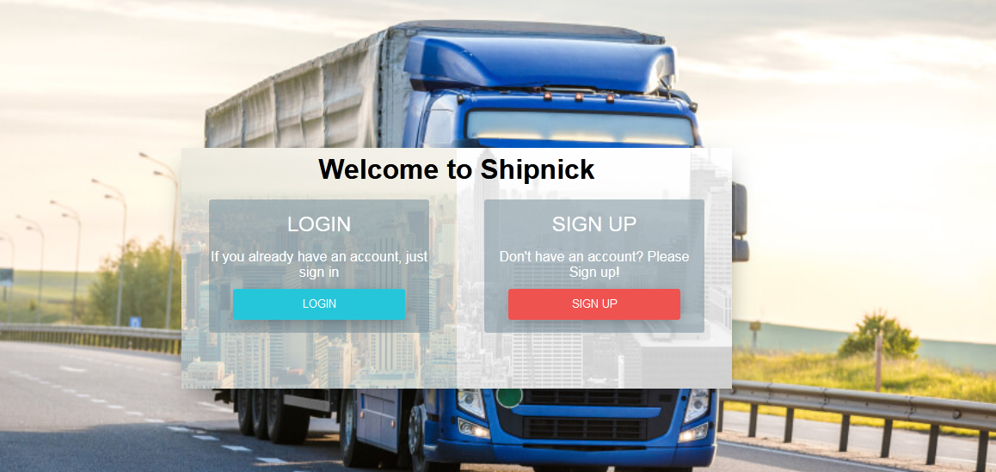

This Is our Log in page. First Interaction with the clients.  
   
Please make this page bit innovative,

1. Need Shipnick Logo
2. Clients can login from ‘Google’
3. Sign up page – Information of client goes no where. Need all the sign up information in company’s mail – [shipnick11@gmail.com](mailto:shipnick11@gmail.com)
4. Change background image IF REQUIRED
5. Can have a decent quote here (Swiftness and Rhyme, the Perfect Combination in Delivery Time).

Log In page should not be boring, make it blissful.



When we open log in pag, DOCUMENT comes written in the TAB, change it to shipnick.

### [shipnick - Transport & Logistics HTML Template](https://www.shipnick.com/)

[shipnick](https://www.shipnick.com/)

[https://www.shipnick.com](https://www.shipnick.com/)

**shipnick** · Innovative and Clever Deliveries Just for Your · Your Coolest Delivery Partner · Rhyme and Rhyme, We Deliver On Time · Classy Delivery Solutions ...

|  |
| --- |
| [Shipnick](https://shipnick.com/login) Dompet is a clean-coded, responsive HTML template that ... |
| [More results from shipnick.com »](https://www.google.com/search?q=shipnick+site:shipnick.com&sca_esv=cd16e367692c841a&sxsrf=ADLYWILjPpAPCol08X3AeSdXnU5I2U9y8g:1731956793119&sa=X&ved=2ahUKEwiLga7ryeaJAxVTSmwGHcipFs0QrAN6BAgLEAE) |

THIS COME WHEN WE GOOLE SHIP NICH >>>>> HTML TEMPLATE

PLEASE GET IT CHANGED

<https://shipnick.com/superlogin>

Login – superadmin

Pw – Prosavvy#23

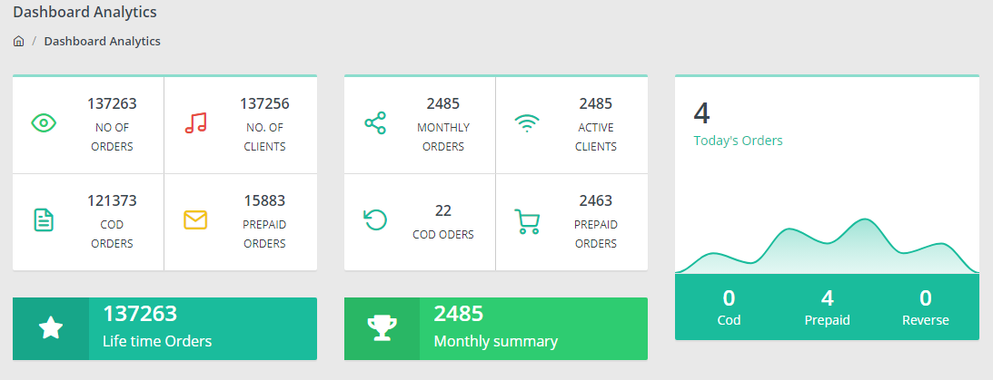

1. Symmetry is not there, in actual theme all were in the same row.
2. Check number of clients – not updated
3. Please get the logos / images changed.

Basically I wanted, while we access the super Admin panel, I should know every thing in fractions. But he has done blunders. Make it visible and data oriented as you feel like.

1. First box I need information of Total summary since we have started. Summary means Total orders, cod orders, prepaid orders, total clients joined)
2. Second Box, current month summary (Summary means Total orders, cod orders, prepaid orders, number of new clients joined)

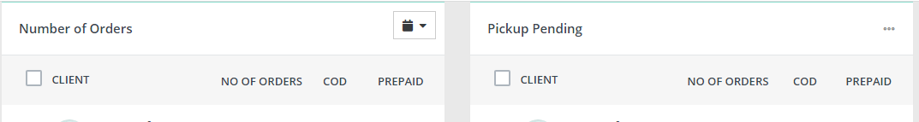

No. of ordrs was for – Today’s number of order punched on the panel

**Client Name No of orders COD Prepaid**

(Under which admin he belongs)

Only client those who hav punched orders, should be visible, rest not. Same is with pick up pending, whose packet is not picked that summary.

What else information is required,

1. Total packets delivered today
2. Total packets delivered Monthly
3. Total cod amount collected (individual courier wise) + combined
4. Track of every client – His outstanding bill (If any)
5. Track on ever clinet COD – when was it paid las time, when is due and how much is due (comparision between bill and COD amount collected.).