Shipon Eunus

Creative Coding

Final Project

Roundtable

Story One: Music Video for 2-minute instrumental

<https://www.youtube.com/watch?v=SqayDnQ2wmw>

guitar, electronic, industrial, factory pressing into objects, clouds that spiral downward into a pit, then in like pop treadmill

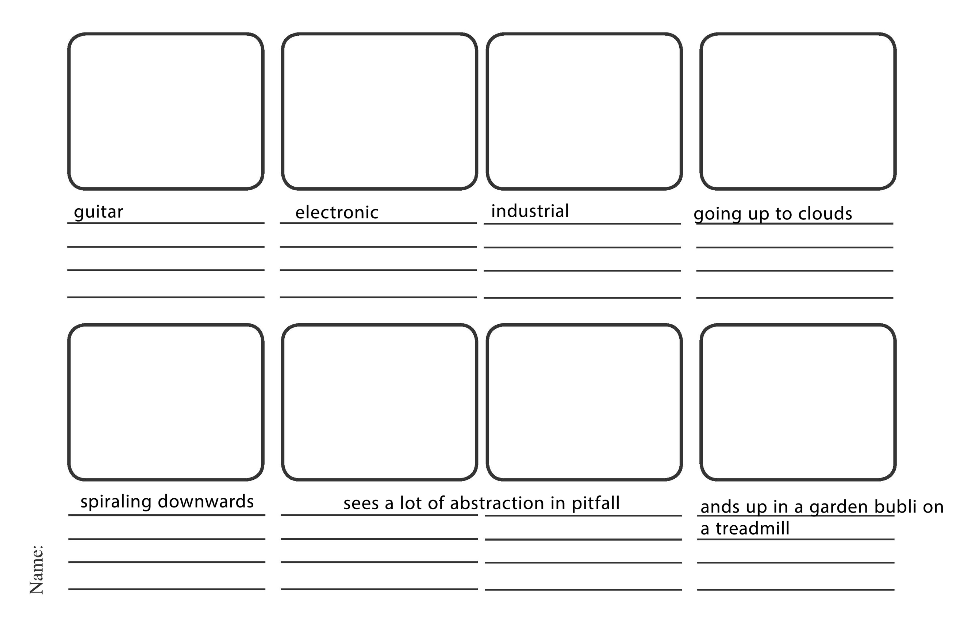

Story Two: Tour Visuals for 30 sec instrumental

<https://www.youtube.com/watch?v=-LzZ0Dv1ilU>

Horror Themed

Menacing

Glass breaking, gun shooting at screen bullets breaking screen

Inspired by watch the throne

Rottweilers

Space war

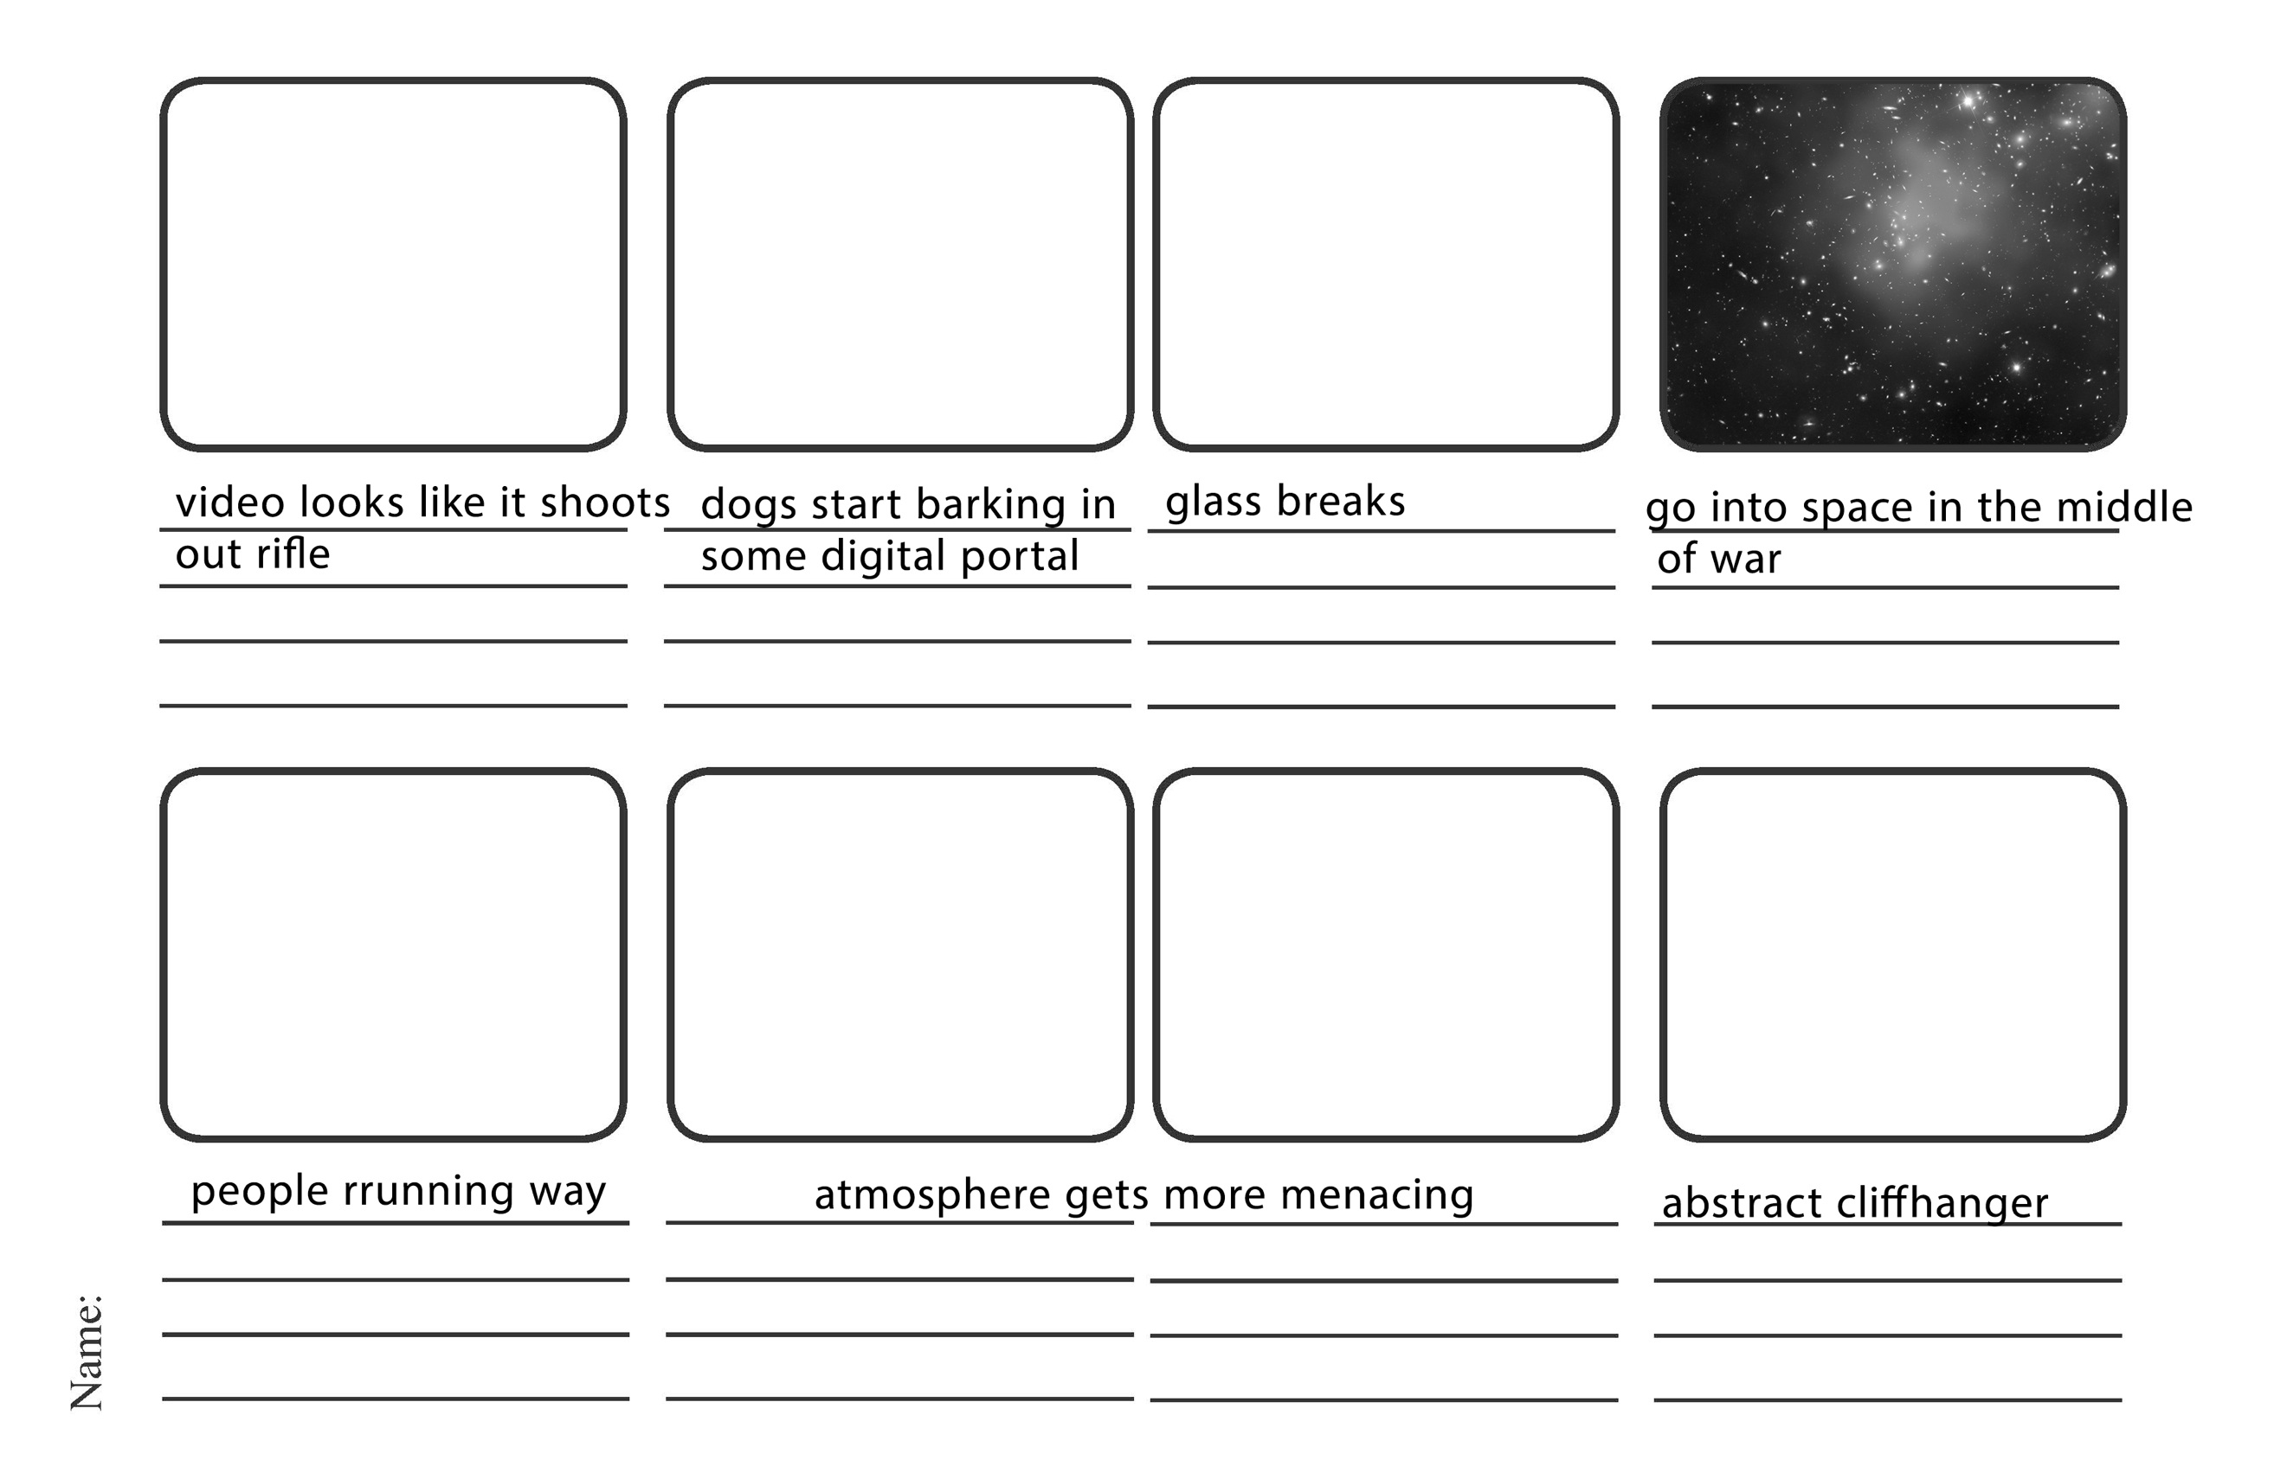

Story 3: Lost Angel Story

Interactive story with angel lost in world that distorts the environment around it everywhere