Screenshots

  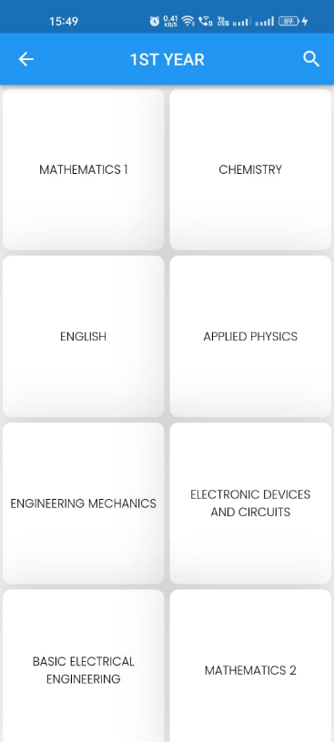

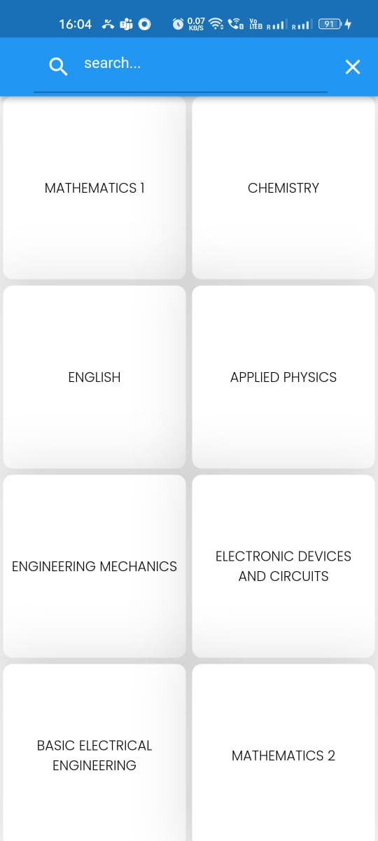  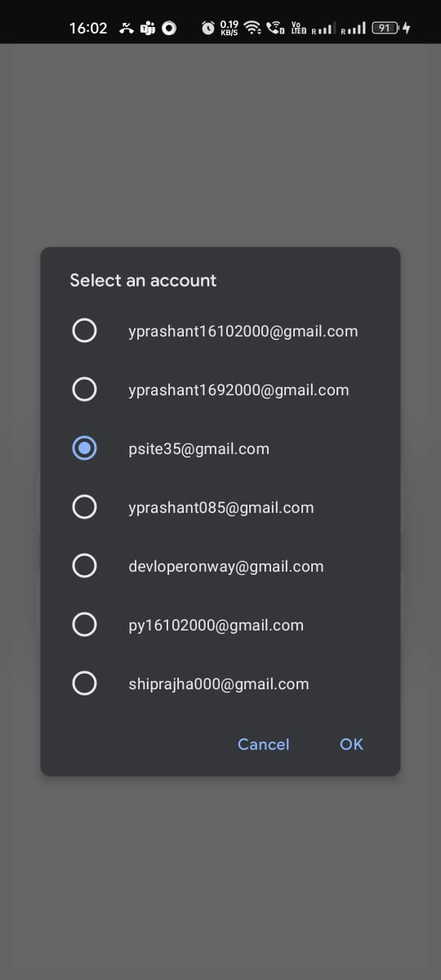 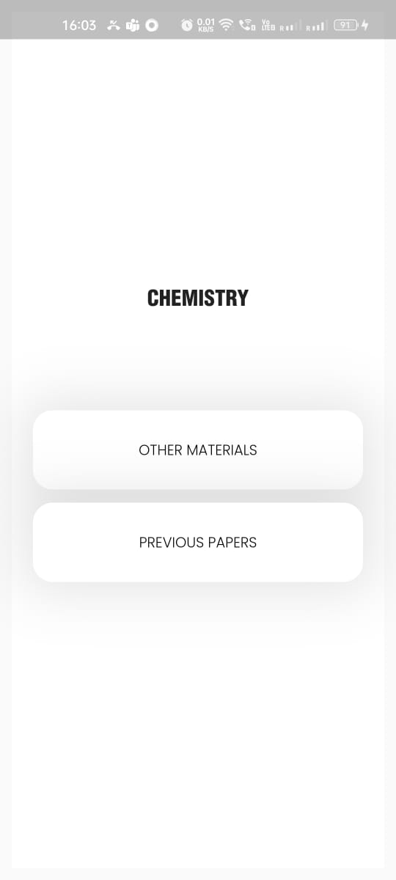 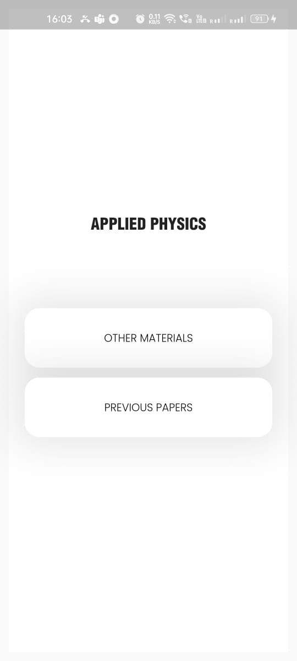 

Manifest.xml

<?xml version="1.0" encoding="utf-8"?>  
<manifest xmlns:android="http://schemas.android.com/apk/res/android"  
 package="com.rajendra.courseapp">  
  
 <uses-permission android:name="android.permission.INTERNET" />  
  
 <application  
 android:allowBackup="true"  
 android:icon="@mipmap/ic_launcher"  
 android:label="@string/app_name"  
 android:roundIcon="@mipmap/ic_launcher_round"  
 android:supportsRtl="true"  
 android:theme="@style/AppTheme">  
 <activity android:name=".CoursePage"></activity>  
 <activity android:name=".MainActivity">  
 <intent-filter>  
 <action android:name="android.intent.action.MAIN" />  
  
 <category android:name="android.intent.category.LAUNCHER" />  
 </intent-filter>  
 </activity>  
  
 <meta-data  
 android:name="preloaded_fonts"  
 android:resource="@array/preloaded_fonts" />  
 </application>  
  
</manifest>

ActivityMain.java

import androidx.appcompat.app.AppCompatActivity;  
import androidx.recyclerview.widget.RecyclerView;  
import androidx.recyclerview.widget.StaggeredGridLayoutManager;  
  
import android.os.Bundle;  
import android.widget.Toast;  
  
import com.rajendra.courseapp.adapter.CategoryAdapter;  
import com.rajendra.courseapp.model.Category;  
import com.rajendra.courseapp.retrofit.ApiInterface;  
import com.rajendra.courseapp.retrofit.RetrofitClient;  
  
import java.util.List;  
  
import retrofit2.Call;  
import retrofit2.Callback;  
import retrofit2.Response;  
import retrofit2.Retrofit;  
  
public class MainActivity extends AppCompatActivity {  
  
 RecyclerView categoryRecyclerView;  
 CategoryAdapter categoryAdapter;  
  
 ApiInterface apiInterface;  
  
 @Override  
 protected void onCreate(Bundle savedInstanceState) {  
 super.onCreate(savedInstanceState);  
  
  
 setContentView(R.layout.*activity_main*);  
  
 apiInterface = RetrofitClient.*getRetrofitClient*().create(ApiInterface.class);  
  
 categoryRecyclerView = findViewById(R.id.*course_recycler*);  
  
 Call<List<Category>> call = apiInterface.getAllCategory();  
  
 call.enqueue(new Callback<List<Category>>() {  
 @Override  
 public void onResponse(Call<List<Category>> call, Response<List<Category>> response) {  
  
 List<Category> categoryList = response.body();  
  
 getAllCategory(categoryList);  
  
 //lets run it  
 }  
  
 @Override  
 public void onFailure(Call<List<Category>> call, Throwable t) {  
 Toast.*makeText*(MainActivity.this, "No response from server", Toast.*LENGTH_SHORT*).show();  
 }  
 });  
  
   
 // now we will setup recyclerview.  
  
  
 }  
  
  
   
  
 private void getAllCategory(List<Category> categoryList){  
  
 RecyclerView.LayoutManager layoutManager = new StaggeredGridLayoutManager(2, 1);  
 categoryRecyclerView.setLayoutManager(layoutManager);  
 categoryAdapter = new CategoryAdapter(this, categoryList);  
 categoryRecyclerView.setAdapter(categoryAdapter);  
 categoryAdapter.notifyDataSetChanged();  
  
 }

activity_main.xml

<?xml version="1.0" encoding="utf-8"?>  
<androidx.constraintlayout.widget.ConstraintLayout xmlns:android="http://schemas.android.com/apk/res/android"  
 xmlns:app="http://schemas.android.com/apk/res-auto"  
 xmlns:tools="http://schemas.android.com/tools"  
 android:layout_width="match_parent"  
 android:layout_height="match_parent"  
 tools:context=".MainActivity">  
  
 <ImageView  
 android:id="@+id/imageView"  
 android:layout_width="wrap_content"  
 android:layout_height="wrap_content"  
 android:layout_marginStart="16dp"  
 app:layout_constraintStart_toStartOf="parent"  
 app:srcCompat="@drawable/ic_menu"  
 tools:layout_editor_absoluteY="27dp" />  
  
 <TextView  
 android:id="@+id/textView"  
 android:layout_width="wrap_content"  
 android:layout_height="wrap_content"  
 android:layout_marginStart="18dp"  
 android:layout_marginTop="32dp"  
 android:fontFamily="@font/nunito_bold"  
 android:text="Hey Shipra,"  
 android:textColor="#0D1333"  
 android:textSize="24sp"  
 app:layout_constraintStart_toStartOf="parent"  
 app:layout_constraintTop_toBottomOf="@+id/imageView" />  
  
 <TextView  
 android:id="@+id/textView2"  
 android:layout_width="wrap_content"  
 android:layout_height="wrap_content"  
 android:layout_marginTop="16dp"  
 android:fontFamily="@font/nunito_bold"  
 android:text="Find a course you want to learn"  
 android:textColor="#61688b"  
 android:textSize="18sp"  
 app:layout_constraintStart_toStartOf="@+id/textView"  
 app:layout_constraintTop_toBottomOf="@+id/textView" />  
  
 <EditText  
 android:id="@+id/editText"  
 android:layout_width="0dp"  
 android:layout_height="50dp"  
 android:layout_marginStart="16dp"  
 android:layout_marginTop="24dp"  
 android:layout_marginEnd="16dp"  
 android:background="@drawable/search_bg"  
 android:drawableLeft="@drawable/ic_search"  
 android:drawablePadding="16dp"  
 android:ems="10"  
 android:fontFamily="@font/nunito"  
 android:hint="Search for courses"  
 android:inputType="textPersonName"  
 android:paddingStart="16dp"  
 android:singleLine="true"  
 app:layout_constraintEnd_toEndOf="parent"  
 app:layout_constraintStart_toStartOf="parent"  
 app:layout_constraintTop_toBottomOf="@+id/textView2" />  
  
 <TextView  
 android:id="@+id/textView3"  
 android:layout_width="wrap_content"  
 android:layout_height="wrap_content"  
 android:layout_marginStart="16dp"  
 android:layout_marginTop="24dp"  
 android:fontFamily="@font/nunito_semibold"  
 android:text="Categories"  
 android:textColor="#0D1333"  
 android:textSize="20sp"  
 app:layout_constraintStart_toStartOf="parent"  
 app:layout_constraintTop_toBottomOf="@+id/editText" />  
  
 <TextView  
 android:id="@+id/textView4"  
 android:layout_width="wrap_content"  
 android:layout_height="wrap_content"  
 android:layout_marginEnd="16dp"  
 android:fontFamily="@font/nunito_semibold"  
 android:text="See All"  
 android:textColor="#6E8AFA"  
 app:layout_constraintBottom_toBottomOf="@+id/textView3"  
 app:layout_constraintEnd_toEndOf="parent"  
 app:layout_constraintTop_toTopOf="@+id/textView3" />  
  
 <androidx.recyclerview.widget.RecyclerView  
 android:id="@+id/course_recycler"  
 android:layout_width="0dp"  
 android:layout_height="0dp"  
 android:layout_marginTop="8dp"  
 app:layout_constraintBottom_toBottomOf="parent"  
 app:layout_constraintEnd_toEndOf="parent"  
 app:layout_constraintStart_toStartOf="parent"  
 app:layout_constraintTop_toBottomOf="@+id/textView3"  
 app:layout_constraintVertical_bias="0.0" />  
</androidx.constraintlayout.widget.ConstraintLayout>

<?xml version="1.0" encoding="utf-8"?>  
<androidx.cardview.widget.CardView xmlns:android="http://schemas.android.com/apk/res/android"  
 xmlns:app="http://schemas.android.com/apk/res-auto"  
 android:layout_width="wrap_content"  
 android:layout_height="wrap_content"  
 android:layout_margin="8dp"  
 app:cardCornerRadius="8dp">  
  
 <androidx.constraintlayout.widget.ConstraintLayout xmlns:android="http://schemas.android.com/apk/res/android"  
 xmlns:app="http://schemas.android.com/apk/res-auto"  
 android:layout_width="wrap_content"  
 android:layout_height="wrap_content">  
  
  
 <ImageView  
 android:id="@+id/course"  
 android:layout_width="wrap_content"  
 android:layout_height="wrap_content"  
 android:layout_weight="1"  
 android:adjustViewBounds="true"  
 android:scaleType="fitStart"  
 app:layout_constraintBottom_toBottomOf="parent"  
 app:layout_constraintDimensionRatio="1:1"  
 app:layout_constraintEnd_toEndOf="parent"  
 app:layout_constraintStart_toStartOf="parent"  
 app:layout_constraintTop_toTopOf="parent"  
 app:srcCompat="@drawable/business" />  
  
 <TextView  
 android:id="@+id/course_name"  
 android:layout_width="wrap_content"  
 android:layout_height="wrap_content"  
 android:layout_marginStart="12dp"  
 android:layout_marginTop="12dp"  
 android:fontFamily="@font/nunito_semibold"  
 android:text="Marketing"  
 android:textColor="#0D1333"  
 android:textSize="18sp"  
 app:layout_constraintStart_toStartOf="parent"  
 app:layout_constraintTop_toTopOf="parent" />  
  
 <TextView  
 android:id="@+id/total_course"  
 android:layout_width="wrap_content"  
 android:layout_height="wrap_content"  
 android:layout_marginTop="4dp"  
 android:fontFamily="@font/nunito"  
 android:text="17"  
 android:textColor="#8F95B2"  
 app:layout_constraintStart_toStartOf="@+id/course_name"  
 app:layout_constraintTop_toBottomOf="@+id/course_name" />  
  
 <TextView  
 android:id="@+id/textView7"  
 android:layout_width="wrap_content"  
 android:layout_height="wrap_content"  
 android:layout_marginStart="2dp"  
 android:fontFamily="@font/nunito"  
 android:text="Courses"  
 android:textColor="#8F95B2"  
 app:layout_constraintBottom_toBottomOf="@+id/total_course"  
 app:layout_constraintStart_toEndOf="@+id/total_course"  
 app:layout_constraintTop_toTopOf="@+id/total_course" />  
 </androidx.constraintlayout.widget.ConstraintLayout>  
  
</androidx.cardview.widget.CardView>

category.xml

activity course.xml

<?xml version="1.0" encoding="utf-8"?>  
<androidx.constraintlayout.widget.ConstraintLayout xmlns:android="http://schemas.android.com/apk/res/android"  
 xmlns:app="http://schemas.android.com/apk/res-auto"  
 xmlns:tools="http://schemas.android.com/tools"  
 android:layout_width="match_parent"  
 android:layout_height="match_parent"  
 tools:context=".CoursePage">  
  
 <ImageView  
 android:id="@+id/imageView6"  
 android:layout_width="0dp"  
 android:layout_height="450dp"  
 android:adjustViewBounds="true"  
 android:scaleType="fitXY"  
 app:layout_constraintEnd_toEndOf="parent"  
 app:layout_constraintHorizontal_bias="0.646"  
 app:layout_constraintStart_toStartOf="parent"  
 app:layout_constraintTop_toTopOf="parent"  
 app:srcCompat="@drawable/ux_big" />  
  
 <ImageView  
 android:id="@+id/imageView7"  
 android:layout_width="wrap_content"  
 android:layout_height="wrap_content"  
 android:layout_marginStart="16dp"  
 android:layout_marginTop="16dp"  
 app:layout_constraintStart_toStartOf="parent"  
 app:layout_constraintTop_toTopOf="parent"  
 app:srcCompat="@drawable/ic_arrow_left" />  
  
 <ImageView  
 android:id="@+id/imageView8"  
 android:layout_width="wrap_content"  
 android:layout_height="wrap_content"  
 android:layout_marginTop="16dp"  
 android:layout_marginEnd="16dp"  
 app:layout_constraintEnd_toEndOf="parent"  
 app:layout_constraintTop_toTopOf="parent"  
 app:srcCompat="@drawable/ic_more_vertical" />  
  
 <androidx.constraintlayout.widget.ConstraintLayout  
 android:layout_width="0dp"  
 android:layout_height="420dp"  
 android:background="@drawable/layout_bg"  
 app:layout_constraintBottom_toBottomOf="parent"  
 app:layout_constraintEnd_toEndOf="parent"  
 app:layout_constraintHorizontal_bias="0.0"  
 app:layout_constraintStart_toStartOf="parent">  
  
  
 <TextView  
 android:id="@+id/textView5"  
 android:layout_width="wrap_content"  
 android:layout_height="wrap_content"  
 android:layout_marginStart="32dp"  
 android:layout_marginTop="24dp"  
 android:fontFamily="@font/nunito_semibold"  
 android:text="Course Content"  
 android:textColor="#0D1333"  
 android:textSize="18sp"  
 app:layout_constraintStart_toStartOf="parent"  
 app:layout_constraintTop_toTopOf="parent" />  
  
 <androidx.recyclerview.widget.RecyclerView  
 android:id="@+id/course_recycler"  
 android:layout_width="0dp"  
 android:layout_height="0dp"  
 android:layout_marginTop="8dp"  
 app:layout_constraintBottom_toBottomOf="parent"  
 app:layout_constraintEnd_toEndOf="parent"  
 app:layout_constraintStart_toStartOf="parent"  
 app:layout_constraintTop_toBottomOf="@+id/textView5"  
 app:layout_constraintVertical_bias="0.0" />  
  
 <androidx.constraintlayout.widget.ConstraintLayout  
 android:layout_width="0dp"  
 android:layout_height="75dp"  
 android:background="@drawable/buy_layout_bg"  
 app:layout_constraintBottom_toBottomOf="parent"  
 app:layout_constraintEnd_toEndOf="parent"  
 app:layout_constraintStart_toStartOf="parent">  
  
 <ImageView  
 android:id="@+id/imageView10"  
 android:layout_width="47dp"  
 android:layout_height="36dp"  
 android:layout_marginStart="32dp"  
 android:layout_marginTop="16dp"  
 android:layout_marginEnd="16dp"  
 android:layout_marginBottom="16dp"  
 app:layout_constraintBottom_toBottomOf="parent"  
 app:layout_constraintEnd_toStartOf="@+id/textView6"  
 app:layout_constraintHorizontal_bias="1.0"  
 app:layout_constraintStart_toStartOf="parent"  
 app:layout_constraintTop_toTopOf="parent"  
 app:srcCompat="@drawable/ic_shopping_bag" />  
  
 <TextView  
 android:id="@+id/textView6"  
 android:layout_width="204dp"  
 android:layout_height="50dp"  
 android:layout_marginStart="16dp"  
 android:layout_marginTop="16dp"  
 android:layout_marginEnd="32dp"  
 android:layout_marginBottom="16dp"  
 android:background="@drawable/buy_button_bg"  
 android:fontFamily="@font/nunito_bold"  
 android:gravity="center"  
 android:text="Buy Now"  
 android:textAlignment="center"  
 android:textColor="#FFFFFF"  
 android:textSize="18sp"  
 app:layout_constraintBottom_toBottomOf="parent"  
 app:layout_constraintEnd_toEndOf="parent"  
 app:layout_constraintHorizontal_bias="0.5"  
 app:layout_constraintStart_toEndOf="@+id/imageView10"  
 app:layout_constraintTop_toTopOf="parent" />  
 </androidx.constraintlayout.widget.ConstraintLayout>  
 </androidx.constraintlayout.widget.ConstraintLayout>  
  
 <ImageView  
 android:id="@+id/imageView4"  
 android:layout_width="wrap_content"  
 android:layout_height="wrap_content"  
 android:layout_marginTop="32dp"  
 app:layout_constraintStart_toStartOf="@+id/imageView7"  
 app:layout_constraintTop_toBottomOf="@+id/imageView7"  
 app:srcCompat="@drawable/ic_bestseller" />  
  
 <TextView  
 android:id="@+id/name"  
 android:layout_width="wrap_content"  
 android:layout_height="wrap_content"  
 android:layout_marginTop="16dp"  
 android:fontFamily="@font/nunito_bold"  
 android:text="Ux Design"  
 android:textColor="#0D1333"  
 android:textSize="24sp"  
 app:layout_constraintStart_toStartOf="@+id/imageView4"  
 app:layout_constraintTop_toBottomOf="@+id/imageView4" />  
  
 <ImageView  
 android:id="@+id/imageView5"  
 android:layout_width="wrap_content"  
 android:layout_height="wrap_content"  
 android:layout_marginTop="24dp"  
 app:layout_constraintStart_toStartOf="@+id/name"  
 app:layout_constraintTop_toBottomOf="@+id/name"  
 app:srcCompat="@drawable/ic_person" />  
  
 <TextView  
 android:id="@+id/members"  
 android:layout_width="wrap_content"  
 android:layout_height="wrap_content"  
 android:layout_marginStart="4dp"  
 android:fontFamily="@font/nunito"  
 android:text="17k"  
 android:textColor="#61688b"  
 app:layout_constraintBottom_toBottomOf="@+id/imageView5"  
 app:layout_constraintStart_toEndOf="@+id/imageView5"  
 app:layout_constraintTop_toTopOf="@+id/imageView5" />  
  
 <TextView  
 android:id="@+id/price"  
 android:layout_width="wrap_content"  
 android:layout_height="wrap_content"  
 android:layout_marginTop="24dp"  
 android:fontFamily="@font/nunito_bold"  
 android:text="50"  
 android:textColor="#0D1333"  
 android:textSize="24sp"  
 app:layout_constraintStart_toStartOf="@+id/imageView5"  
 app:layout_constraintTop_toBottomOf="@+id/imageView5" />  
  
 <ImageView  
 android:id="@+id/imageView9"  
 android:layout_width="wrap_content"  
 android:layout_height="wrap_content"  
 android:layout_marginStart="8dp"  
 app:layout_constraintBottom_toBottomOf="@+id/members"  
 app:layout_constraintStart_toEndOf="@+id/members"  
 app:layout_constraintTop_toTopOf="@+id/members"  
 app:srcCompat="@drawable/ic_star" />  
  
 <TextView  
 android:id="@+id/rating"  
 android:layout_width="wrap_content"  
 android:layout_height="wrap_content"  
 android:layout_marginStart="4dp"  
 android:fontFamily="@font/nunito"  
 android:text="4.2"  
 android:textColor="#61688b"  
 app:layout_constraintBottom_toBottomOf="@+id/imageView9"  
 app:layout_constraintStart_toEndOf="@+id/imageView9"  
 app:layout_constraintTop_toTopOf="@+id/imageView9" />  
  
</androidx.constraintlayout.widget.ConstraintLayout>