BizInsight AI
Week 2 Task: Data Exploration and Cleaning Strategy
Data preparation workflow for a Business Analytics Tool for Small and Medium Enterprises (SMEs)

Introduction

Data quality is an important part of business analytics because the quality of input data directly affects the reliability of the insights generated from it. BizInsight AI is designed as a business analytics tool for small and medium organizations where users can provide their business data and receive useful insights for decision-making. Before generating these insights, uploaded data needs to be explored, checked, and cleaned. Business datasets may contain missing values, duplicate records, inconsistent formats, incorrect data types, and unusual values. If these problems are not handled properly, they can lead to misleading analysis and poor business decisions. Therefore, this workflow focuses on a systematic strategy for data exploration and cleaning using Python-based tools. The cleaned dataset will then be prepared for further analysis, visualization, forecasting, and AI-based business insights.

Methodology

The proposed methodology follows a structured pipeline. First, the user uploads business data in a common format such as CSV or Excel. The system explores the dataset by checking its structure, columns, data types, basic statistics, and missing values. Next, data quality issues such as missing values, duplicates, outliers, inconsistent values, and incorrect data types are identified. Appropriate cleaning techniques are then applied without unnecessarily removing useful business information. After cleaning, the dataset is validated to make sure that the major issues have been resolved. Finally, the validated dataset is made ready for visualization, reporting, and further AI-based analysis.

Data Exploration and Cleaning Workflow

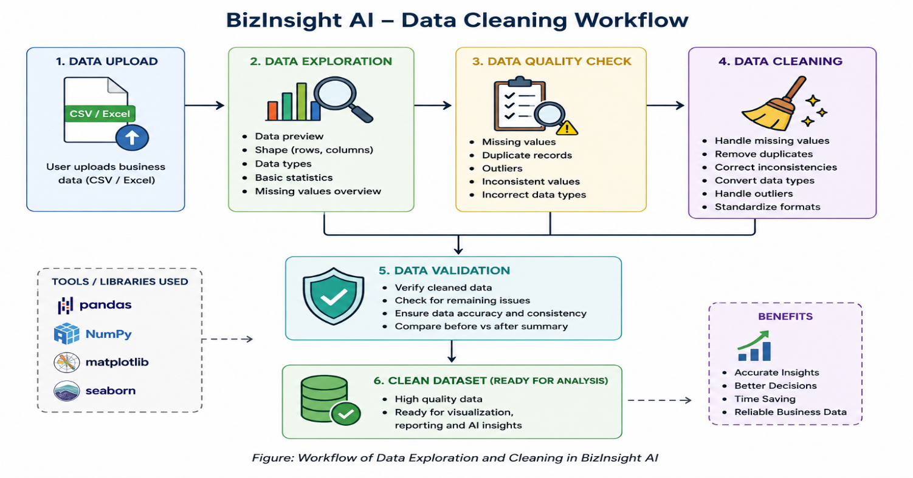
Data Cleaning Techniques

- Handling Missing Values: Missing values are identified and handled according to the type of data. Numerical values can be filled using mean or median, while categorical values can be replaced using the most frequent value or an appropriate category.

- Removing Duplicate Records: Duplicate rows are detected and removed so that the same transaction or customer record is not counted more than once.

- Handling Outliers: Unusual values are identified using statistical methods such as IQR or standard deviation. Outliers are reviewed before removing or modifying them because some unusual values may represent genuine business events.

- Correcting Inconsistent Data: Different formats and spellings are standardized. For example, Male, male, and M can be converted into a common format.

- Data Type Conversion: Columns are converted into appropriate data types, such as converting sales and profit into numerical values and dates into a proper date format.

- Data Transformation: Where required, data can be normalized, aggregated, or transformed into a format that makes further analysis easier.

For BizInsight AI, these techniques help ensure that business data is clean, consistent, and ready for generating meaningful insights.

Best Practices

- Keep the original data unchanged before starting the cleaning process.
- Check data quality first by identifying missing, duplicate, inconsistent, and unusual values.
- Use suitable cleaning methods according to the type and meaning of each column.
- Avoid blindly deleting outliers, as some unusual values may represent genuine business transactions.
- Maintain consistent formats for dates, categories, numbers, and text.
- Validate the cleaned dataset before using it for analysis or visualization.
- Keep a record of major cleaning steps so that the process can be repeated when new business data is uploaded.

Pseudocode Examples

A. Data Loading
START
Upload business data file
Read the dataset
Display first few records
Check columns and data types
END

B. Data Quality Check
START
Check for missing values
Check for duplicate records
Check data types
Identify inconsistent values
Detect possible outliers
END

C. Data Cleaning
START
Handle missing values
Remove duplicate records
Correct inconsistent formats
Convert columns to correct data types
Review and handle outliers
Save cleaned dataset
END

D. Data Preparation for Analysis
START
Take cleaned dataset
Transform required columns
Create useful business metrics
Validate the final dataset
Send data for analysis and visualization
END

Python Libraries Used

- Pandas – Used for loading, exploring, filtering, cleaning, and transforming business datasets.
- NumPy – Used for numerical operations and handling numerical values during preprocessing.
- Matplotlib – Can be used to visualize distributions and identify unusual patterns or outliers.
- Seaborn – Can be used for statistical visualizations during exploratory data analysis.

Conclusion

The Week 2 strategy establishes the data preparation stage of BizInsight AI. By systematically exploring, cleaning, transforming, and validating uploaded business data, the system can create a reliable foundation for later dashboards, predictive analysis, time-series analysis, and AI-generated business insights. The goal is not only to clean data, but to make the data trustworthy enough to support practical business decisions.

