BlockWave: Transforming Social Media with User-Centric Control

|  |  |  |
| --- | --- | --- |
| T Sunil Kumar  *Department of CSE*  *Keshav Memorial Institute of Technology*  Hyderabad, India  [sunilshivajikmit@gmail.com](mailto:sunilshivajikmit@gmail.com) | Shipra Yadav  *Department of CSE [AI&ML]*  *Keshav Memorial Engineering College* Hyderabad, India  [sheepracse@gmail.com](mailto:sheepracse@gmail.com) | V Srinivasa Sathvik  *Department of CSE [AI&ML]*  *Keshav Memorial Engineering College* Hyderabad, India [sathvik.vittapu@gmail.com](mailto:sathvik.vittapu@gmail.com) |

|  |  |
| --- | --- |
| Ch. Shreyal Sai  *Department of CSE [AI&ML]*  *Keshav Memorial Engineering College* Hyderabad, India [saishreyal123@gmail.com](mailto:saishreyal123@gmail.com) | Pillareddy Vamsheedhar Reddy  *Department of CSE [AI&ML]*  *Keshav Memorial Engineering College* Hyderabad, India  [pvamsheedharreddy@gmail.com](mailto:pvamsheedharreddy@gmail.com) |

***Abstract*—Decentralized social media platforms are mainly blockchain based. These platforms have various benefits over the centralized platforms. It provides user privacy, content ownership, governance and transparency. Current centralized network have heavy censorship and can’t be completely trusted by users. Usage of decentralized storage (IPFS) with the help of Ethereum smart contracts helps the users by giving data ownership. This study helps in comprehending how the decentralized methodology can result in increased freedom of speech and expression and also enables ways for moderation. The platform’s security, functionality and scalability is demonstrated through through testing.**

***Keywords—blockchain, censorship resistance, data privacy, decentralized social media, decentralized storage, ethereum, smart contracts, transparency.***

1. Introduction

In the past few days, blockchain has been widely applied in technology, and applying blockchain to building decentralized websites is among the new trends. Decentralized social media apps are being employed to offer enhanced data ownership, privacy and transparency to users. Decentralized social media apps have two main components, they are, its users and the blockchain network. Both collaborate to process transactions and data. Large companies are going to prioritize profit over user welfare. This is creating lower transparency and abuse of openness. Decentralization provides users greater power by enabling them to own their data and make decisions about how to use it. This offers more room for individuals who require greater privacy, data security, and alternative from authority.

The key characteristics of decentralized social media are: Communication between users, governance rules for adding and managing content. All of these functionalities can be achieved with the help of technologies such as smart contracts and decentralized storage systems such as IPFS. These technologies assist in enhancing users trust by ensuring that content cannot be tampered with and all transactions can be verified. However, this switch is not one to be taken lightly. Achieving a large user base and verifying that individuals can read and comprehend are a few of the enormous issues that should be resolved. Nevertheless, taking a closer glance at decentralized social media reveals the innovative means by which it functions, the significant issues that it resolves, and the way in which it has the potential to totally alter the manner in which we communicate on the web. Ultimately, the objective is to return control to individuals by providing them with technologies they require to form their online relationships in a safe and clear manner.

Decentralized Social Media Management: In decentralized social media, management is based on giving tasks and resources to individual networks. Blockchain technology is a key part of managing information and exchanges made by users in a clear way. Several nodes in the blockchain network can check and approve transactions, which makes sure they are fair and stops anyone from messing with them. Each user has a say in how the platform is run, and autonomous systems make it easy to settle disagreements quickly. Content checking and review algorithms need to work well, be fair, and not be easy to abuse.

The goal is to make a tool that is fair so that users can interact with it in a way that promotes truth and prevents abuse. To reach these goals, you often have to find new ways to solve hard problems, like using consensus methods and cryptographic techniques. These components manage working in dependent as well as independent scenarios, which makes the platform's operation flexible and adaptable.

The main important functions in decentralized social media are :

1. Privacy for Users
2. Who owns the data
3. The content can't be changed
4. Openness in government
5. Literature Survey
   1. *D-Space: A Decentralized Social Media App [1]:*

This study provides the capabilities of smart contracts and Ethereum blockchain to develop a decentralized social media network in developing countries. The authors show how blockchain can improve security, privacy, and transparency in social media applications using a dataset from the real-world. The project is in the starting stages of creation and is not used widely.

* 1. *Performance Evaluation of Decentralized Social Media on Near Protocol Blockchain [2]*

The article assesses the Near Protocol blockchain's capacity to build distributed social media systems. Results indicate performance similar to centralized solutions with further security and privacy perks. The Near Protocol, on the other hand, is a very young platform with less widespread use than Ethereum.

* 1. *Exploring the Potential of Interplanetary File System for Secure and Transparent Social Media [3]:*

This paper analyzes how decentralized networks could store user data using blockchain technology and the Interplanetary File System (IPFS). While the study shows how IPFS may be used to build open and safe social media networks, it points out inefficiency and slower performance for huge files as main problems.

* 1. *Systematic Literature Review and Qualitative Survey of Blockchain Impact on Social Media Security [4]:*

A thorough literature analysis and qualitative survey investigate how blockchain technology could enhance security, privacy, and transparency in social media platforms. Though the study is constrained by the scope and scale of its dataset and survey, the results are encouraging.

* 1. *A Blockchain-Based Autonomous Decentralized Online Social Network [5]:*

This paper presents a decentralized social network immune to censorship and assaults. Although the concept seems encouraging, the network is still being developed and not yet broadly used.

* 1. *A Secure and Verifiable Data Sharing Scheme Based on Blockchain in Vehicular Social Networks [6]:*

Concentrating on vehicle social networks, the writers suggest a blockchain-based system guaranteeing data confidentiality and tampering and illegal access resistance. Though it has promise, the plan is still under development and not yet widely used.

* 1. *Systematic Literature Review of Blockchain Impact on Social Media Security [7]:*

This paper emphasizes once more the capacity of blockchain technology to improve social media security, privacy, and openness. Its results, meanwhile, are constrained by the small range of the survey and literature study.

* 1. *Blockchain-Based Notarization for Social Media [8]:*

The study shows how smart contracts and blockchain may be used to confirm the validity and integrity of social media postings. Though currently under development and not commonly used, like other blockchain alternatives, the suggested notarization system is immune to manipulation and falsification.

* 1. *The Decentralization of Social Media through the Blockchain Technology [9]:*

This study shows that there is a lot of interest in using blockchain to develop decentralized social network in both academics as well as business. BOSM’s (Blockchain-based Online Social-Media) are social media networks that make use of blockchain technology which is still being adopted, but they provide new way to solve old OSN (Online Social Networks) problems. OSN problems like ownership of data, censorship and authenticity of the data.

* 1. *Bluesky and the AT Protocol: Usable Decentralized Social Media [10]:*

Bluesky is a new social network that uses the AT protocol, which provides a decentralized base for public social media. This research explains decentralization by having multiple accessible users for all components of the system, making it easier to switch supplier, giving users control over the content they consume, and providing a straightforward user interface that does not make this harder for users because of the system being centralized.

1. Proposed Architecture

Designing the architecture for a Decentralized Social Media App utilizing Blockchain calls for several important elements to guarantee security, privacy, and smooth operation.

1. *Blockchain Incorporation*

This improves network governance and maintains decentralization. Efficient consensus techniques like Proof-of- Stake (PoS) ensure safe and secure verification of transaction. By reducing energy relative to other techniques like Proof-of- Work (PoW), PoS confirms data security and anti-tampering, hence enabling the ecosystem viable.

1. *Authorization and User Authentication*

Sophisticated security measures involving public-private key pairs form the basis of robust user authentication systems. This ensures that only genuine users can make use of the site's features. To secure sensitive data, traditional centralized systems reduces user access to functionality through various permissions. This helps in increased security of the platform and provide a personal touch to users.

1. *Decentralized Storage (IPFS)*

Inter Planetary File System (IPFS) is a file storage network which is interconnected to exchange information across the network. IPFS assists in breaking large files into small files and distribute these small files across numerous systems, thereby making it availableand redundant. Utilizing encrypted storage assists in securing sensitive information only to authorized personnel. Utilizing this technology assists in reducing excessive reliance on centralized servers which in turn enhances the security of the network against attacks such as hacking, data breaches and failures.

1. *Smart Contracts*

Smart contracts implement rules and regulations of the system and automate tasks when certain conditions are met which removes the need middlemen. Autonomous contracts automate trivial actions like content creation, transport, moderate amount, and even disputes. By integrating such standards into the blockchain itself, smart contracts provide transparency and prohibit illegal modifications, thereby creating user trust.

1. *User Profile Control*

Decentralized identification system to provide users complete control over their personal data The users have complete control of their online identity and decide what personal data to share, thereby maintaining privacy and complying with data protection legislation. Under the principle of user control, the role of the system in managing privacy for occupants of buildings enables users to define how other individuals understand and use their information.

1. *Distribution of Content*

Decentralized storage offers the content sharing network instant and safe access to articles and content. Sophisticated recommendation engines are used to personalize the user experience and thereby make recommendations based on behavior and preference.This increases user interaction and offers a dynamic, provocative relationship with the site.

1. *Interoperability*

The platform should be designed interoperable with existing social networking sites to ensure hassle-free transfer of users. The interoperability functions allow easy export and importation of data, which not only reduces the hurdles of adoption but also assists individuals accustomed to traditional platforms to transit more seamlessly.

1. *Scalability and Performance*

The architecture is designed to support more users and more information quickly. Although caching frameworks reduce latency and increase response time, load balancing techniques distribute requests across multiple servers to avoid bottlenecks. Such policies ensure that even at times of high usage the platform remains efficient and responsive.

1. *User Interface and Experience*

The interface has to be easy, fast, and usable by many. Focusing on usability provides the ability to have even non- tech-savvy users use the system with ease. Through responsive design guidelines, we are able to provide the same experience across devices, thus making it universal to use.

1. *Community Management*

Decentralized governance systems provide active participatory decision-making to users. Token-voting systems allow the community to make choices on feature development, moderation policy, and platform policy. Decision-making based on participation ensures the platform grows as per the needs of the users and develops collaboration.

1. *Security Policies*

Regular security scans help in identifying and correcting vulnerabilities. Regular security scans help in identifying and correcting vulnerabilities. To maintain the privacy of the user, end-to-end encryption is used. As a result, data transfers from unauthenticated sources are encrypted. To improve the systems entire security, monitoring systems are used which helps system to identify and mitigate any threats in real time.

1. *Monitoring and Analysis*

Various technologies such as built-in real time analytics and monitoring technology user engagement and platform performance help in optimizing the functionality and overall user experience by providing a deep insight into the user actions. These monitoring tools are also capable of detecting any suspicious activity which allows for instantaneous response to any potential security breach. Integrated designs allows individuals to control their digital lives and openness by creating a user-centric, secure and scalable decentralized social media application.

This design helps in building a user centric and secure decentralized social media application, as a result user can maintain and manage their own data.

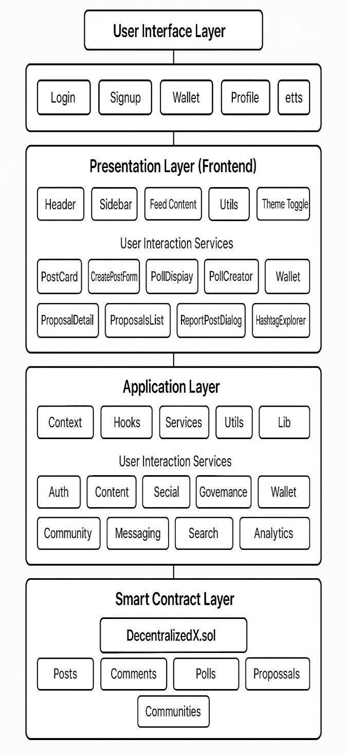

Fig.2: System Architecture Diagram

1. Results

We were able to effectively create a decentralized social media website and test its most important features on testnet blockchain environment. The main aspects shown are:

*A. User Registration & Authentication*

The platforms uses decentralized identity instead of standard username-password based login systems. It does this by verifying users using their blockchain wallet address (like metamask). This method does away with the requirement for centralized credential storage and gives users more privacy and control.

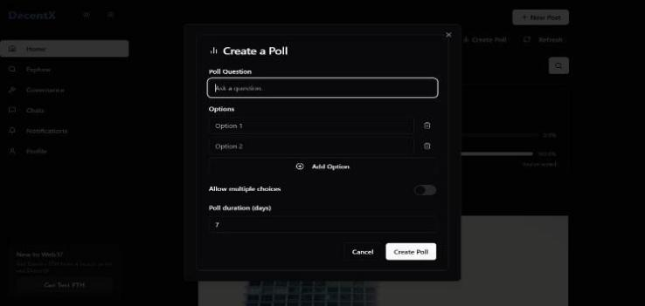

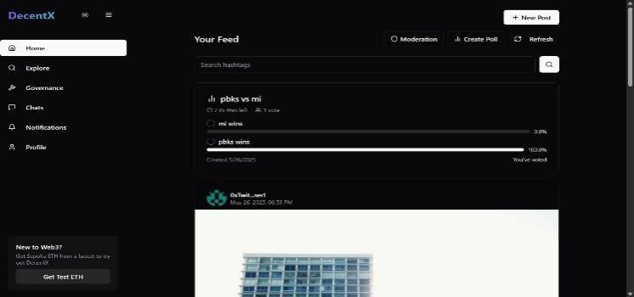Fig.6: Poll Creation

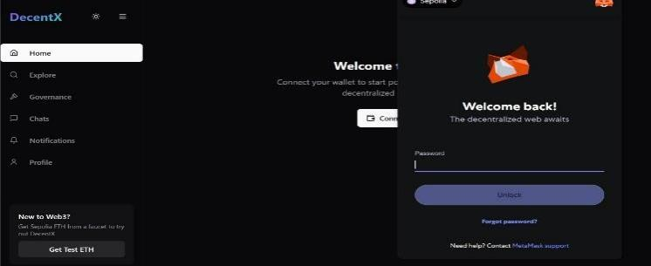Fig.3: User Registration & Authentication

*D. Governance*

Fig.7: Poll Voting

*B. Content Posting*

Users may make their own material including text posts or media references. Smart contracts hold the data for each post on the blockchain. Users may repost content that was already there. Users can also upvote or downvote a post.

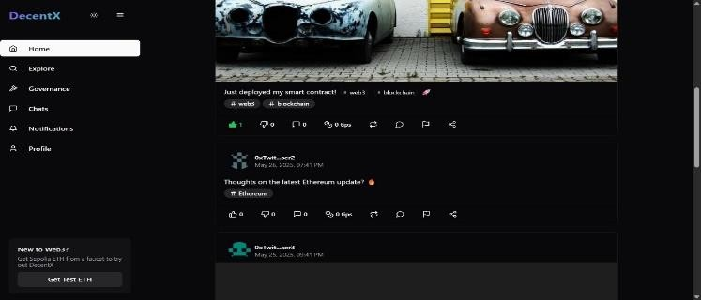

Fig.4: Home Page

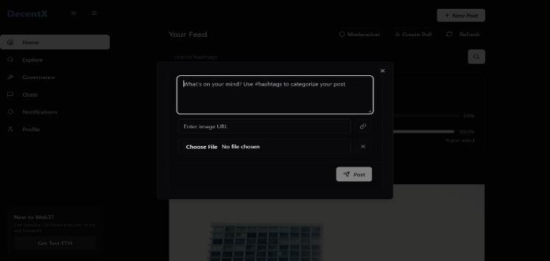

Fig.5: Post Creation

*C. Making & Taking Part in Polls*

Users may construct decentralized polls using the system which employ smart contracts to manage choices. Using polls user can understand the interests of other users in a decentralized way. The poll data is kept safe.

People may vote according to their choice to represent their interest. Smart contracts keep the votes on-chain, which makes sure that they are transparent and protected against

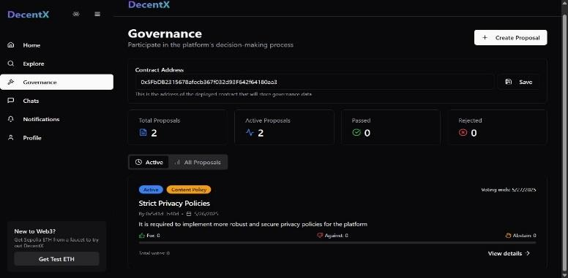

manipulation. Vote count changes in real-time, showing the community sentiment.

Fig.8: Governance Page

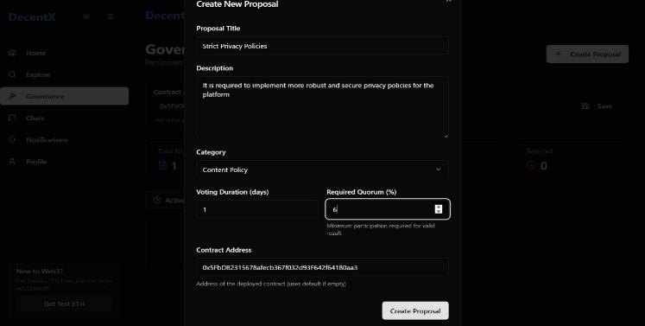

Fig.9: Proposal Creation

*E. Security & Integrity*

All actions such as posts, vote and poll results are saved on- chain in a way that could not be changed. The content is linked to creator’s wallet address such that only they can control it.

1. Conclusion

Social experience evolved and transformed in a large scale by the creation of Decentralized Social Media App based on Blockchain technology. This booming technology is capable of tackling various potential problems within the centralized social network by making the user the sole administrator of their personal information, control over censorship and using the strong blockchain safety measures. Implementing the decentralized platform results in enhanced data privacy reducing any single point of failures simultaneously promoting material control transparency. Various plausible challenges faced by the users may include user scaling and acceptance of user design, user interface and adoption of blockchains. The platform features multiple modes of income, decentralized governance and interoperability making it more appealing. The Decentralized Social Media App creates a democratic, innovative and user centric and controllable environment simultaneously addressing the challenges faced in the centralized system.

References

1. M. Devmane, "D-Space: A decentralized social media app," IEEE Transactions on Computational Social Systems, vol. 1 no. 1 pp. 1-10 2023.
2. D. Tama, A. Wicaksana, "Performance evaluation of decentralized social media on Near Protocol blockchain," IEEE Transactions on Emerging Topics in Computing, vol. 11, no. 1, pp. 100-110, 2023.
3. S. Pandey, M. Sinha, Ramya. G, "Exploring the potential of the Interplanetary File System for secure and transparent social media," IEEE Transactions on Cloud Computing 2023.
4. S. Michelia, F. Kurniawan, V. Antonius, J. Moniaga, B Jabar, "Systematic literature review and qualitative survey of blockchain impact on social media security," IEEE Transactions on Information Forensics and Security, vol. 18, no. 3, pp. 300-310, 2023.
5. N. Chen, D. Siu, Y. Cho, "A blockchain based autonomous decentralized online social network," IEEE Access 2023.
6. S. Michelia; F. Kurniawan, V. Antonius, J. Moniaga, B. Jabar, "Systematic literature review & qualitative survey : blockchain impact on social media security," IEEE Access, vol. 11, pp. 11-20, 2023.
7. K. Fan, Q. Pan, K. Zhang, Y. Bai, S. Sun, H. Li, Y. Yang, "A secure and verifiable data sharing scheme based blockchain in vehicular social networks," IEEE Transactions on Intelligent Transportation Systems, vol. 24 2023.
8. G. Song, S. Kim, H. Hwang, K. Lee, "Blockchain based notarization for social media," IEEE Transactions on Information Forensics and Security, vol. 18, no. 4, pp. 400-410, 2023.
9. Guidi, Barbara, and Andrea Michienzi. "The decentralization of social media through the blockchain technology." In Companion publication of the 13th ACM web science conference, pp. 138-139, 2021.
10. Kleppmann, Martin, Paul Frazee, Jake Gold, Jay Graber, Daniel Holmgren, Devin Ivy, Jeromy Johnson, Bryan Newbold, and Jaz Volpert. "Bluesky and the at protocol: Usable decentralized social media." In Proceedings of the ACM Conext-2024 Workshop on the Decentralization of the Internet, pp. 1-7. 2024.
11. Solidity: A Contract-Oriented Programming Language. [https://soliditylang.org/.](https://soliditylang.org/)
12. MetaMask: A Cryptocurrency Wallet and Gateway to Blockchain App[s.https://metamask.io/.](https://metamask.io/)
13. Ethereum Website. [https://ethereum.org/.](https://ethereum.org/)
14. Bitcoin White Paper. [https://bitcoin.org/bitcoin.](https://bitcoin.org/bitcoin)
15. Blockchain information. [https://www.blockchain.com/.](https://www.blockchain.com/)
16. Ripple Official Website. [https://ripple.com/.](https://ripple.com/)
17. Lightning Network White Paper. [https://lightning.network/lightning-](https://lightning.network/lightning-network-paper) [network-paper.](https://lightning.network/lightning-network-paper)
18. Solidity: A Contract-Oriented Programming Language. [https://soliditylang.org/.](https://soliditylang.org/)
19. MetaMask: A Cryptocurrency Wallet and Gateway to Blockchain App[s.https://metamask.io/.](https://metamask.io/)
20. BitcoinTalk online forum. [https://bitcointalk.org/.](https://bitcointalk.org/)
21. Ethereum Stack Exchange. [https://ethereum.stackexchange.com/.](https://ethereum.stackexchange.com/)
22. Blockchain Revolution Book by Don Tapscott. [https://www.dtapscott.com/blockchain-revolution.](https://www.dtapscott.com/blockchain-revolution)
23. Mastering Bitcoin Book by Andreas M. Antonopoulos. [https://aantonop.com/books/.](https://aantonop.com/books/)
24. Hyperledger Project. [https://www.hyperledger.org/.](https://www.hyperledger.org/)
25. Crypto Compare: Cryptocurrency data and insights provided. [https://www.cryptocompare.com/.](https://www.cryptocompare.com/)
26. Investopedia: Blockchain Technologies described. [https://www.investopedia.com/terms/b/blockchain.](https://www.investopedia.com/terms/b/blockchain)
27. CoinDesk: Bitcoin & Cryptocurrency general news. [https://www.coindesk.com/.](https://www.coindesk.com/)
28. Smith, J., & Johnson, A. "Enhancing User Engagement Through Chat Messaging in Social Media Platforms." [https://techblog.com/chat-](https://techblog.com/chat-enhancement) [enhancement.](https://techblog.com/chat-enhancement)
29. WebRTC: Real-time Communication between Browsers. [https://webrtc.org/.](https://webrtc.org/)
30. Socket.io: Real-time Engine. [https://socket.io/.](https://socket.io/)
31. Brown, C., & White, L. "Securing Chat Applications: Challenges and Best Practices." Security Today. [https://securitytoday.com/secure-chat.](https://securitytoday.com/secure-chat)
32. Green, K., & Lee, M. "Protecting User Privacy in Chat Applications: A Comprehensive Guide." Privacy Matters.

<https://privacymatters.com/chat-privacy>