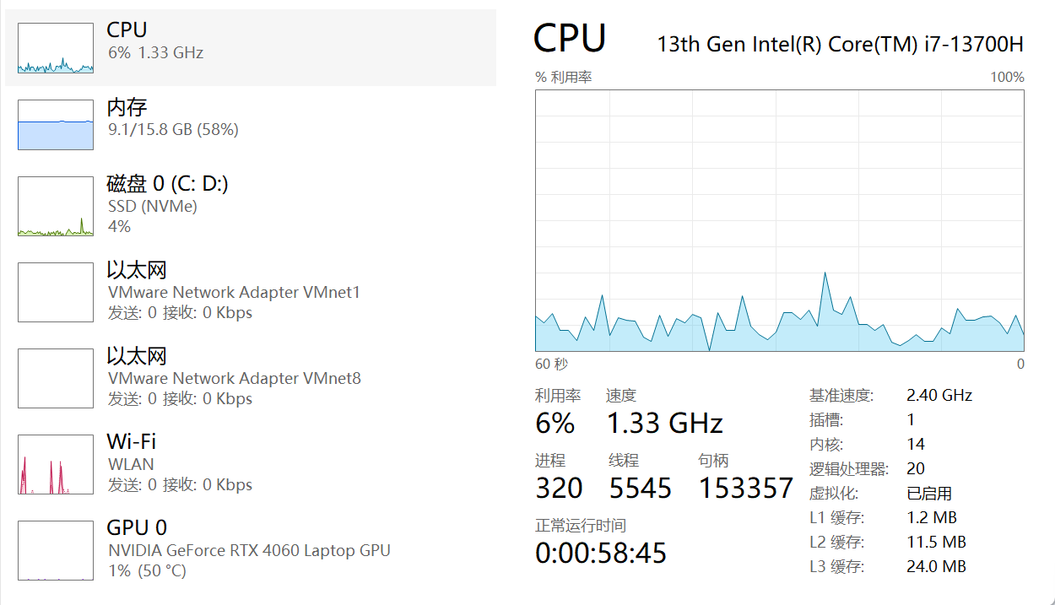
2. Cloud Computing
Fundamental reasons for success: Cost efficiency, scalability, accessibility
Three pros: Lower IT costs, high availability, rapid deployment
Three cons: Security risks, internet dependency, vendor lock-in
3. Hypervisor Function
To create and manage virtual machines by abstracting and partitioning hardware resources.
4. Virtual Machine (VM)
A software-based emulation of a physical computer that runs an operating system and applications with isolated virtual hardware.
5. Benefits of Using Virtual Machines
Hardware consolidation, isolation between workloads, portability, legacy system support, simplified backup and recovery.
6. Five Use Cases of Virtual Machines
Server consolidation, development and testing environments, running legacy applications, desktop virtualization, disaster recovery.
7. Guest Operating System
b) The operating system installed on a virtual machine
8. Virtual Machine Isolation
c) Virtual machines run independently and are isolated from each other and the host system
9. Benefit of Virtual Machine Portability
c) It allows virtual machines to be moved between different physical machines with compatible hypervisors
10. Purpose of Cloning a Virtual Machine
To create identical copies for rapid deployment, testing, scaling, or backup purposes.

