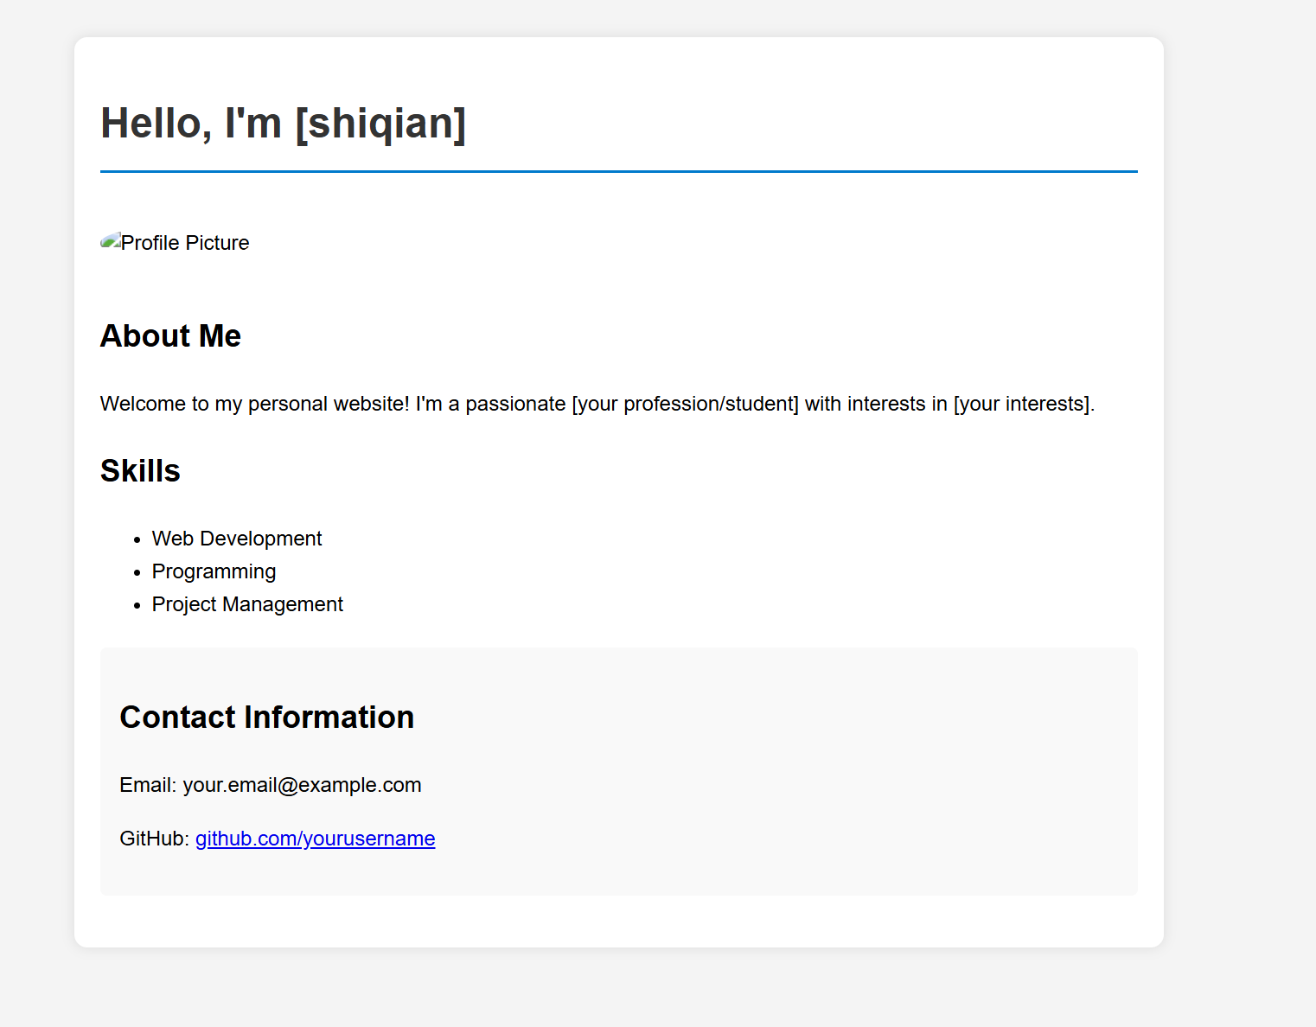
My website is https://shiqian369.github.io/shiqian.github.io/

