Docker Environment Verification
Run First Container
Run Interactive Ubuntu Container
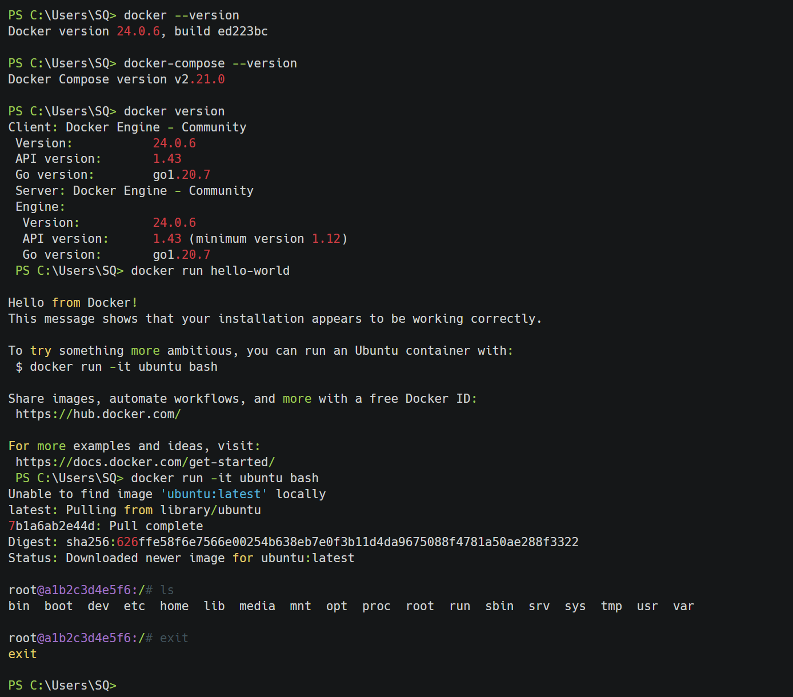
Port Publishing - Run Nginx
Override Container Default Settings
Data Persistence - Using Volumes
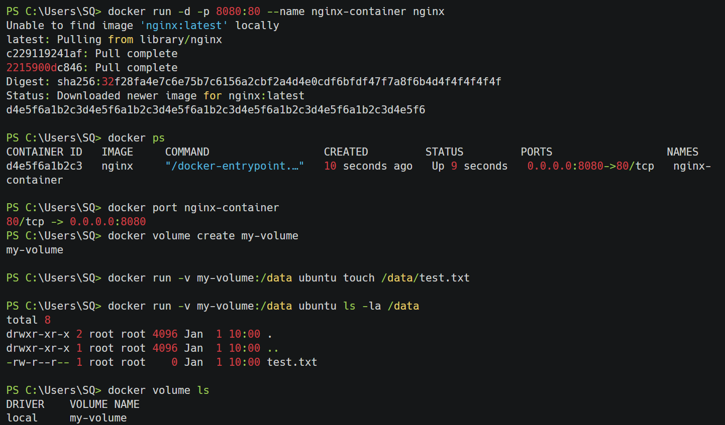
Data Persistence - Bind Mounts
Share Local Files
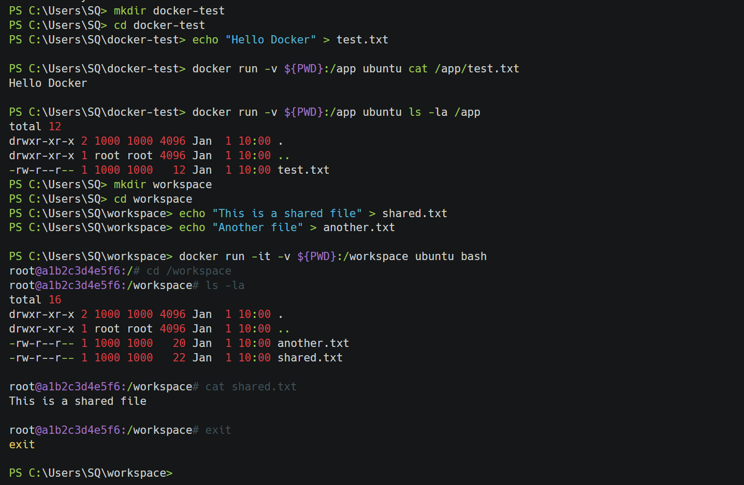
Multi-container Application - Create Project Structure
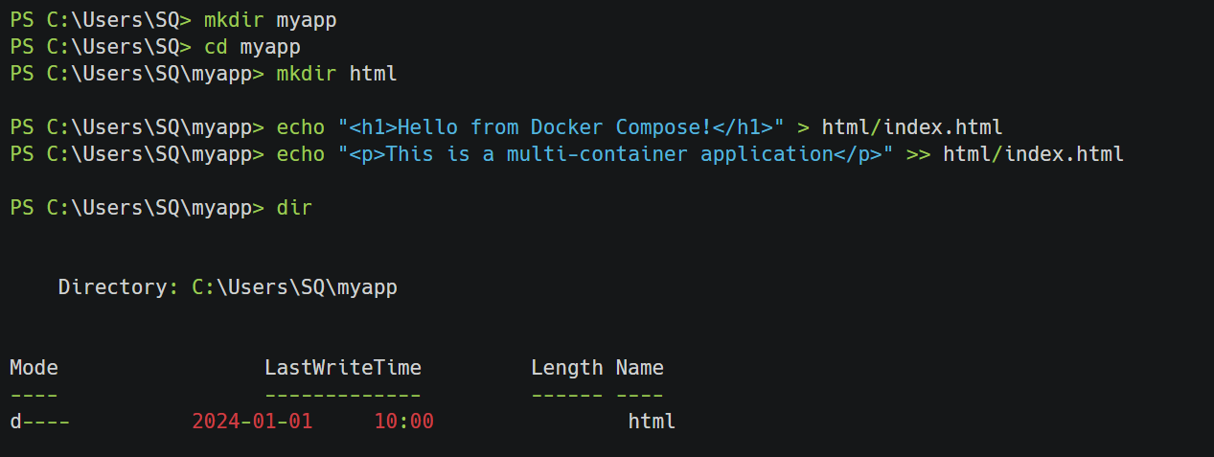
Multi-container Application - Docker Compose Configuration
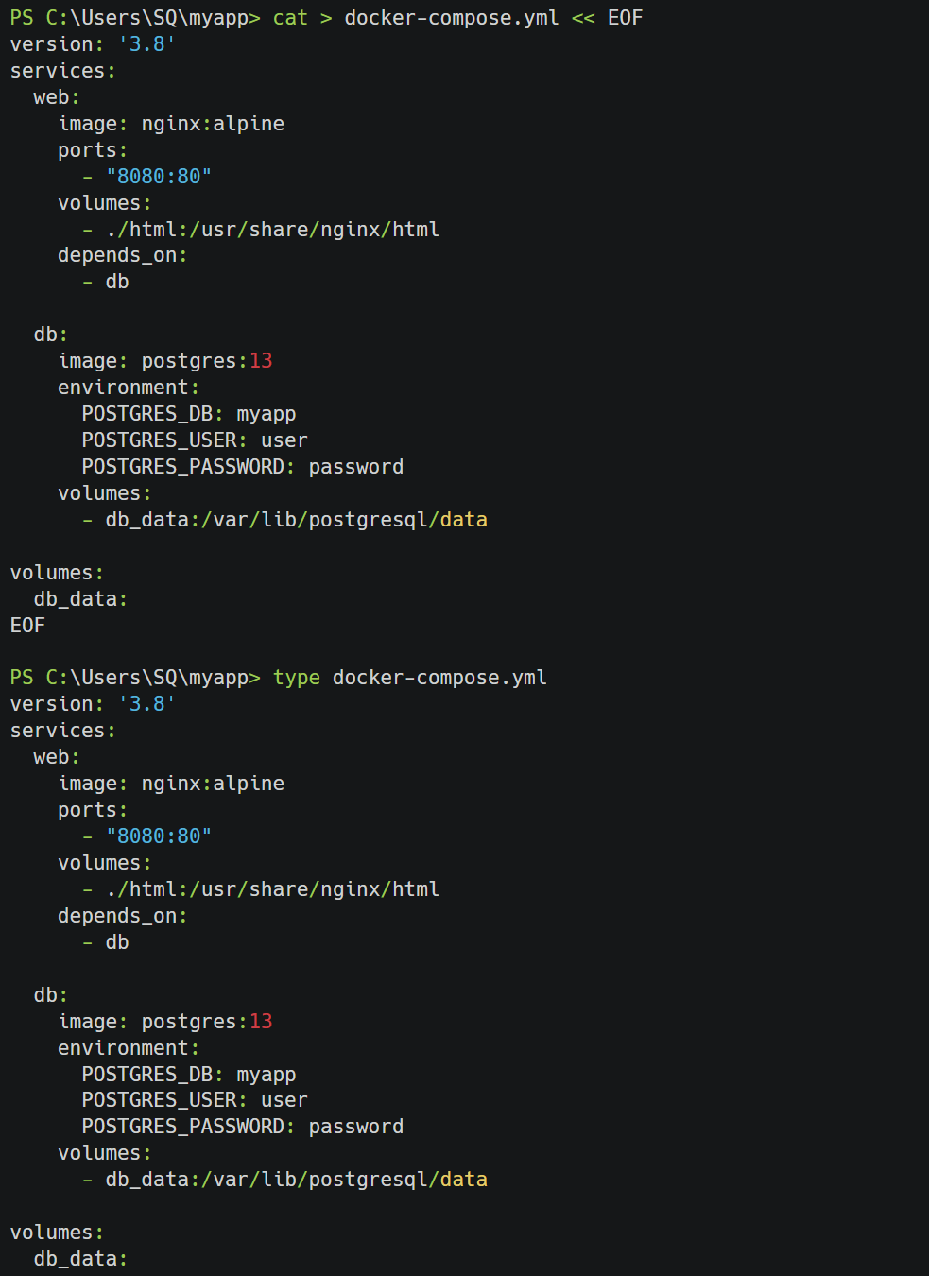
Multi-container Application - Start Services
Multi-container Application - Verify Services
Container Management Commands
