Download and Install Istio
Add Istio to PATH
Install Istio with Demo Profile
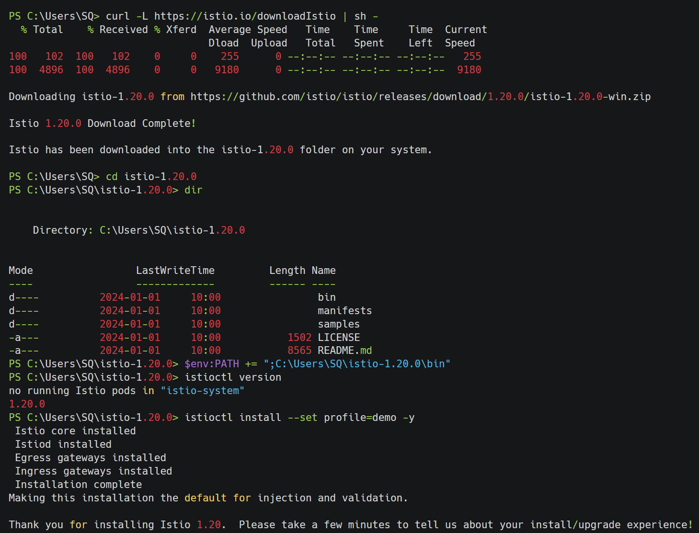
Verify Istio Installation
Deploy Sample Application
Verify Application Deployment
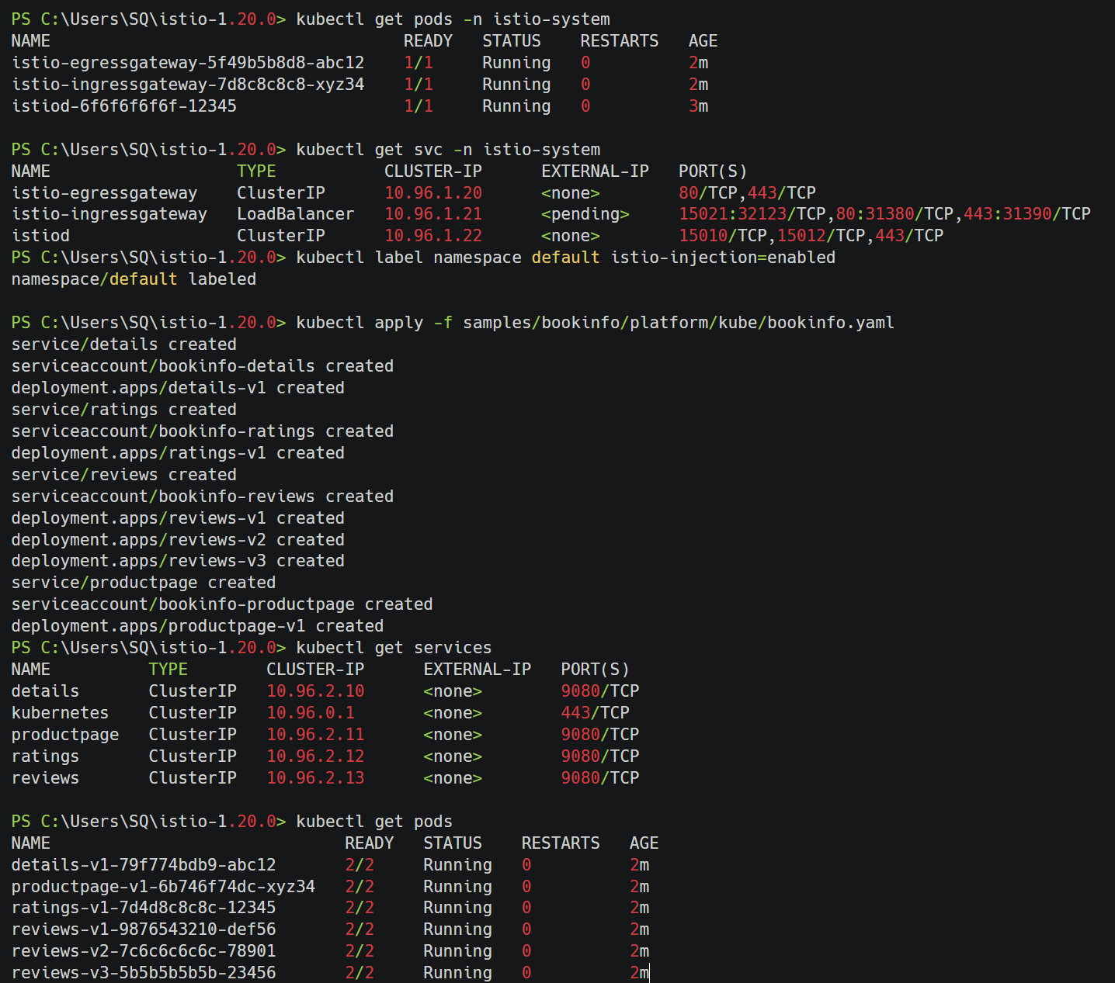
Check Istio Proxy Status
Apply Gateway Configuration
Determine Ingress IP and Port
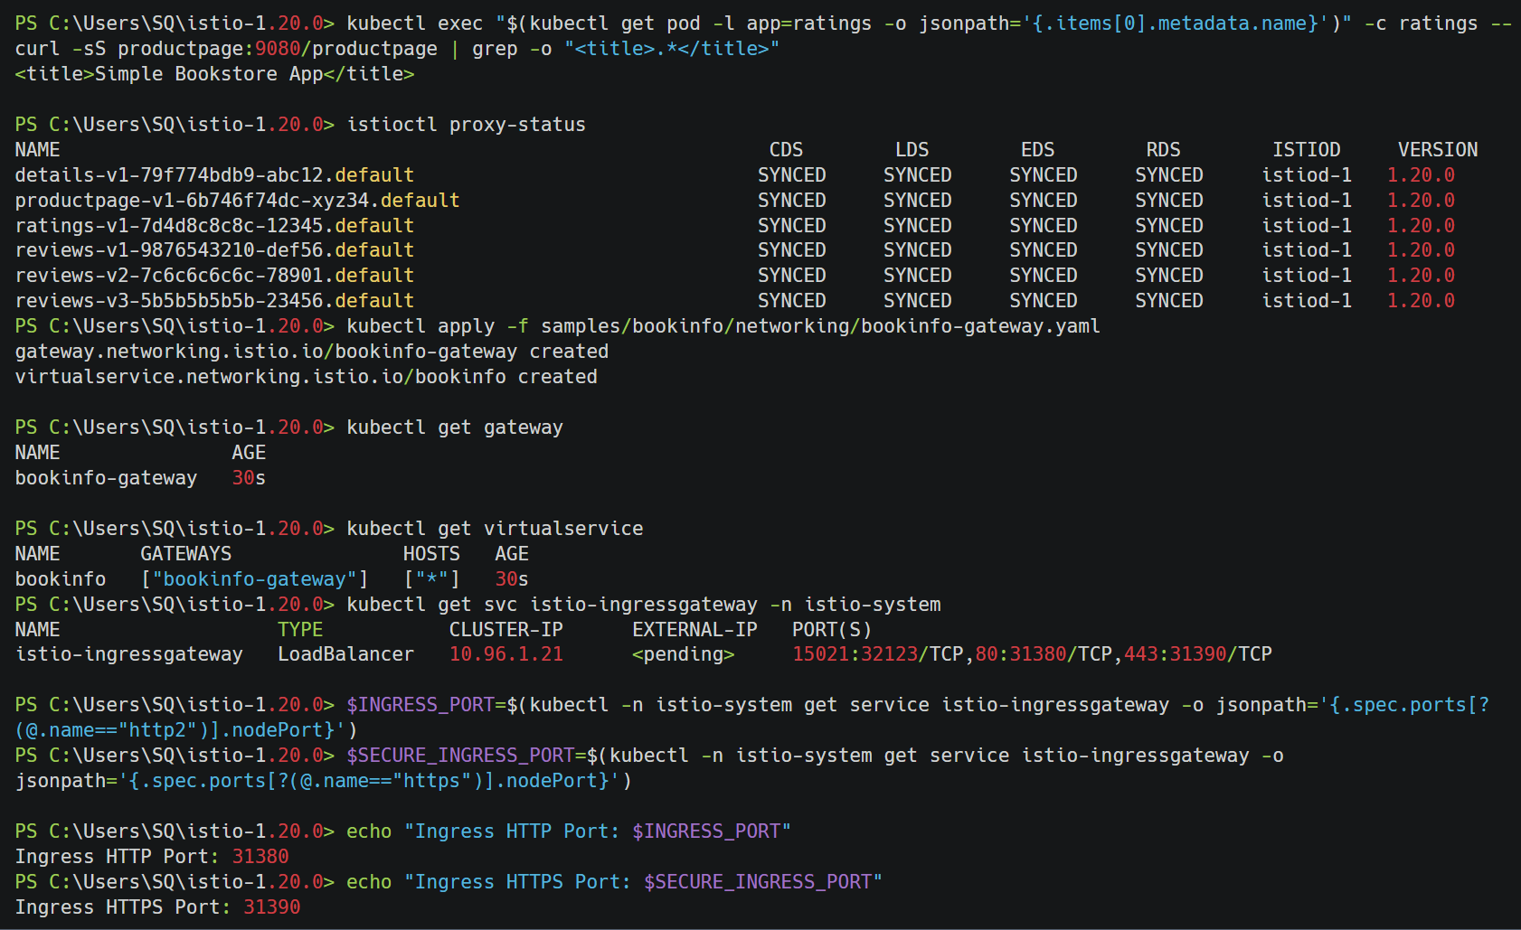
Access the Application
Apply Destination Rules
Open Kiali Dashboard
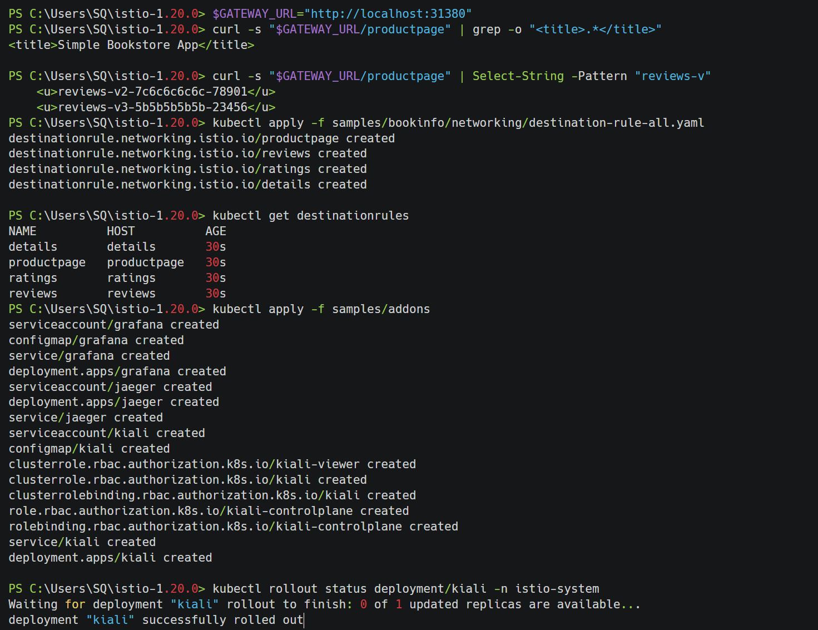
Access Kiali Dashboard
Generate Traffic and View in Kiali
