Traffic Shifting - Deploy Initial Version

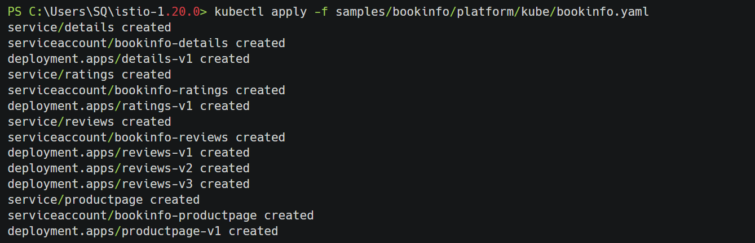

Traffic Shifting - Apply Initial Virtual Service
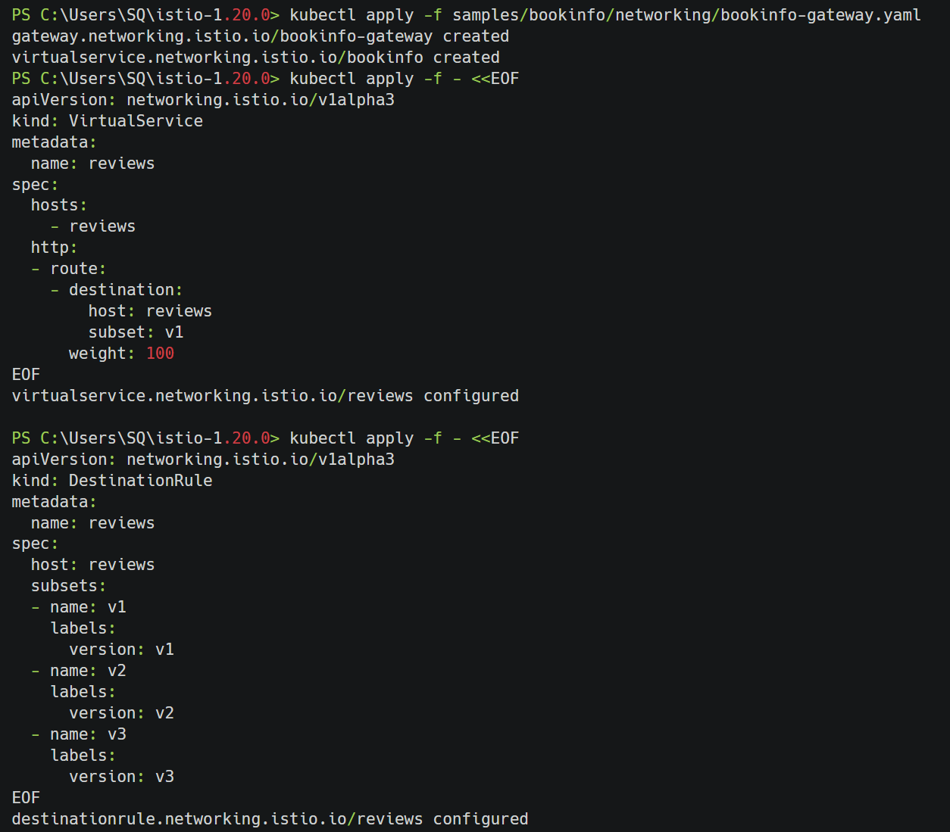
Traffic Shifting - Shift 50% Traffic to v2
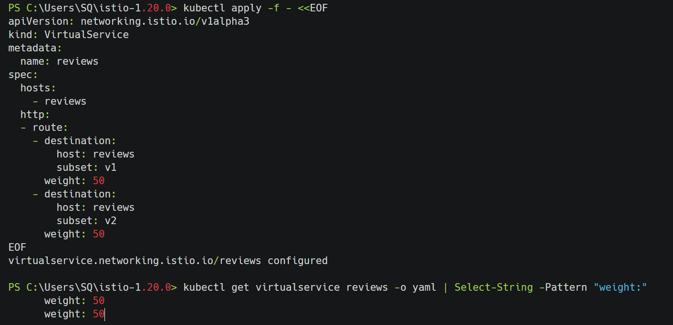
Traffic Shifting - Verify Traffic Distribution
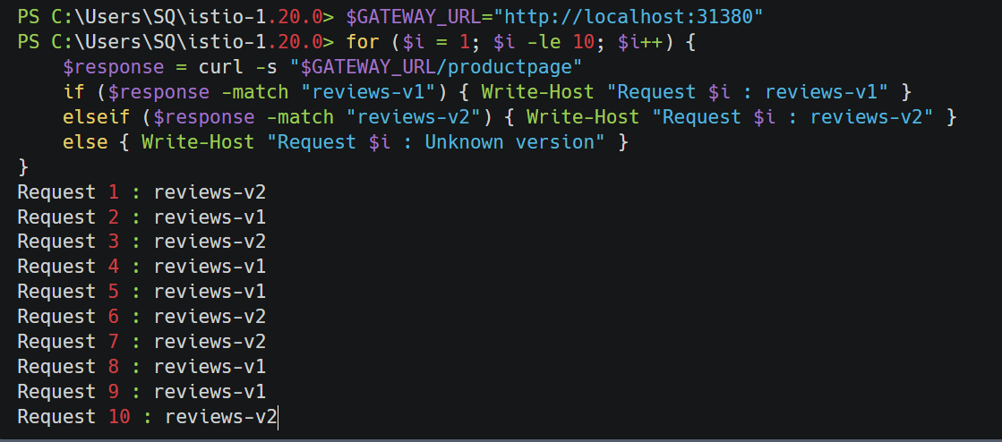
Request Routing - Apply User-based Routing
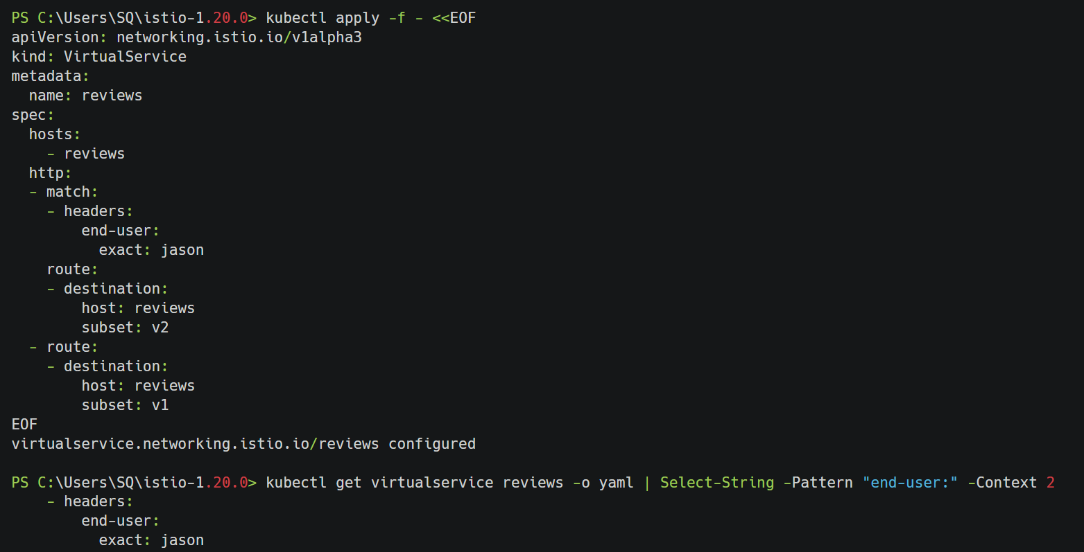
Request Routing - Test User-based Routing
Request Routing - Apply Content-based Routing
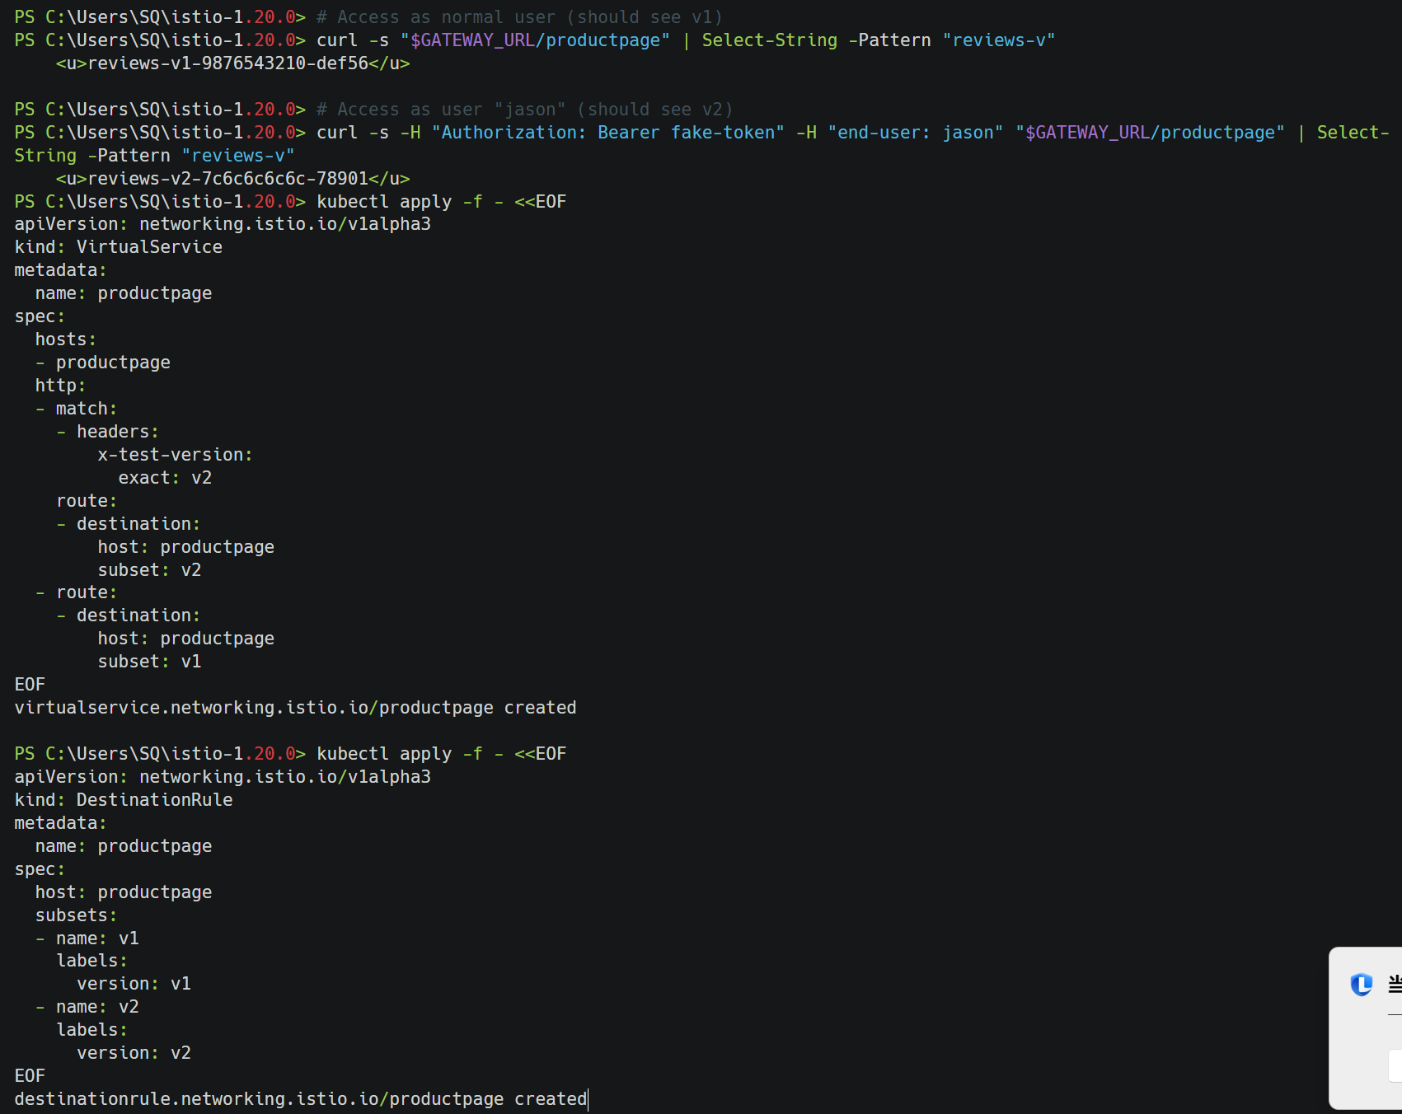
Fault Injection - Apply Delay Fault
Fault Injection - Test Delay Fault
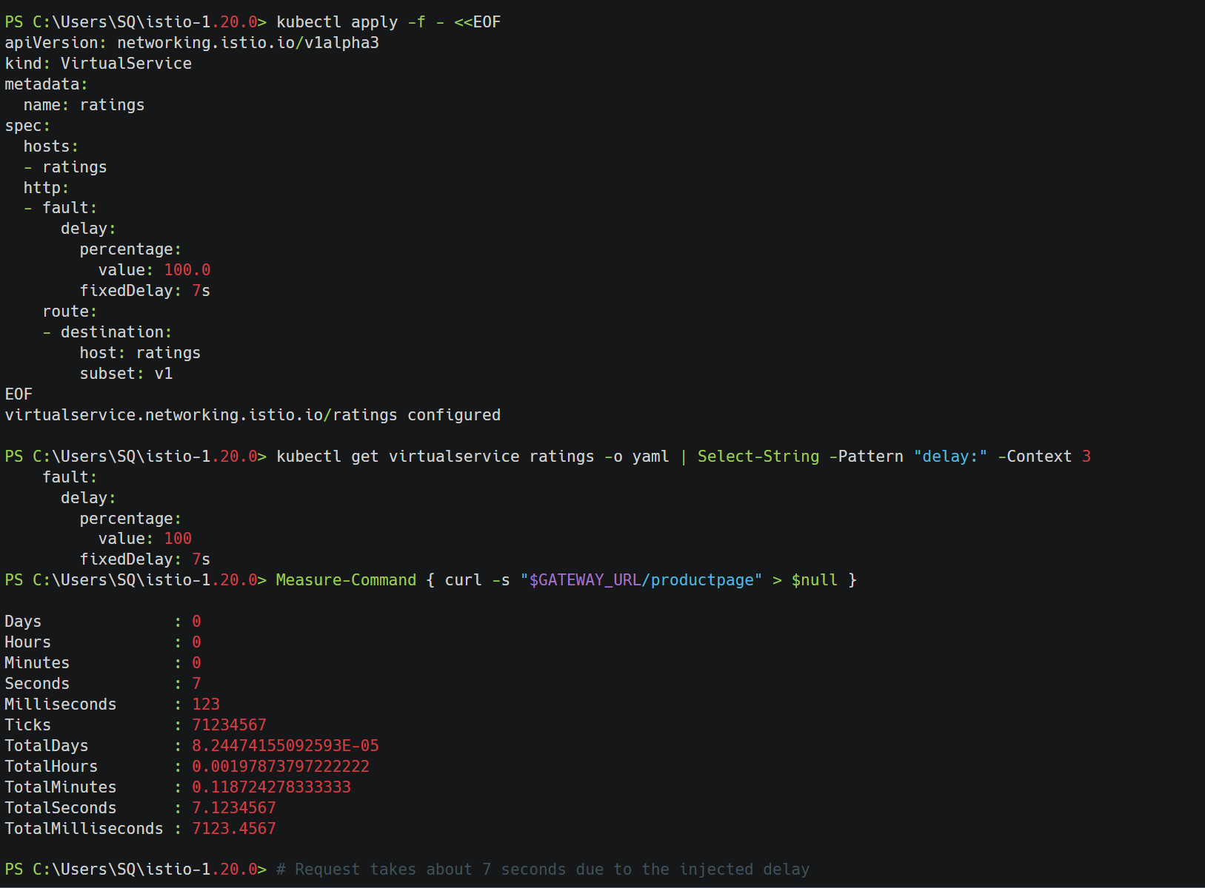
Fault Injection - Apply HTTP Abort Fault

Fault Injection - Test HTTP Abort
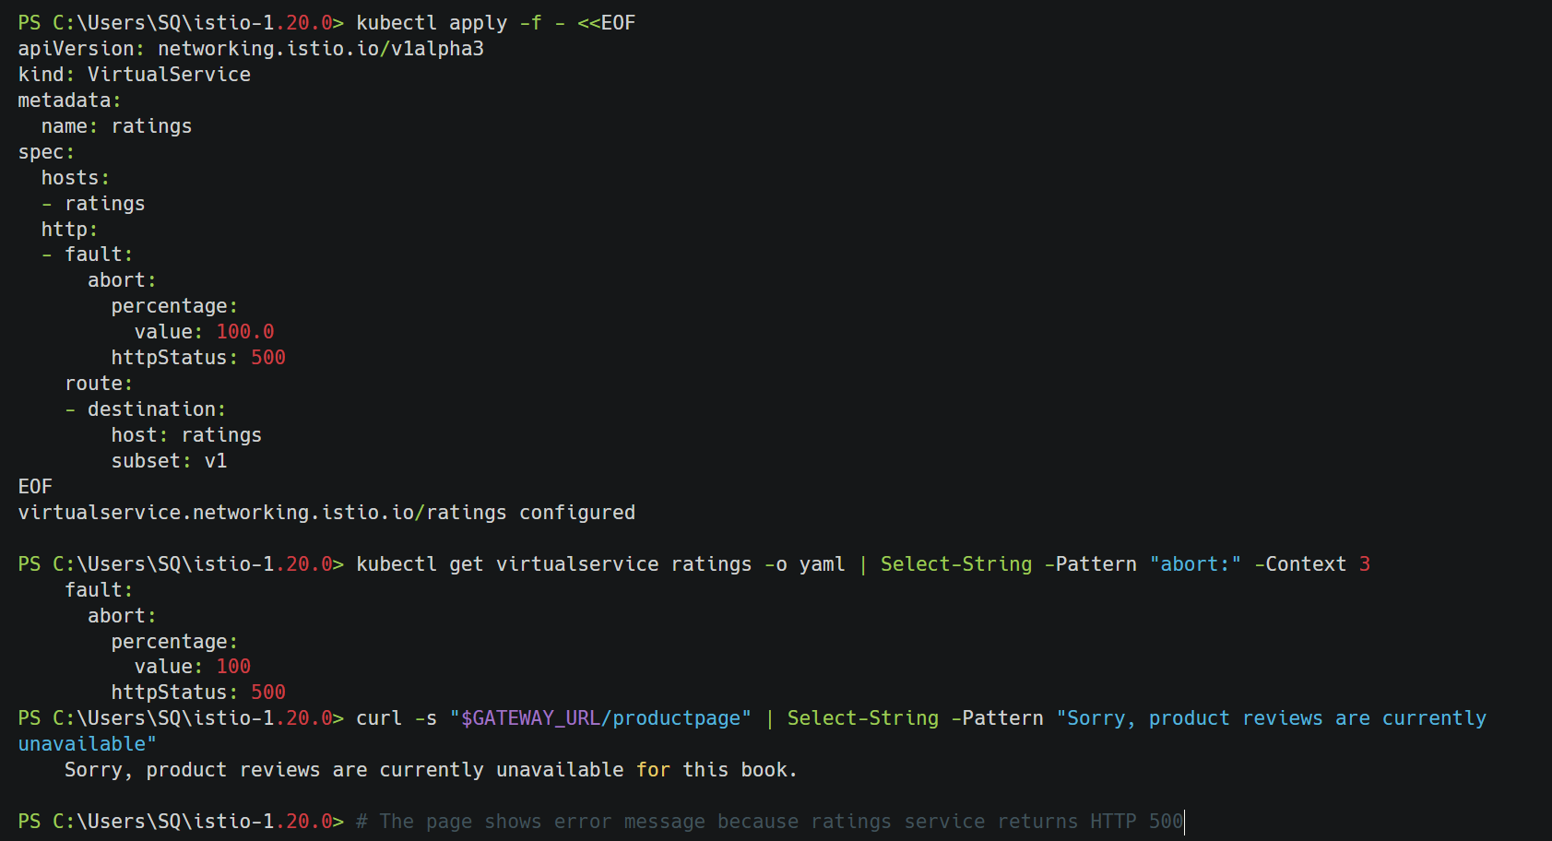
Circuit Breaking - Deploy Httpbin Service
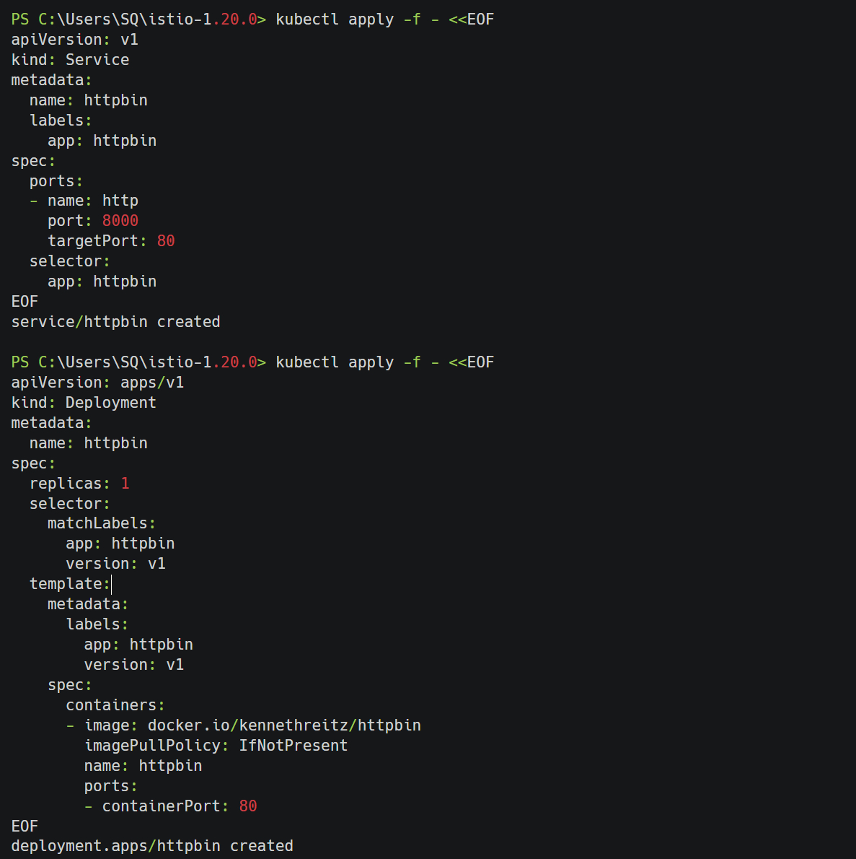
Circuit Breaking - Configure Circuit Breaker
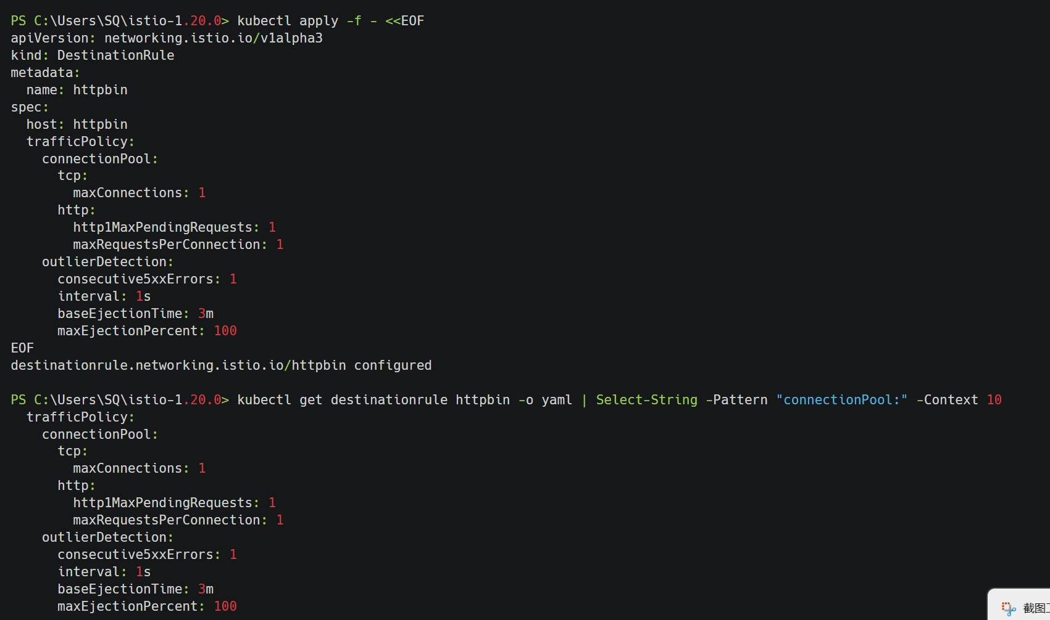
Circuit Breaking - Test Circuit Breaker

Circuit Breaking - Monitor Circuit Breaker Status
