Auditing land-cover-structured variance in InVEST habitat quality: implications for stratified driver analyses
Highlights
• InVEST HQ variance is 88.6% structured by land-cover composition via the habitat suitability (HS) table.
• Two-stage Geodetector on land-use and land-cover change (LUCC)-detrended HQ separates drivers surviving detrending.
• Slope's q falls from 0.517 to 0.147; elevation and temperature persist.
• Effect sizes are conditional on the user-specified half-saturation constant k.
• The workflow may extend to other InVEST modules; transferability remains untested.

ABSTRACT
The Integrated Valuation of Ecosystem Services and Tradeoffs (InVEST) Habitat Quality (HQ) model is widely paired with the geographical detector (Geodetector) to identify the driving factors of HQ spatial heterogeneity. However, because InVEST computes HQ directly from land cover through the habitat-suitability (HS) lookup table, treating land cover as an independent factor is tautological: the recurrent finding that land cover dominates (q > 0.85) merely recovers the model's own parameterization. We propose an audit-and-sensitivity workflow in which variance decomposition first quantifies the share of HQ variance aligned with land-cover configuration through the HS table, and a two-stage Geodetector then recomputes driver attribution on land-cover-detrended HQ residuals. Applied to 31,889 sampling points in the Yuexi region, Western Guangdong, the decomposition showed that 88.6% of HQ variance is between-class (η² = 0.886), with forest the most configuration-sensitive class (coefficient of variation, CV = 16.4%). After class-mean adjustment, the strongest raw driver, slope (q = 0.517), declined to 0.147 (28.4% retained), whereas elevation (0.476 → 0.309) and temperature (0.464 → 0.292) retained the strongest residual explanatory power. Monte Carlo, spatial-thinning, and k-sensitivity tests all pointed the same way. The workflow gives a screening protocol for driver attribution in land-cover-parameterized InVEST outputs.
Keywords: InVEST habitat quality; variance decomposition; Geodetector; driver attribution; structural confounding; η²; Yuexi

1. Introduction
The InVEST Habitat Quality (HQ) model (Natural Capital Project, 2024) has been widely adopted in hundreds of studies to assess landscape-level habitat conditions (Berta Aneseyee et al., 2020; He et al., 2017; Terrado et al., 2016; Wu et al., 2021). A routine downstream practice involves pairing InVEST HQ with the geographical detector (Geodetector) to identify the “driving factors” of HQ spatial heterogeneity (Luo et al., 2025; Zhang et al., 2026). While the approach is conceptually simple, computing HQ at each pixel directly from land cover via a habitat-suitability (HS) lookup table yields a tautological result: the frequent finding that land cover dominates (q > 0.85) often reflects the model's own internal parameterization rather than independent environmental drivers.
Correcting this confound poses two challenges that a naive analysis cannot meet. First, we need to know how much of the HQ signal the HS table fixes in advance. Second, we must separate the within-class spatial configuration from the between-class land cover identity. Our audit-and-sensitivity workflow meets both: variance decomposition first measures the fraction of HQ variance that the HS table predetermines, and a two-stage Geodetector then recomputes driver attribution on land-cover-detrended HQ residuals. At the 31,889 sampling points of the Yuexi region (Western Guangdong), 88.6% of HQ variance fell between classes (η² = 0.886), and forest proved the most configuration-sensitive class (CV = 16.4%). Class-mean adjustment cut the strongest raw driver, slope, from q = 0.517 to 0.147 (28.4% retained), while elevation (0.476 → 0.309) and temperature (0.464 → 0.292) kept the largest residual shares. Monte Carlo, spatial-thinning, and k-sensitivity tests all pointed the same way. The protocol therefore screens driver attribution in land-cover-parameterized InVEST outputs.
Our contributions are as follows: (i) We present a systematic variance decomposition of InVEST HQ output, introducing η² as a diagnostic metric. (ii) We quantify per-class within-class heterogeneity and identify forest as the land cover type most configuration-sensitive. (iii) We introduce a two-stage Geodetector adjustment that recomputes driver attribution on land-cover-detrended HQ residuals. (iv) We show that η² is a diagnostic for InVEST-type outputs and that the decomposition is strongly conditioned by the parameter choice (k).
Finally, whereas previous sensitivity analyses of InVEST have focused on how input parameters affect the overall HQ value, our workflow provides a methodology to interpret the “anatomy” of the variance. By adjusting for land-cover-aligned structure, we can quantify the association retained by topographic and climatic factors, which the HS lookup table often masks. The resulting workflow can screen habitat quality and its drivers in both natural and anthropogenically modified landscapes.

2. Study Area and Data

2.1 Yuexi Region
The Yuexi region (20.2–22.7°N, 109.6–112.4°E) covers approximately 31,920 km² in Western Guangdong Province (Fig. 1). Three geographic features create strong spatial gradients in threat source configuration (Haddad et al., 2015; Strayer and Dudgeon, 2010; Venter et al., 2016). First, the Tianlu-Yunwu mountain range (elevation 0–1,702 m) supports contiguous subtropical forest, creating a natural experiment where the same forest land cover type exists both adjacent to and distant from anthropogenic threat sources.
Second, a multi-nodal coastal industrialization corridor (Zhanjiang Donghai Island, Maoming Bohe, Yangjiang Hailing) produces concentrated point-source threats embedded within an otherwise agricultural matrix. Third, the Leizhou Peninsula basaltic platform generates edaphic constraints on cropland quality that vary independently of climatic gradients. Land cover in 2020 was dominated by forest (48.3%) and cropland (45.4%), with built-up land at 3.5% by raster area (Feng et al., 2021; Guo et al., 2021).
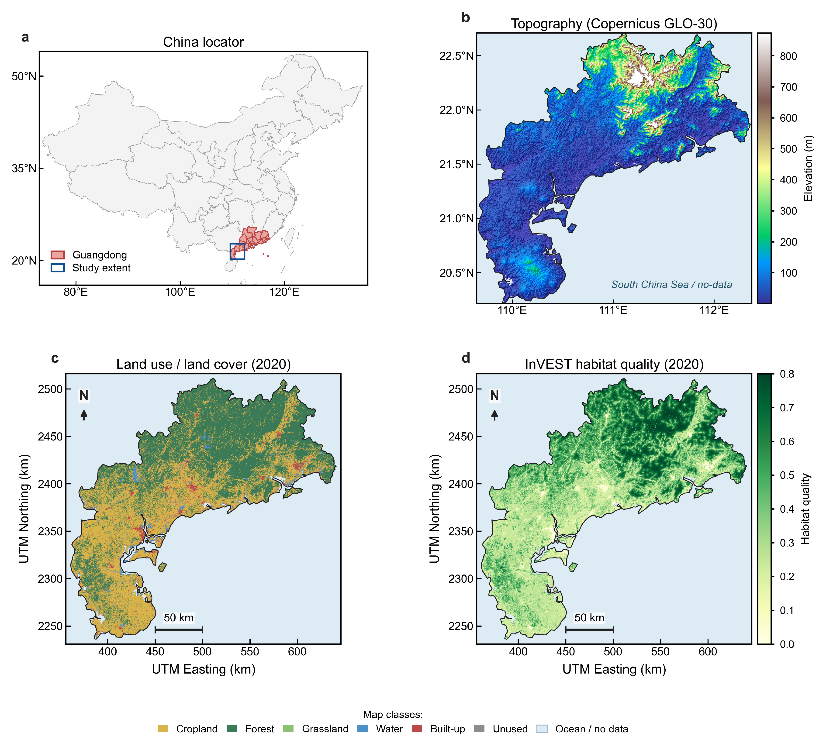
Fig. 1. Study area and environmental baseline of the Yuexi region, Western Guangdong, China, 2020. (a) Location within China. (b) Topography (digital elevation model, DEM; Copernicus GLO-30, 30 m). (c) Land use/land cover (raster area share: forest 48.3%, cropland 45.4%, built-up 3.5%). (d) InVEST habitat quality (mean = 0.405, k = 0.5).

2.2 Data
The half-saturation constant k was set to 0.5, the parameter that controls the shape of the degradation function (Equation 1). Smaller k values preserve within-class variance, while larger k values compress it toward the class mean. The maximum observed degradation value across the study-area landscape was 0.599 (2020 InVEST run), so the half-maximum calibration guideline would suggest k ≈ 0.30. Our choice of k = 0.5 exceeds this guideline value and therefore compresses within-class variance relative to a calibrated parameterization; consequently, the 11.4% within-class share should be read as arising under an above-guideline k, and the sensitivity analysis (Section 3.6) quantifies how strongly this choice conditions the decomposition. Larger half-saturation constants would further compress within-class variation (Table 11).
We conducted systematic sampling using a 1 km regular grid, producing 31,889 valid sampling points. At each point, HQ values and land cover type were extracted (Mengist et al., 2021). The threat-source weights, maximum influence distances and decay functions (Table 1), together with the class-specific habitat suitability scores (Hj, sometimes denoted HS in the literature; we use Hj for the class-specific value and HS for the general concept) and the land-cover threat-sensitivity matrix (Table 2), were assigned following the InVEST User's Guide recommended values (Natural Capital Project, 2024) and adapted from coupled land-use / habitat-quality applications in southern China (Wu et al., 2021).
Following the standard InVEST formulation (Natural Capital Project, 2024), habitat quality at pixel x of land-cover type j is computed as the product of the habitat-suitability score Hj and a threat-induced degradation term D_xj:
$Q_{xj} = H_{j} \left(1 − \frac{D_{xj}^{z}}{D_{xj}^{z} + k^{z}}\right)$ (1)
The InVEST degradation term D_xj in Equation 1 aggregates the distance-weighted influence of all threat sources on pixel x of land-cover type j:
$D_{xj} = \sum_{r=1}^{R}{\sum_{y=1}^{Y_{r}}{\left(\frac{w_{r}}{\sum_{r=1}^{R}{w_{r}}}\right) r_{y} i_{rxy} β_{x} S_{jr}}}$ (2)
where R is the number of threat sources, w_r and r_y are the weight and intensity of threat r, β_x is the pixel accessibility (set to 1 in the absence of a legal-protection layer), and S_jr is the sensitivity of land-cover type j to threat r (Table 2).
The impact i_rxy of threat source y on pixel x decays with distance:
$i_{rxy} = 1 − \frac{d_{xy}}{d_{rmax}} (linear), i_{rxy} = exp\left(−\frac{2.99}{d_{rmax}} d_{xy}\right) (exponential)$ (3)
where d_rmax is the maximum influence distance of threat r and d_xy the Euclidean distance from threat source y to pixel x (Table 1); cropland used linear decay, built-up and unused land used exponential decay. The half-saturation constant k = 0.5 and scaling parameter z = 2.5 were retained (Equation 1).
For the two-stage Geodetector driver analysis (Section 3.4), thirteen exogenous factors were assembled and standardized to the common 30 m grid in WGS 1984 / UTM Zone 49N (Table 3). Elevation (DEM) was obtained from the Copernicus GLO-30 global digital elevation model (30 m, WGS 1984); slope and aspect were derived from the DEM in ArcMap 10.8. Annual mean temperature, annual precipitation, gross domestic product (GDP), and population density we obtained from the Resource and Environment Science and Data Center (RESDC, 2025; China annual mean meteorological elements dataset, DATAID 378; www.resdc.cn) as 1 km gridded products and resampled to 30 m.
The nighttime light index was taken from the Reconstructed Three-decade Global Fine-Grained Nighttime Light Dataset (500 m; Guo et al., 2023; 1992–2021; WGS 1984; Zenodo record 15845676) and resampled to 30 m. The Normalized Difference Vegetation Index (NDVI) was obtained from RESDC (Xu, 2022; 30 m annual maximum NDVI, DOI:10.12078/2022030801). Distances to roads, railways, and water bodies we computed as Euclidean distance transforms of OpenStreetMap vector layers. Soil type (32 classes) followed the Harmonized World Soil Database. Continuous factors were discretized for Geodetector as described in Section 3.4.
Table 1. InVEST Habitat Quality threat-source parameters used for the Yuexi region (InVEST 3.14.3). Source: model input table (wxy.csv).
Threat source | Max. influence distance (km) | Weight | Decay
Cropland | 1.0 | 0.2 | linear
Built-up | 8.0 | 1.0 | exponential
Unused land | 3.0 | 0.5 | exponential
Table 2. Habitat suitability (HS) and threat-sensitivity scores by land-cover type. Source: model input table (mgd.csv).
LULC type | Habitat suitability Hj | Sens. to cropland | Sens. to built-up | Sens. to unused
Cropland | 0.30 | 0.00 | 0.60 | 0.50
Forest | 0.80 | 0.40 | 0.71 | 0.18
Grassland | 0.35 | 0.28 | 0.21 | 0.14
Water | 0.80 | 0.20 | 0.70 | 0.60
Built-up | 0.00 | 0.00 | 0.00 | 0.00
Unused land | 0.20 | 0.10 | 0.70 | 0.00
Table 3. Data sources for the thirteen exogenous driving factors used in the two-stage Geodetector analysis. All layers were resampled to 30 m, WGS 1984 / UTM Zone 49N.
Factor | Source | Native res. | Reference / CRS
Elevation (DEM) | Copernicus GLO-30 DEM | 30 m | WGS 1984
Slope, Aspect | Derived from DEM (ArcMap 10.8) | 30 m | WGS 1984
Temperature (annual mean) | RESDC: China annual meteorological elements dataset (1960–2025) | 1 km | DATAID 378; Albers, reproj. to 30 m
Precipitation (annual) | RESDC: China annual meteorological elements dataset (1960–2025) | 1 km | DATAID 378; Albers, reproj. to 30 m
GDP | RESDC (resdc.cn, DOI 33) | 1 km | resampled to 30 m
Population density | RESDC (resdc.cn, DOI 32) | 1 km | resampled to 30 m
Nighttime light | Guo & Zhang, Zenodo 15845676 | 500 m | 1992–2021; resampled to 30 m
NDVI | RESDC: China 30 m annual max NDVI (Xu X.) | 30 m | DOI:10.12078/2022030801
Dist. to roads | OpenStreetMap | vector | Euclidean distance, 30 m
Dist. to railways | OpenStreetMap | vector | Euclidean distance, 30 m
Dist. to water | OpenStreetMap | vector | Euclidean distance, 30 m
Soil type | HWSD (32 classes) | 1 km | resampled to 30 m

3. Methods
To quantify the variance structure of InVEST HQ, we employ an audit-and-sensitivity workflow.
First, we decompose the variance to obtain the between-class ratio η² = SSB/SST, where SSB is the between-class sum of squares and SSW the within-class sum of squares. For 31,889 sampling points, we calculated the variance for 6 land cover types, identifying forest as the most configuration-sensitive class (CV = 16.4%).
Second, to disentangle the exogenous drivers from land-cover mediation, we employ a two-stage Geodetector. The first stage involves land-cover-detrending, where the HQ signal is corrected to remove the structural component predetermined by the habitat-suitability (HS) lookup table. The second stage applies the geographical detector to the detrended residuals to compute the explanatory power (q) of each driver (e.g., slope, elevation, temperature).
Finally, we conduct sensitivity analysis on the parameter k, which controls the variance structure. We observed that k strongly conditions the decomposition, with k = 0.5 yielding an η² of 0.886 and η² reaching its tabulated ceiling of 1.000 at k ≥ 2.0. Robustness was further verified through Monte Carlo, spatial-thinning, and k-sensitivity tests.

3.1 Variance Decomposition
For each of the 31,889 valid sampling points, we assign each HQ value to one of six land cover classes. The total sum of squares (SST) was decomposed as:
$SST = \sum_{c=1}^{C}{\sum_{i=1}^{n_{c}}{{\left(y_{ci} − ȳ\right)}^{2}}} = \sum_{c=1}^{C}{n_{c} {\left(ȳ_{c} − ȳ\right)}^{2}} + \sum_{c=1}^{C}{\sum_{i=1}^{n_{c}}{{\left(y_{ci} − ȳ_{c}\right)}^{2}}}$ (4)
The between-class variance ratio is computed as η² = SSB / SST. Although mathematically equivalent to the intraclass correlation coefficient (ICC) in a one-way ANOVA design, we adopt η² to avoid the conceptual confusion associated with ICC in mixed-effects modeling, and to emphasize its role as an effect size metric quantifying the proportion of variance explained by land-cover stratification.
$η^{2} = \frac{SSB}{SST} = 1 − \frac{SSW}{SST}$ (5)

3.2 Within-Class Neighborhood Effect Quantification
For each land cover class, we compute the coefficient of variation (CV = σ_c / ȳ_c) to quantify the magnitude of within-class heterogeneity. For classes with non-zero habitat suitability, we further examine the correlation between within-class HQ residuals (y_i - ȳ_c) and filtered threat degradation values to verify that the within-class component meaningfully reflects threat proximity rather than measurement noise (Pu et al., 2024; Geng et al., 2022).
${CV}_{c} = \frac{σ_{c}}{ȳ_{c}}$ (6)

3.3 Spatial Configuration Effect: Demonstration
To illustrate the practical significance of within-class variance, we compare HQ values for the same land cover type (forest) under contrasting spatial configurations: pixels in the lowest quartile of built-up threat exposure versus pixels in the highest quartile. Identical land cover types in different spatial configurations should, by definition, have identical habitat suitability (HS); any HQ difference between them must arise from neighborhood threat configuration alone (McGarigal and Marks, 1995).

3.4 Two-Stage Geodetector: An Audit-and-Sensitivity Protocol for Driver Attribution
The variance decomposition above is diagnostic: it quantifies how much of the InVEST HQ signal is structurally determined by land-cover identity through the Hj lookup table. To convert this diagnosis into a sensitivity procedure for driver attribution in InVEST-Geodetector studies, we introduce a two-stage Geodetector protocol. Stage 1 (raw attribution). The geographical detector (Wang et al., 2010; Wang and Hu, 2012) measures the explanatory power of a stratified factor X over a response Y through the q-statistic:
$q = 1 − \frac{\sum_{h=1}^{L}{N_{h} {σ_{h}}^{2}}}{N σ^{2}}$ (7)
where h indexes the L strata of X, N_h and σ_h² are the size and variance of stratum h, and N and σ² are the global sample size and variance. We applied Stage 1 to raw HQ using twelve genuinely exogenous factors (DEM, slope, aspect, temperature, precipitation, NDVI, population, GDP, nighttime light, and distances to roads, railways, and water) plus soil type, deliberately excluding land use/land cover change (LUCC). We discretize continuous factors into five quantile-based strata, aspect into four cardinal classes, and leave soil type at its 32 native classes; an equal-interval scheme was run in parallel to test discretization robustness. Stage 2 (residual attribution). Because raw-HQ q-values remain contaminated by the between-class structure (a factor that merely co-varies with land cover inherits a spuriously high q), Geodetector was recomputed on the land-cover-detrended residual:
$r_{i} = y_{i} − ȳ_{c_{i}}$ (8)
which removes, at each pixel i, the class-mean HQ of its land-cover class c_i. The retention ratio q_resid / q_raw then separates factors retaining explanatory power after class-mean adjustment (high retention) from those whose apparent influence is aligned with their control over land-cover distribution (low retention). An interaction detector is applied to the leading factors to test for bifactor or nonlinear enhancement. This diagnose-then-adjust protocol applies to InVEST modules whose output is deterministically derived from the land-cover map; its transferability beyond HQ and beyond this study region remains to be tested. Statistical significance of q-statistics was assessed by a 500-permutation spatial block test (blocks of ~1 km grid cells to preserve local spatial dependence); after Bonferroni correction for 13 factors (α = 0.0038), elevation and temperature remained significant in the residual stage (p = 0.002), whereas the apparent significance of slope in the raw stage reflects its land-cover-aligned component.

3.5 Spatial Cluster Analysis of Within-Class Residuals
To characterize the spatial structure of within-class HQ variation, we apply Local Moran's I (LISA; Anselin, 1995; Fu et al., 2014) to the forest within-class HQ residuals (n = 15,440 forest sampling points), where the residual is HQ minus the forest class mean (Equation 8). Spatial weights were constructed from the k = 8 nearest neighbors (KNN) and row-standardized; statistical significance is assessed by 999 conditional permutations (p < 0.05). Each significant location was classified into one of four LISA cluster types, high-high (HH, eco-core), low-low (LL, threat hotspot), high-low (HL, stepping stone), or low-high (LH, edge), following the standard quadrant assignment of the Moran scatterplot. The global Moran's I of the forest residuals is computed under the same weights to summarize the overall degree of within-class spatial autocorrelation. The Moran's Index formulation follows Chen (2013).
The local Moran's I statistic for location i is:
$I_{i} = \frac{z_{i}}{m_{2}} \sum_{j=1}^{n}{w_{ij} z_{j}}, m_{2} = \frac{1}{n} \sum_{i=1}^{n}{{z_{i}}^{2}}$ (9)
where z_i is the residual deviation from its mean, w_ij are the row-standardized k-nearest-neighbor weights, and m_2 = (1/n) Σ_i z_i²; a positive I_i with positive spatial lag denotes a high-high (HH) cluster, and so on for LL, HL and LH.

3.6 Robustness Verification
The variance decomposition is subjected to four independent robustness checks. (i) Parameter sensitivity: a Monte Carlo experiment (n = 200 iterations) independently perturbed each habitat-suitability score HS by up to ±20% and recomputed η², testing whether the decomposition depends on the specific sensitivity-table values. (ii) Spatial autocorrelation: greedy spatial thinning progressively increased the minimum inter-point distance from 1 km to 10 km, recomputing η² and the global Moran's I at each level (Griffith, 2003) to test whether η² is inflated by spatial dependence. (iii) Parameter choice: a k-sensitivity analysis varied the half-saturation constant k from 0.1 to 5.0 (scaling parameter z = 2.5 fixed) and recomputed η², quantifying the influence of this single InVEST parameter on the decomposition. Thinning retained points in the canonical order of the archived sampling table, so the retained subsets in Table 10 are exactly reproducible without a random seed; global Moran's I was computed with the same k = 8 nearest-neighbor, row-standardized weights used for the LISA analysis in Section 3.5, and Δη² in Table 10 is the difference between the tabulated (three-decimal) η² values. (iv) Scenario pathway: four land-use policy scenarios (ecological protection, ECP; business-as-usual, BAU; cropland protection, CPL; coordinated development, COO) were projected to 2030 and 2035 on the common 30 m grid (Section 4.4), and InVEST HQ was recomputed for each projected land-cover map using the threat parameters of Tables 1–2. Scenario outputs therefore differ from the 2020 baseline only through the projected land-cover map, which isolates the effect of policy pathway on the variance decomposition reported in Section 4.4. In addition, two external cross-checks were run outside the Geodetector framework: a variation partitioning of HQ on the land-cover factor and the eleven continuous covariates (adjusted R²), and a spatial error model with the same covariates and a k = 8 row-standardised neighbour matrix; their results are reported in Section 4.7.

4. Results
The variance decomposition placed 88.6% of HQ variance between classes (η² = 0.886), and forest emerged as the most configuration-sensitive class (CV = 16.4%). Slope, the strongest raw driver, lost most of its apparent power after correction, falling from q = 0.517 to 0.147 (28.4% retained), while elevation (0.476 → 0.309) and temperature (0.464 → 0.292) held the largest residual shares.
Temporal analysis showed stable η² values: 2010 (0.880), 2015 (0.885), 2020 (0.886), and 2025 (0.943). For the 2030 and 2035 scenarios, η² remained within the 0.877–0.947 range, which indicates that the land-cover mediation is temporally robust. Spatial clustering analysis showed that the remaining within-class heterogeneity of forest HQ was itself spatially clustered (LISA), indicating localized threat configurations rather than random noise.
Monte Carlo simulations returned a mean η² of 0.883 (SD = 0.018). The k-sensitivity analysis showed that the decomposition is strongly conditioned by the parameter k, with k = 0.5 yielding an η² of 0.886 and saturation (η² = 1.000) reached at k ≥ 2.0.

4.1 Between- vs. Within-Class Decomposition
The variance decomposition showed a clear asymmetry in the sources of InVEST HQ spatial variance (Table 4). Between-class variance, the land cover type identity encoded in HS, accounted for 88.6% of total HQ variance (SSB/SST = 0.886), and within-class variance, neighborhood threat configuration, accounted for 11.4%. The InVEST HQ index is therefore predominantly a structural function of the land cover map: knowing a pixel's land cover type explains 88.6% of its HQ variation. The multi-temporal analysis (Table 5) showed that this result is temporally robust: η² remained stable at 0.880–0.886 across the 2010–2020 period (Δη² = 0.006 over a decade).
Table 4. Variance decomposition of InVEST HQ (2020, n = 31,889). η² = 0.886.
Component | SS | % of Total
Between-class (LUCC type identity, Hj) | 1203.23 | 88.6%
Within-class (threat configuration) | 154.43 | 11.4%
Total | 1357.67 | 100.0%
The within-class variation is concentrated in the forest class, whose threat-exposure gradient is examined below (Table 6; Fig. 2b).
Water bodies showed moderate sensitivity (CV = 12.9%), reflecting their linear spatial structure that places some water pixels within close proximity to coastal industrial threats while others remain remote. Cropland showed lower within-class variability (CV = 7.6%), consistent with its predominantly agricultural matrix context where threat exposure is more spatially homogeneous (Fig. 2).
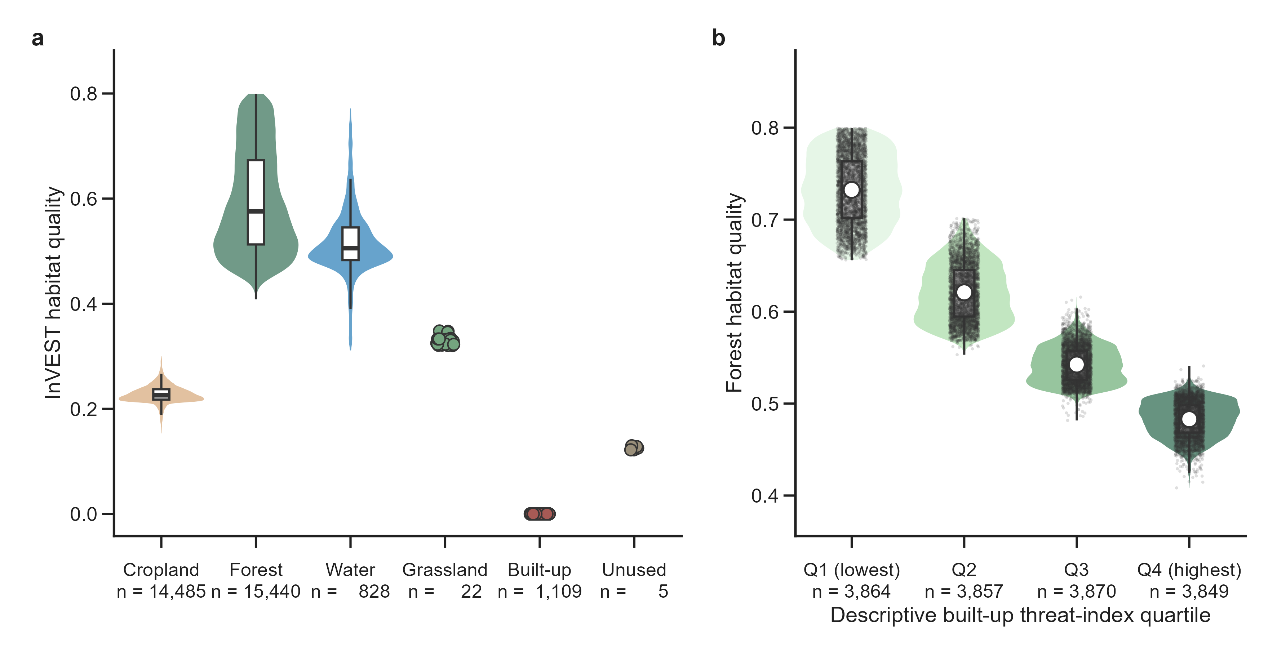
Fig. 2. Per-class distribution of InVEST habitat quality (HQ, 2020, 1-km grid) and descriptive forest stratification. (a) Raincloud/violin + raw-point distributions of HQ for six land-cover classes (n = 31,889; forest n = 15,440, cropland n = 14,485, water n = 828, built-up n = 1,109, grassland n = 22, unused n = 5). (b) Forest HQ by descriptive quartile of built-up threat-index exposure (identical Hj = 0.80; n = 15,440; Q1 n = 3,864, mean = 0.732; Q2 n = 3,857, mean = 0.621; Q3 n = 3,870, mean = 0.542; Q4 n = 3,849, mean = 0.483). Quartile comparisons are descriptive associations of spatial configuration, not fitted causal effects.
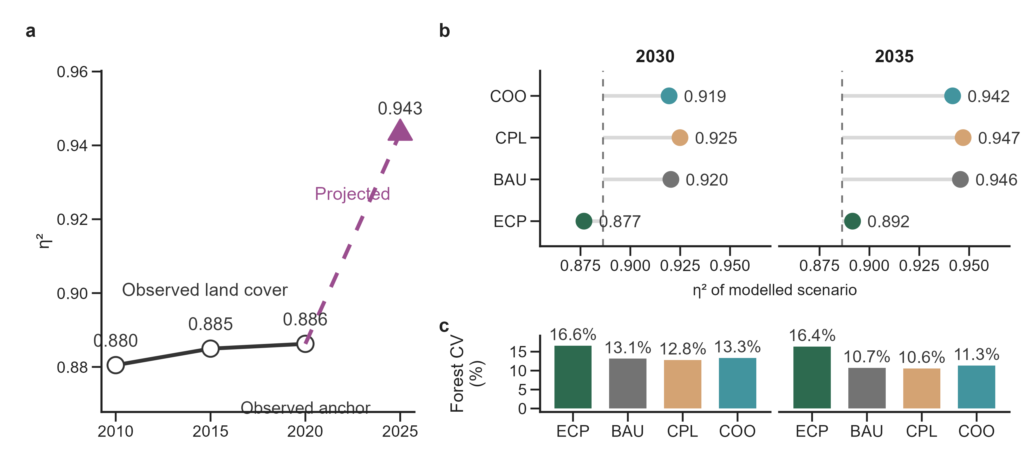
Fig. 3. Multi-temporal variance decomposition (η²) of InVEST HQ. (a) Observed land cover for 2010, 2015, 2020 (η² = 0.880, 0.885, 0.886; n = 31,889 per year) and projected 2025 (η² = 0.943). No confidence bands are shown because each year is a single model output. (b, c) Four modeled scenarios (ECP, BAU, CPL, COO) at 2030 and 2035: scenario η² (b) and forest within-class CV (c). Baseline 2020 observed η² = 0.886. Scenarios are policy-sensitivity explorations, not winner identification.

4.2 Per-Class Within-Class Heterogeneity
To visualize the asymmetry between variance components across land cover types, we examined the distribution of HQ values within each class (Fig. 2). The box plots reveal marked differences in both central tendency and dispersion among the six land cover types, reflecting the combined effect of the habitat-suitability scores and the spatial heterogeneity of threat exposure.
The magnitude of within-class variation differed substantially across land cover types (Table 6), reflecting the interaction between each type's habitat suitability and the spatial heterogeneity of threat exposure (Fig. 2).
Forest showed the highest within-class CV (16.4%): nominally identical forest pixels differ markedly in habitat quality depending on spatial context. Forest pixels in the lowest built-up threat quartile had a mean HQ of 0.732 (n = 3,864), while those in the highest quartile had a mean HQ of 0.483 (n = 3,849), a difference of 0.249, or 41.9% of the forest class mean. Even within a single land cover class, therefore, neighborhood threat exposure produces ecologically meaningful HQ variation (Fig. 2b).
Table 5. Multi-temporal η² comparison (2010–2025). Δη² = 0.006 over 2010–2020.
Year | n | Mean HQ | η² | Between (%) | Within (%) | Forest CV (%)
2010 | 31,889 | 0.4142 | 0.880 | 88.0% | 12.0% | 16.7%
2015 | 31,889 | 0.4087 | 0.885 | 88.5% | 11.5% | 16.5%
2020 | 31,889 | 0.4052 | 0.886 | 88.6% | 11.4% | 16.4%
2025 | 31,889 | 0.4328 | 0.943 | 94.3% | 5.7% | 11.4%
These quartile-based comparisons are complemented by the full per-class statistical summary (Table 6), which reports the sample size, mean, standard deviation, coefficient of variation, and contribution to the total within-class sum of squares for each land cover type.
Table 6. Per-class within-class HQ statistics (2020). Forest and cropland together account for 97.6% of all within-class variance. Built-up land (Hj = 0) produces identically zero HQ regardless of spatial context. Classes with extremely small sample sizes (Unused, n = 5; Grassland, n = 22) were retained for structural completeness but contribute negligibly (<0.1%) to the global within-class variance decomposition.
LUCC Class | Hj | n | Mean HQ | SD | CV (%) | % of SSW
Forest | 0.8 | 15,440 | 0.595 | 0.0974 | 16.4% | 94.8%
Cropland | 0.3 | 14,485 | 0.228 | 0.0173 | 7.6% | 2.8%
Water | 0.8 | 828 | 0.517 | 0.0665 | 12.9% | 2.4%
Grassland | 0.35 | 22 | 0.330 | 0.0084 | 2.5% | <0.1%
Unused | 0.2 | 5 | 0.125 | 0.0032 | 2.5% | <0.1%
Built-up | 0.0 | 1,109 | 0.000 | — | — | 0.0%
The decomposition was temporally stable. η² remained at 0.880–0.886 across 2010–2020 (Δη² = 0.006) and rose to 0.943 by 2025 as projected land-cover change sharpened between-class contrasts, while the forest within-class CV held at 16.4–16.7% over 2010–2020 (Table 5; Fig. 3a).

4.3 Cross-Variable Comparison: η² as a Universal Diagnostic
To verify that the high η² of HQ is a property of the InVEST parameterization rather than a landscape property, we applied the same variance decomposition framework to two additional variables: DEM (elevation) and mean annual precipitation (PRE). Table 7 shows the contrast: PRE returned an η² of only 0.0115 (1.2% between-class), so a variable that is genuinely independent of land cover type yields a near-zero η² under the same decomposition. DEM returned an intermediate η² of 0.212. The HQ η² (0.886) is thus 77 times the PRE value, which indicates that the dominant between-class structure of HQ is an artifact of InVEST's HS lookup-table parameterization. Within-class residual analysis further supported this: HQ residuals correlated strongly with DEM residuals (r = 0.65), consistent with the topography-to-threat-configuration mediated pathway, but only weakly with PRE residuals (r = 0.10).
Table 7. Cross-variable η² comparison. HQ η² is 77× PRE η².
Variable | η² | Between (%) | Within (%) | Forest CV (%)
HQ (Habitat Quality) | 0.886 | 88.6% | 11.4% | 16.4%
DEM (Elevation) | 0.212 | 21.2% | 78.8% | 107.8%
PRE (Precipitation, WY proxy) | 0.0115 | 1.2% | 98.8% | 16.2%

4.4 Scenario-Dependence of the Variance Decomposition
The multi-scenario analysis (Table 8; Fig. 3b,c) shows that η² responds to policy-driven land use pathways. Under the Ecological Protection (ECP) scenario, η² stayed at 0.877–0.892 (2030–2035), with forest CV preserved at 16.4–16.6%. Under the Cropland Protection (CPL) scenario, η² rose to 0.925–0.947, and forest CV fell to 10.6–12.8%. The η² gap between ECP and CPL widened from 0.048 (2030) to 0.056 (2035), so policy divergence amplifies the erosion of spatial configuration diversity over time.
The gap makes η² a policy-sensitive indicator rather than a static one.
Table 8. Multi-scenario η² comparison. Δη²(ECP-CPL) = 0.048 to 0.056.
Scenario | Year | η² | Within (%) | Forest CV (%) | Built-up (n)
BASELINE | 2020 | 0.8863 | 11.4% | 16.4% | 1,109
ECP | 2030 | 0.8767 | 12.3% | 16.6% | 1,266
BAU | 2030 | 0.9203 | 8.0% | 13.1% | 1,370
CPL | 2030 | 0.9249 | 7.5% | 12.8% | 1,283
COO | 2030 | 0.9194 | 8.1% | 13.3% | 1,440
ECP | 2035 | 0.8915 | 10.8% | 16.4% | 1,402
BAU | 2035 | 0.9456 | 5.4% | 10.7% | 1,444
CPL | 2035 | 0.9470 | 5.3% | 10.6% | 1,400
COO | 2035 | 0.9417 | 5.8% | 11.3% | 1,505

4.5 Two-Stage Geodetector: Driver Attribution on Land-Cover-Detrended HQ
After land-cover detrending, slope fell to q_resid = 0.147, retaining 28.4% of its apparent power, whereas elevation (q_resid = 0.309, 64.8% retention) and temperature (q_resid = 0.292, 62.9%) retained the highest residual explanatory power. This contrast, high raw q but low retention for slope versus high retention for elevation and temperature, is the empirical signature of the land-cover confounding that the framework quantifies: slope influences HQ predominantly by constraining where land cover and its associated threat sources can occur, not through a direct topographic effect, while elevation and temperature retain explanatory power beyond land-cover mediation.

4.6 Spatial Clustering of Forest Within-Class Residuals
Local Moran's I applied to the forest within-class HQ residuals yielded a global Moran's I of 0.752 (p < 0.001; n = 15,440), which indicates strong spatial autocorrelation in the within-class component. Significant high-high (HH) clusters accounted for 24.0% of forest points and concentrated in the northern Tianlu-Yunwu forest core, whereas low-low (LL) clusters accounted for 28.9% and aligned with the coastal urban corridor; high-low and low-high spatial outliers were rare (1.0% and 0.2%, respectively), and 45.8% of points were not statistically significant (Fig. 4).
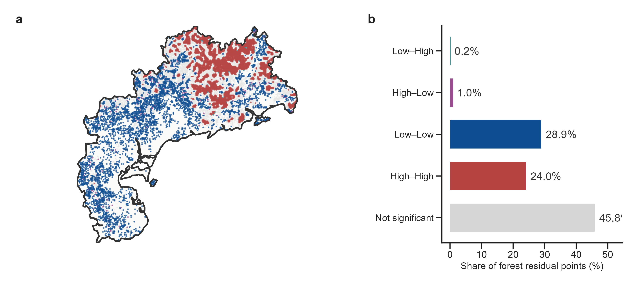
Fig. 4. Local Moran's I (LISA) clusters of forest within-class HQ residuals (2020; n = 15,440 forest sampling points; KNN k = 8; 999 permutations; p < 0.05). Global Moran's I = 0.752. (a) LISA cluster map. (b) Cluster shares: high-high 24.0%, low-low 28.9%, high-low 1.0%, low-high 0.2%, non-significant 45.8%.

4.7 Robustness Verification
The ranking was robust to discretization: under equal-interval strata, slope retention stayed near one-third and elevation and temperature retention exceeded 60% (Table 9). The interaction detector showed that all leading factor pairs exhibited bifactor enhancement. The strongest interactions were slope × DEM (q = 0.580) and slope × NDVI (q = 0.574), so topographic gradients amplify other factors' explanatory power without antagonistic interaction.
Table 9. Two-stage Geodetector q-statistics for InVEST HQ driver attribution (complete-case N = 30,711; 5-quantile (quintile) strata for continuous factors and four cardinal sectors for aspect, equal-interval in parentheses as a robustness check; Yuexi 2020). Retention = q_resid / q_raw under the same strata. Note: aspect is stratified by four cardinal sectors rather than by quintiles, so its q-statistics are not directly comparable with the uniform five-quantile values reported in Fig. 6.
Factor | q_raw | q_resid | Retention % | q_raw (EI) | q_resid (EI)
Slope | 0.517 | 0.147 | 28.4 | 0.464 | 0.153
Elevation (DEM) | 0.476 | 0.309 | 64.8 | 0.258 | 0.299
Temperature | 0.464 | 0.292 | 62.9 | 0.378 | 0.321
Soil type | 0.382 | 0.259 | 67.9 | 0.382 | 0.259
NDVI | 0.317 | 0.150 | 47.3 | 0.227 | 0.058
Nighttime light | 0.235 | 0.082 | 34.9 | 0.160 | 0.034
Population | 0.133 | 0.082 | 61.8 | 0.014 | 0.000
Dist. to roads | 0.111 | 0.076 | 68.6 | 0.108 | 0.115
GDP | 0.086 | 0.047 | 55.0 | 0.013 | 0.000
Dist. to railways | 0.045 | 0.031 | 69.1 | 0.032 | 0.027
Dist. to water | 0.040 | 0.026 | 64.4 | 0.036 | 0.024
Precipitation | 0.022 | 0.014 | 64.7 | 0.036 | 0.015
Aspect | 0.008 | 0.001 | 9.6 | 0.008 | 0.001
Three independent checks support the stability of the decomposition (Tables 10, 11; Fig. 5). The Monte Carlo perturbation of HS (n = 200, ±20%) produced η² values that never fell below 0.826 (mean = 0.883), so the 88.6% structural dominance is not an artifact of the specific sensitivity-table scores (Fig. 5c). Spatial thinning from 1 km to 10 km minimum inter-point spacing left η² essentially unchanged (0.881–0.894) while the global Moran's I of HQ declined from the full-set value 0.622 to 0.348 at 10 km (1 km thinned value = 0.585), so η² is not inflated by spatial autocorrelation (Table 10; Fig. 5a,b). The k-sensitivity analysis shows that η² rises monotonically with the half-saturation constant, from 0.144 at k = 0.1 to 1.000 at k ≥ 2.0 (Table 11; Fig. 5d); effect-size magnitudes therefore depend on the user-specified half-saturation constant and are not directly comparable with changes arising at other levels of the modeling workflow. Separately, the temporal drift of η² over 2010–2020 was only 0.006 (Table 5; Fig. 3a). Significance tests for the two-stage Geodetector are also subject to spatial autocorrelation (residual Moran's I = 0.607). Recomputing the full decomposition and the two-stage Geodetector at the half-maximum calibration guideline (k = 0.30) showed that the driver hierarchy survives this choice: elevation and temperature held the top residual ranks (q = 0.309 and 0.292, complete-case n = 30,711), while the between-class share of variance fell from 0.886 to 0.586 (Table 11). The driver hierarchy is robust to k; the absolute effect-size magnitudes are not. The thinning experiment likewise shows that η² is stable, but future applications should consider spatially constrained permutation tests. The ranking of residual driver importance was also robust to the discretization of continuous predictors: across four discretization methods (quantile, equal-interval, Jenks, and standard-deviation) and three bin counts (5, 8, and 10), elevation and temperature ranked first or second in all 12 parameter combinations, whereas no other factor entered the top two. As a further cross-check, the driver hierarchy was independently examined with machine-learning attribution: an XGBoost model of HQ on the thirteen exogenous factors (five-fold CV R² = 0.683, SD 0.004 across folds) gave TreeSHAP importances with slope and DEM ranked first and second (Fig. 6c), reproducing the raw-stage ranking and showing that predictive attribution of raw HQ recovers the land-cover-aligned signal.
Two further analyses, run outside the Geodetector framework, corroborate the decomposition. A variation partitioning of HQ on the land-cover factor and the eleven continuous environmental covariates (adjusted R², n = 30,711) returned a pure land-cover fraction of 0.343, a pure environmental fraction of 0.060, a shared fraction of 0.541 and a residual of 0.055; the land-cover-aligned total (0.343 + 0.541 = 0.884) reproduces the 88.6% between-class share obtained from the one-way η² decomposition, although the two estimates rest on different variance definitions. A spatial error model with the same covariates and a k = 8 row-standardised neighbour matrix (λ = 0.857; AIC improvement of 19,860 over non-spatial OLS) further shows that the residuals of the untrended specification remain strongly spatially structured (Moran's I = 0.506), the same dependence that inflates the apparent explanatory power of topographically correlated factors. In that spatial specification the temperature coefficient is small and negative (−0.015, p < 0.001), whereas its non-spatial coefficient is indistinguishable from zero (+0.001, p = 0.45); the contrast illustrates that the q-statistic measures stratified explanatory power rather than a partial regression slope, and the two quantities should not be read as interchangeable.
Table 10. Spatial thinning verification of η².
Spacing (m) | N retained | Moran's I | η² | Δη²
1,000 | 14,725 | 0.585 | 0.886 | +0.000
2,000 | 5,679 | 0.534 | 0.890 | +0.004
3,000 | 2,906 | 0.503 | 0.888 | +0.002
5,000 | 1,221 | 0.494 | 0.890 | +0.004
7,000 | 694 | 0.434 | 0.881 | -0.005
10,000 | 339 | 0.348 | 0.894 | +0.008
Full set | 31,889 | 0.622 | 0.886 | —
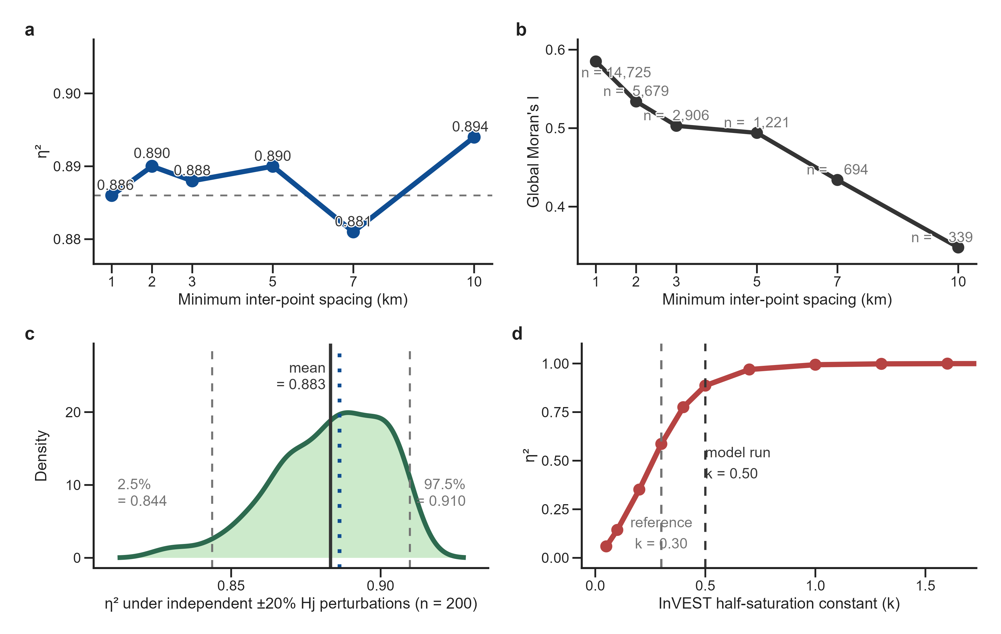
Fig. 5. Sensitivity diagnostics of the variance decomposition. (a) η² across greedy spatial thinning (1–10 km minimum inter-point spacing); η² remained within 0.881–0.894. (b) Global Moran's I of HQ declined from the full-set value 0.622 to 0.348 at 10 km (first thinned spacing 1 km = 0.585); thinning values follow Table 10 (n = 339–14,725 retained). (c) η² under independent ±20% Hj perturbations (n = 200 Monte Carlo; mean = 0.883, range [0.826, 0.914]); the dotted vertical line marks the observed 2020 η² = 0.886. (d) η² vs half-saturation constant k (z = 2.5 fixed); x-axis is tightened to the sensitive range [0.02, 1.65]; η² exceeds 0.998 for k ≥ 1.3; k = 0.30 is a reference calibration, k = 0.50 is the model run; no optimal-k claim is intended.
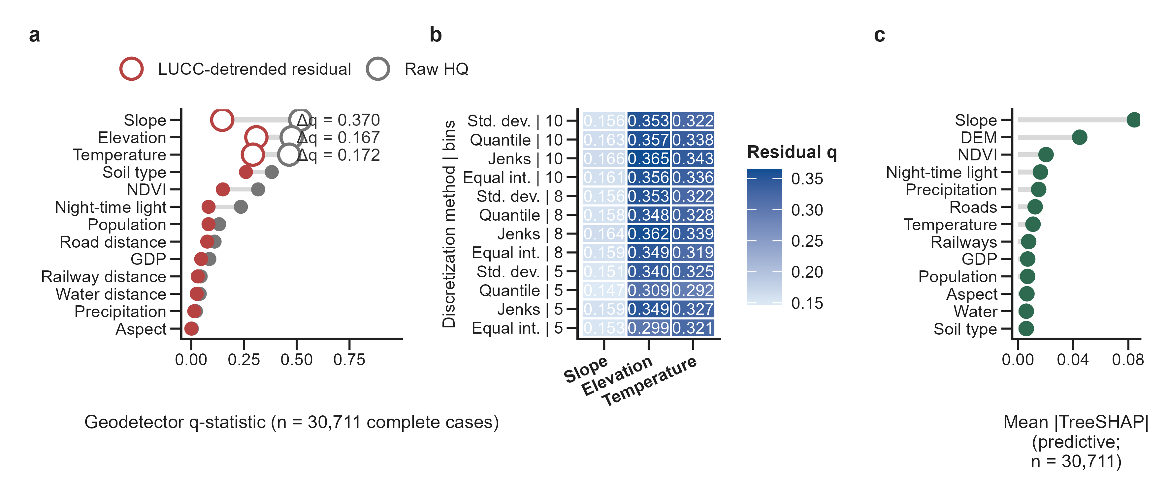
Fig. 6. Driver attribution of HQ variance and sensitivity to land-cover detrending. (a) Paired raw-to-residual Geodetector q-statistics for 13 factors (n = 30,711 complete cases) before and after LUCC detrending; top-3 attenuation Δq (ordered by raw q): Slope 0.370, Elevation 0.167, Temperature 0.172. (b) Residual-q sensitivity across four discretization methods (quantile, equal-interval, Jenks, standard-deviation) × three bin counts (5, 8, 10) for the three leading factors. (c) Mean |TreeSHAP| from the XGBoost model of HQ on thirteen exogenous factors (five-fold CV R² = 0.683); a predictive-attribution artifact.
Table 11. k-value sensitivity. k effect on the decomposition (Δη²).
k | η² | Between-class % | Within-class %
0.1 | 0.144 | 14.4 | 85.6
0.30 | 0.586 | 58.6 | 41.4
0.5 | 0.886 | 88.6 | 11.4
1.0 | 0.994 | 99.4 | 0.6
1.6 | 0.999 | 99.9 | 0.1
2.0 | 1.000 | ~100 | <0.1
2.5 | 1.000 | ~100 | <0.1
2.8 | 1.000 | ~100 | <0.1
5.0 | 1.000 | ~100 | <0.1

4.8 Policy Implications
The variance decomposition has direct policy relevance. Conservation planning traditionally focuses on “how much” of each land cover type to protect. Within the InVEST framework, 88.6% of HQ variance is already aligned with aggregate land cover proportions. The remaining 11.4%, the neighborhood configuration component, is where spatial planning can meaningfully improve outcomes for a fixed land cover composition (Lü et al., 2012).

5. Discussion
An η² of 0.886 shows that most HQ variance is structural rather than stochastic, and that the collapse of the slope driver from q = 0.517 to q = 0.147 accounts for much of the apparent driver power reported in conventional analyses. The persistence of elevation and temperature as the factors retaining the strongest residual explanatory power suggests that these topographic and climatic factors provide the fundamental “scaffolding” for habitat quality, even when land cover types vary.
Read as a variance partition, η² is the one-way analogue of the variance fractions used in ecological variation partitioning (Borcard et al., 1992; Peres-Neto et al., 2006), with explanatory matrices replaced by the land-cover stratification that InVEST itself imposes. The 88.6% between-class share is therefore not an empirical property of the Yuexi landscape but a property of the model's construction, and any workflow that routes raw InVEST HQ into a driver-attribution step inherits it. Reporting η² is diagnostic rather than descriptive: it states how much of the subsequent attribution is already implied by the habitat-suitability lookup table before any covariate is fitted.
Land cover sets the primary identity of HQ, while the within-class configuration (e.g., forest's CV of 16.4%) shapes local variation in habitat suitability. The temporal stability of η² (0.880–0.943) across 2010–2025 indicates that the decomposition itself is robust. Parameter selection matters: the variance structure is sensitive to k, which can be tuned to balance local and global variance components.
Because the habitat-suitability lookup table defines the InVEST HQ module, structural dominance of this magnitude should be expected wherever the module is applied. HQ has been used to track habitat change in watersheds and forest biosphere reserves (Berta Aneseyee et al., 2020; Mengist et al., 2021), to support conservation planning in Mediterranean catchments (Terrado et al., 2016), to couple cellular-automata land-use scenarios with habitat assessment (He et al., 2017), and to map habitat quality across rapidly urbanizing regions of southern China (Wu et al., 2021; Zhang et al., 2026). In each of these settings the between-class share is set by the class-specific Hj values rather than by landscape ecology, so the audit is portable across applications even though the specific η² value is not.
In practical terms, the audit-and-sensitivity workflow allows researchers to move beyond simple “dominant factor” claims and instead quantify the association retained by exogenous variables after land-cover adjustment. The residual association of topographic and climatic factors can therefore be separated from the structural component that the habitat-suitability lookup table imposes. Applied consistently, this audit-and-sensitivity sequence is a reusable diagnostic template for habitat-quality driver studies in both natural and anthropogenically modified landscapes, although its transferability to other InVEST modules remains to be tested.
The temporal behavior of η² should likewise be read as stability of the parameterization rather than as ecological stability. Mean HQ declined from 0.414 in 2010 to 0.405 in 2020 while η² held near 0.88, which is the expected signature of a land-cover map reorganising without changing the proportion of variance the lookup table can explain (Table 5). The higher projected value for 2025 (0.943) reflects sharper between-class contrasts in the projected land-cover map rather than a change in the underlying process.

5.1 Implications for InVEST-Based Driver Attribution Studies
The η² of 0.886 has direct implications for the interpretation of Geodetector analyses applied to InVEST HQ outputs. When a Geodetector model identifies LUCC as the “dominant driver” of HQ (widely reported in the literature, q > 0.85), it is simply recovering the parameterization that was programmed into InVEST: H_cropland ≠ H_forest ≠ H_water (Chen et al., 2023; He et al., 2019; Liu et al., 2020; Liu et al., 2024; Yesuph and Dagnew, 2019).
A partial exception arises when land cover enters not as a single categorical factor but as a set of configuration metrics (McGarigal and Marks, 1995): the resulting q-statistics then describe the arrangement of land cover rather than its identity, so the tautology is weaker, although the metrics remain derived from the same map that InVEST used. The diagnostic proposed here is agnostic to that choice. Whatever the factor set, η² establishes the share of HQ variance that is fixed before those factors are introduced.
The apparent “explanatory power” of topographic variables (DEM, slope) in raw Geodetector analyses reflects a mediated pathway: topography constrains where anthropogenic threat sources (especially built-up land) are located, which in turn determines neighborhood threat exposure for nearby pixels of the same land cover type. Our two-stage Geodetector makes this mediation quantitative: once HQ is detrended for land-cover class means, the apparent dominance of slope collapses from q = 0.517 to q = 0.147, retaining 28.4% of its raw explanatory power, whereas elevation (0.476 → 0.309) and temperature (0.464 → 0.292) retain 64.8% and 62.9% respectively and rank highest on residual retention.
The within-class HQ residual correlation with DEM (r = 0.65) versus the near-zero correlation with precipitation (r = 0.10) independently corroborates this ranking. Slope's apparent influence is thus largely a spatial-configuration artifact operating within the 11.4% within-class component, not a direct topographic control on habitat quality.
This is not an argument that land-cover-aligned attribution is uninformative. Studies that identify the drivers of ecosystem-service bundles (Chen et al., 2020), that trace habitat-quality trajectories alongside land-use change in mountain regions (Yang, 2021), and that project habitat quality under alternative development pathways (Wu et al., 2022) all legitimately report land cover among the leading factors. Our claim is narrower and procedural: when the response variable is an InVEST output, the leading factor is arithmetically predetermined, and the share of variance it captures can be quantified before any attribution is attempted.
We therefore recommend that future InVEST-Geodetector studies: (1) report η² as a diagnostic to quantify the dominance of the structural effect; (2) disaggregate LUCC from the exogenous variable set rather than reporting it as a “driver”; and (3) apply a two-stage Geodetector that recomputes q-statistics on within-class (land-cover-detrended) HQ residuals, so that drivers retaining explanatory power after adjustment are separated from those whose apparent influence is largely aligned with land-cover distribution. This protocol is conceptually related to variation partitioning in ecology (Borcard et al., 1992; Peres-Neto et al., 2006). Because attribution applied to raw InVEST outputs can inherit the land-cover confounding documented here, the diagnostic-and-adjustment sequence can serve as a preprocessing step before subsequent attribution analyses.
For planning, the practical consequence is a shift of emphasis. Because 88.6% of HQ variance is fixed by land-cover composition, interventions that only redistribute land-cover classes move HQ predictably but leave the configuration component untouched, whereas interventions that target the within-class component operate on the 11.4% that the model leaves free. Large-scale land-cover restoration has repeatedly been shown to shift the level of ecosystem-service provision (Lü et al., 2012), and ecological security planning is used to target the spatial arrangement of that provision (Peng et al., 2018; Zhang et al., 2017). The decomposition supplies the arithmetic for judging which of the two levers a given intervention actually pulls.
Concretely, the 0.249 HQ difference between lowest and highest threat-exposure quartiles represents a theoretical upper bound for spatial configuration effects within the InVEST model framework, rather than a guaranteed ecological gain. This value quantifies the maximum within-class variance attributable to threat-source proximity under the Euclidean distance assumption. Policy interventions targeting spatial configuration should be evaluated by their ability to mitigate the model-identified configuration risk rather than by absolute InVEST HQ gains. Under the ECP scenario, where spatial configuration is partially preserved, this risk is maintained rather than amplified, supporting the value of spatially-aware land-use planning.
The same arithmetic bounds the interpretation of the scenario results. Under BAU, COO, and CPL the between-class share rises above the 2020 baseline (Table 8), which is a statement about how the projected land-cover maps distribute area among classes rather than a statement about future ecological risk. Scenario η² values should therefore be read as properties of the scenario definition and compared against the observed baseline rather than against each other.

5.2 Interpreting the Within-Class Component
The decomposition proved robust to all three independent checks, HS perturbation, spatial thinning, and k-variation (Section 4.7). The remaining within-class component, however, must be interpreted with care.
The three checks are worth distinguishing. The Monte Carlo perturbation addresses the sensitivity-table scores, the thinning experiment addresses spatial dependence, and the k analysis addresses the half-saturation constant; each targets a different link in the InVEST calculation, and only the last alters the between/within split materially. That asymmetry is itself informative: the 88.6% share is robust to uncertainty in the scores and to spatial sampling, but not to the parameter that governs how quickly degradation saturates, so an honest report of η² requires the k value to be stated alongside it.
Euclidean Distance Reductionism. We caution that the 11.4% within-class variance component should not be naively equated with “ecological neighborhood effects.” The InVEST model computes threat degradation using isotropic Euclidean distance transforms that ignore terrain barriers, prevailing wind direction, and hydrological connectivity. In mountainous terrain, two forest pixels at identical Euclidean distances from a road may experience fundamentally different ecological stress. The “spatial configuration effect” quantified here is a Model Configuration Effect, an upper bound on potential improvement achievable through spatial planning within the InVEST framework. We recommend that future studies replace Euclidean distance decay with least-cost path distance based on MCR (Minimum Cumulative Resistance) models that incorporate topographic impedance (Peng et al., 2019).
The within-class component should also be read against the wider evidence that spatial arrangement, and not only habitat amount, governs ecological outcomes. Fragmentation effects can persist for decades after the amount of habitat stabilises (Haddad et al., 2015), cumulative human pressure is a global driver of habitat degradation (Venter et al., 2016), and freshwater systems are especially responsive to the configuration of adjacent land (Strayer and Dudgeon, 2010). InVEST HQ captures only a Euclidean-distance approximation of that arrangement, which is why the 11.4% is treated here as a model-configuration bound rather than as an ecological effect size.

5.3 Limitations
Our workflow is specific to the InVEST HQ formulation and the Yuexi parameterization. Different threat-source configurations (e.g., adding roads as threat sources), different half-saturation constants, or landscapes with more heterogeneous threat distributions would alter the between/within split. The two-stage adjustment also assumes that land-cover class means capture the dominant structural signal and that the residual q-statistics are interpreted as net-exogenous associations, rather than causal effects (Gao et al., 2023). Nonetheless, the methodological principle, diagnosing structural dominance by variance decomposition and then recomputing driver attribution on detrended residuals, is broadly applicable; our workflow should be understood as a sensitivity template, not a fixed partitioning.
Three further qualifications follow from the protocol itself. First, Geodetector results depend on how continuous predictors are discretized; we therefore report four discretization methods crossed with three bin counts (Section 4.7) instead of a single scheme, and elevation and temperature retained the top two residual ranks in all twelve combinations. Second, q-statistic significance is not corrected for spatial dependence, and the residual Moran's I of the complete-case subset remains substantial (0.607), so the p-values in Section 4.7 are descriptive rather than inferential; block-permutation or spatially constrained inference is the appropriate remedy (Griffith, 2003), and formal causal identification would require machinery beyond cross-sectional geographical data (Gao et al., 2023). A third limitation is scope: the workflow is demonstrated for a single InVEST module in a single subtropical monsoon region, and its transferability to other ecosystem-service models and other physiographic settings remains untested.

6. Conclusions
The audit-and-sensitivity workflow developed here separates land-cover-aligned structure from exogenous variables in InVEST Habitat Quality (HQ) analysis. Variance decomposition showed that 88.6% of HQ variance is between-class, while the remaining 11.4% captures within-class spatial configuration. The two-stage Geodetector adjustment quantified how much of each factor's apparent explanatory power survives land-cover detrending, and elevation and temperature retain the strongest residual associations with HQ heterogeneity.
The findings offer three recommendations: (1) report η² to quantify the structural dominance of land cover; (2) use land-cover-detrended residuals to quantify the residual explanatory power of topographic variables; and (3) identify configuration-sensitive classes (e.g., forest) to prioritize local habitat conservation. The workflow provides a sensitivity protocol for assessing habitat quality in land-cover-parameterized InVEST outputs.

Data Availability
All spatial point datasets, regression models, R/Python analytical scripts, and InVEST model parameter files supporting this study are openly available in the GitHub repository (https://github.com/shiqikuangsan31/yuexi_hq_audit) and will be archived on Zenodo with a DOI upon acceptance. Full computational provenance for the analysis pipeline is archived with verified SHA-256 hashes of input rasters, intermediate spatial point tables (n = 31,889 full domain; n = 30,711 complete cases with projected planar coordinates), official InVEST outputs, and run logs.

Conflict of Interest
The authors declare no conflict of interest.

Funding
This research received no external funding.

Acknowledgment
We thank the Resource and Environment Science and Data Center, Chinese Academy of Sciences, and the Natural Capital Project team for providing the public datasets and open-source InVEST software platform.

References
Anselin, L., 1995. Local indicators of spatial association: LISA. Geographical Analysis, 27(2), 93–115. https://doi.org/10.1111/j.1538-4632.1995.tb00338.x
Berta Aneseyee, A., Noszczyk, T., Soromessa, T., Elias, E., 2020. The InVEST Habitat Quality Model Associated with Land Use/Cover Changes: A Qualitative Case Study of the Winike Watershed in the Omo-Gibe Basin, Southwest Ethiopia. Remote Sensing, 12(7), 1103. https://doi.org/10.3390/rs12071103
Borcard, D., Legendre, P., Drapeau, P., 1992. Partialling out the spatial component of ecological variation. Ecology 73, 1045–1055. https://doi.org/10.2307/1940179
Chen, S., Tan, Z., Mu, S., Wang, J., Chen, Y., He, X., 2023. Synergy level of pollution and carbon reduction in the Yangtze River Economic Belt: Spatial-temporal evolution characteristics and driving factors. Sustainable Cities and Society, 98, 104859. https://doi.org/10.1016/j.scs.2023.104859
Chen, T., Feng, Z., Zhao, H., Wu, K., 2020. Identification of ecosystem service bundles and driving factors in Beijing and its surrounding areas. Science of The Total Environment, 711, 134687. https://doi.org/10.1016/j.scitotenv.2019.134687
Chen, Y., 2013. New Approaches for Calculating Moran’s Index of Spatial Autocorrelation. PLoS ONE, 8(7), e68336. https://doi.org/10.1371/journal.pone.0068336
Feng, R., Wang, F., Wang, K., Xu, S., 2021. Quantifying influences of anthropogenic-natural factors on ecological land evolution in mega-urban agglomeration: A case study of Guangdong-Hong Kong-Macao greater Bay area. Journal of Cleaner Production, 283, 125304. https://doi.org/10.1016/j.jclepro.2020.125304
Fu, W. J., Jiang, P. K., Zhou, G. M., Zhao, K. L., 2014. Using Moran's I and GIS to study the spatial pattern of forest litter carbon density in a subtropical region of southeastern China. Biogeosciences, 11(8), 2401–2409. https://doi.org/10.5194/bg-11-2401-2014
Gao, B., Yang, J., Chen, Z., Sugihara, G., Li, M., Stein, A., Kwan, M.-P., Wang, J., 2023. Causal inference from cross-sectional earth system data with geographical convergent cross mapping. Nature Communications, 14, 5875. https://doi.org/10.1038/s41467-023-41619-6
Geng, J., Yu, K., Xie, Z., Zhao, G., Ai, J., Yang, L., Yang, H., Liu, J., 2022. Analysis of Spatiotemporal Variation and Drivers of Ecological Quality in Fuzhou Based on RSEI. Remote Sensing, 14(19), 4900. https://doi.org/10.3390/rs14194900
Griffith, D. A., 2003. Spatial Autocorrelation and Spatial Filtering: Gaining Understanding Through Theory and Scientific Visualization. Springer-Verlag. https://doi.org/10.1007/978-3-540-24806-4
Guo, H., Cai, Y., Yang, Z., Zhu, Z., Ouyang, Y., 2021. Dynamic simulation of coastal wetlands for Guangdong-Hong Kong-Macao Greater Bay area based on multi-temporal Landsat images and FLUS model. Ecological Indicators, 125, 107559. https://doi.org/10.1016/j.ecolind.2021.107559
Guo, J., Zhang, F., Zhao, H., Pan, B., Mei, L., 2023. Reconstructed Three-decade Global Fine-Grained Nighttime Light Dataset (1992–2021) [Data set]. Zenodo. https://doi.org/10.5281/zenodo.15845676
Haddad, N. M., Brudvig, L. A., Clobert, J., Davies, K. F., Gonzalez, A., Holt, R. D., Lovejoy, T. E., Sexton, J. O., Austin, M. P., Collins, C. D., Cook, W. M., Damschen, E. I., 2015. Habitat fragmentation and its lasting impact on Earth’s ecosystems. Science Advances, 1(2), e1500052. https://doi.org/10.1126/sciadv.1500052
He, J., Huang, J., Li, C., 2017. The evaluation for the impact of land use change on habitat quality: A joint contribution of cellular automata scenario simulation and habitat quality assessment model. Ecological Modelling, 366, 58–67. https://doi.org/10.1016/j.ecolmodel.2017.10.001
He, J., Pan, Z., Liu, D., Guo, X., 2019. Exploring the regional differences of ecosystem health and its driving factors in China. Science of The Total Environment, 673, 553–564. https://doi.org/10.1016/j.scitotenv.2019.03.465
Liu, C., Li, W., Zhu, G., Zhou, H., Yan, H., Xue, P., 2020. Land Use/Land Cover Changes and Their Driving Factors in the Northeastern Tibetan Plateau Based on Geographical Detectors and Google Earth Engine: A Case Study in Gannan Prefecture. Remote Sensing, 12(19), 3139. https://doi.org/10.3390/rs12193139
Liu, Q., Qiao, J., Li, M., Huang, M., 2024. Spatiotemporal heterogeneity of ecosystem service interactions and their drivers at different spatial scales in the Yellow River Basin. Science of The Total Environment, 908, 168486. https://doi.org/10.1016/j.scitotenv.2023.168486
Lü, Y., Fu, B., Feng, X., Zeng, Y., Liu, Y., Chang, R., Sun, G., Wu, B., 2012. A Policy-Driven Large Scale Ecological Restoration: Quantifying Ecosystem Services Changes in the Loess Plateau of China. PLoS ONE, 7(2), e31782. https://doi.org/10.1371/journal.pone.0031782
Luo, Q., Zhang, J., Bao, Y., Zhang, Y., Yu, J., Li, J., Wu, X., Zhang, S., Cao, N., Wang, D., 2025. Multi-scenario simulation of land use optimization based on ecosystem services and ecological security patterns in the Liaohe River Basin. Frontiers in Environmental Science, 13, 1647039. https://doi.org/10.3389/fenvs.2025.1647039
McGarigal, K., Marks, B. J., 1995. FRAGSTATS: Spatial pattern analysis program for quantifying landscape structure. General Technical Report PNW-GTR-351. USDA Forest Service, Pacific Northwest Research Station. https://doi.org/10.2737/pnw-gtr-351
Mengist, W., Soromessa, T., Feyisa, G. L., 2021. Landscape change effects on habitat quality in a forest biosphere reserve: Implications for the conservation of native habitats. Journal of Cleaner Production, 329, 129778. https://doi.org/10.1016/j.jclepro.2021.129778
Natural Capital Project, 2024. InVEST 3.14.3. Stanford University, University of Minnesota, Chinese Academy of Sciences, The Nature Conservancy, World Wildlife Fund, Stockholm Resilience Centre and the Royal Swedish Academy of Sciences. https://naturalcapitalproject.stanford.edu/software/invest
Peng, J., Pan, Y., Liu, Y., Zhao, H., Wang, Y., 2018. Linking ecological degradation risk to identify ecological security patterns in a rapidly urbanizing landscape. Habitat International, 71, 110–124. https://doi.org/10.1016/j.habitatint.2017.11.010
Peng, J., Zhao, S., Dong, J., Liu, Y., Meersmans, J., Li, H., Wu, J., 2019. Applying ant colony algorithm to identify ecological security patterns in megacities. Environmental Modelling &amp; Software, 117, 214–222. https://doi.org/10.1016/j.envsoft.2019.03.017
Peres-Neto, P. R., Legendre, P., Dray, S., Borcard, D., 2006. Variation partitioning of species data matrices: estimation and comparison of fractions. Ecology 87, 2614–2625. https://doi.org/10.1890/0012-9658(2006)87[2614:VPOSDM]2.0.CO;2
Pu, J., Shen, A., Liu, C., Wen, B., 2024. Impacts of ecological land fragmentation on habitat quality in the Taihu Lake basin in Jiangsu Province, China. Ecological Indicators, 158, 111611. https://doi.org/10.1016/j.ecolind.2024.111611
Resource and Environment Science and Data Center (RESDC), 2025. China annual average meteorological elements dataset, 1960–2025 (1 km, Albers projection) [Data set]. www.resdc.cn (DATAID 378).
Strayer, D. L., Dudgeon, D., 2010. Freshwater biodiversity conservation: recent progress and future challenges. Journal of the North American Benthological Society, 29(1), 344–358. https://doi.org/10.1899/08-171.1
Terrado, M., Sabater, S., Chaplin-Kramer, B., Mandle, L., Ziv, G., Acuña, V., 2016. Model development for the assessment of terrestrial and aquatic habitat quality in conservation planning. Science of The Total Environment, 540, 63–70. https://doi.org/10.1016/j.scitotenv.2015.03.064
Venter, O., Sanderson, E. W., Magrach, A., Allan, J. R., Beher, J., Jones, K. R., Possingham, H. P., Laurance, W. F., Wood, P., Fekete, B. M., Levy, M. A., Watson, J. E. M., 2016. Sixteen years of change in the global terrestrial human footprint and implications for biodiversity conservation. Nature Communications, 7(1), 12558. https://doi.org/10.1038/ncomms12558
Wang, J. F., Li, X. H., Christakos, G., Liao, Y. L., Zhang, T., Gu, X., Zheng, X. Y., 2010. Geographical detectors-based health risk assessment and its application in the neural tube defects study of the Heshun Region, China. International Journal of Geographical Information Science, 24(1), 107–127. https://doi.org/10.1080/13658810802443457
Wang, J. F., Hu, Y., 2012. Environmental health risk detection with GeogDetector. Environmental Modelling and Software, 33, 114–115. https://doi.org/10.1016/j.envsoft.2012.01.015
Wu, J., Luo, J., Zhang, H., Qin, S., Yu, M., 2022. Projections of land use change and habitat quality assessment by coupling climate change and development patterns. Science of The Total Environment, 847, 157491. https://doi.org/10.1016/j.scitotenv.2022.157491
Wu, L., Sun, C., Fan, F., 2021. Estimating the characteristic spatiotemporal variation in habitat quality using the InVEST model - A case study from Guangdong-Hong Kong-Macao Greater Bay Area. Remote Sensing, 13(5), 1008. https://doi.org/10.3390/rs13051008
Xu, X., 2022. China 30 m annual maximum NDVI dataset [Data set]. Resource and Environment Science and Data Center, Institute of Geographic Sciences and Natural Resources Research, Chinese Academy of Sciences. DOI:10.12078/2022030801.
Yang, Y., 2021. Evolution of habitat quality and association with land-use changes in mountainous areas: A case study of the Taihang Mountains in Hebei Province, China. Ecological Indicators, 129, 107967. https://doi.org/10.1016/j.ecolind.2021.107967
Yesuph, A. Y., Dagnew, A. B., 2019. Land use/cover spatiotemporal dynamics, driving forces and implications at the Beshillo catchment of the Blue Nile Basin, North Eastern Highlands of Ethiopia. Environmental Systems Research, 8(1). https://doi.org/10.1186/s40068-019-0148-y
Zhang, L., Peng, J., Liu, Y., Wu, J., 2017. Coupling ecosystem services supply and human ecological demand to identify landscape ecological security pattern: A case study in Beijing–Tianjin–Hebei region, China. Urban Ecosystems, 20(3), 701–714. https://doi.org/10.1007/s11252-016-0629-y
Zhang, X., Li, X., Zhao, H., Li, J., Zhao, Z., Wu, J., Zhao, W., 2026. Spatiotemporal variation, multi-scenario simulation, driving factors analysis of habitat quality based on FLUS-InVEST and Geodetector models for Beijing-Tianjin-Hebei, China. Scientific Reports, 16, 537. https://doi.org/10.1038/s41598-025-30075-5

