## TOMCAT

### SAP发送订单给MES 测试环境 在30.62 上；

### 备份配置文件



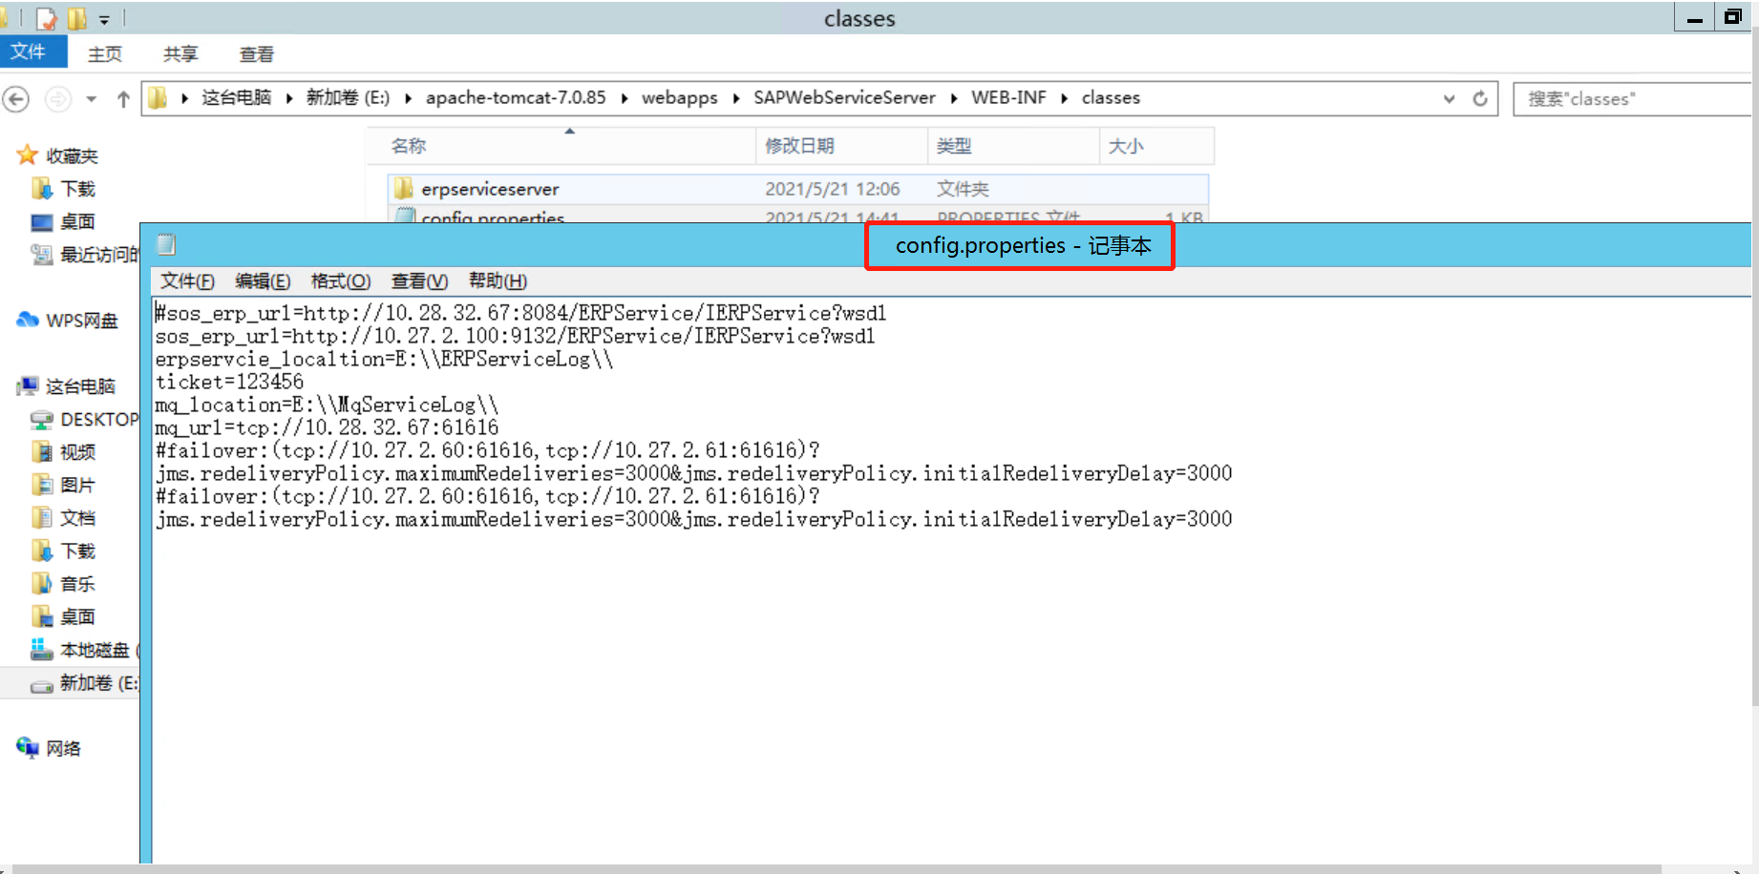

### 备份原来的war包

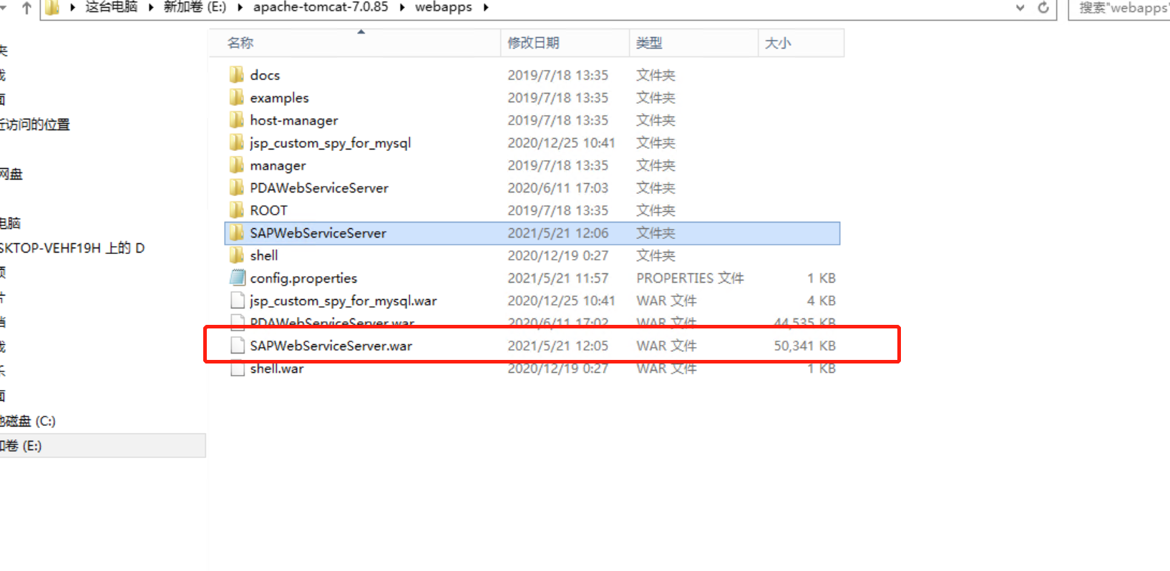

### 将备份的war包放置到svn上；

### 拿到源代码修改并达成war包；

### 用新的war替代原来的war

### 用备份的配置文件替代新的配置文件

### 重启tomcat

### 用soupUI工具测试接口联调性

http://10.27.2.62:8132/ERPService/IERPService



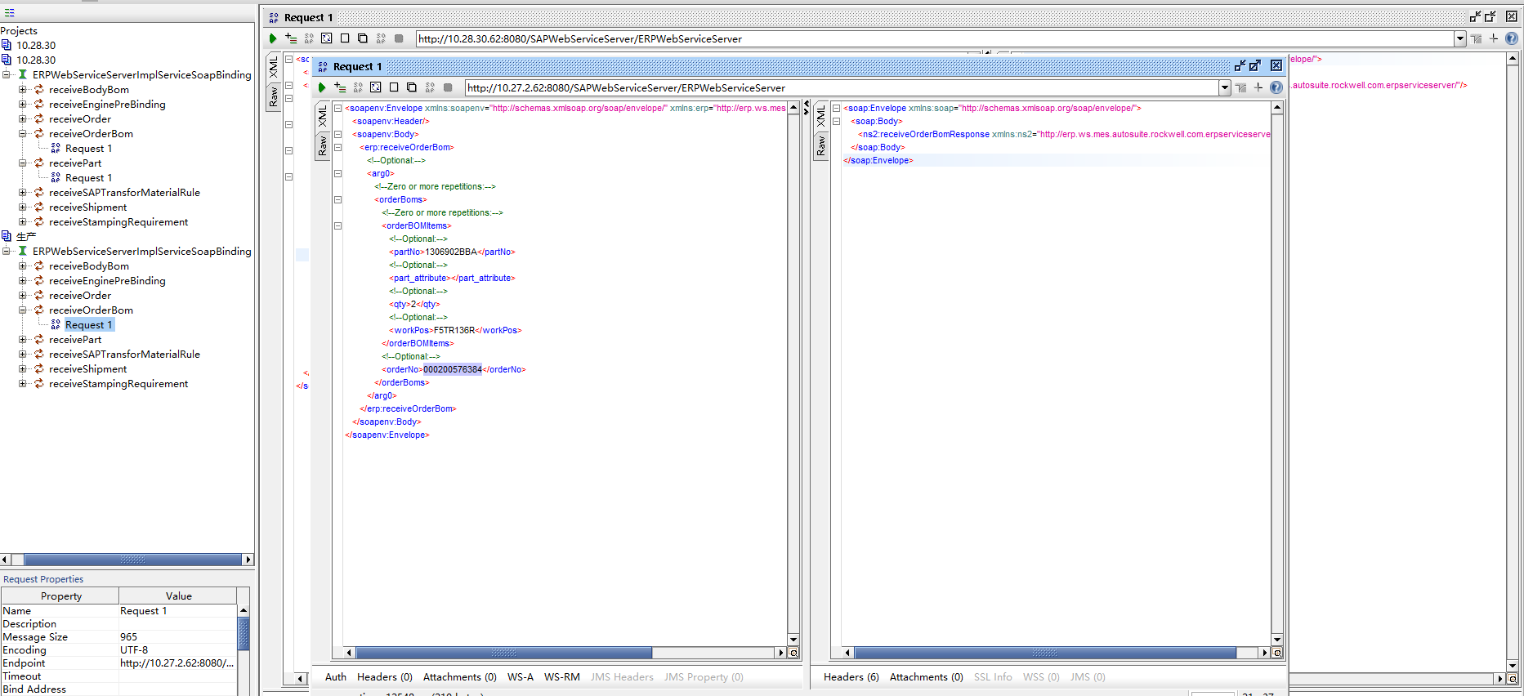

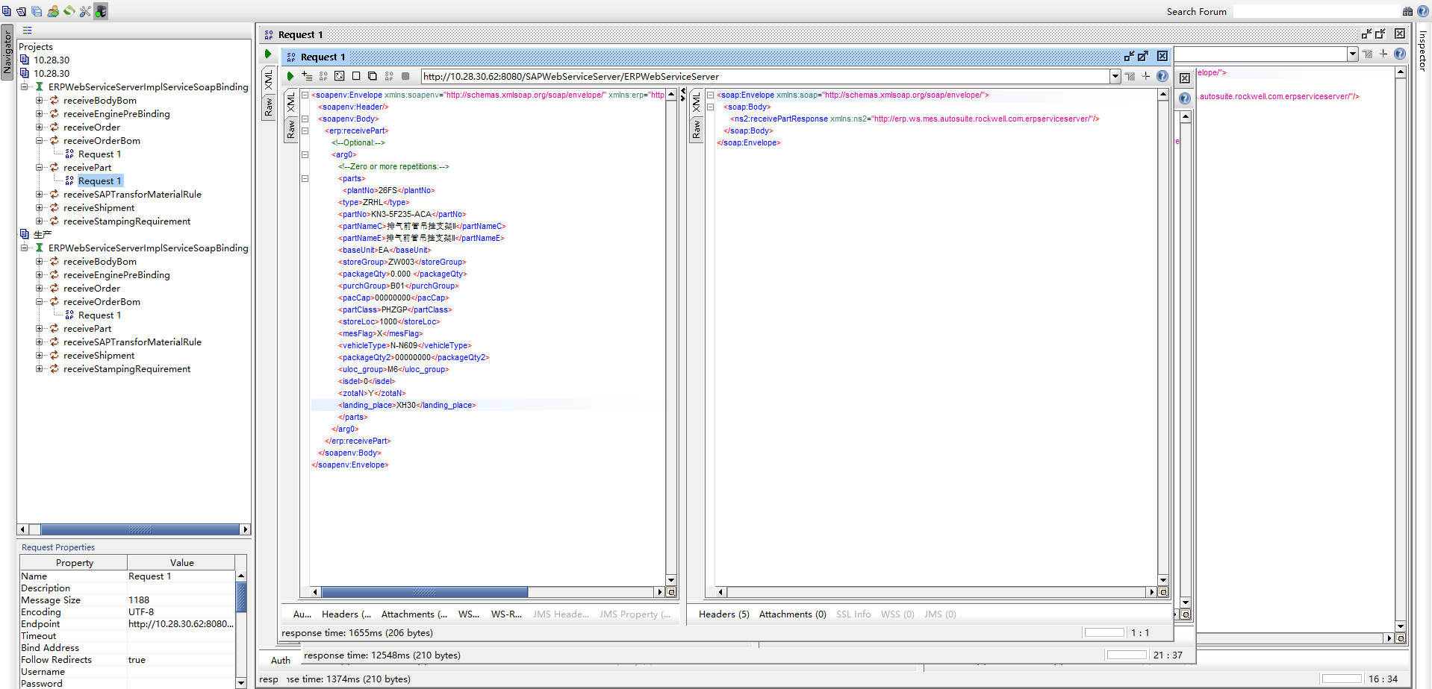

#### 物料

<soapenv:Envelope xmlns:soapenv="http://schemas.xmlsoap.org/soap/envelope/" xmlns:erp="http://erp.ws.mes.autosuite.rockwell.com.erpserviceserver/">

<soapenv:Header/>

<soapenv:Body>

<erp:receivePart>

<!--Optional:-->

<arg0>

<!--Zero or more repetitions:-->

<parts>

<!--Optional:-->

<plantNo>26FS</plantNo>

<type>ZRHL</type>

<partNo>KS1-V43150-BA</partNo>

<partNameC>尾门自吸锁总成</partNameC>

<partNameE>尾门自吸锁总成</partNameE>

<baseUnit>EA</baseUnit>

<storeGroup>ZW001</storeGroup>

<packageQty>512.000 </packageQty>

<purchGroup>B01</purchGroup>

<exStorageNo>1002</exStorageNo>

<pacCap>00000000</pacCap>

<partClass>PGFGP</partClass>

<storeLoc>1000</storeLoc>

<mesFlag>X</mesFlag>

<mrpControl>Z17</mrpControl>

<vehicleType>CX756</vehicleType>

<packageQty2>00000000</packageQty2>

<MRPGROUP>1001</MRPGROUP>

<uloc_group>T2</uloc_group>

<isdel>0</isdel>

<zotaN>Y</zotaN>

<landing_place>XH34</landing_place>

</parts>

</arg0>

</erp:receivePart>

</soapenv:Body>

</soapenv:Envelope>

#### orderBom

<soapenv:Envelope xmlns:soapenv="http://schemas.xmlsoap.org/soap/envelope/" xmlns:erp="http://erp.ws.mes.autosuite.rockwell.com.erpserviceserver/">

<soapenv:Header/>

<soapenv:Body>

<erp:receiveOrderBom>

<!--Optional:-->

<arg0>

<!--Zero or more repetitions:-->

<orderBoms>

<!--Zero or more repetitions:-->

<orderBOMItems>

<!--Optional:-->

<partNo>?</partNo>

<!--Optional:-->

<part_attribute>?</part_attribute>

<!--Optional:-->

<qty>?</qty>

<!--Optional:-->

<workPos>?</workPos>

</orderBOMItems>

<!--Optional:-->

<orderNo>?</orderNo>

</orderBoms>

</arg0>

</erp:receiveOrderBom>

</soapenv:Body>

</soapenv:Envelope>

### 查看本地文件是否生成xml

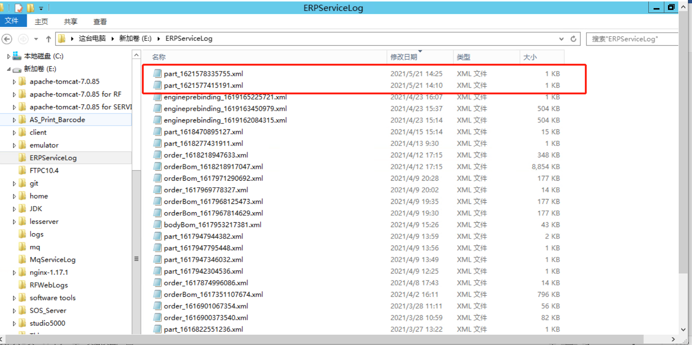

### 查看给les有无转发

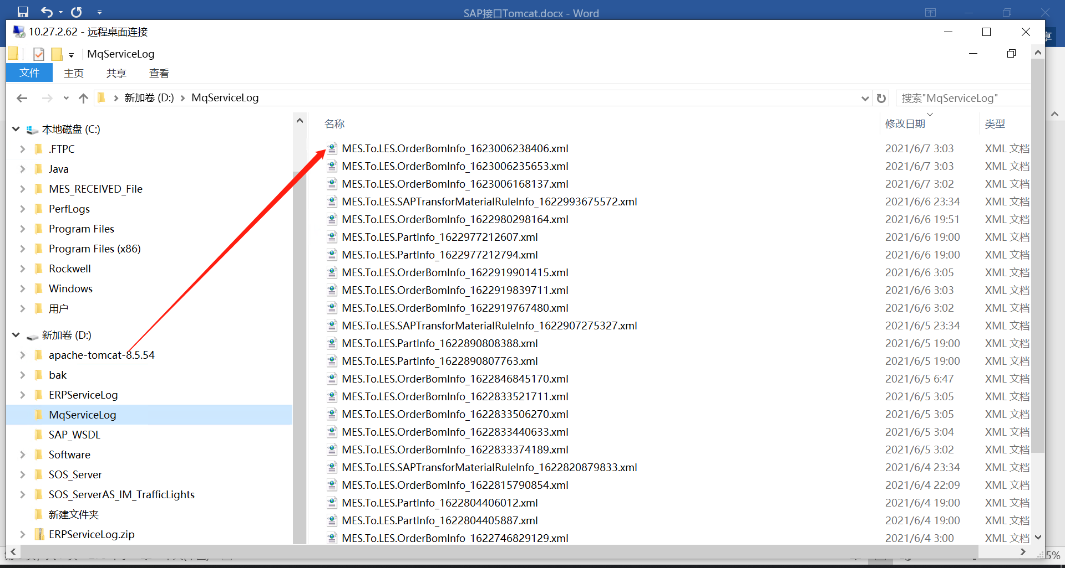

### 查看有没有MES生成本地文件

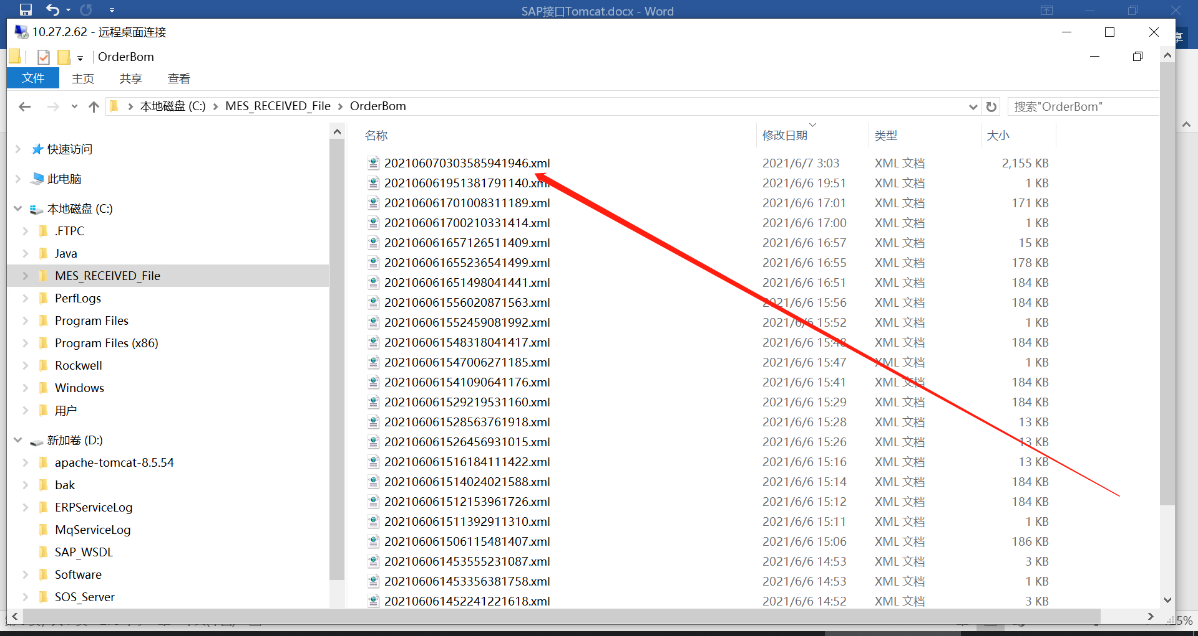

## 测试环境 30.62

## 生产环境 2.62

### 后期需要将生产环境上的配置文件中的

sos_erp_url=http://10.27.2.62:8132/ERPService/IERPService?wsdl

改成2.59

