## 打开BDC服务 2.63

## 查看BDC服务日志

### VIN在库中不存在

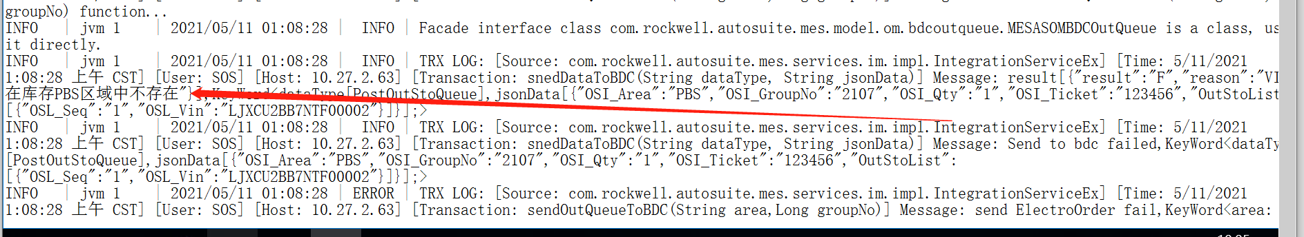

#### 联系天奇去核对该车辆是否在库中

### 网络问题

#### 日志报错：

System.Data.SqlClient.SqlException (0x80131904): A network-related or instance-specific error occurred while establishing a connection to SQL Server. The server was not found or was not accessible. Verify that the instance name is correct and that SQL Server is configured to allow remote connections. (provider: Named Pipes Provider, error: 40 - Could not open a connection to SQL Server) ---> System.ComponentModel.Win32Exception (2): 系统找不到指定的文件。

### 分组号重复

INFO | jvm 1 | 2021/05/08 13:43:21 | ERROR | TRX LOG: [Source: com.rockwell.autosuite.mes.services.im.impl.IntegrationServiceEx] [Time: 5/8/2021 1:43:21 下午 CST] [User: SOS] [Host: 10.27.2.63] [Transaction: sendOutQueueToBDC(String area,Long groupNo)] Message: send ElectroOrder fail,KeyWord<area:[WBS],groupNo:[2347]>,ERROR INFO:Unknown Exception : Send to bdc failed,KeyWord<dataType[PostOutStoQueue],jsonData[{"OSI_Area":"WBS","OSI_GroupNo":"2347","OSI_Qty":"3","OSI_Ticket":"123456","OutStoList":[{"OSL_Seq":"3","OSL_Vin":"LJXCU2BBXMTF00607"},{"OSL_Seq":"4","OSL_Vin":"LJXCU2BB1MTF00608"},{"OSL_Seq":"5","OSL_Vin":"LJXCU2BB3MTF00609"}]}];>,reason[该区域的分组号已存在]

#### 与天奇核对这组队列中那几台车已经接收到 那几台没有接收到；并确定那几辆车未发送成功；

#### 在AT_AS_OM_BDC_OutQueue中删除该组中未发送成功vin的车辆信息

delete from AT_AS_om_bdc_outqueue where 1=1 and area_s = 'WBS' and group_no_i = 1985 and vin_S = 'LJXCU3CB1MTP30182';

#### 通过组号中未发送的车辆信息VIN 在at_AS_OM_bdc_Stock中更新is_inqueue_y 字段值未0

update AT_AS_OM_bdc_stock set is_inqueue_y =0 where 1=1 and vin_s = 'LJXCU3CB1MTP30182'