importSubroutine("MES_Common_Base")

importSubroutine("MES_Common_Log")

importSubroutine("MES_Common_Configuration")

importSubroutine("MES_Common_Transaction")

importSubroutine("MES_Common_Log")

function beforeStart()

{

    function handleBeforeStartException(exception)

    {

        logException(MODULE_IM, exception)

        //log to DB

        logError(MODULE_IM, exception.getMessage(), getDBTime(), "EventSheet:AS_IM_CL", "Function:beforeStart")

    }

    catch(Exception, handleBeforeStartException)

    class [com.rockwell.mes.commons.base.ifc.services.PCContext::setEnvironment(environment](http://com.rockwell.mes.commons.base.ifc.services.pccontext::setEnvironment(environment/))

    //设置全局service

    integrationService = getIntegrationService()

    setProperty("INTEGRATIONSERVICE",integrationService)

    brokerURL = getEIGMessageBrokerUrl()

    println("eigbrokerurl: "+brokerURL)

    //send StmFrameInfo To Les

//     sendDeviceMperationModeToCL.getActivity().setBrokerUrl(brokerURL)

//     sendDeviceMperationModeToCL.getActivity().connect()

//     //接收方法

//     receiveDeviceMperationModeToCL.getActivity().setBrokerUrl(brokerURL)

//     receiveDeviceMperationModeToCL.getActivity().connect()

//     DeviceMperation = class com.rockwell.autosuite.mes.services.im.impl.InDeviceMperationMode()

//     receiveDeviceMperationModeToCL.getActivity().setReceiveProcess(DeviceMperation)

    //设备状态上传 receiveActivityCheckLineEquipStatus

//     receiveActivityCheckLineEquipStatus.getActivity().setBrokerUrl(brokerURL)

//     receiveActivityCheckLineEquipStatus.getActivity().connect()

//     CheckLineEquipStatus = class com.rockwell.autosuite.mes.services.im.impl.InDeviceStatusPut()

//     receiveActivityCheckLineEquipStatus.getActivity().setReceiveProcess(CheckLineEquipStatus)

//         //称重数据检测 com.rockwell.autosuite.mes.bo.im.transferweight.TransferWeightSet

//     receiveActivityCheckLineWeighing.getActivity().setBrokerUrl(brokerURL)

//     receiveActivityCheckLineWeighing.getActivity().connect()

//     WeightSet = class com.rockwell.autosuite.mes.services.im.impl.InWeighingDetection()

//     receiveActivityCheckLineWeighing.getActivity().setReceiveProcess(WeightSet)

//     //检测线各设备生产节拍  receiveActivityCheckLineEquipJPH

//     receiveActivityCheckLineEquipJPH.getActivity().setBrokerUrl(brokerURL)

//     receiveActivityCheckLineEquipJPH.getActivity().connect()

//     EquipmentBeat = class com.rockwell.autosuite.mes.services.im.impl.InCLEquipmentBeat()

//     receiveActivityCheckLineEquipJPH.getActivity().setReceiveProcess(EquipmentBeat)

//     //检测线总评结果  com.rockwell.autosuite.mes.services.im.impl.InCLOverallAppraisal

//     receiveActivityCheckLineOverAllRusult.getActivity().setBrokerUrl(brokerURL)

//     receiveActivityCheckLineOverAllRusult.getActivity().connect()

//     OverallAppraisal = class com.rockwell.autosuite.mes.services.im.impl.InCLOverallAppraisal()

//     receiveActivityCheckLineOverAllRusult.getActivity().setReceiveProcess(OverallAppraisal)

//     //OBD检测数据

//     receiveActivityCheckLineOBD.getActivity().setBrokerUrl(brokerURL)

//     receiveActivityCheckLineOBD.getActivity().connect()

//     Obd = class com.rockwell.autosuite.mes.services.im.impl.InObdDetection()

//     receiveActivityCheckLineOBD.getActivity().setReceiveProcess(Obd)

//     //Avm检测数据receiveActivityCheckLineAVM

//     receiveActivityCheckLineAVM.getActivity().setBrokerUrl(brokerURL)

//     receiveActivityCheckLineAVM.getActivity().connect()

//     avm = class com.rockwell.autosuite.mes.services.im.impl.InAvmDetection()

//     receiveActivityCheckLineAVM.getActivity().setReceiveProcess(avm)

//     //Adas检测数据 receiveActivityCheckLineAdas

//     receiveActivityCheckLineAdas.getActivity().setBrokerUrl(brokerURL)

//     receiveActivityCheckLineAdas.getActivity().connect()

//     adas = class com.rockwell.autosuite.mes.services.im.impl.InAdasDetection()

//     receiveActivityCheckLineAdas.getActivity().setReceiveProcess(adas)

//     //Brake 制动检测数据

//     receiveActivityCheckLineBrake.getActivity().setBrokerUrl(brokerURL)

//     receiveActivityCheckLineBrake.getActivity().connect()

//     brake = class com.rockwell.autosuite.mes.services.im.impl.InBrakeDetection()

//     receiveActivityCheckLineBrake.getActivity().setReceiveProcess(brake)

//     //动鼓检测数据 Drum

//     receiveActivityCheckLineDrum.getActivity().setBrokerUrl(brokerURL)

//     receiveActivityCheckLineDrum.getActivity().connect()

//     drum = class com.rockwell.autosuite.mes.services.im.impl.InDrumDetection()

//     receiveActivityCheckLineDrum.getActivity().setReceiveProcess(drum)

//     //四轮定位  FourWheelCalibration com.rockwell.autosuite.mes.bo.im.transferfourwheelalignment.TransferFourWheelAlignmentSet

//     receiveActivityCheckLineFourWheelCalibration.getActivity().setBrokerUrl(brokerURL)

//     receiveActivityCheckLineFourWheelCalibration.getActivity().connect()

//     FourWheelCalibration = class com.rockwell.autosuite.mes.services.im.impl.InCaFwdemarcate()

//     receiveActivityCheckLineFourWheelCalibration.getActivity().setReceiveProcess(FourWheelCalibration)

//     //大灯数据检测 Headlamp

//     receiveActivityCheckLineHeadlightDetection.getActivity().setBrokerUrl(brokerURL)

//     receiveActivityCheckLineHeadlightDetection.getActivity().connect()

//     Headlamp = class com.rockwell.autosuite.mes.services.im.impl.InHeadlightDetection()

//     receiveActivityCheckLineHeadlightDetection.getActivity().setReceiveProcess(Headlamp)

//     //称重数据检测 Weight

//     receiveActivityCheckLineWeighingDetection.getActivity().setBrokerUrl(brokerURL)

//     receiveActivityCheckLineWeighingDetection.getActivity().connect()

//     WeighingDetection = class com.rockwell.autosuite.mes.services.im.impl.InWeighingDetection()

//     receiveActivityCheckLineWeighingDetection.getActivity().setReceiveProcess(WeighingDetection)

//     //四轮定位 FourWheelAlignment com.rockwell.autosuite.mes.bo.im.transferfourwheelalignment.TransferFourWheelAlignmentSet

//     receiveActivityCheckLineClFwalignMent.getActivity().setBrokerUrl(brokerURL)

//     receiveActivityCheckLineClFwalignMent.getActivity().connect()

//     ClFwalignMent = class com.rockwell.autosuite.mes.services.im.impl.InClFwalignMent()

//     receiveActivityCheckLineClFwalignMent.getActivity().setReceiveProcess(ClFwalignMent)

}

function beforeStop()

{

//     sendDeviceMperationModeToCL.getActivity().shutdown()

//     receiveDeviceMperationModeToCL.getActivity().shutdown()

    rollbackAllUserTransaction()

}

//

// // send StmFrameInfo To Les

// function frmDeviceMperationModeToCL()

// {

// //     integrationService = getProperty("INTEGRATIONSERVICE")

// //     integrationService.sendStmFrameInfoToLesPnuts(sendDeviceMperationModeToCL.getActivity())

//     response = getIntegrationService().sendDeviceMperationModeToCLPnuts(sendDeviceMperationModeToCL.getActivity())

//     i=1

//     if(response.isError())

//     {

//         logException(MODULE_IM, response.getFirstErrorMessage())

//         logError(MODULE_IM,response.getFirstErrorMessage(),createTime(), eventsheet.getName(), "Function:frmDeviceMperationModeToCL")

//

//     }

// }

// // resend StmFrameInfo To Les

// function frmReDeviceMperationModeToCL()

// {

//     sendDeviceMperationModeToCL.getActivity().resendMessageFromLocalFile()

// }C:\Users\ADMINI~1\AppData\Local\Temp\enhtmlclip\YX00075580.pngC:\Users\ADMINI~1\AppData\Local\Temp\enhtmlclip\YX00075590.png

接口测试 ：

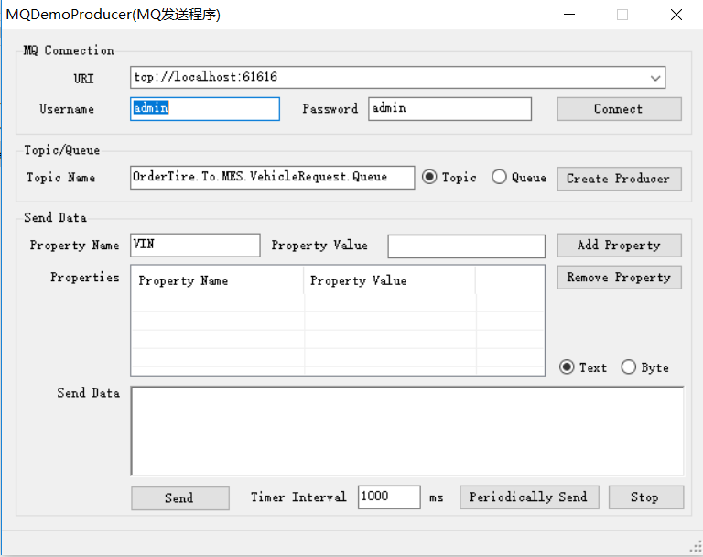

安装测试工具 ：

在sos 建立测试方法：

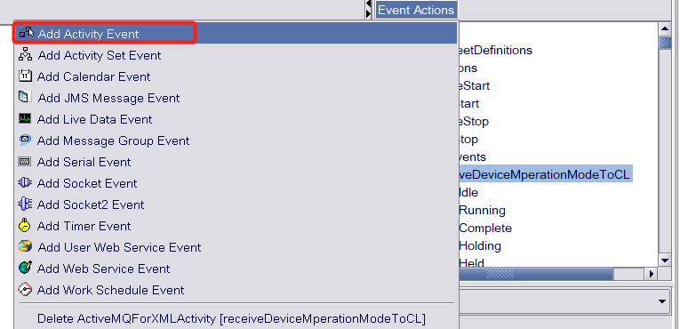

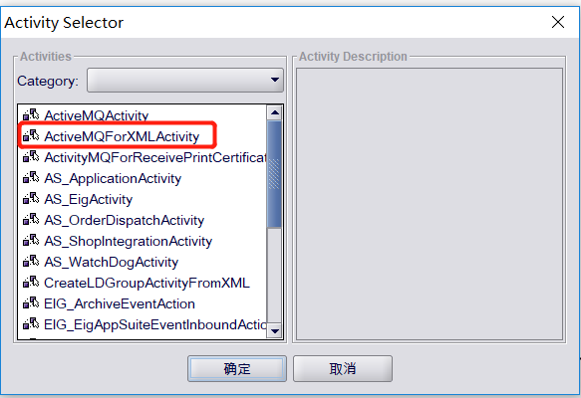

配置：

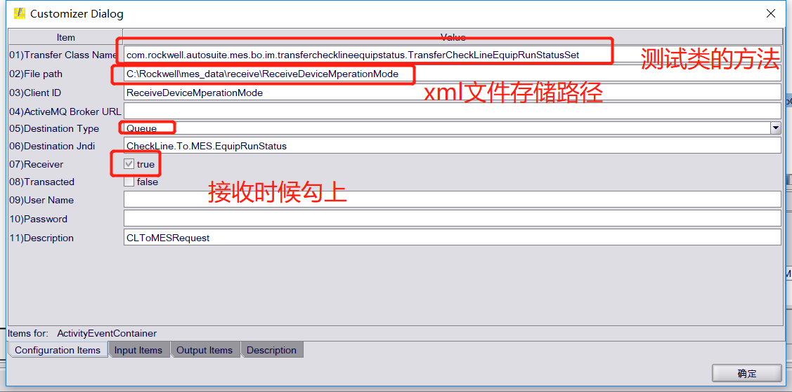

加载以及运行xml文件：

//     receiveActivityCheckLineWeighingDetection.getActivity().setBrokerUrl(brokerURL)

//     receiveActivityCheckLineWeighingDetection.getActivity().connect()

//     WeighingDetection = class com.rockwell.autosuite.mes.services.im.impl.InWeighingDetection()

//     receiveActivityCheckLineWeighingDetection.getActivity().setReceiveProcess(WeighingDetection)

//     //四轮定位 FourWheelAlignment com.rockwell.autosuite.mes.bo.im.transferfourwheelalignment.TransferFourWheelAlignmentSet

[http://10.27.2.61:8161](http://10.27.2.61:8161/)//activityMQ  账户名  admin  admin

[tcp://10.27.2.61:61616](tcp://10.27.2.61:61616/)  测试接口 路径

测试接口xml文件：

<?xml version="1.0" encoding="UTF-8" standalone="yes"?>

<data>

    <CheckLineEquipRunStatusList>

        <CheckLineEquipRunStatus>

            <ZPlant>zPlant1</ZPlant>

            <ZLineNO>zLineNO1</ZLineNO>

            <ZEquipNO>zEquipNO1</ZEquipNO>

            <ZMode>zMode</ZMode>

        </CheckLineEquipRunStatus>

        <CheckLineEquipRunStatus>

            <ZPlant>zPlant2</ZPlant>

            <ZLineNO>zLineNO2</ZLineNO>

            <ZEquipNO>zEquipNO2</ZEquipNO>

            <ZMode>zMode</ZMode>

        </CheckLineEquipRunStatus>

    </CheckLineEquipRunStatusList>

</data>

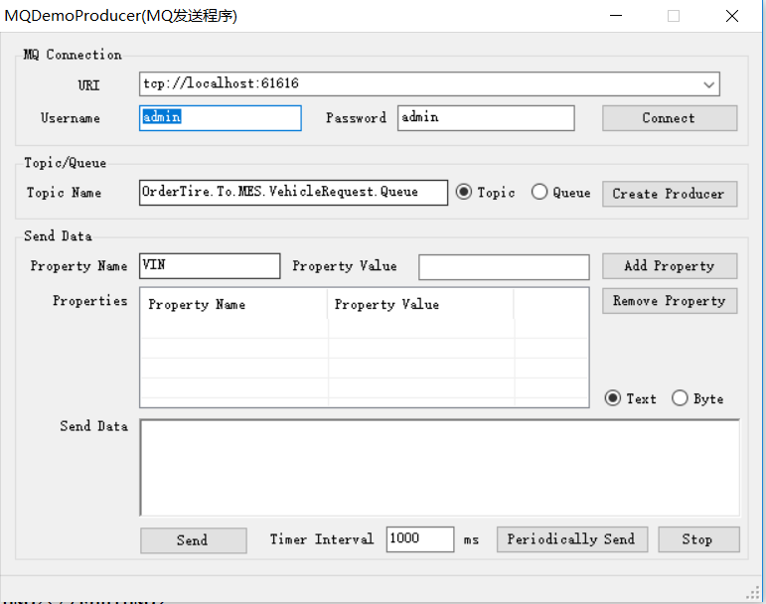

点击发送 在界面查看消息队列 ：

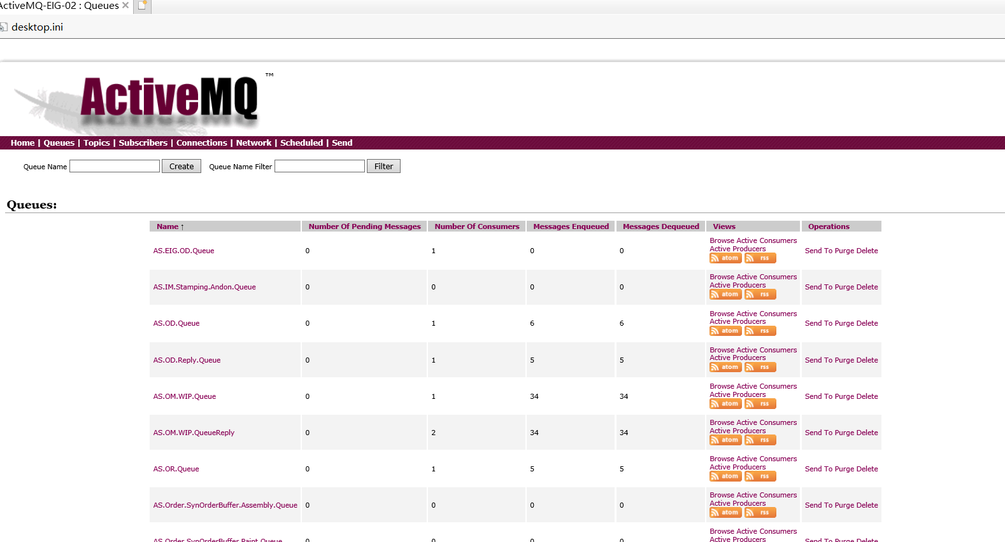

以及在路径里面查看发送记录：

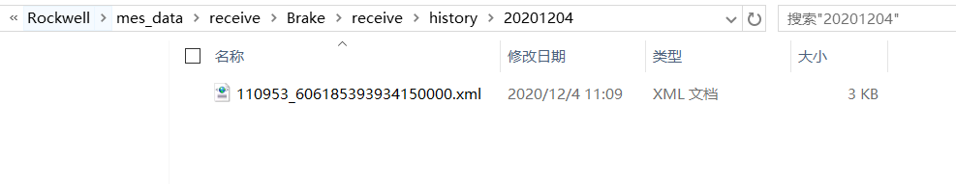

数据库查看 ：

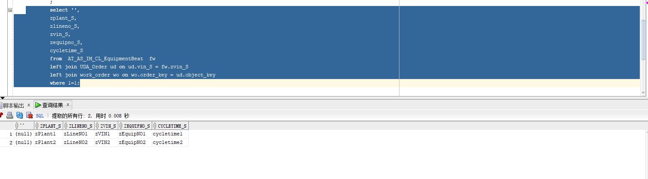

测试成功