1. a. compile with debug symbol:
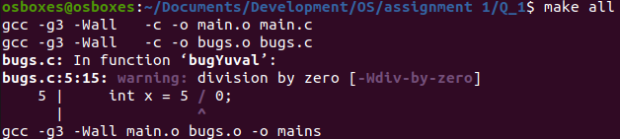
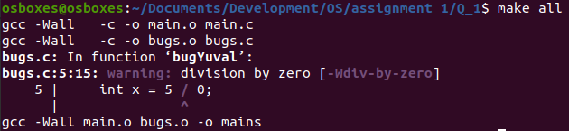
b. compile without debug symbol (deleted “-g3” from the makefile):
2. run the program:
Bug A:
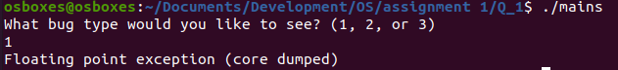
Bug B:
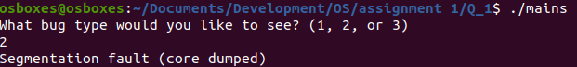
Bug C:
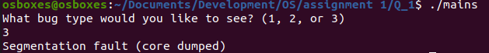

3. show the necessary steps to get core:
→computer
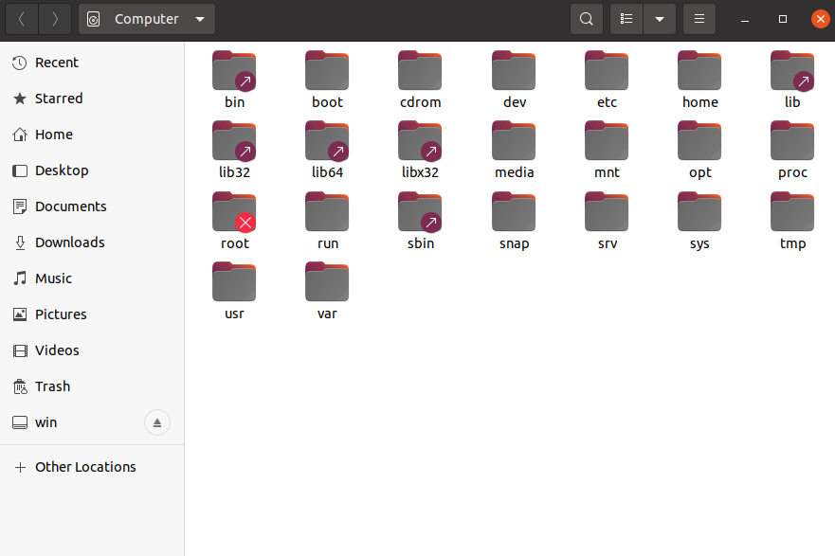

→ var
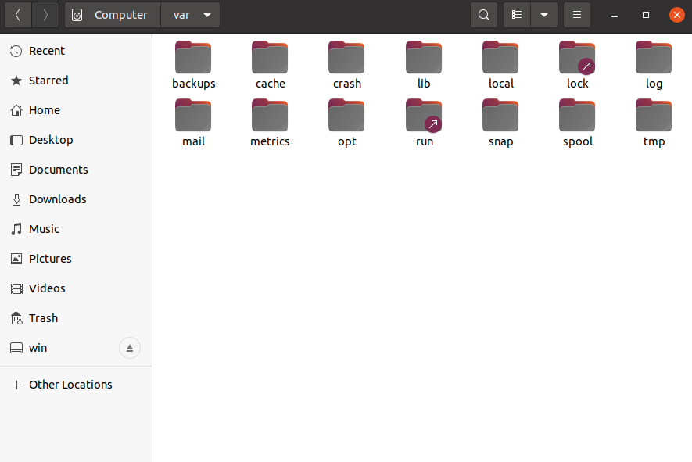

→ lib
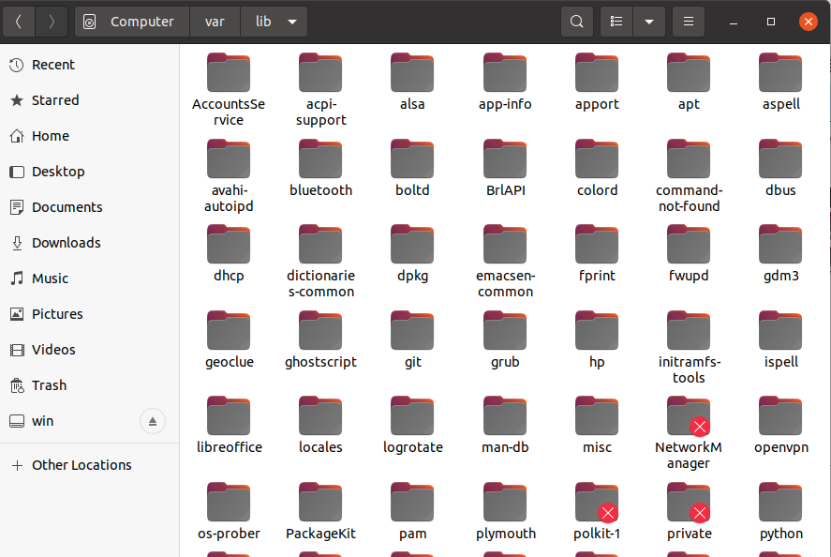

→ apport
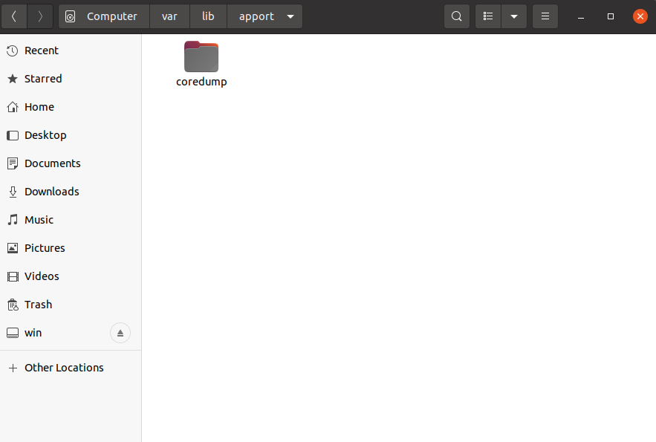

→ coredump

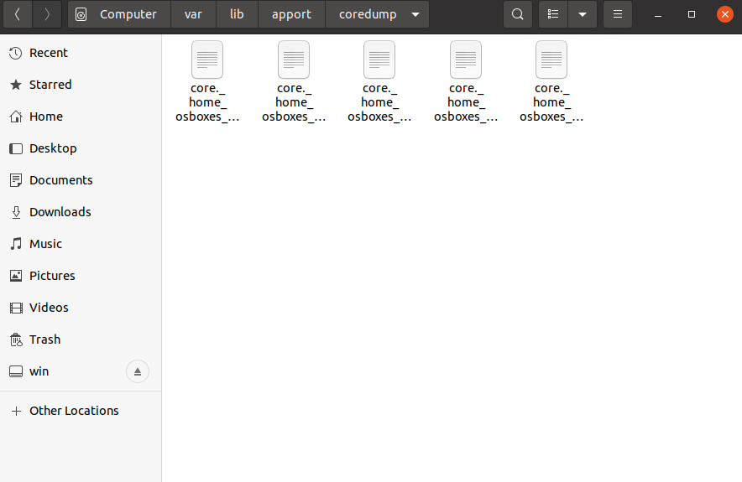

then we copied the core files into the current working directory and changed their names accordingly.

4.a. load in gdb with debug symbol:
Bug A:
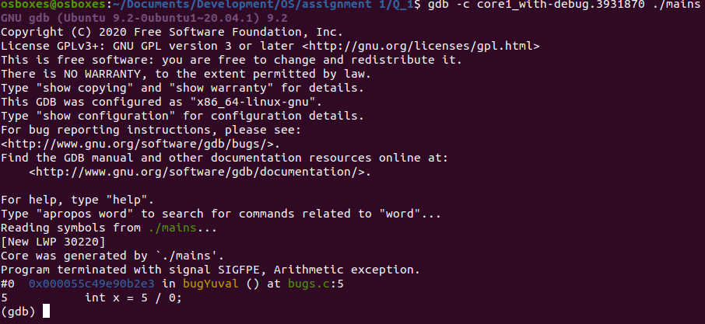
Bug B:
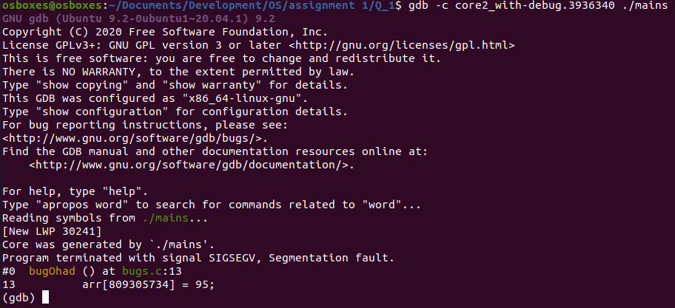

Bug C:
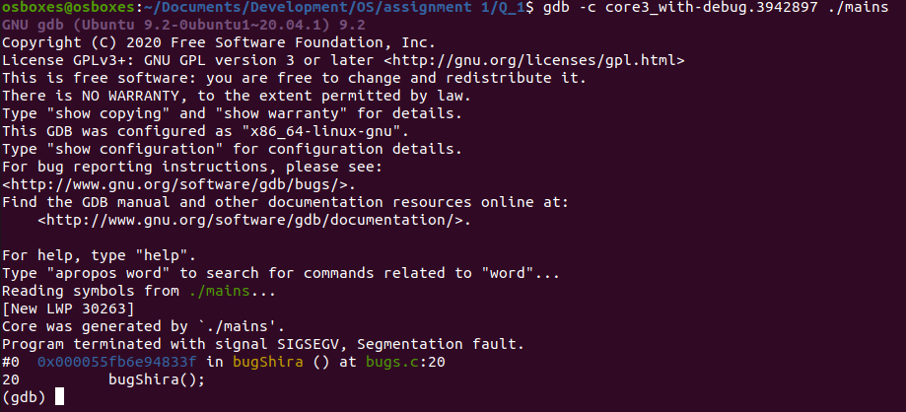
b. load in gdb without debug symbol:
Bug A:
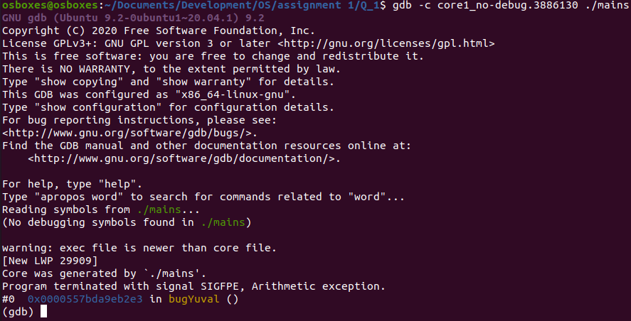

Bug B:
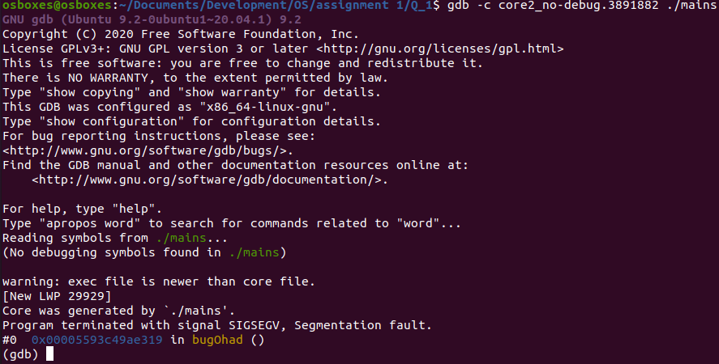
Bug C:
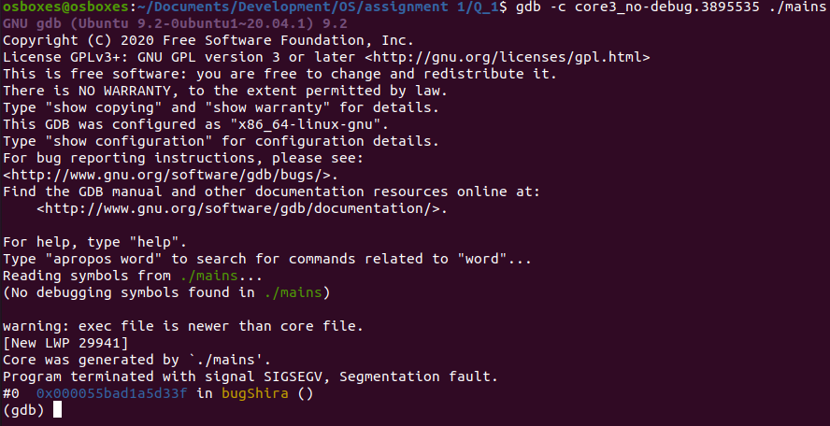
5. show the relevant row in the code where the program crashed with core
Bug A:
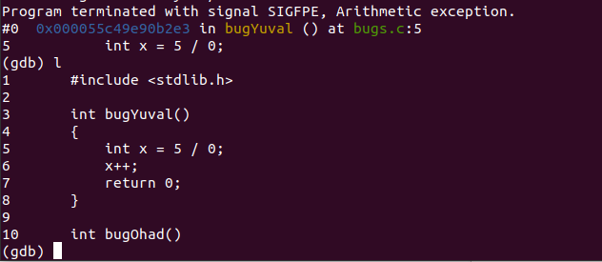
Bug B:
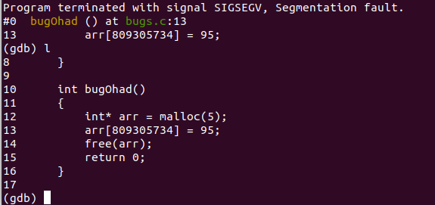

Bug C:
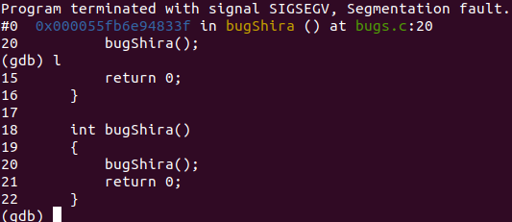

6. open the core with a graphic debugger (such as ddd):
Bug A:
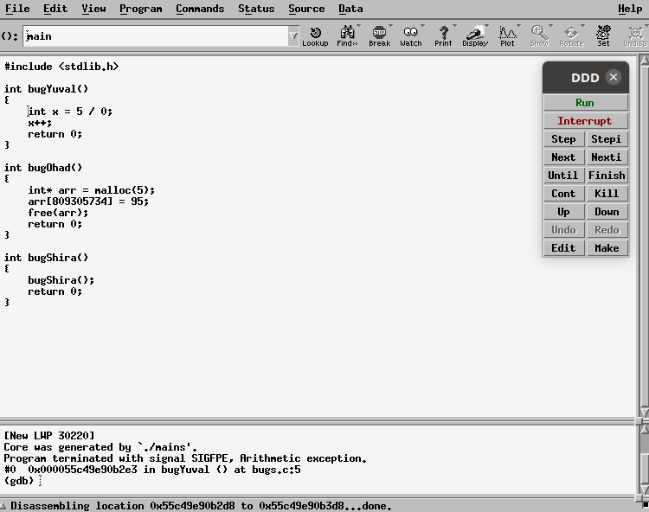

Bug B:
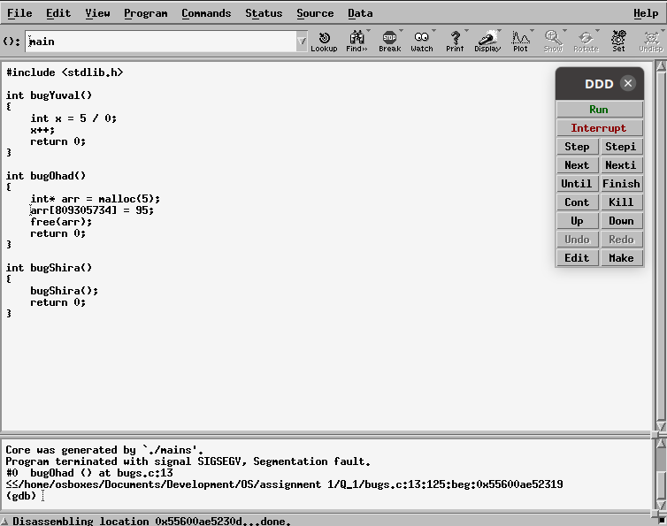
Bug C:
