Arrays:

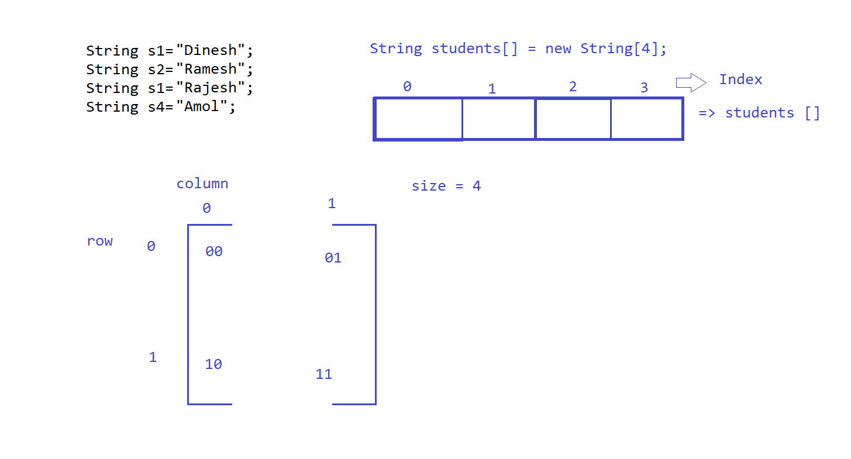

There are two types of array.

* Single Dimensional Array
* Multidimensional Array
* It is use store multiple elements of same data type.
* We can declare arrays in two ways:

String students [] = **new** String[4];

String students [] ={“abc”,”xyz”};

* Arrays nothing but object inside object.
* Arrays read and write is performed on basis of index. It will always starts from Zero.
* Arrays can sorted using Arrays class which is having sort method

Ex: Arrays.sort(students);

//declaration

String stduents [] = **new** String[4];

Limitation:

* Array is declared for similar data type that we can’t use multiple data type in same array.

String ():-

Exception(weekend)

Encasulation(automation)

Collection(weekend)

**package** stringArrays;

**import** java.util.Arrays;

**public** **class** Demo {

**public** **static** **void** main(String[] args) {

// declaration

String stduents[] = **new** String[4];

// Initialize

stduents[0] = "Dinesh";

stduents[1] = "Ramesh";

stduents[2] = "Rajesh";

stduents[3] = "Amol";

System.***out***.println("-------Original array elements------");

**for** (**int** i = 0; i <= stduents.length - 1; i++) {

System.***out***.println(stduents[i]);

}

System.***out***.println("-------ascending array elements------");

Arrays.*sort*(stduents); // Ascending

**for** (**int** i = 0; i <= stduents.length - 1; i++) {

System.***out***.println(stduents[i]);

}

// for descending use for loop in reverse oder

}

}

**package** stringArrays;

**public** **class** Demo1 {

**public** **static** **void** main(String[] args) {

**int** num[] = **new** **int**[5];

num[0]=50;

num[1]=800;

num[2]=505;

num[3]=60;

num[4]=150;

System.***out***.println(num.length);

}

}

**package** stringArrays;

**import** java.util.Arrays;

**public** **class** Demo2 {

**public** **static** **void** main(String[] args) {

// Declaration & Initialization

**int** num[] = { 500, 600, 77, 88, 45, 658, 7, 62, 4585 };

System.***out***.println("-------Original array elements------");

**for** (**int** i = 0; i <= num.length - 1; i++) {

System.***out***.println(num[i]);

}

System.***out***.println("-------ascending array elements------");

Arrays.*sort*(num);

**for** (**int** i = 0; i <= num.length - 1; i++) {

System.***out***.println(num[i]);

}

System.***out***.println("-------descending array elements------");

**for** (**int** i = 8; i >= 0; i--) {

System.***out***.println(num[i]);

}

}

}

**package** stringArrays;

**public** **class** Demo3 {

**public** **static** **void** main(String[] args) {

**int** ar[][] = **new** **int**[2][2]; // [2] => row, [2]=> column

**int** ar1[][] = { { 10, 20 }, { 30, 40 } };

ar[0][0] = 10;

ar[0][1] = 20;

ar[1][0] = 30;

ar[1][1] = 40;

**for** (**int** i = 0; i <= 1; i++) {

**for** (**int** j = 0; j <= 1; j++) {

System.***out***.print(ar[i][j] + " ");

}

System.***out***.println();

}

}

}

**package** stringArrays;

**import** java.util.Scanner;

**public** **class** scan1 {

**public** **static** **void** main(String[] args) {

Scanner sss = **new** Scanner(System.***in***);

**int** num=sss.nextInt();

System.***out***.println(num);

**for**(**int** i=0; i<=num; i++) {

System.***out***.println(i);

}

}

}