Selenium wait/ synchronization:

To maintain synchronization between webpage and automation script selenium waits are used.

**implicit wait:**

driver.manage().timeouts().~~implicitlyWait~~(10,TimeUnit.***SECONDS***);

driver.manage().timeouts().~~pageLoadTimeout~~(10, TimeUnit.***SECONDS***);

* Applicable to all elements on web page.
* It will wait till all the elements load on webpage.
* Dynamic in behavior
* This available in selenium only

Explicit wait:

* Dynamic in nature
* It is applicable to one specific element element at a time
* We can give different condition like VisisbilityOfelement, elementTobeclickable, elementTobeSelectable, etc.
* This available in selenium only
* TO use this wait we have use class WebDriverWait which is present insdide selenium lib.
* To give different We have to call ExpectedConditions class and it consists of diffetent static methods like:
* 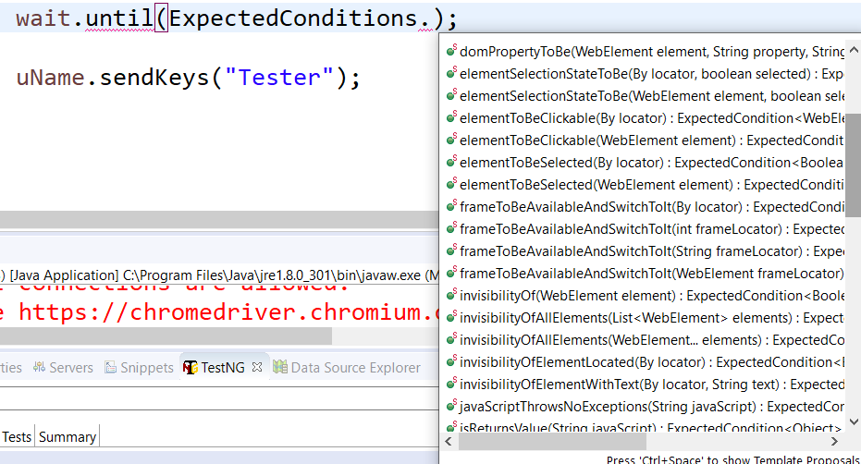

Ex:

**package** seleniumwait;

**import** java.util.concurrent.TimeUnit;

**import** org.openqa.selenium.By;

**import** org.openqa.selenium.WebDriver;

**import** org.openqa.selenium.WebElement;

**import** org.openqa.selenium.chrome.ChromeDriver;

**import** org.openqa.selenium.support.ui.ExpectedConditions;

**import** org.openqa.selenium.support.ui.WebDriverWait;

**import** com.vel.config.Configurations;

**public** **class** Test {

**public** **static** **void** main(String[] args) **throws** InterruptedException {

System.*setProperty*("webdriver.chrome.driver", Configurations.***driverPath***);

WebDriver driver = **new** ChromeDriver();

driver.get("https://www.facebook.com/");

driver.manage().window().maximize();

WebElement uName = driver.findElement(By.*xpath*("//input[@id='email']"));

WebDriverWait wait = **new** ~~WebDriverWait~~(driver, 10); //Explicit wait

wait.until(ExpectedConditions.*visibilityOf*(uName));

uName.sendKeys("Tester");

}

}

Q. If we apply both wait that is implit and explicit then which will work first?

Fist implicit wait will wait till all elements on will load

And then explicit wait will wait till particular condition meets.