Shira Pahmer 575285308  
Maeven Fanebust 559816034

OOPD Theoretical HW 3

Part A.

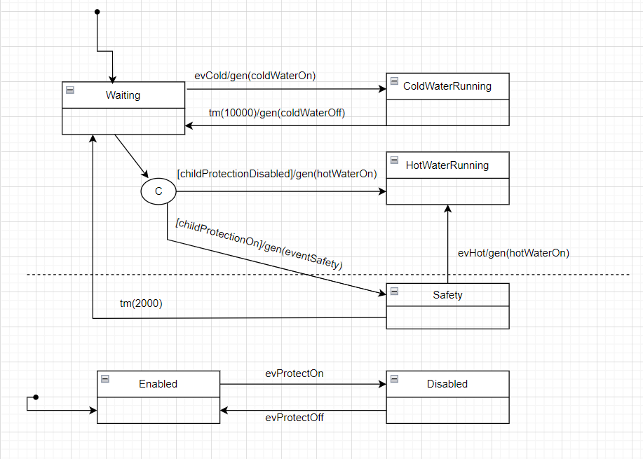

Part B.

Part C.

We can change the initial constructor of the protection class to take in a parameter that sets the initial value of the childProtection based on the input parameter. This holds by the principle of OCP whereby the program is open for extension to enable the initial childProtection setting to be determined upon initialization but keeps it closed to modification by not needing to recompile the water bar class.