T1a- Addresses - based on usful link
565c7 – bss 565c5- text 56e - Heap
- &addr2: 0xffaaa79c  - &addr3: 0xffaaa7a0 | Both are stored at high address (ff)- STACK!  Distance between addr3 and addr 2 ia 4 bytes (size of int)
- foo: 0x565c5779 | Text segment (function)
- &addr5: 0x565c7018 | Bss.
dist1: (size_t)&addr6 - (size_t)p: -4 | *p = &addr5  both addr5 and addr6 are uninitialized segments, so it is located at bss.  This is why dist1 = -4.
dist2: (size_t)&local - (size_t)p: -1454491852 | regarding dist2, which is very very big: local is located on the stack, so basically, local seats at high addresses while p (addr5) seats at low addresses.  Overflow.
dist3: (size_t)&foo - (size_t)p: -6303 | This distance is relativaly small. Foo- text. close to bss.
- addr0: 0x565c7008 | Initialized data
- addr1: 0x565c7010 | Static. On bss next to addr5,l addr6
- &addr6: 0x565c7014 | Bss. With addr5
- yos: 0x565c5970 | Text (“ree”)
- addr4: 0x56e83160 | Heap. Address of data it points at. (malloc from line 17)
- &addr4: 0xffaaa7a4 | pointer’s address. Stack. High address (ff)
- &foo1: 0x565c5867  - &foo1: 0x565c5892 | Text. function
- &foo2 - &foo1: 43 | Probably size of function
4 | My addition- Sizeof(long).  Not enough. Long works in two’s completment. Thats why the range is smaller (now we consider also negative numbers).  We even received a “warning: format ‘%ld’ expects argument of type ‘long int’, but argument 2 has type ‘int’ [-Wformat=]”
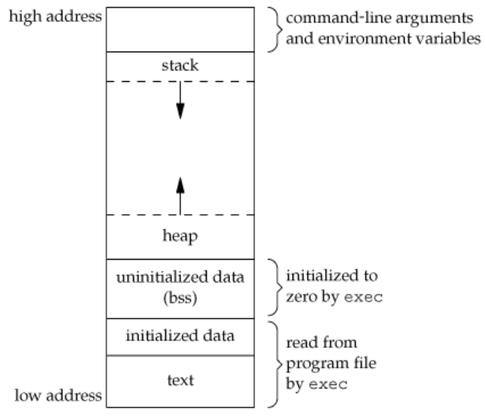

T1b- Distances
?

T1c- Arrays memory layout

0xfff898d8 0xfff898dc
0xfff898e4 0xfff898e8
0xfff898f0 0xfff898f8
0xfff89909 0xfff8990a

int, float -> 4 bytes
double -> 8 bytes
char -> 1 byte

‘+’ operator is acknowledge to the size of variables at the array.

Memory layout of arrays- sequence of cells in memory. In this case, on the stack.

* As expected, all cells are distanced by 4 (sizeof(int)) bytes from each other.

T1d- Pointers and arrays

P is on stack.

