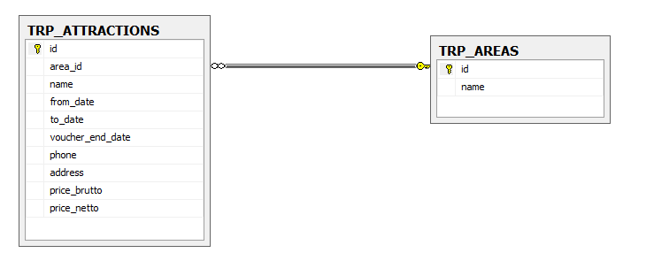TRP_ATTRACTIONS

** Id is incremental int (1, 1)

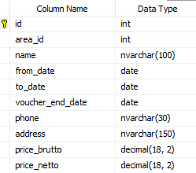

TRP_AREAS



Queries

* Get all the attractions which contains the char 'a'.
* Get all the attractions that from date in year 2019.
* Get all the attractions in area Eilat. (The area name is in table TRP_AREAS)
* Get all **areas IDs** (area_id) which has more than 1 attraction in. (at least 2 attraction in area_id)
* Get all areas Names which has more than 1 attraction in. (at least 2 attraction in area_id)
* Get all the attractions that the address in not in the area.   
  (Example: Kayaks is connected to Tel-Aviv area_id and the address contains 'Eilat')
* Get the most profitable attraction. (brutto minus netto = profit)