Test 15: χ2-test for a Population Variance

# Load Required Packages:  
source(file = "muFunc.R")  
library(package = dplyr)  
library(package = psych)  
library(package = TeachingDemos)  
  
# Load Required Data:  
data <- read.csv(file = "data/Data_Test_15.csv", header = TRUE)  
  
# Show Data:  
headTail(x = data)

## Year Razavi_Khorasan  
## 1 1397-98 3755  
## 2 1397-98 4843  
## 3 1397-98 3007  
## 4 1397-98 4792  
## ... <NA> ...  
## 47 1397-98 3252  
## 48 1397-98 2569  
## 49 1397-98 2471  
## 50 1397-98 2802

# Assumption Checking:  
# 1. It is assumed that the population from which the sample is drawn follows  
# a normal distribution.

# setting initial parameter values:  
var_popu = 3000000  
  
(result <- sigma.test(x = data$Razavi_Khorasan, sigmasq = var_popu,  
 alternative = "two.sided", conf.level = 0.95))

##   
## One sample Chi-squared test for variance  
##   
## data: data$Razavi_Khorasan  
## X-squared = 30.979, df = 49, p-value = 0.04147  
## alternative hypothesis: true variance is not equal to 3e+06  
## 95 percent confidence interval:  
## 1323472 2945260  
## sample estimates:  
## var of data$Razavi_Khorasan   
## 1896682

plotDistStat(dist = "Chi-Squared",  
 df = 49,  
 from = 20,  
 to = 100,  
 # title = "Chi-Square Distribution",  
 alpha_level = 0.05,  
 statistic_point = result$statistic,  
 p_value = result$p.value)

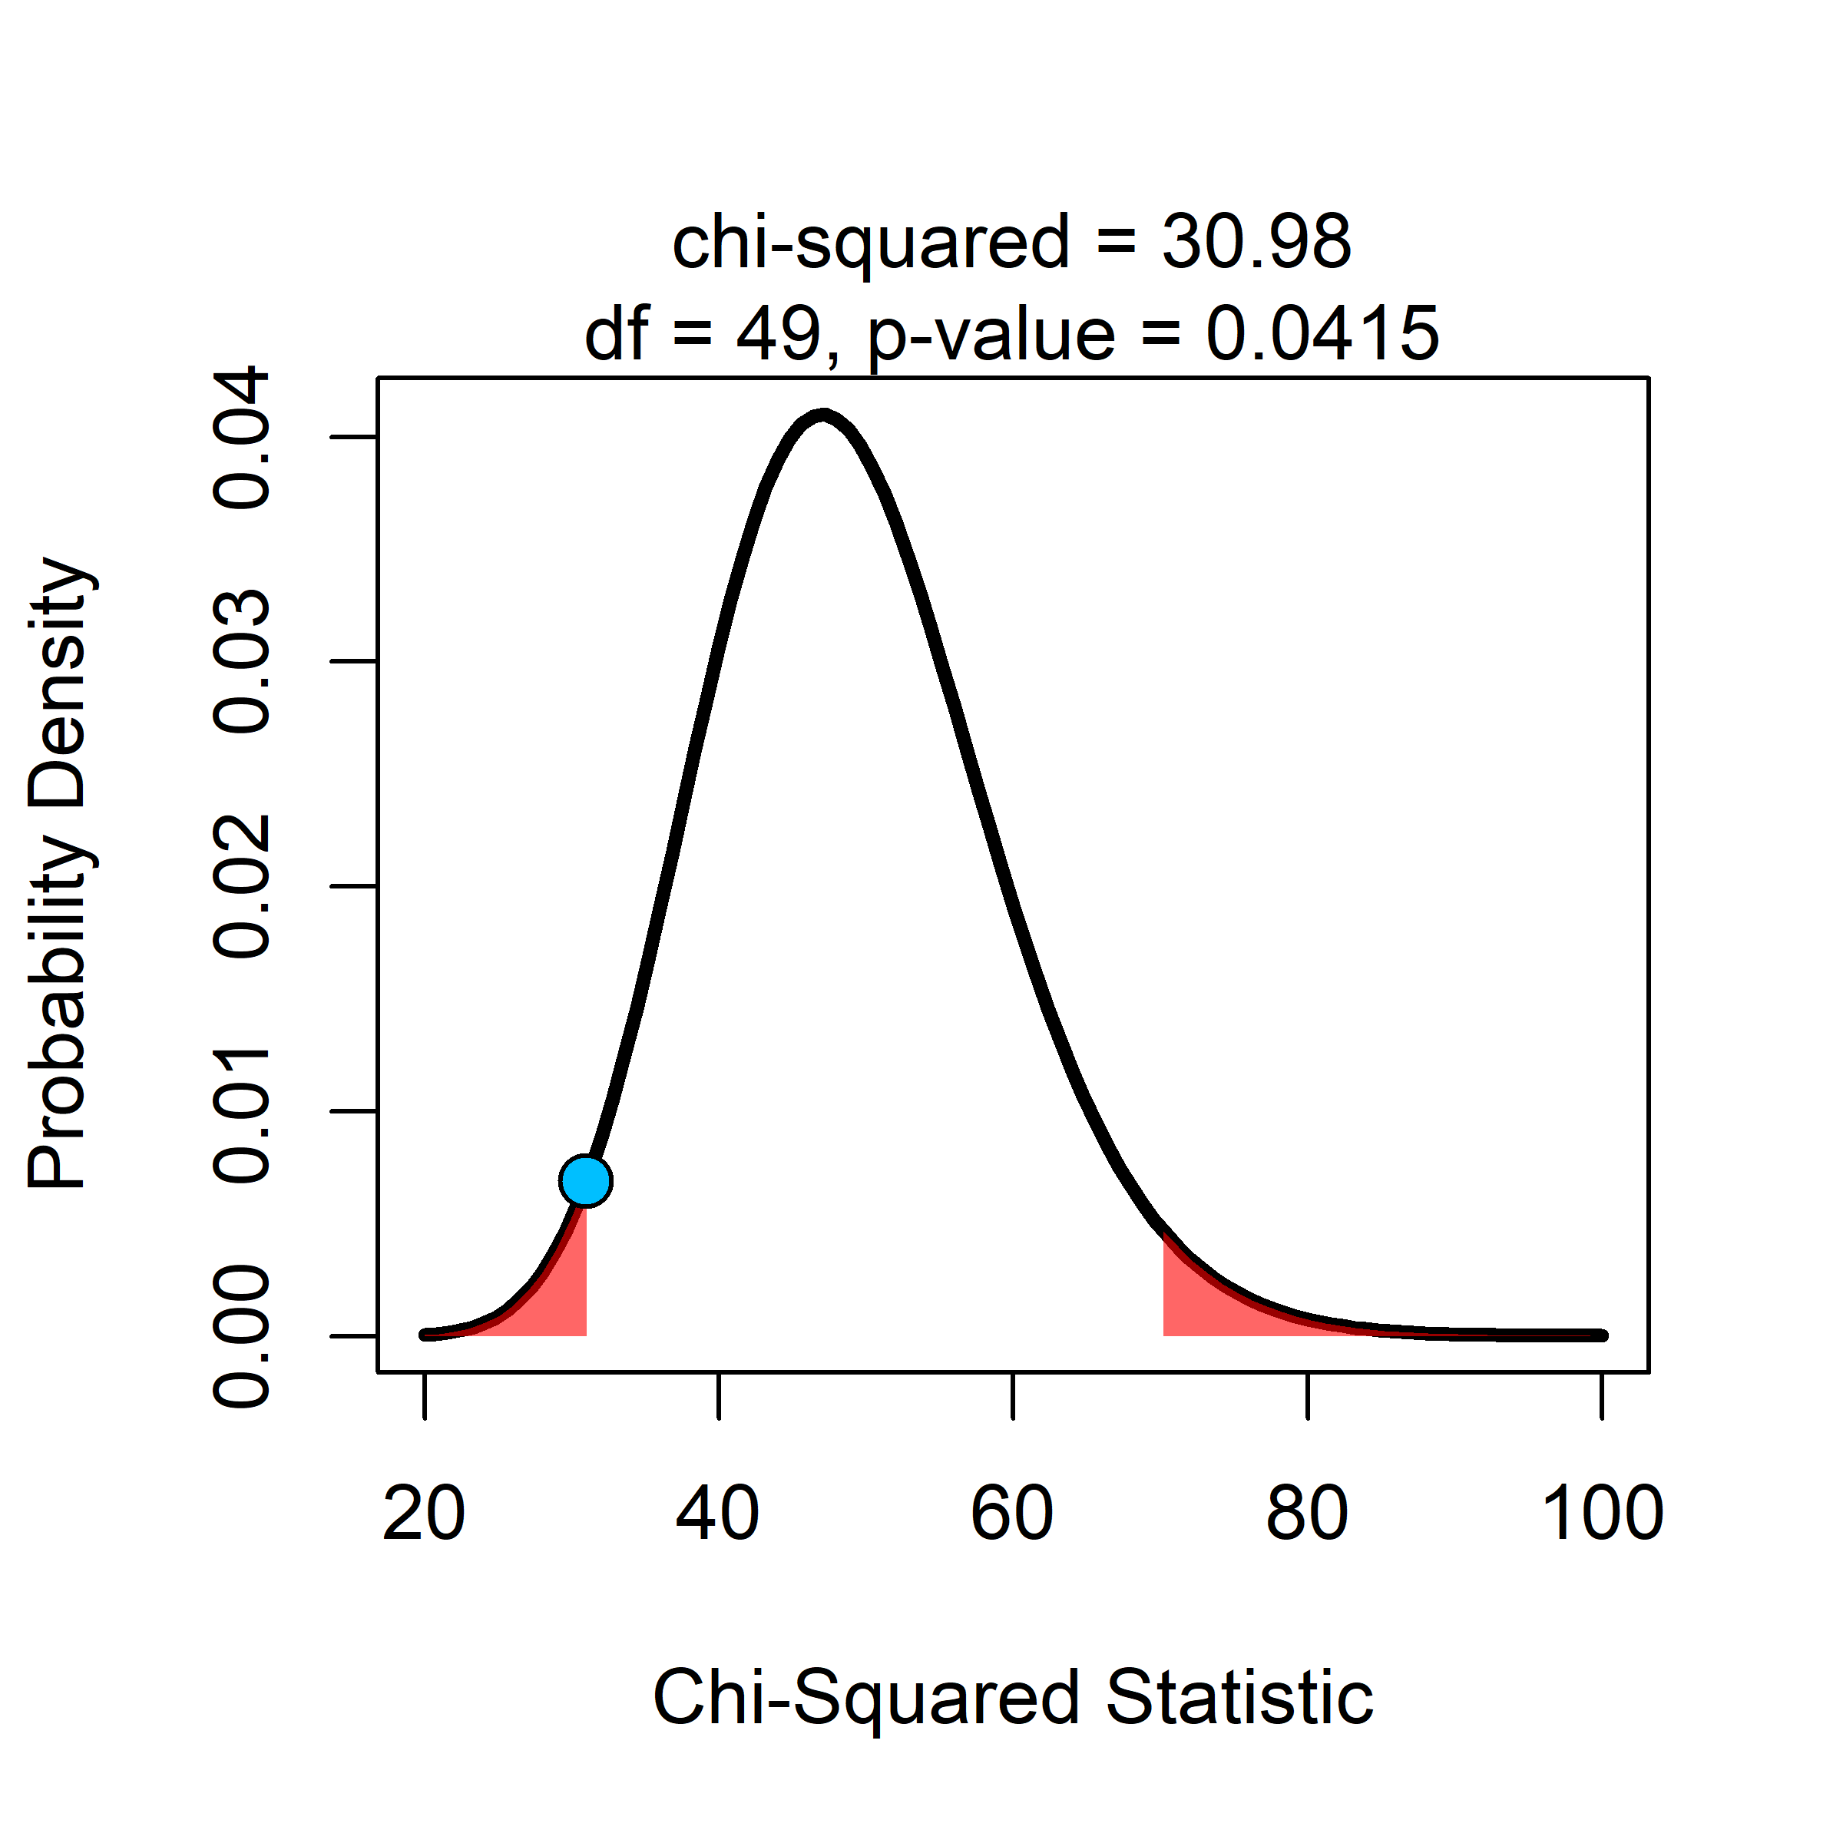

dchisq(x = result$statistic,  
 df = 49)

## X-squared   
## 0.006878947