Test 13: Z-test of a Correlation Coefficient

Pooya Shirazi

# Load Required Packages:  
library(package = dplyr)  
library(package = ggplot2)  
library(package = miscor)  
library(package = psych)  
library(package = PerformanceAnalytics)  
  
# Load Required Data:  
data <- read.csv(file = "data/Data_Test_13.csv",  
 header = TRUE)  
  
# Prepare Data:  
data_1959_2003 <- data %>% filter(Year <= 2003)  
data_2004_2018 <- data %>% filter(Year > 2003)  
  
# Show Data:  
headTail(x = data)

## Year Mashhad Torbat  
## 1 1959 234.5 258.7  
## 2 1960 174.5 263.7  
## 3 1961 254.5 270  
## 4 1962 196.8 198.4  
## ... ... ... ...  
## 57 2015 207.6 227.2  
## 58 2016 246.2 208.5  
## 59 2017 238.1 180.9  
## 60 2018 237.4 197.3

# Assumption Checking:  
# 1. The x and y values originate from normal distributions.  
# 1.1. Precipitation Mashhad  
shapiro.test(data_2004_2018$Mashhad)

##   
## Shapiro-Wilk normality test  
##   
## data: data_2004_2018$Mashhad  
## W = 0.97788, p-value = 0.9529

# 1.2. Precipitation Torbat Heydariyeh  
shapiro.test(data_2004_2018$Torbat)

##   
## Shapiro-Wilk normality test  
##   
## data: data_2004_2018$Torbat  
## W = 0.94089, p-value = 0.3937

# 2. The relationship is linear.  
chart.Correlation(data_2004_2018[, c("Mashhad", "Torbat")])

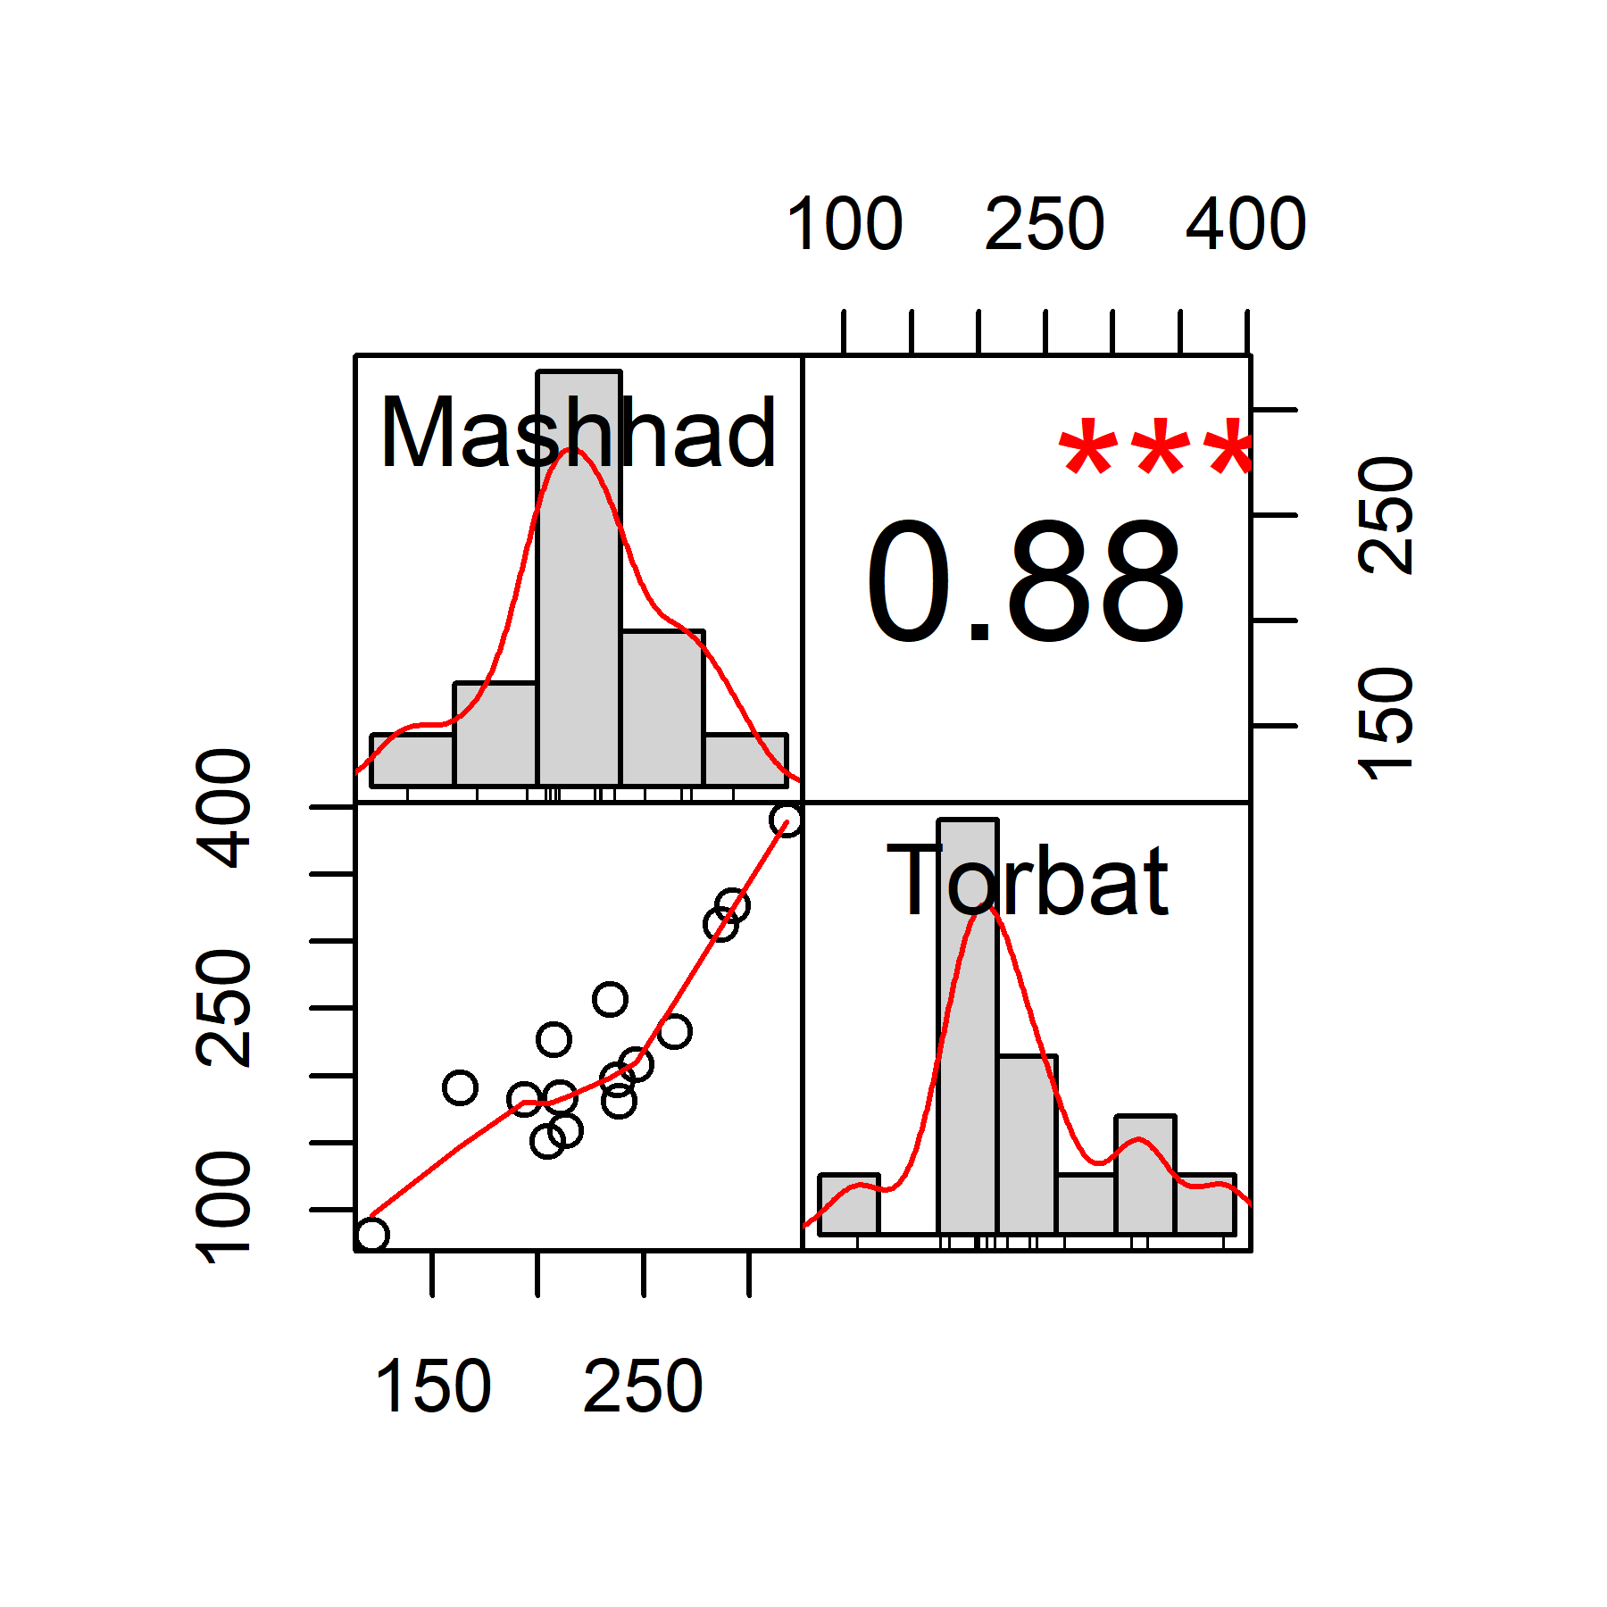

ggplot(data_2004_2018, aes(Torbat, Mashhad)) +   
 geom_point() +   
 geom_smooth(method=lm) +  
 xlim(50, 400) +  
 ylim(50, 400)

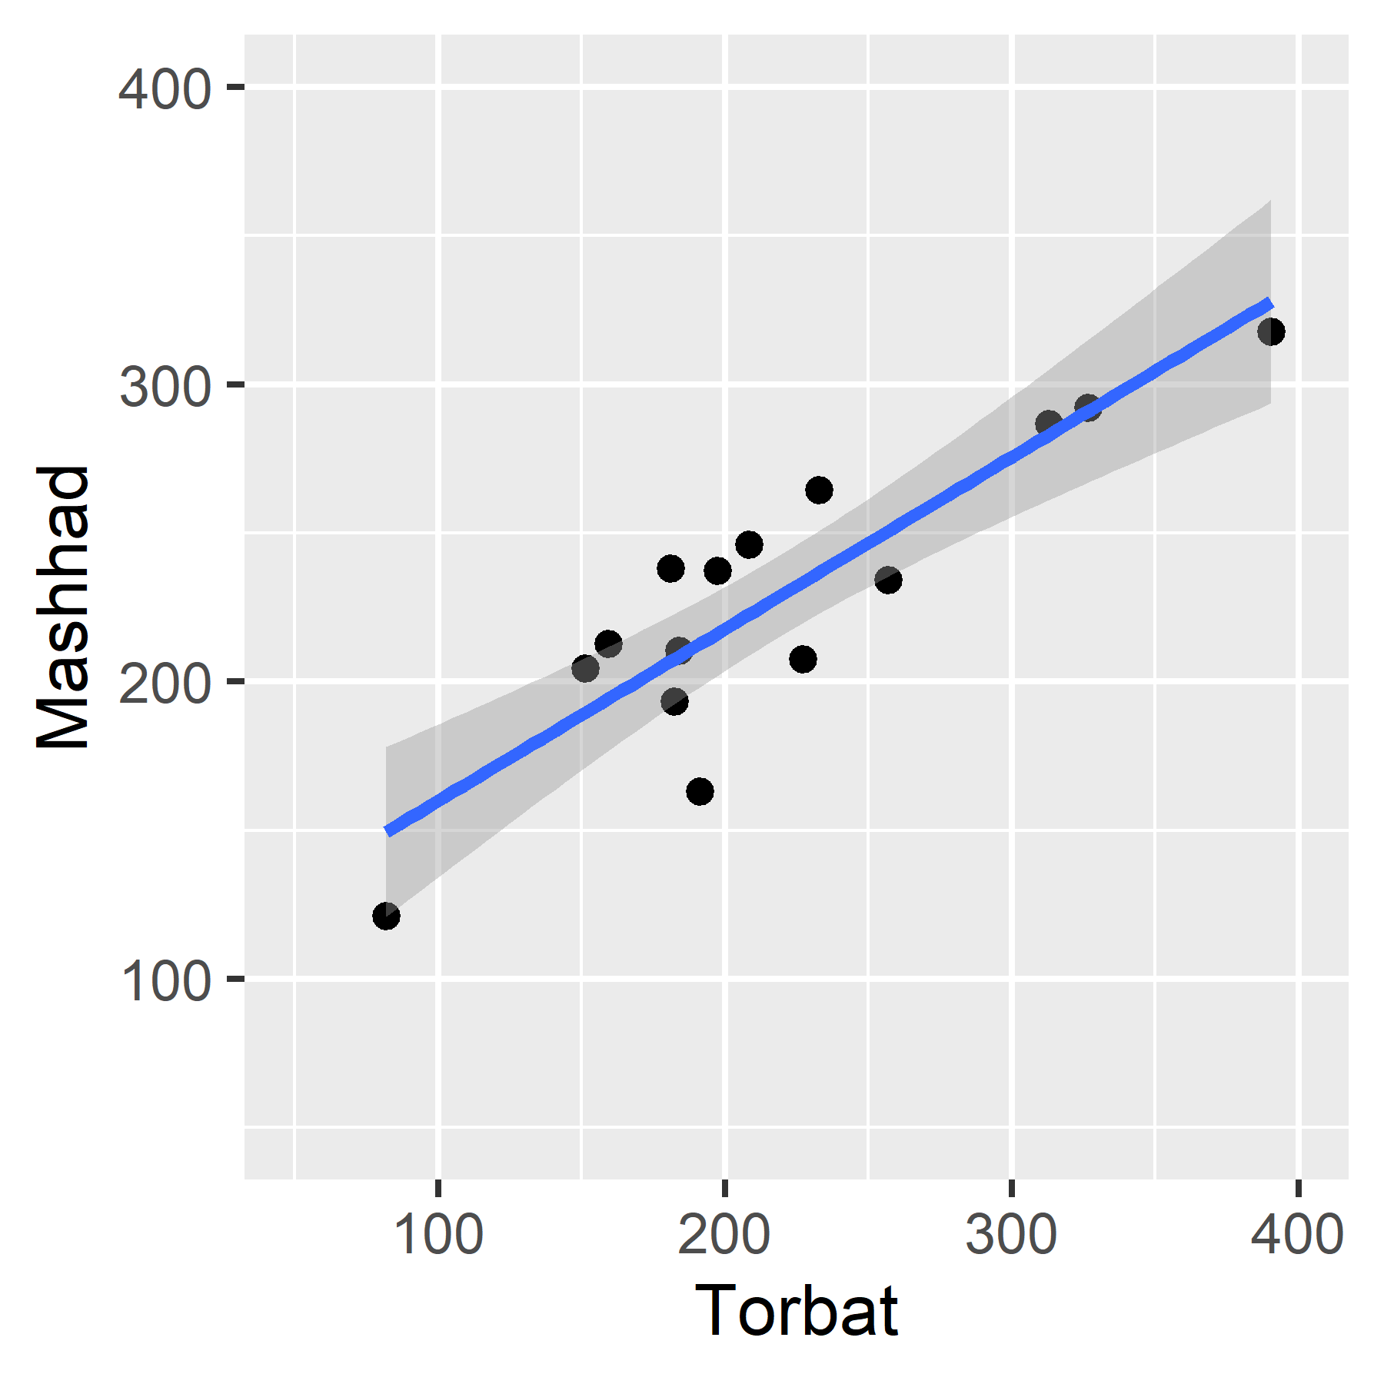

# setting initial parameter values:  
r = cor(x = data_2004_2018$Torbat, y = data_2004_2018$Mashhad)  
rho0 = cor(x = data_1959_2003$Torbat, y = data_1959_2003$Mashhad)  
n = nrow(x = data_2004_2018)  
  
# use test.core function:  
test.cor(r = r, n = n, rho0 = rho0, conf.level = 0.95, reduced = TRUE)

##   
## Statistical test for the product-moment correlation coefficient  
##   
## H0: rho == 0.6902987 versus H1: rho != 0.6902987   
##   
## z = 1.890, p-value = 0.0588  
##   
## Sample estimate r: 0.884   
## Two-sided 95% CI: [0.680, 0.961]