1.

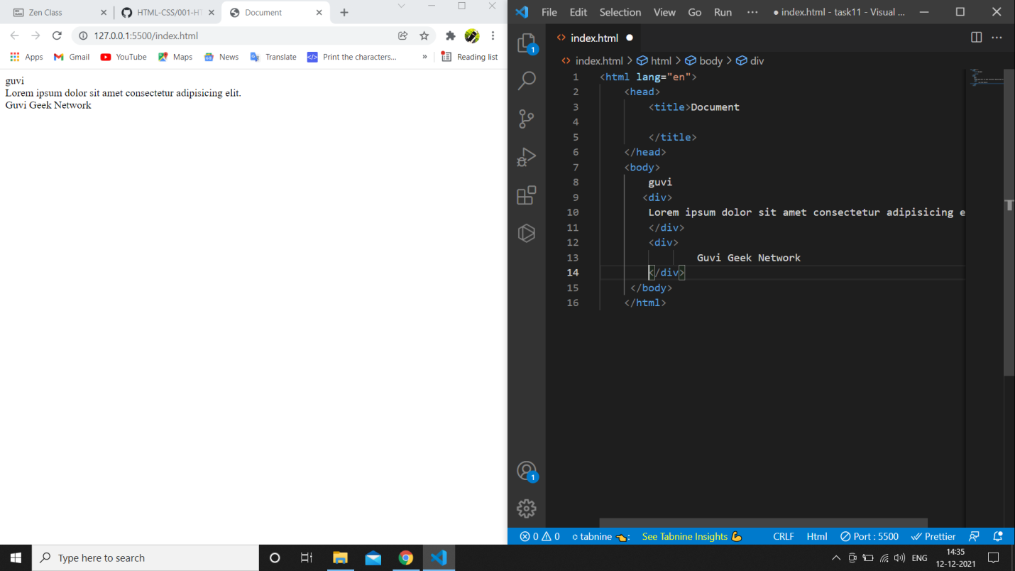

2.

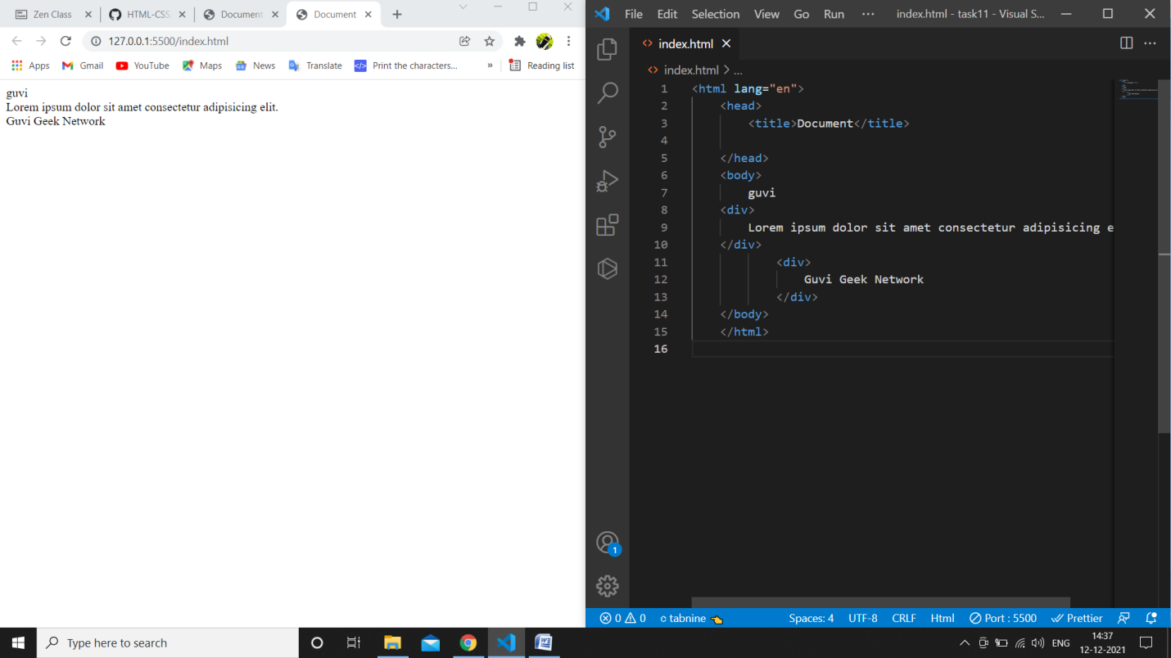

3.

Html code

<!DOCTYPE html>

<html lang="en">

<head>

    <meta charset="UTF-8">

    <meta http-equiv="X-UA-Compatible" content="IE=edge">

    <meta name="viewport" content="width=device-width, initial-scale=1.0">

    <link rel="stylesheet" href="css/bootstrap.min.css">

    <link rel="stylesheet" href="css/form.css">

    <title>Document</title>

</head>

<body>

    <div calss="container">

        <form>

            <h4>contact us now..!</h4>

            <input type="text" name="your name" placeholder="Please Enter Your Name" class="form-control form-control-sm">

            <input type="text" name="your name" placeholder="Please Enter Your Email" class="form-control">

            <input type="text" name="your name" placeholder="Please Enter Your Mobile Number" class="form-control">

            <textarea name="your name" placeholder="Please Enter Your Message" rows="4" cols="50" class="form-control"></textarea>

            <button type="submit" class="btn btn-primary form-control" >Submit</button>

        </form>

    </div>

<script src="js/jquery-3.6.0.min.js"></script>

<script scr="js/bootstrap.min.js"></script>

</body>

</html>

Css code:

body{

    background-color:green;

    display: flex;

}

div{

    background-color:white;

    margin-top:50px;

    margin-bottom:50px;

    width: 400px;

    height: 500px;

    margin-left: auto;

    margin-right: auto;

}

h4{

    text-align:center;

    text-decoration: none;

    color:rgb(228, 63, 91);

    font-family: 'Segoe UI', Tahoma, Geneva, Verdana, sans-serif;

}

input[type="text"]{

    margin-top: 40px;

    margin-bottom: 40px;

    justify-content: center;

}

textarea{

    margin-left:auto;

    margin-right:auto;

    margin-bottom: 25px;

}

button{

    color:rgb(228, 63, 91);

    background-color:greenyellow;

    text-align: center;

    margin-left: auto;

}

o/p:

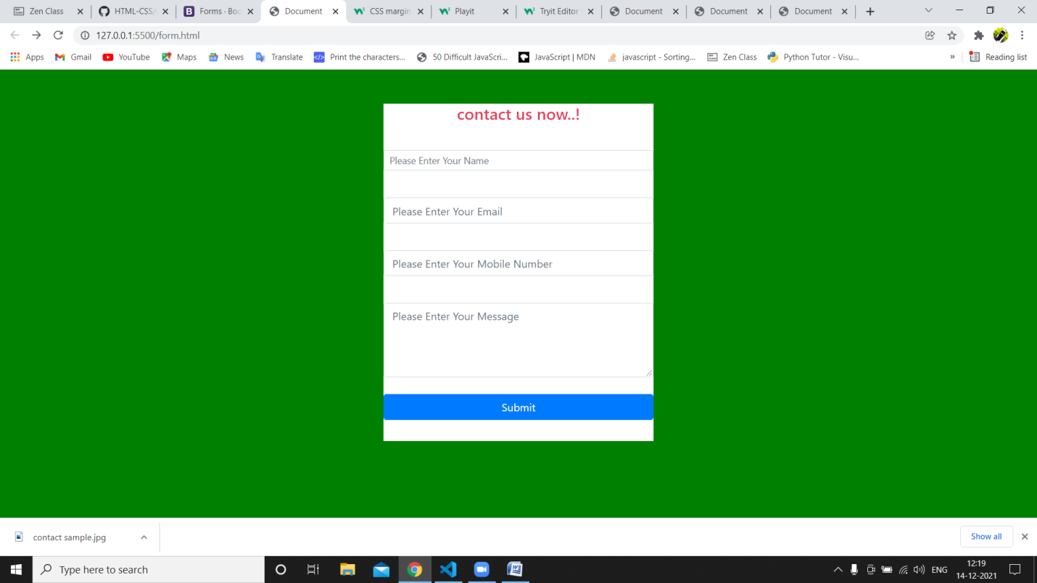

4.

<!DOCTYPE html>

<html lang="en">

<head>

    <meta charset="UTF-8">

    <meta http-equiv="X-UA-Compatible" content="IE=edge">

    <meta name="viewport" content="width=device-width, initial-scale=1.0">

    <title>Document</title>

</head>

<body>

    <ul>Programming Language

        <ul>javascript

            <ol type="a">

                <li>Angular</li>

                <li>React</li>

                <li>Vue.js</li>

            </ol>

        </ul>

        <ul>Python

            <ol type="a">

                <li>Django framework</li>

                <li>flask framework</li>

            </ol>

        </ul>

        <ul>java

            <ol type="a">

                <li>spring</li>

                <li>maven</li>

                <li>hibernet</li>

            </ol>

        </ul>

        <ul>databases

            <ol type="a">

                <li>mysql</li>

                <li>mongodb</li>

                <li>cansandra</li>

            </ol>

        </ul>

    </ul>

</body>

</html>

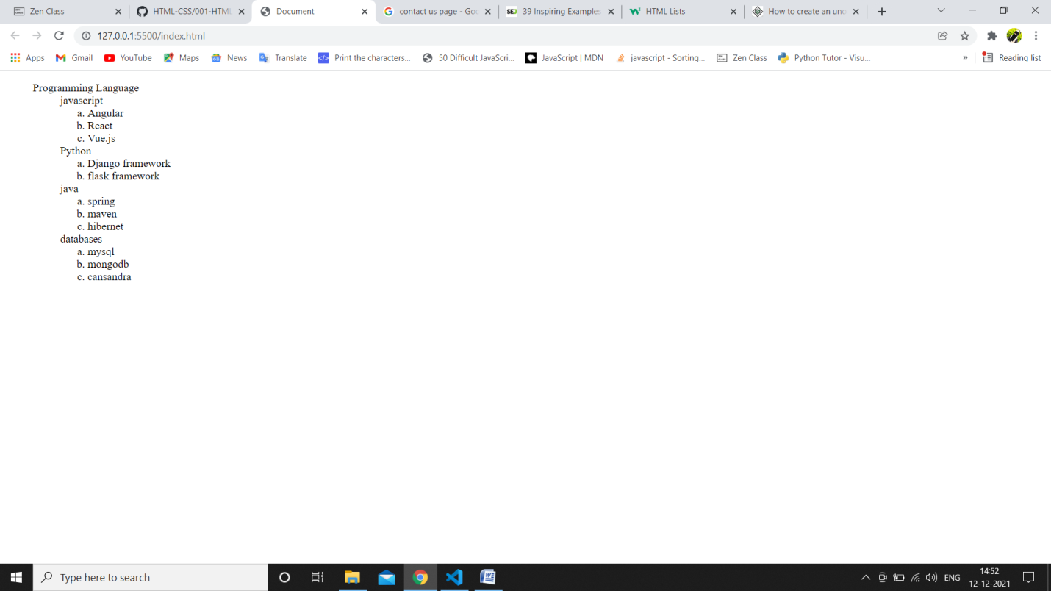

5.

<!DOCTYPE html>

<html lang="en">

<head>

    <meta charset="UTF-8">

    <meta http-equiv="X-UA-Compatible" content="IE=edge">

    <meta name="viewport" content="width=device-width, initial-scale=1.0">

    <title>Document</title>

</head>

<body>

    <a href="https://google.com" target="_blank">hi google!</a>

</body>

</html>

6.

<!DOCTYPE html>

<html lang="en">

<head>

    <meta charset="UTF-8">

    <meta http-equiv="X-UA-Compatible" content="IE=edge">

    <meta name="viewport" content="width=device-width, initial-scale=1.0">

    <title>Document</title>

</head>

<body>

    <form>

        <p>employee type:

        <input type="radio" id="salaried" name="fav_language" value="salaried">

        <label for="salaried">salaried</label>

        <input type="radio" id="business" name="fav_language" value="business">

        <label for="business">business</label></p>

    </form>

</body>

</html>

o/p:

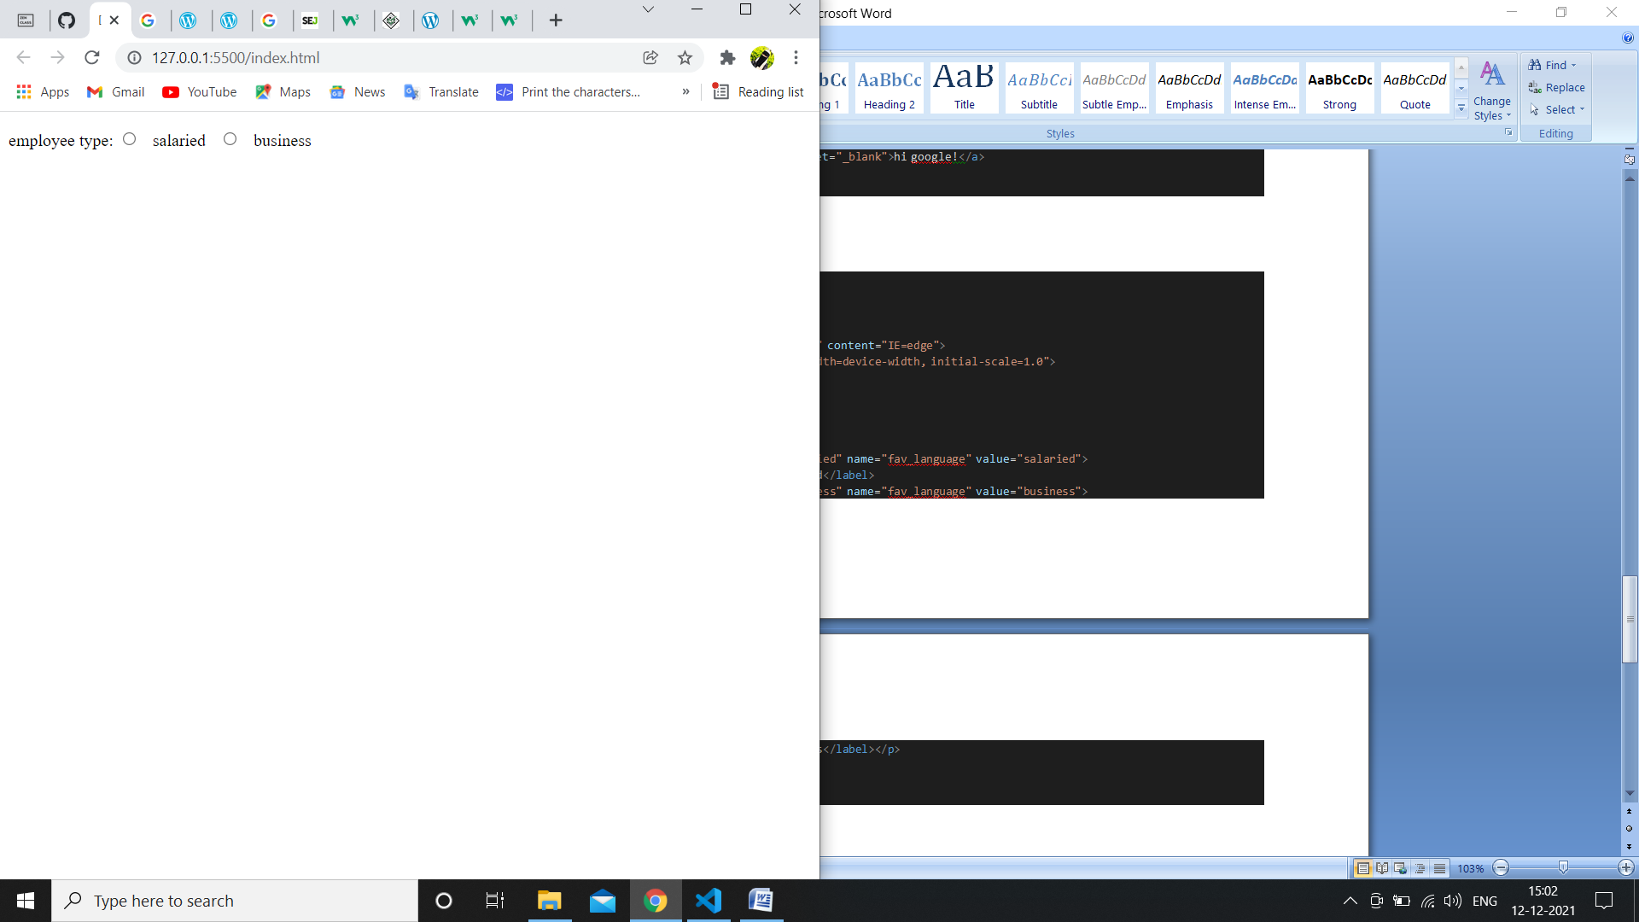

7.

Index.html

<!DOCTYPE html>

<html lang="en">

<head>

    <meta charset="UTF-8">

    <meta http-equiv="X-UA-Compatible" content="IE=edge">

    <meta name="viewport" content="width=device-width, initial-scale=1.0">

    <title>form</title>

    <link rel="stylesheet" href="css/style.css">

</head>

<body>

    <div>

        <form>

        <p id="fs">Yes! I want to subscribe to Mag-O-Zine</p>

        <input id="sn" type="text" name="firstname"/>&nbsp;&nbsp;&nbsp;&nbsp;&nbsp;&nbsp;&nbsp;<input  type="text" name="lastname"/><br/>

        <label>First Name</label>&nbsp;&nbsp;&nbsp;&nbsp;&nbsp;&nbsp;&nbsp;&nbsp;&nbsp;&nbsp;&nbsp;&nbsp;&nbsp;&nbsp;&nbsp;&nbsp;&nbsp;&nbsp;&nbsp;&nbsp;&nbsp;&nbsp;&nbsp;&nbsp;&nbsp;&nbsp;&nbsp;&nbsp;&nbsp;&nbsp;&nbsp;<label>Last Name</label>

        <input id="ip" type="text" name="Address"/><br/>

        <label>Address</label><br/>

        <input class="sff" type="text" name="city"/><input class="sff" type="text" name="State"/><input class="sff" type="text" name="zip"/><br/>

        <label>City</label>&nbsp;&nbsp;&nbsp;&nbsp;&nbsp;<label>State</label>&nbsp;&nbsp;&nbsp;&nbsp;&nbsp;&nbsp;&nbsp;&nbsp;&nbsp;&nbsp;&nbsp;&nbsp;&nbsp;<label>Zip</label><br/>

        <p id="rb">Subscribe for: <input class="sami" type="checkbox" name="1year" value="1year"><label>1 year($19.95)</label>

            <input class="sami" type="checkbox" name="2year" value="2year"><label>2 year($35.00)</label></p>

        <p id="az">Send me more information about:<br/>

            <input type="checkbox" name="abc" value="abc"><label>Computer-Zine</label><br/>

            <input type="checkbox" name="ab" value="ab"><label>Fishing-Zine</label><br/>

            <input type="checkbox" name="a" value="a"><label>Cat-O-Zine</label><br/>

        </form>

    </div>

</body>

</html>

Style.css

div{

    background-color:white;

    width: 600px;

    height: 325px;

    margin-left: auto;

    margin-right: auto;

    border: solid 5px;

    display: flex;

}

#fs{

    background-color:red;

    color:white;

    height:30px;

    padding-top:10px;

    justify-content:center;

    text-align:center;

    font-family: 'Franklin Gothic Medium', 'Arial Narrow', Arial, sans-serif;

    margin-left: 10px;

    margin-right: 10px;

    font-size: 18px;

}

input[type="text"]{

    /* margin-left:50px;

    margin-right:50px; */

    border-top: none;

    border-right: none;

    border-left: none;

}

#sn{

    margin-left: 10px;

    margin-right: 140px;

}

label{

    margin-left: 50px;

    margin-right: 50px;

}

#ip{

    width:90%;

    margin-left: 10px;

}

.sff{

    margin-left:10px;

    margin-right:10px;

}

#rb{

    margin-left: 10px;

}

#az{

    margin-left: 10px;

}

.sami{

    margin: none;

    padding:none;

}

o/p:

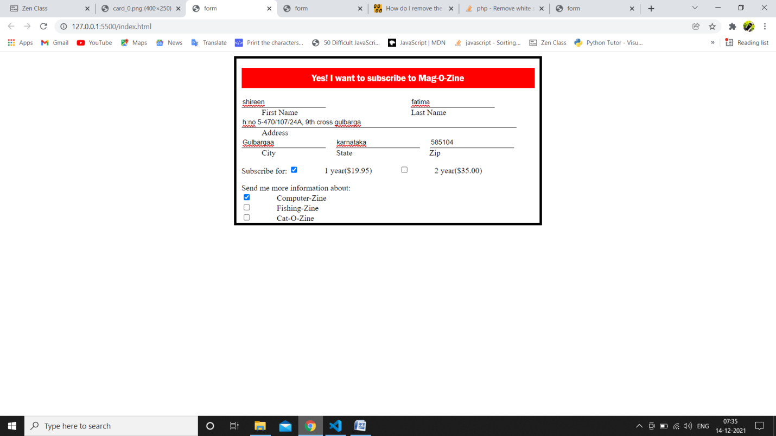

8.

Html code:

<!DOCTYPE html>

<html lang="en">

<head>

    <meta charset="UTF-8">

    <meta http-equiv="X-UA-Compatible" content="IE=edge">

    <meta name="viewport" content="width=device-width, initial-scale=1.0">

    <title>table</title>

    <link rel="stylesheet" href="css/table.css">

<style>

    /* body {

        display: flex;

    } */

    h1{

        text-align: center;

    }

    table {

        width: auto;

        height: 200px;

        /* justify-content: center; */

        margin-left: auto;

        margin-right: auto;

    }

    h1{

        justify-content: cent;

    }

</style>

</head>

<body>

    <h1 style="text-align:center;">health Chart</h1>

    <table  border=" solid 5px black" cellspacing="0" cellpadding="5px">

        <tr>

            <th rowspan="2">State of health</th>

            <th colspan="2">fasting value</th>

            <th>after eating</th>

        </tr>

        <tr>

            <td>Minimum</td>

            <td>Maximum</td>

            <td>2 hr after eating</td>

        </tr>

        <tr>

            <td>heathy</td>

            <td>70</td>

            <td>100</td>

            <td>less than 140</td>

        </tr>

        <tr>

            <td>pre diabetic</td>

            <td>101</td>

            <td>126</td>

            <td>140 to 200</td>

        </tr>

        <tr>

            <td>diabetes</td>

            <td>more than 126</td>

            <td>N/A</td>

            <td>more than 200</td>

        </tr>

    </table>

</body>

</html>

o/p:

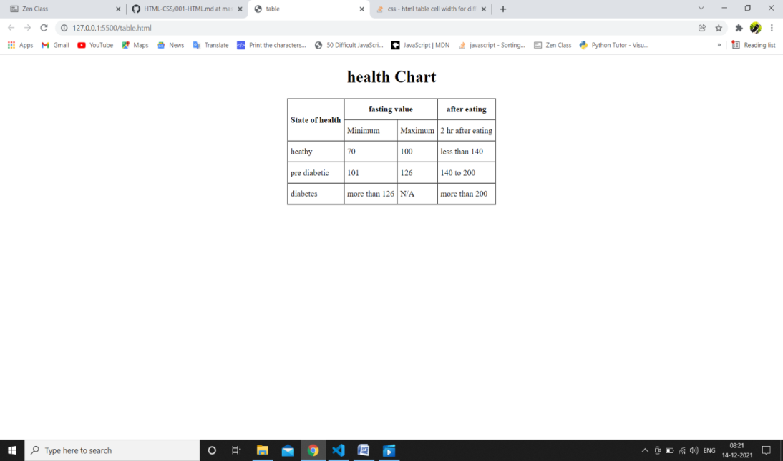

9.

<form action="/action_page.php">  
  <label for="fname">First name:</label>  
  <input type="text" id="fname" name="fname" value="John"><br><br>  
  <label for="lname">Last name:</label>  
  <input type="text" id="lname" name="lname" value="Doe"><br><br>  
  <input type="submit" value="Submit">  
</form>

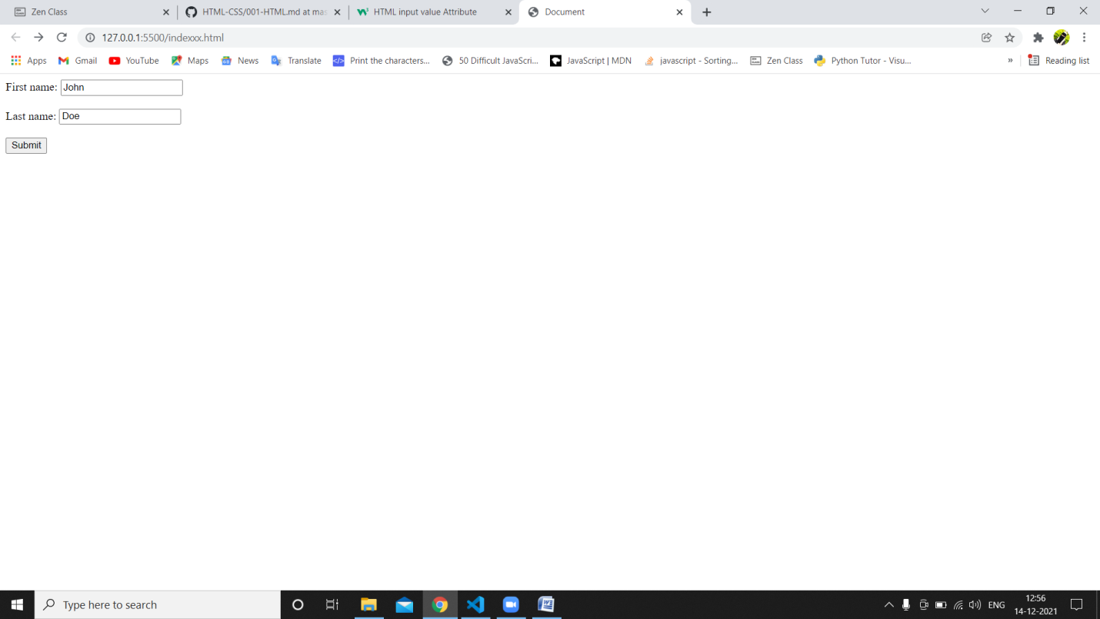

10.

<!DOCTYPE html>

<html lang="en">

<head>

    <meta charset="UTF-8">

    <meta http-equiv="X-UA-Compatible" content="IE=edge">

    <meta name="viewport" content="width=device-width, initial-scale=1.0">

    <title>Document</title>

</head>

<body>

    <div>

        <p>

            <mark>HTML & CSS is awesome</mark>

        </p>

    </div>

</body>

</html>

o/p:

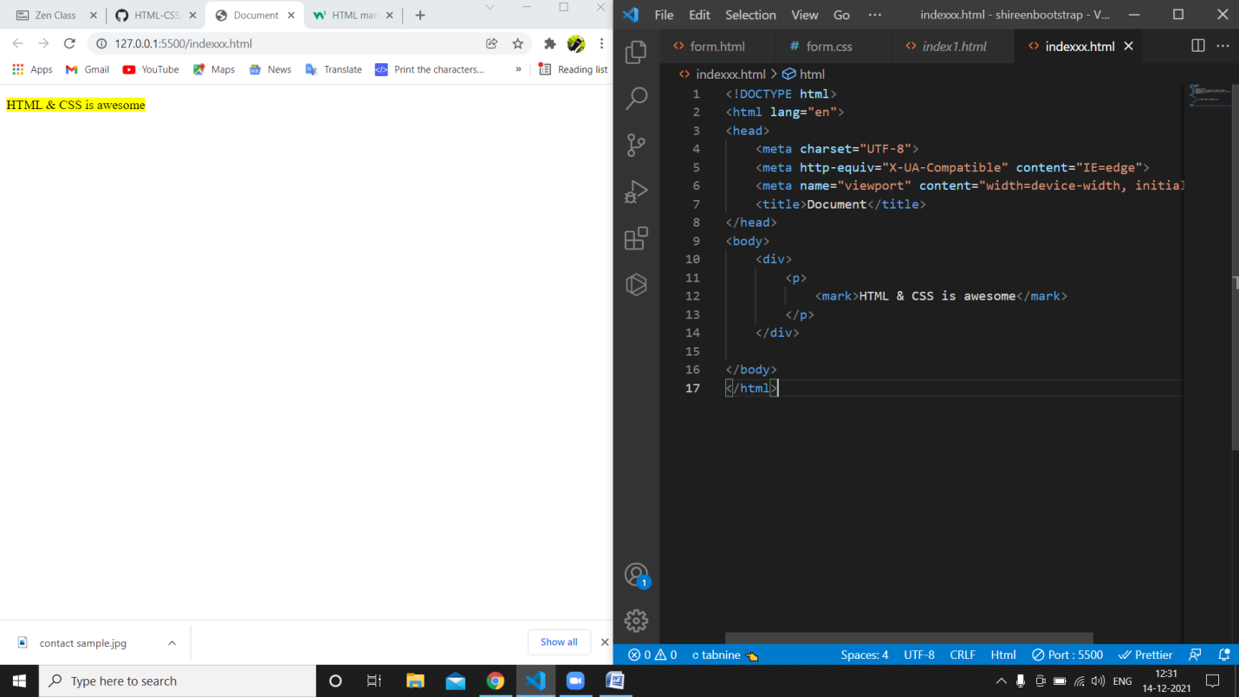

11.

<!DOCTYPE html>

<html lang="en">

<head>

    <meta charset="UTF-8">

    <meta http-equiv="X-UA-Compatible" content="IE=edge">

    <meta name="viewport" content="width=device-width, initial-scale=1.0">

    <title>Document</title>

</head>

<body>

    <form action="/action_page.php">

        <label for="fname">First name:</label>

        <input type="text" id="fname" name="fname"><br><br>

        <label for="lname">Last name:</label>

        <input type="text" id="lname" name="lname"><br><br>

        <label for="date">Date:</label>

        <input type="date" id="current_date" name="current_date"><br><br>

        <label for="time">Time:</label>

        <input type="time" id="time" name="time"><br><br>

        <input type="submit" value="Submit">

      </form>

</body>

</html>

