**Class - Movie**

Code:

class Movie {

constructor(title, studio, rating = "PG") {

this.title = title;

this.studio = studio;

this.rating = rating;

}

getPG = function (arr) {

return arr.filter((m) => {

return m.rating === "PG";

});

};

}

let movie1 = new Movie("Casino Royale", "Eon Productions", "PG13");

let movie2 = new Movie("Avengers", "Disney", "PG15");

let movie3 = new Movie("Fight Club", "Dalmount", "PG18");

let movie4 = new Movie("Avengers End Game", "Disney");

let movie5 = new Movie("Lion King", "Disney");

const arr = [movie1, movie2, movie3, movie4, movie5];

let a = movie1.getPG(arr);

console.log(arr); //returns the array of movies

console.log(a); // return movies with PG rating

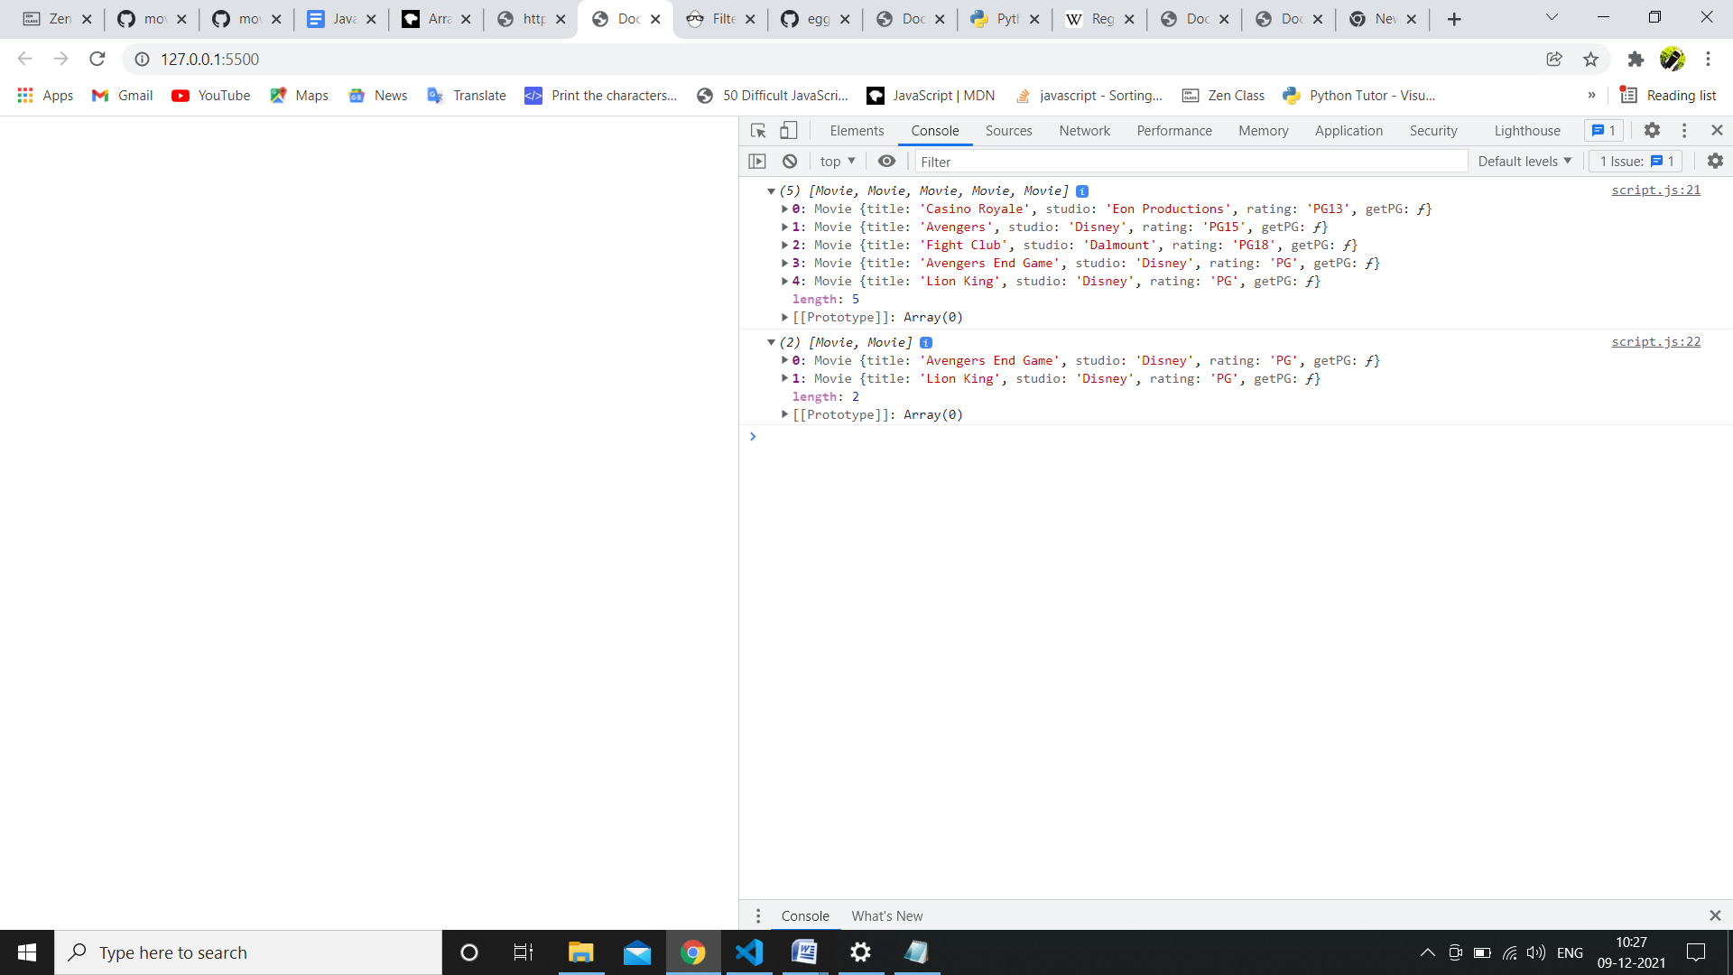

2. <https://github.com/rvsp/typescript-oops/blob/master/Practice/class-circle.md>

Code:

let obj ={

    radius:1,

    color:"red"

}

class Circle{

    getradius(){

        console.log(this.radius);

    }

    setradius(radius){

        this.radius = radius;

        // console.log(this.radius);

    }

    getcolor(){

        console.log(this.color.tostring());

    }

    setcolor(color){

        this.color = color;

        // console.log(color.toString());

    }

    getarea(){

        let area=Math.PI*(this.radius)*(this.radius)

        console.log(area);

    }

    getcircumference(){

        let cir=2*Math.PI*(this.radius);

        console.log(cir);

    }

}

let cirobj=new Circle();

console.log(obj.radius,obj.color);

cirobj.radius=obj.radius;

cirobj.color=obj.color;

console.log(obj.radius,obj.color);

// cirobj.getradius();

cirobj.setradius(2);

// console.log(cirobj.getradius());

cirobj.setcolor("blackk");

cirobj.getarea();

cirobj.getcircumference();

o/p:

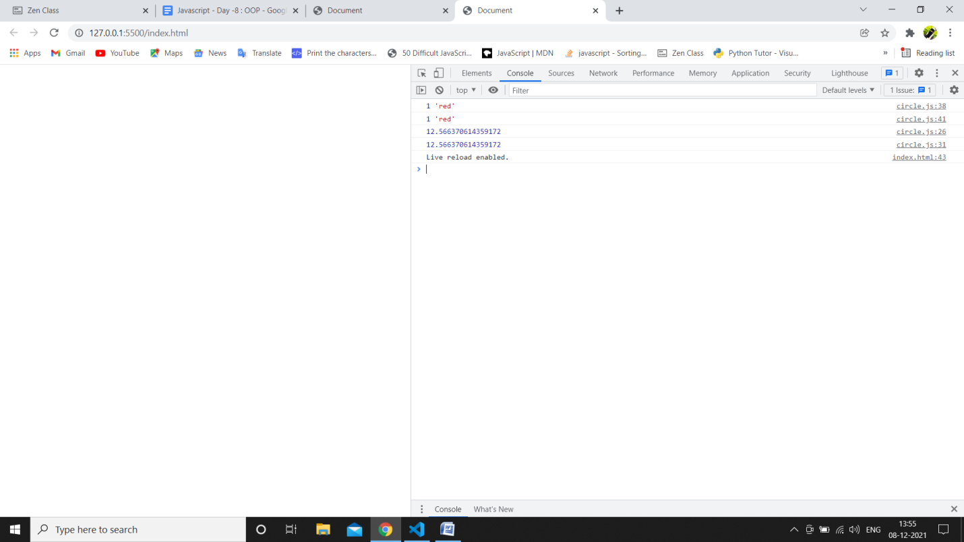

3. Write a “person” class to hold all the details.

class Person{

    constructor(firstname,lastname,age,gender,location){

        this.firstname = firstname;

        this.lastname = lastname;

        this.age = age;

        this.gender = gender;

        this.location = location;

        console.log(`

        name:${this.firstname} ${this.lastname}

        age:${this.age}

        gender:${this.gender}

        location:${this.location}`);

    }

}

let perinfo=new Person("shireen", "fatima",23,"female","gulbarga");

// console.log(perinfo);

o/p:



4. write a class to calculate uber price.

class Uberprice{

    constructor(basefare, costpermin, costpermile, timeofride,ridedistance,surgeboostmultiplier,bookingfee){

        this.basefare = basefare;

        this.costpermin = costpermin;

        this.costpermile = costpermile;

        this.timeofride = timeofride;

        this.ridedistance= ridedistance;

        this.surgeboostmultiplier= surgeboostmultiplier;

        this.bookingfee = bookingfee;

    }

    gettotalcost(){

        let totalcost = (this.basefare)+((this.costpermin * this.timeofride) + (this.costpermile * this.ridedistance) * this.surgeboostmultiplier) + this.bookingfee;

        console.log(totalcost);

    }

}

let uberobj=new Uberprice(3, 5, 15,45,1,3,250);

console.log(uberobj.gettotalcost());

o/p:

