1. Solving problems using array functions on rest countries data.
   1. Get all the countries from Asia continent /region using Filter function
   2. Get all the countries with a population of less than 2 lakhs using Filter function
   3. Print the following details name, capital, flag using forEach function
   4. Print the total population of countries using reduce function
   5. Print the country which uses US Dollars as currency.

a.code:

var xhr = new XMLHttpRequest();

xhr.open('GET',"https://raw.githubusercontent.com/rvsp/restcountries-json-data/master/res-countries.json");

xhr.onload = function() {

    if(xhr.status >=200 && xhr.status< 300){

        var data =JSON.parse(this.responseText);

        // console.log(data);

    var data1=data.filter((element)=>{

            if(element.region==="Asia"){

                console.log(element.name);

            }

        })

    }

    else{

        console.log(xhr.responseText);

    }

};

xhr.send();

o/p:

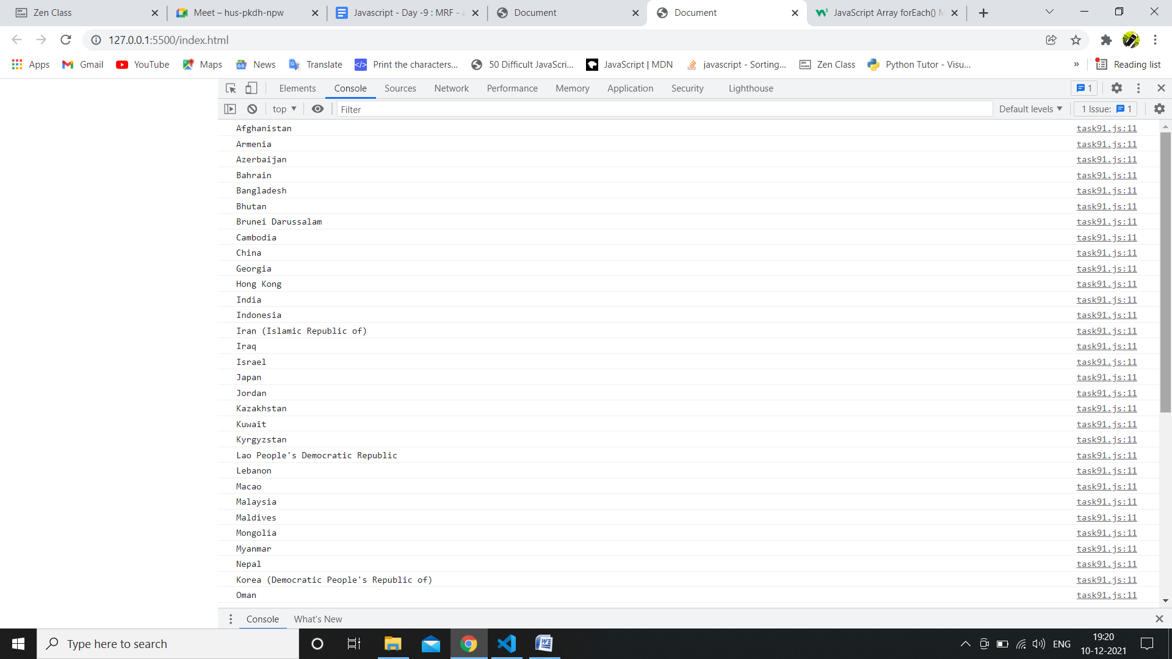

b.code:

// Get all the countries with a population of less than 2 lakhs using Filter function

var xhr = new XMLHttpRequest();

xhr.open('GET',"https://raw.githubusercontent.com/rvsp/restcountries-json-data/master/res-countries.json");

xhr.onload = function() {

    if(xhr.status >=200 && xhr.status< 300){

        var data =JSON.parse(this.responseText);

        console.log(data);

        // for(let i=0; i<data.length; i++){

        //console.log(data[i].flag);

        var data1=data.filter((element)=>{

            // for(let i=0; i<data.length; i++){

                if(element.population<200000){

                    console.log(element.name);

                }

        })

    }

    else{

        console.log(xhr.responseText);

    }

};

xhr.send();

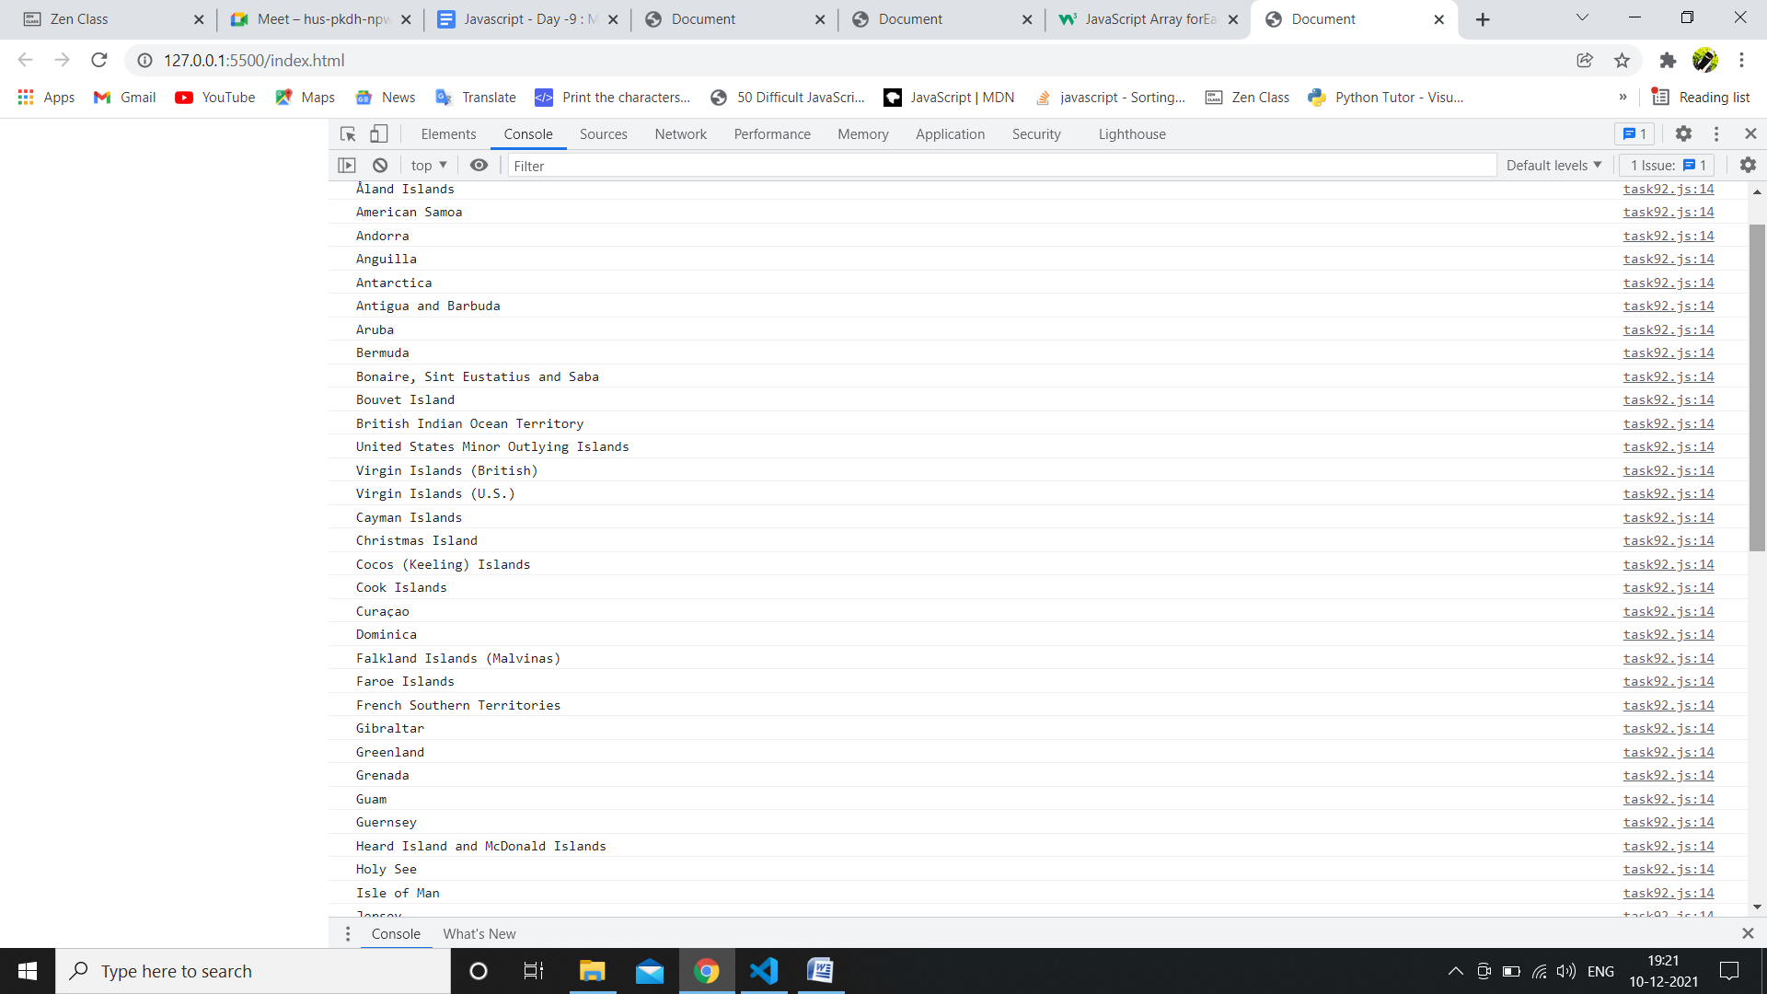

c.code:

var xhr = new XMLHttpRequest();

xhr.open('GET',"https://raw.githubusercontent.com/rvsp/restcountries-json-data/master/res-countries.json");

xhr.onload = function() {

    if(xhr.status >=200 && xhr.status< 300){

        var data =JSON.parse(this.responseText);

        // console.log(data);

        data.forEach(function(nme){

            console.log(`${nme.name}, ${nme.capital}, ${nme.flag}`)

        })

    }

        else{

        console.log(xhr.responseText);

    }

};

xhr.send();

o/p:

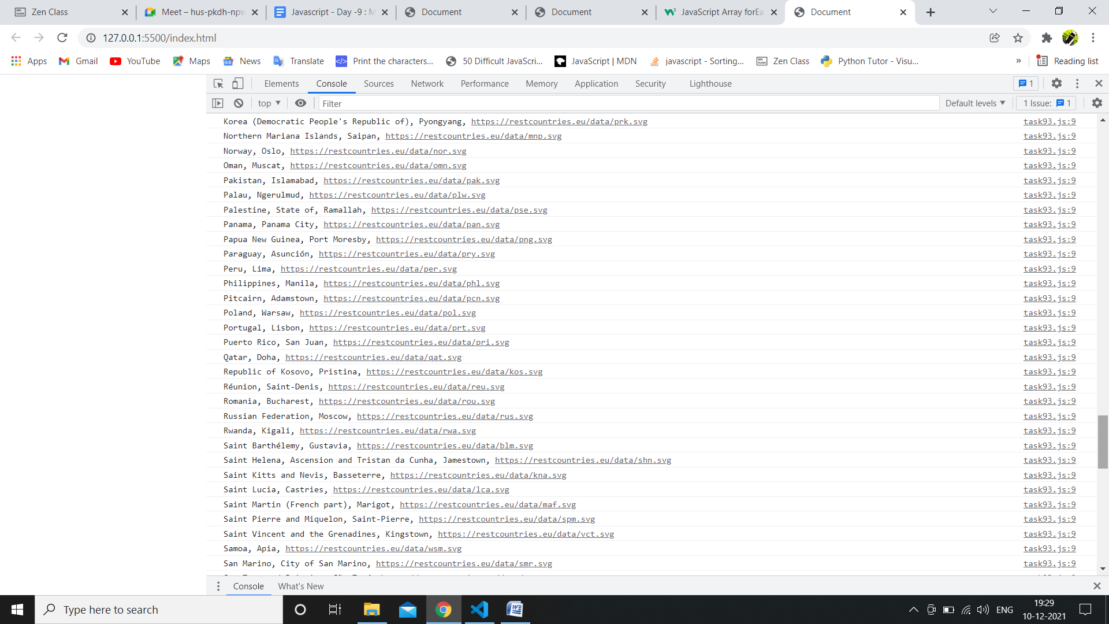

d.code:

var xhr = new XMLHttpRequest();

xhr.open('GET',"https://raw.githubusercontent.com/rvsp/restcountries-json-data/master/res-countries.json");

xhr.onload = function() {

    if(xhr.status >=200 && xhr.status< 300){

        var data =JSON.parse(this.responseText);

        //console.log(data);

        let total = data.reduce((initial,current) =>{

            return initial+current.population;

        },0);

        console.log(total);

    }

        else{

        console.log(xhr.responseText);

    }

};

xhr.send();

o/p:

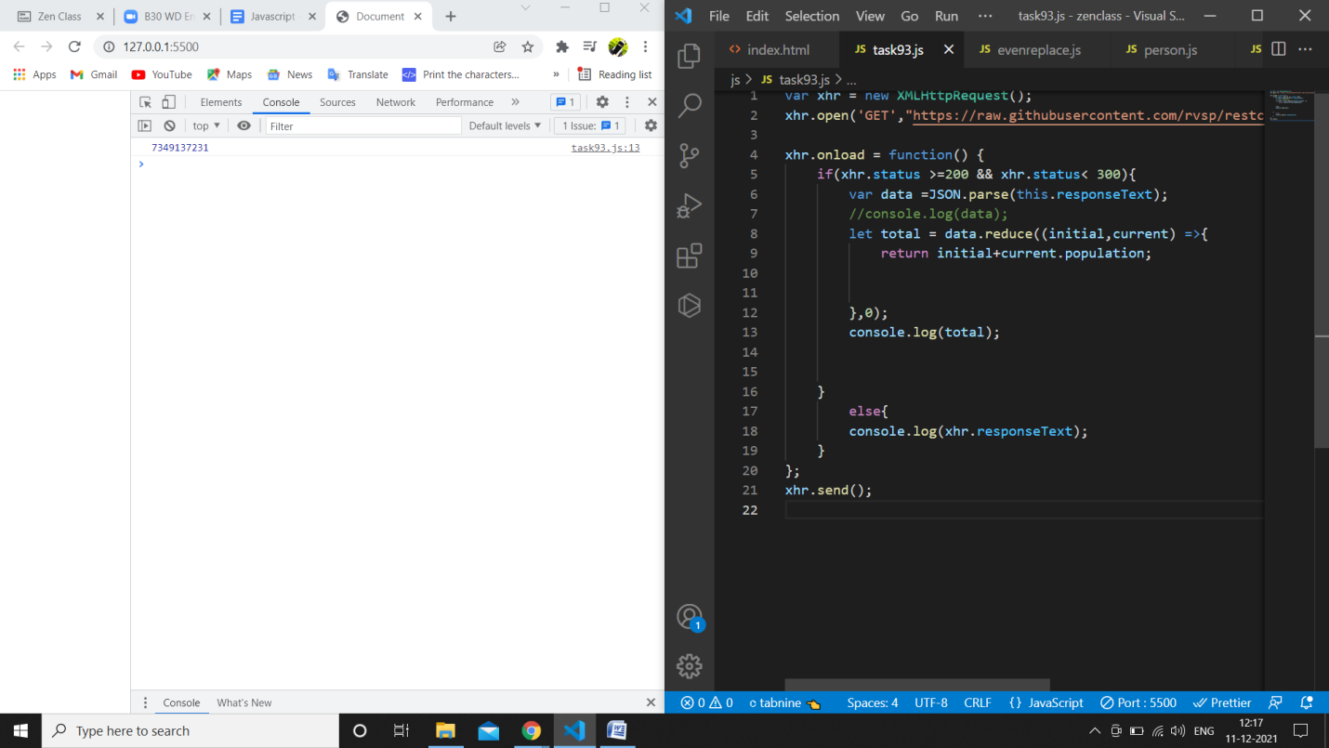

e.code:

var xhr = new XMLHttpRequest();

xhr.open('GET',"https://raw.githubusercontent.com/rvsp/restcountries-json-data/master/res-countries.json");

xhr.onload = function() {

    if(xhr.status >=200 && xhr.status< 300){

        var data =JSON.parse(this.responseText);

        console.log(data);

        var result=data.filter((element)=>{

            for(var i in element.currencies){

                if(element.currencies[i].code==="USD"){

                    return true;

                }

            }

        }).map((element)=>element.name)

        console.log(result);

    }

        else{

        console.log(xhr.responseText);

    }

};

xhr.send();

O/P:

