1. How to compare two JSON have the same properties without order?
   1. var obj1 = { name: "Person 1", age:5 };
   2. var obj2 = { age:5, name: "Person 1" };

CODE:

var obj1 = { name: "Person 1", age:5 };

var obj2 = { age:5, name: "Person 1" };

if(JSON.stringify(obj1)===JSON.stringify(obj2)){

console.log("two JSON having same properties");

}

else{

console.log("two JSON having different properties");

}

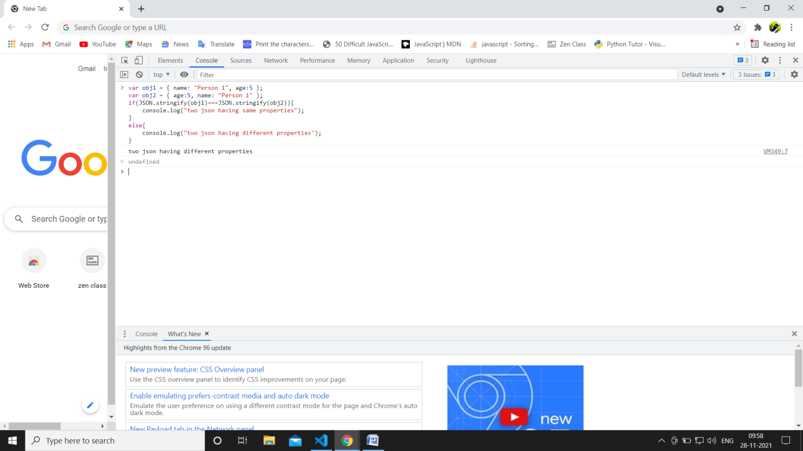

---------------------------------------------------------------------------------------------------------------------

1. Use the rest countries API url -><https://restcountries.eu/rest/v2/all> and display all the country flags in console.

var xhr = new XMLHttpRequest();

xhr.open('GET',"https://raw.githubusercontent.com/rvsp/restcountries-json-data/master/res-countries.json");

xhr.onload = function() {

if(xhr.status >=200 && xhr.status< 300){

var data =JSON.parse(this.responseText);

//console.log(data);

for(let i=0; i<data.length; i++){

console.log(data[i].flag);

}}

else{

console.log(xhr.responseText);

}

};

xhr.send();

output:

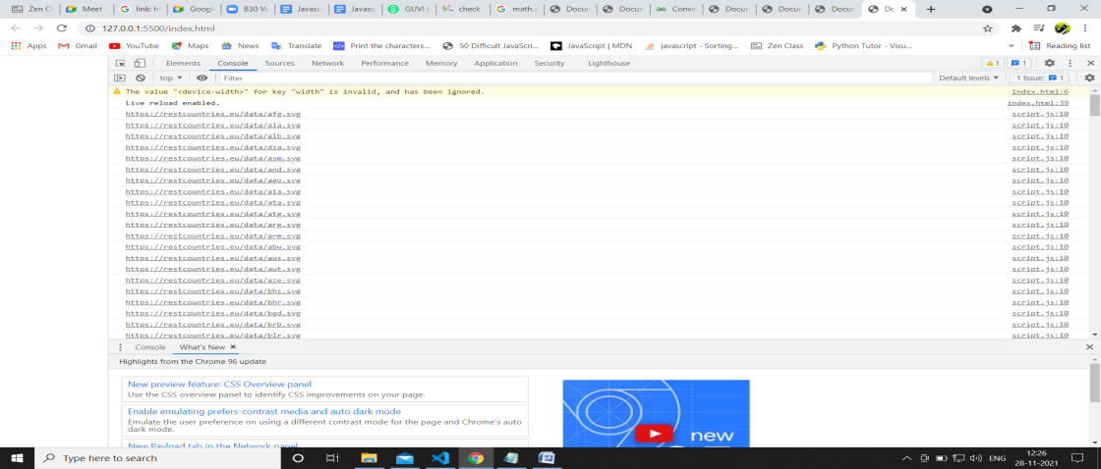

1. Use the same rest countries and print all countries name, region, sub region and population

Code:

//set up a http request object

var xhr = new XMLHttpRequest();

xhr.open('GET',"https://raw.githubusercontent.com/rvsp/restcountries-json-data/master/res-countries.json");

xhr.onload = function() {

if(xhr.status >=200 && xhr.status< 300){

var data =JSON.parse(this.responseText);

console.log(data);

for(let i=0; i<data.length; i++){

console.log(data[i].name, data[i].region, data[i].subregion,data[i].population);

}}

else{

console.log(xhr.responseText);

}

};

xhr.send();

output:

