1. WHAT DO WE UNDERSTAND BY SDLC?

Software development life cycles serve as a structured framework with software organization for building, maintaining, replacing and enhancing software products

Also includes planning, detailing the entire software cycle.

SDLC also helps with streamlining and improves quality for development process

1. Why SDLC?

SDLC is used in providing the final product that is reliable and stable and meeting the quality standards

Also it is useful for understanding and managing the stages of a system existence

1. STAGES OF SDLC?

1**.Planning and analysis**: planning is used to define project scope, set the objective and goals and resource planning.

**2.Defining requirements** : defines the functional requirements and technical requirements

**3.design architecture**: it includes architecture like low level design and high-level design

**4.developing product**: in this process we use the standard coding, scalable code and reviewing the code

**5. Product testing and integration**: this helps in checking the software errors and issues

**6. deployment and maintenance of product**: supports and updates the software by addressing issues or adapt to the user needs and providing the feedback.

1. **Models of SDLC**

* **Water fall model** : water fall development and testing uses steps to plan, execute and maintain the software this method is best suited for small applications rather than the large application   
  development phase cannot begin until the previous phase is completed. We cannot overlap phases in waterfall model.

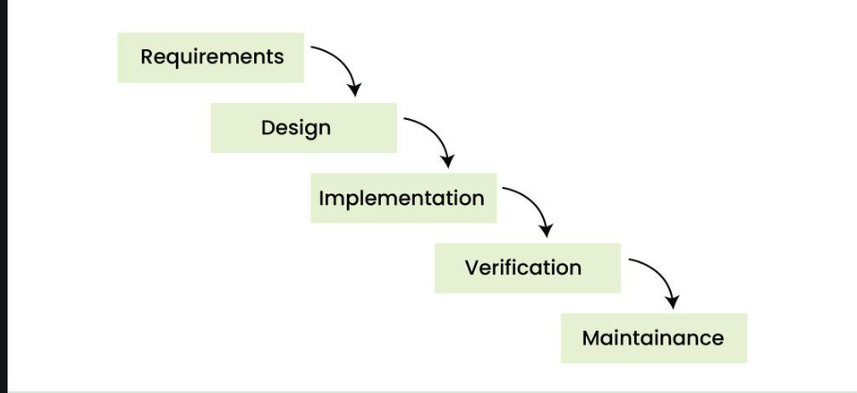

**Applications of waterfall model**

System design

Small scale development

Maintenance

Validation

Verification

**Advantages**   
clear and define process

It is easy for Easy documentation

**Disadvantages**

Not flexible to changes

It is limited user friendly

And not suitable for complex projects

**V- MODEL**

This model is extension of the waterfall model it follows the v shape that includes 2 sections verification and validation   
both the activities run simultaneously and both of them are connected to each other in V-Shape through Coding Phase, hence it is called V-Model.

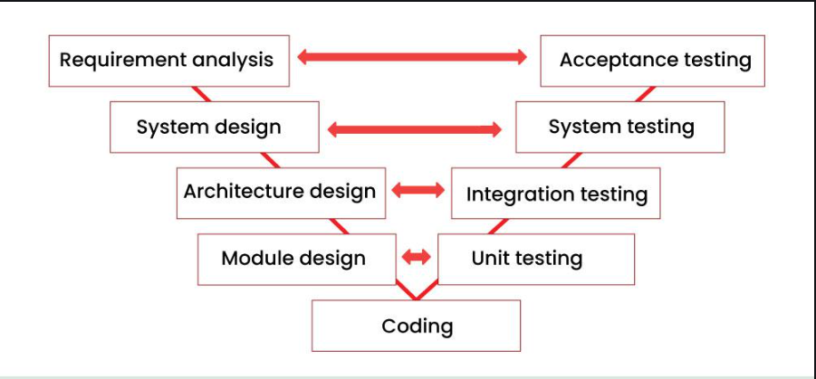

**Applications of v model**

used while designing

used in uat

occurs mostly in testing phase

**advantages**

it helps in detection of defect early

it has a clear documentation

it has improved quality

**disadvantages**

it doesn’t have rework potential

it is not flexible

**Iterative model**

It is basically breaking down the project into smaller components where each is then iterated and tested before merging into final product

In this cycle each component is fully developed from planning and design to testing and deployment

It uses the results of each life cycle for the next iteration created its idea for flexible application

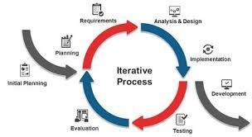

**Model is used in**   
planning

Development

Testing

Review and feedback

Iteration

Advantages

It is easly adaptable to changes

User friendly

It have a improved quality

Disadvantages

Timelines cannot be predicted

Not flexible for small projects

Highly skilled resources

Agile model

The Agile method focuses on being flexible when delivering software. Instead of launching everything at once

Agile allows stages to overlap and includes frequent communication with stakeholders to continually refine requirements

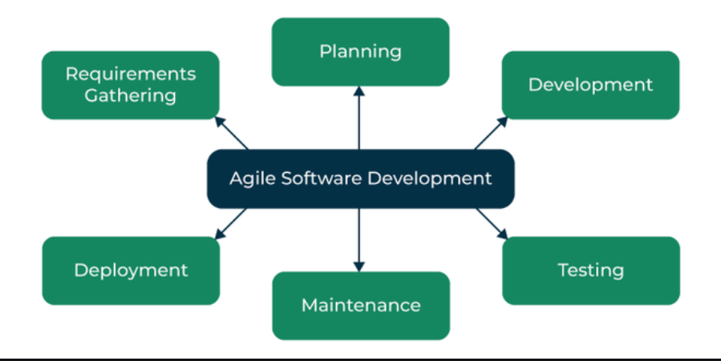

Model is used in   
planning

Development

Testing

Daily stand-up meeting

Sprit review

Advantages

Easily adaptable to changes

Increases team productivity

Provides regular feedback

Disadvantages

Timelines cannot be predicted

Not flexible for small projects

Increases management overhead

**XP MODEL**

In this model aspects pair programming 2 people develop each piece of software at the same workstation

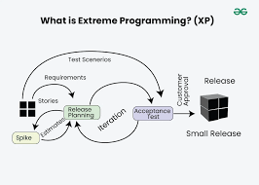

Model is used in

Small releases

Pair programming

Continuous integration

Simple design

Advantages

High quality codes

Flexible changes

Enhanced team communications

Disadvantages

Requires highly skilled team

High resources require

Has limited documentation

**SCRUM**: scrum is basically the framework that the team uses to organize the work towards the goal for initiation, planning, implementing, reviewing and releasing.

Work is organized in the short iterations called “sprints”

**Sprint**: basically, sprints are the time constraints where team has to work and achieve the goal

**Dos and don’ts in sprints**

**Do’s:**

understanding the team capacity and avoid over committing

Avoiding the backlogs

Team commitment and focus

**Don’ts**

Don’t change the goal of sprints

Shouldn’t ignore the concern raised by the team

Choose manageable work don’t over load the sprint

**Backlogs / stories in sprints**

It’s a list of work that team plans to complete during a project sprint or the tasks that needs to be completed with a given amount of time constraints

Scrum artifacts

1 product backlog: it is an important list of work the team needs to deliver the product, it provides a clear roadmap for product development

Example: features to add to app

2 sprint backlogs: it is the items that the development team plans to work

3 increments: it is the result of the sprint which includes all the completed product backlog items

4.burndown chart: A visual representation of the progress made on a Sprint

To track our goals

**PORTS AND PROTOCOLS**

**PORTS:** ports are identified as a specific process or services on a computer they act as data transfer between devices and applications

Port is a logical address of a 16-bit unsigned integer that is allotted to every application on the computer that uses the internet to send or receive data.

**Protocols**: defined rules and procedures for the data transfer

Computer network is basically which connects many computers to share information or data through cable or wireless

**NETWORK TYPES**

Personal area network – connects around single person ex Bluetooth

Local area network – connects within geographical area like building or office

Metropolitan area networks – connects network across cities

Wide area networks – connects large geographical areas like country to country

Virtual private network – creates a secure private connection over public network

**What are the types of servers?**

Server is a computer that provides information to other computers

Types of servers

1 web server : this server basically host and delivers websites these servers delivers web pages to users through internet

2 mail servers : these servers handels email communications , for receiving and delivering

3 data base servers : serves and manage data like sql

4 application servers these servers managaesoftware applications

5 file server :stores and manages files

6 dns server : translates domain names into ip address allowing users to access websites

**What do you know about DNS? Domain Name System**

DNS turns domain names into ip addresses which allows browsers to get to websites

It translates human-friendly domain names like www.example.com into machine-readable IP addresses such as 192.0.2.1, enabling browsers and other applications to locate and connect to websites and services.

**Types of network topologies**

1. bus topology:

* All devices connects to a single cable and acts as a communication
* This topology is easy to install

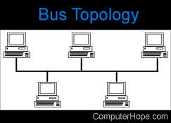

1. star topology:

* devices connect to a central hub or switch with communication flowing through the central point
* Adding or removing devices is straightforward

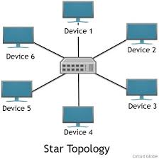

1. ring topologies:

* devices connect in circular manner with data flowing in one direction
* In this data flows in one direction which reduces the chance of packet collisions.

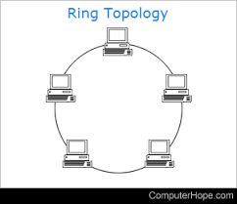

1. mesh topology :

* Each device is connected to multiple devices
* Data can be routed through different paths   
  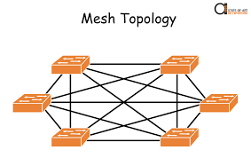

1. tree topology

* devices are structured with a central root node branch like a tree
* Efficient data transfer
* The central root node acts as the hub for the entire network, connecting to multiple nodes

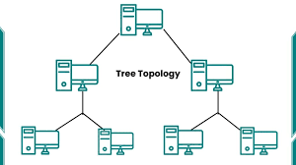

1. hybrid topology :

* combines elements of two or more topologies
* This can offer a balance of cost, performance, and scalability for a wide range of scenarios.

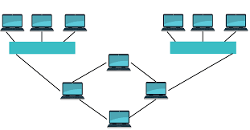

What is OSI Model?

Open systems interconnections is the frame work that describes how data communication occurs throughout the network

OSI MODEL basically includes 7 layers

1. Physical layer: this is the lowest layer encodes the signals and stores the information in the form of bits

This layer is responsible for transmitting bits from one node to next

Transmission of the data over the physical media ex : wifi

1. Data link layer: this layer is responsible for the node-to-node transfer of message

Defines the format of data on the network

2 sub layers are – MAC, LLC

1. Network layer: choose best routes for transmission of data from one host to another from different network

It chooses the shortest path to transfer the packets

1. Transport layer: here the data transmission is over the network using TCP or UDP
2. Session layer: Maintains connection and is responsible for controlling ports and session.
3. Presentation layer: this layer is responsible for translation, encryption and data compression for the application layer .It ensures data is in usable format
4. Application layer: these is the final layer which is implemented by network applications

Applications are ready for the users to use ex: google chrome