Mongod –version

Mongod

Mongosh

* **To create database**

Use school

* **To create collection**

db.students.insertOne(

{

“name”:”siri”,

“age’:20

}

)

* **To see which db we are in**

db

* **To see collections**

Show collections

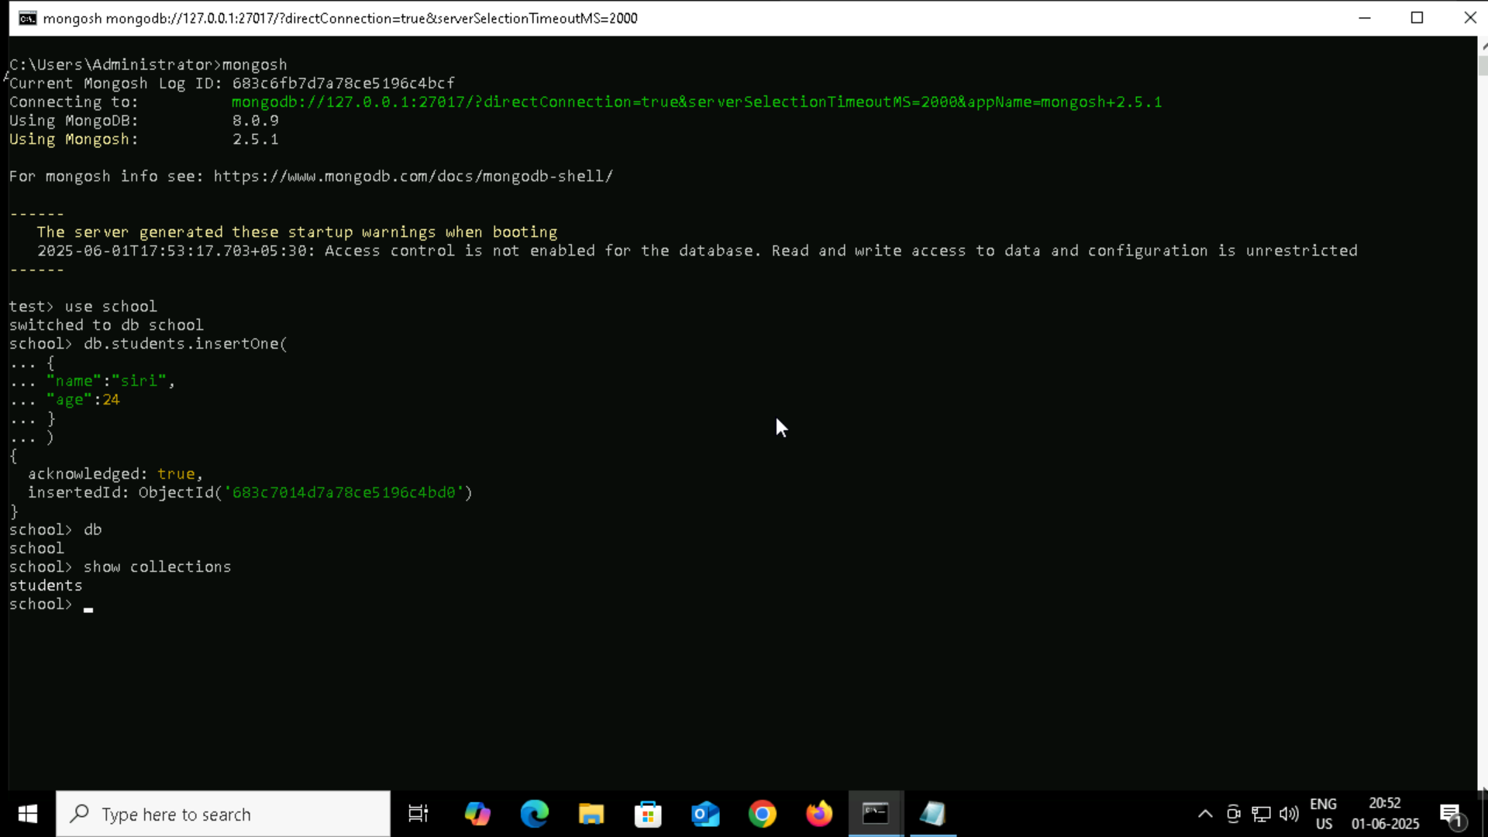

* **CURD operations**

Create: insertOne() , insertMany()

Read: find(),findOne()

Update: updateOne() , updateMany()

Delete: deleteOne(),deleteMany()

* **Sample document for insertOne**

**Syntax**: db.collectionname.insertOne({})

db.teachers.insertOne(

{

name:"roger",

subject:"maths"

}

)

* Sample document for insertMany

Syntax: db.collectionname.insertMany({},{}…)

db.teachers.insertMany([

{

name:"roger",

subject:"maths"

},

{

name:"anita",

subject:"chemistry"

},

{

name:"thomas",

subject:"physics"

},

{

name:"tina",

subject:"maths"

},

{

name:"jonty",

subject:"english"

}

]

)

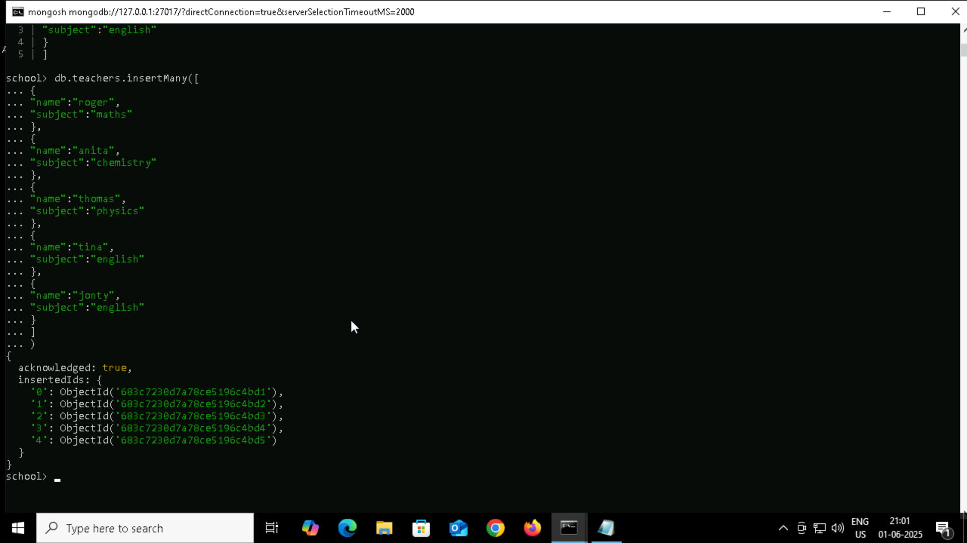

**READ**

db.collectionname.find({})

**UPDATE**

UpdateOne()

Syntax : db.collectionname.updateOne({},{})

db.cars.updateOne(

{model: “Nexon”},

{$set:{colour:”red”}}

)

db.cars.updateOne(

{model: “Nexon”},

{$push:{features:”red”}}

)

$push to push the data

$set : to set

**UpdateMany()**

db.cars.updateMany({},$set:{}}}

**Delete**

deleteOne()

db.cars.deleteOne({fule_type:”petrol”})

db.cars.deleteMany({fule_type:”petrol”})

db.aggregateproduct.insertMany( [

{ product: "register", quantity: 25, size: { height: 14, weight: 21, unit: "cm" }, status: "A" },

{ product: "book", quantity: 50, size: { height: 8.5, weight: 11, unit: "in" }, status: "A" },

{ product: "sheet", quantity: 100, size: { height: 8.5, weight: 11, unit: "in" }, status: "D" },

{ product: "timetable", quantity: 75, size: { height: 22.85, weight: 30, unit: "cm" }, status: "D" },

{ product: "envelop", quantity: 45, size: { height: 10, weight: 15.25, unit: "cm" }, status: "A" },

{ product: "register", quantity: 25, size: { height: 14, weight: 21, unit: "cm" }, status: "A" },

{ product: "book", quantity: 50, size: { height: 8.5, weight: 11, unit: "in" }, status: "A" },

{ product: "sheet", quantity: 100, size: { height: 8.5, weight: 11, unit: "in" }, status: "D" },

{ product: "timetable", quantity: 75, size: { height: 22.85, weight: 30, unit: "cm" }, status: "D" },

{ product: "envelop", quantity: 45, size: { height: 10, weight: 15.25, unit: "cm" }, status: "A" },

{ product: "register", quantity: 25, size: { height: 14, weight: 21, unit: "cm" }, status: "A" },

{ product: "book", quantity: 50, size: { height: 8.5, weight: 11, unit: "in" }, status: "A" }

]);

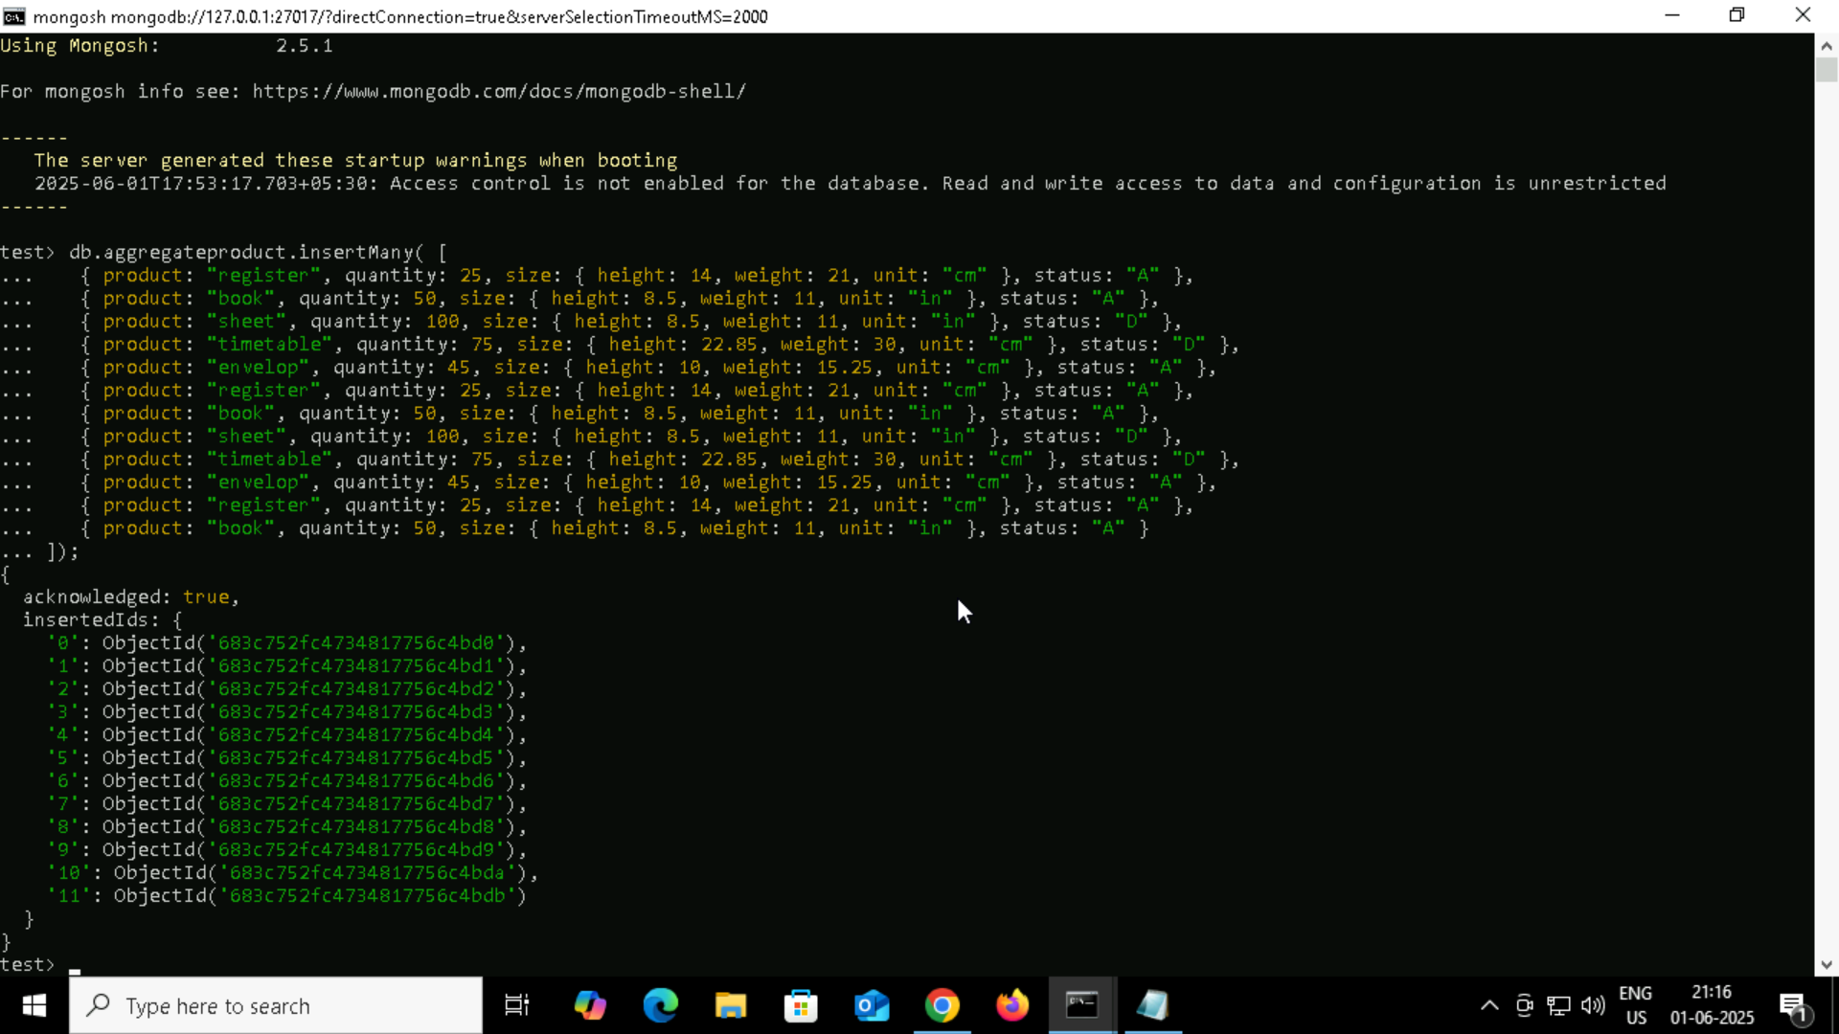

db.aggregateproduct.aggregate([

{ $match: { status: "A" } },

{ $group: { _id: "$product", total: { $sum: "$quantity" } } }

])

db.aggregateproduct.aggregate([

{ $match: { status: "A" } },

{ $group: { _id: "$product", total: { $sum: "$quantity" } } },

{$sort : { total : 1 }

}

])

db.aggregateproduct.aggregate([

{ $match: { status: "A" } },

{ $addFields: {

maxWeight: { $max: "$size.weight" },

minSizeHeight: { $min: "$size.height" }

} }

])

db.aggregateproduct.aggregate([

{ $match: { status: "A" } },

{ $addFields: {

maxQ: { $max: "$quantity" },

minSizeHeight: { $min: "$size.height" }

} }

])

db.aggregateproduct.aggregate([

{ $project : { product : 1,quantity : 1 } } , //optional line

{ $group: { _id: "$product", total: { $sum: "$quantity" } } },

{$sort : { total : 1 }

}

])

firstdb> db.aggregateproduct.aggregate([

... { $project : { product : 1,quantity : 1 } } ,

... { $group: { _id: "$product", total: { $sum: "$quantity" } } },

... {$sort : { total : 1 }

... }

... ])

[

{ _id: 'register', total: 75 },

{ _id: 'envelop', total: 90 },

{ _id: 'book', total: 150 },

{ _id: 'timetable', total: 150 },

{ _id: 'sheet', total: 200 }

]

firstdb> db.aggregateproduct.aggregate([{ $group: { _id: "$product", total: { $sum: "$quantity" } } }, { $sort: { total: 1 } }] )

[

{ _id: 'register', total: 75 },

{ _id: 'envelop', total: 90 },

{ _id: 'book', total: 150 },

{ _id: 'timetable', total: 150 },

{ _id: 'sheet', total: 200 }

]

