DAY1_ JAVA
Task1
Wap to display greetings
package day1_java;
public class task001 {
public static void main(String[] args){
System.out.println("hello this is my first code");
System.out.println("i am siri");
}
}
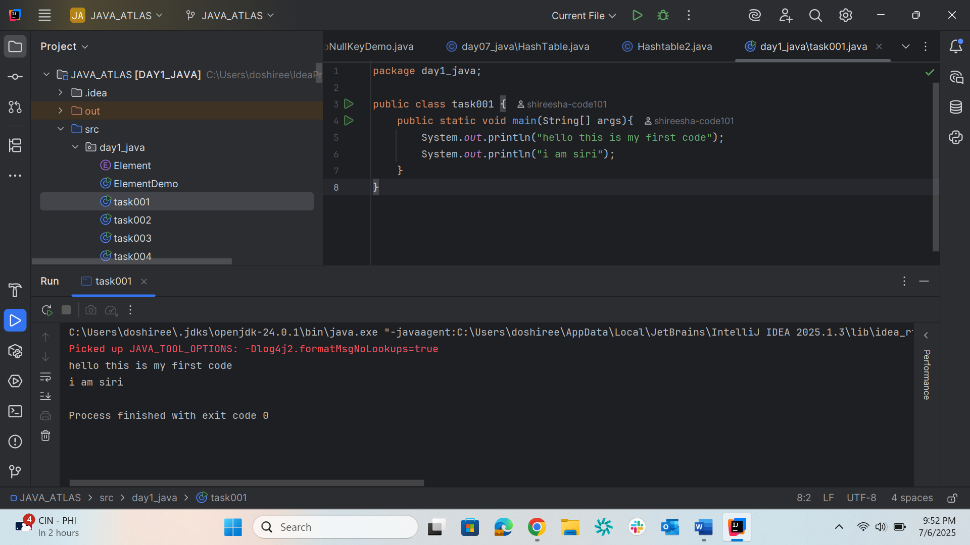

Task02
Wap to create a add method and call the method 3 times
Hint in method add declare variables and display them
package day1_java;
public class task002{
public static void add(int a,int b){
int sum = a + b;
System.out.println("sum is :" + sum);
}
public static void main(String[] args){
add(2,4);
add(3,4);
add(10,20);
}
}

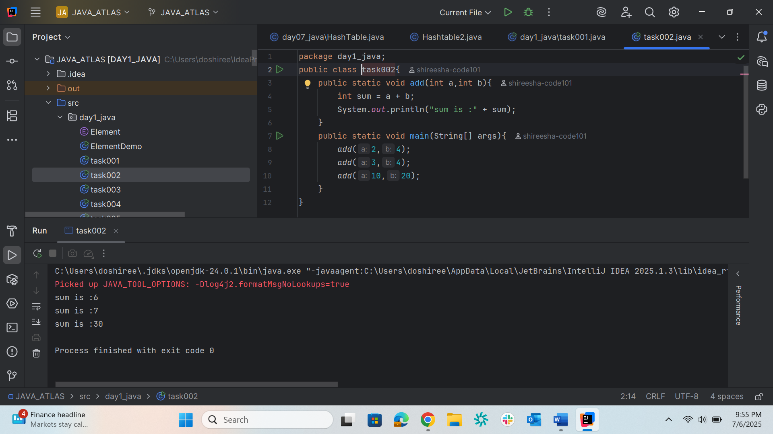
Task003
Write a Program in Java to Add two Numbers.
Input: 2 3
Output: 5
package day1_java;
public class task003 {
public static void main(String[] args) {
int a = 2;
int b = 3;
int sum = a + b;
System.out.println("the sum is :" + sum);
}
}

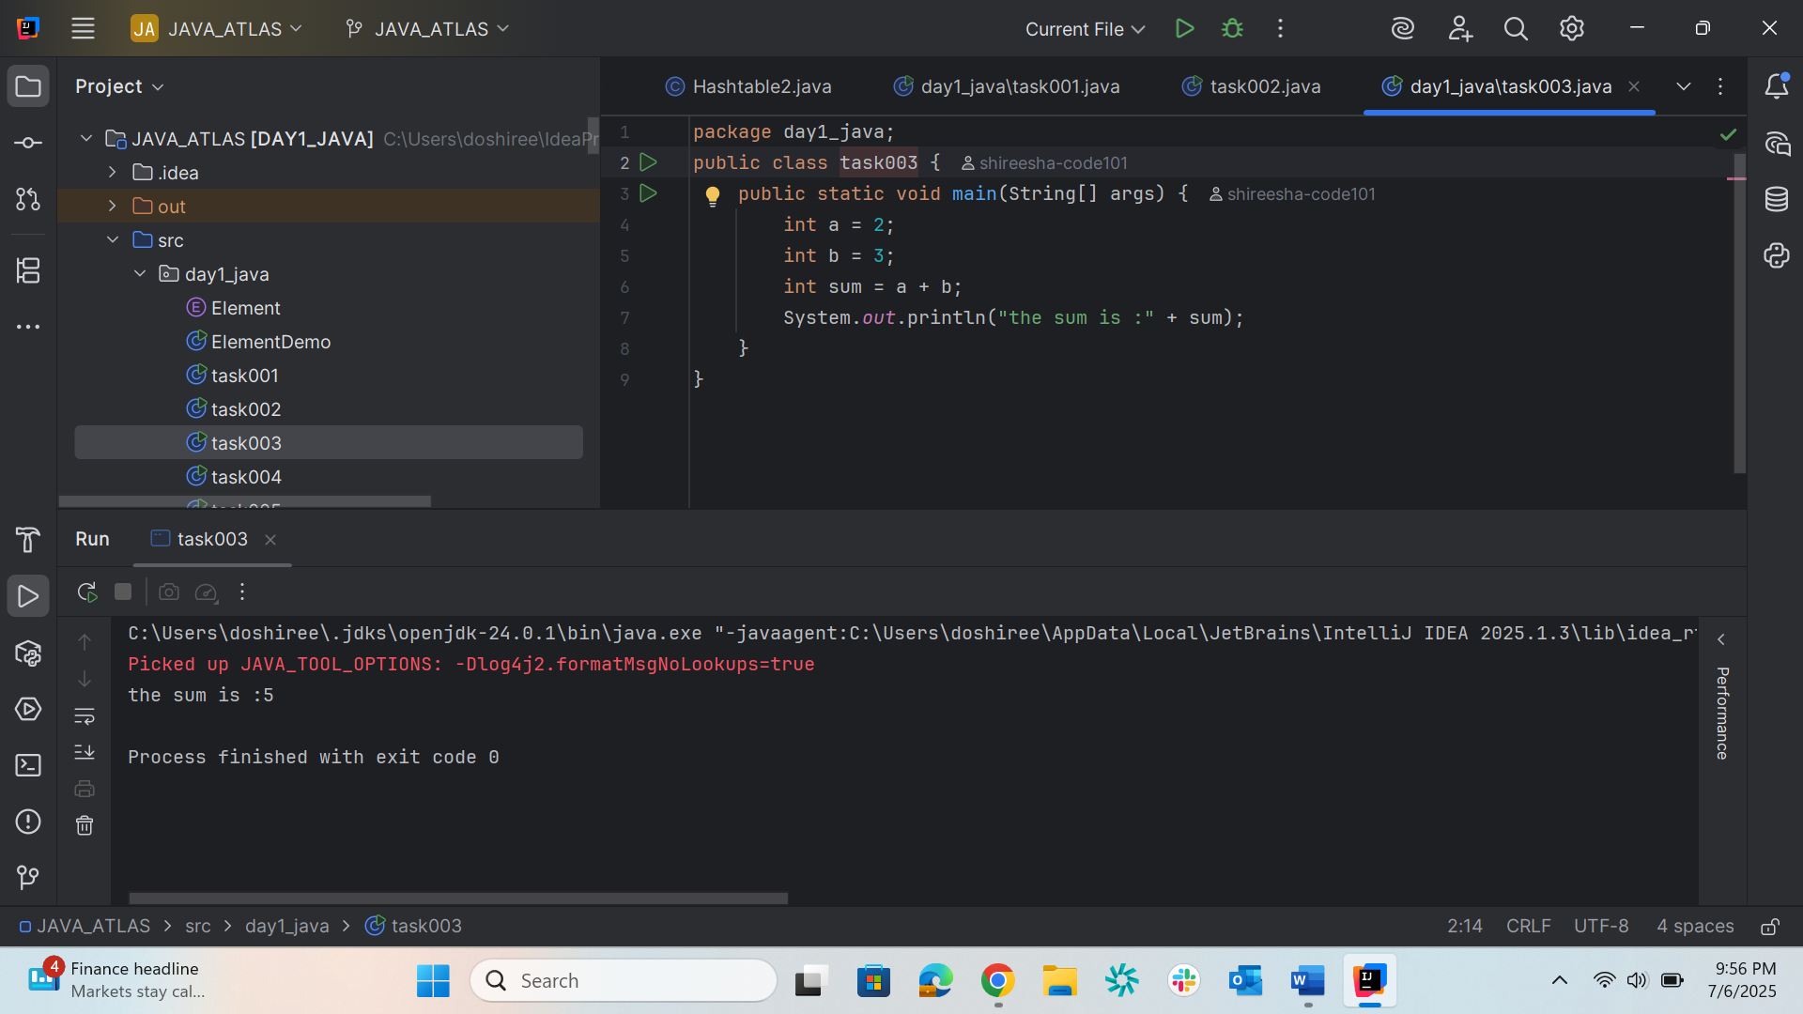

//swap 2 numbers
Task005
package day1_java;
public class task004 {
public static void main(String[] args){
int a = 2;
int b = 5;
System.out.println("before swap :a :" + a + " b : " + b);
int temp = a;
a=b;
b=temp;
System.out.println("after swap : a :" + a + " b :" + b);
}
}
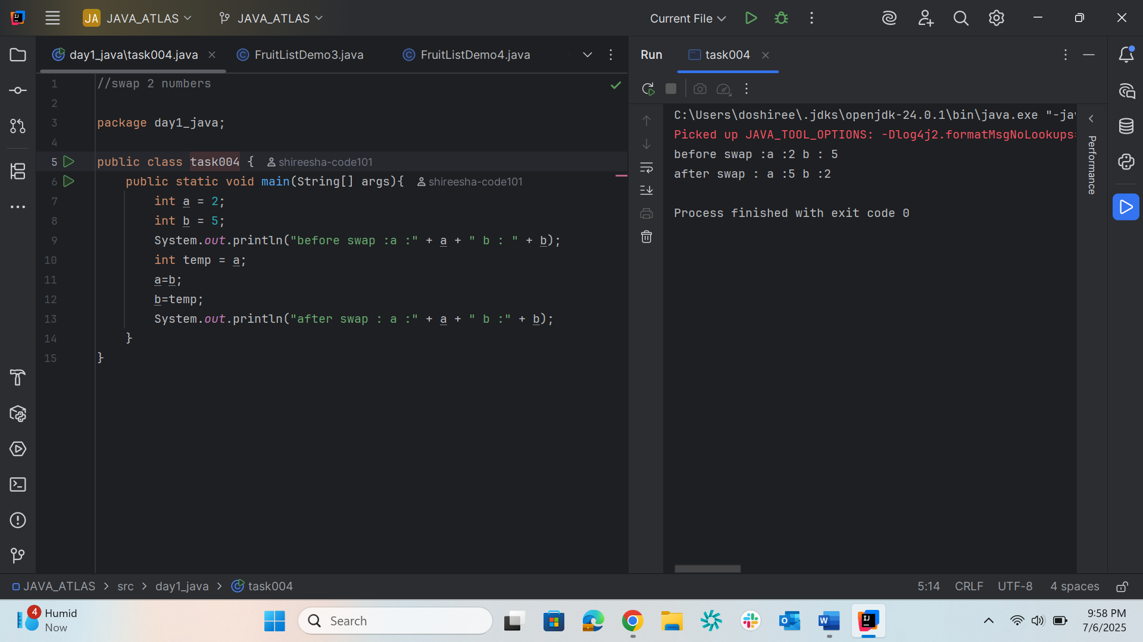

/*Create a code in which you have 4 methods add,
subtract, multiply and divide (return type int)
with a main method to call all the other methods*/
Task006
package day1_java;
public class task005 {
// Method to add two numbers
public static int add(int a, int b) {
return a + b;
}
// Method to subtract two numbers
public static int subtract(int a, int b) {
return a - b;
}
public static int multiply(int a, int b) {
return a * b;
}
public static int divide(int a, int b) {
if (b != 0) {
return a / b;
} else {
System.out.println("Error: Division by zero");
return 0;
}
}
public static void main(String[] args) {
int num1 = 20;
int num2 = 5;
System.out.println("Addition: " + add(num1, num2));
System.out.println("Subtraction: " + subtract(num1, num2));
System.out.println("Multiplication: " + multiply(num1, num2));
System.out.println("Division: " + divide(num1, num2));
}
}

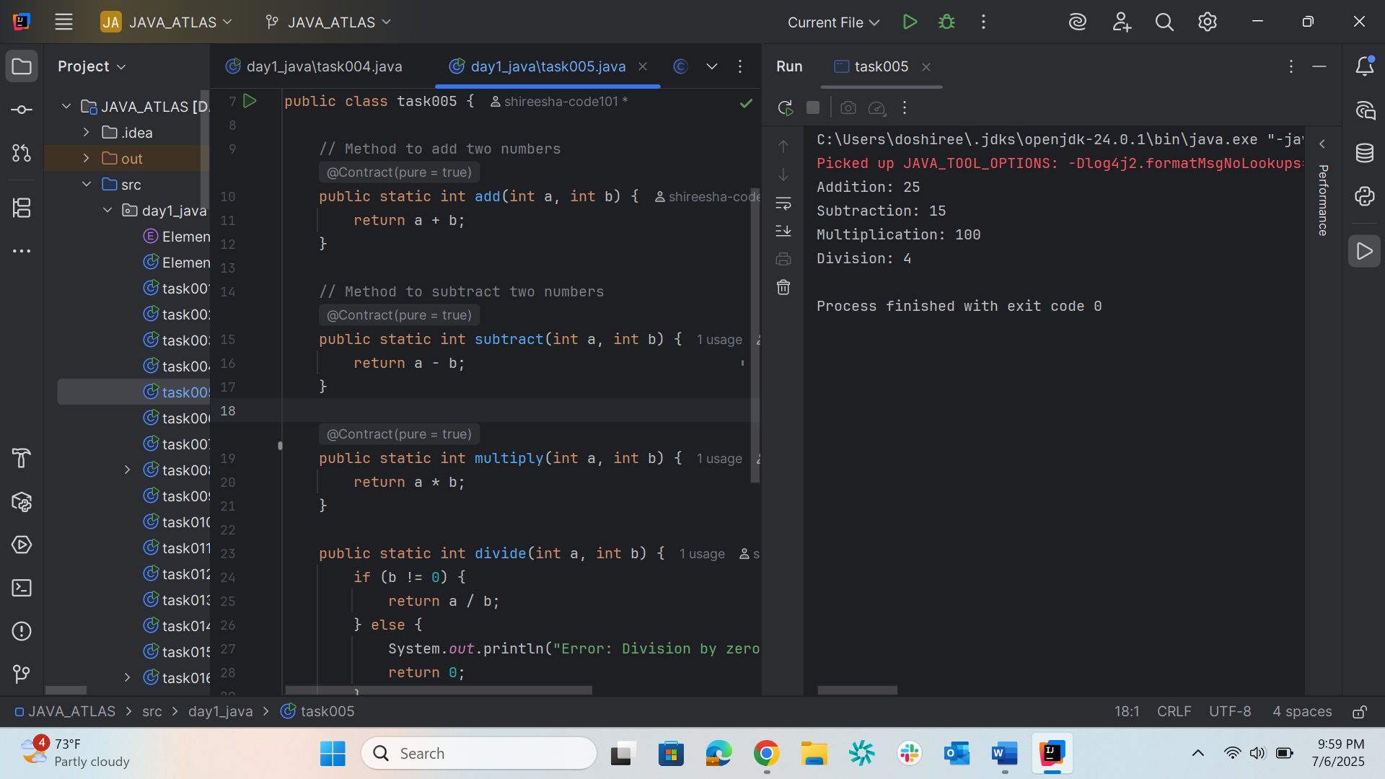

//Write a program to check if a is greater or b Use ternary op
Task006
package day1_java;
public class task006 {
public static void main(String[] args) {
int a = 10;
int b = 15;
String result = (a > b) ? "a is greater" : (a < b) ? "b is greater" : "a and b are equal";
System.out.println(result);
}
}
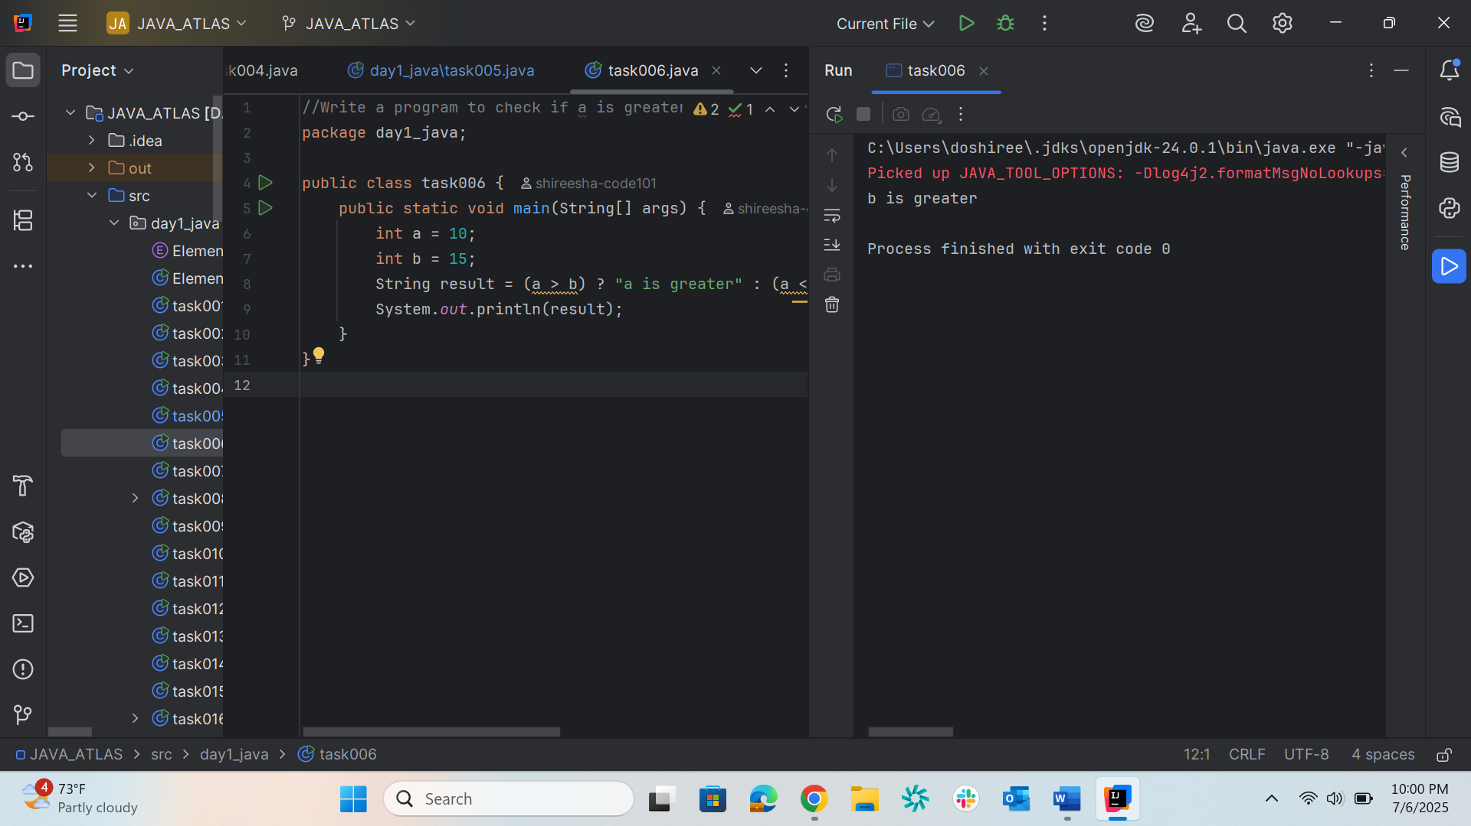

//Write a program to take input from the user and display it to the user
Task007
package day1_java;
import java.util.Scanner;
public class task007 {
public static void main(String[] args){
Scanner scanner = new Scanner(System.in);
System.out.print("enter your login id: ");
String loginID = scanner.nextLine();
System.out.print("enter your password: ");
String password = scanner.nextLine();
System.out.println("your login is" + loginID);
System.out.println("password is : +" + password);
}
}
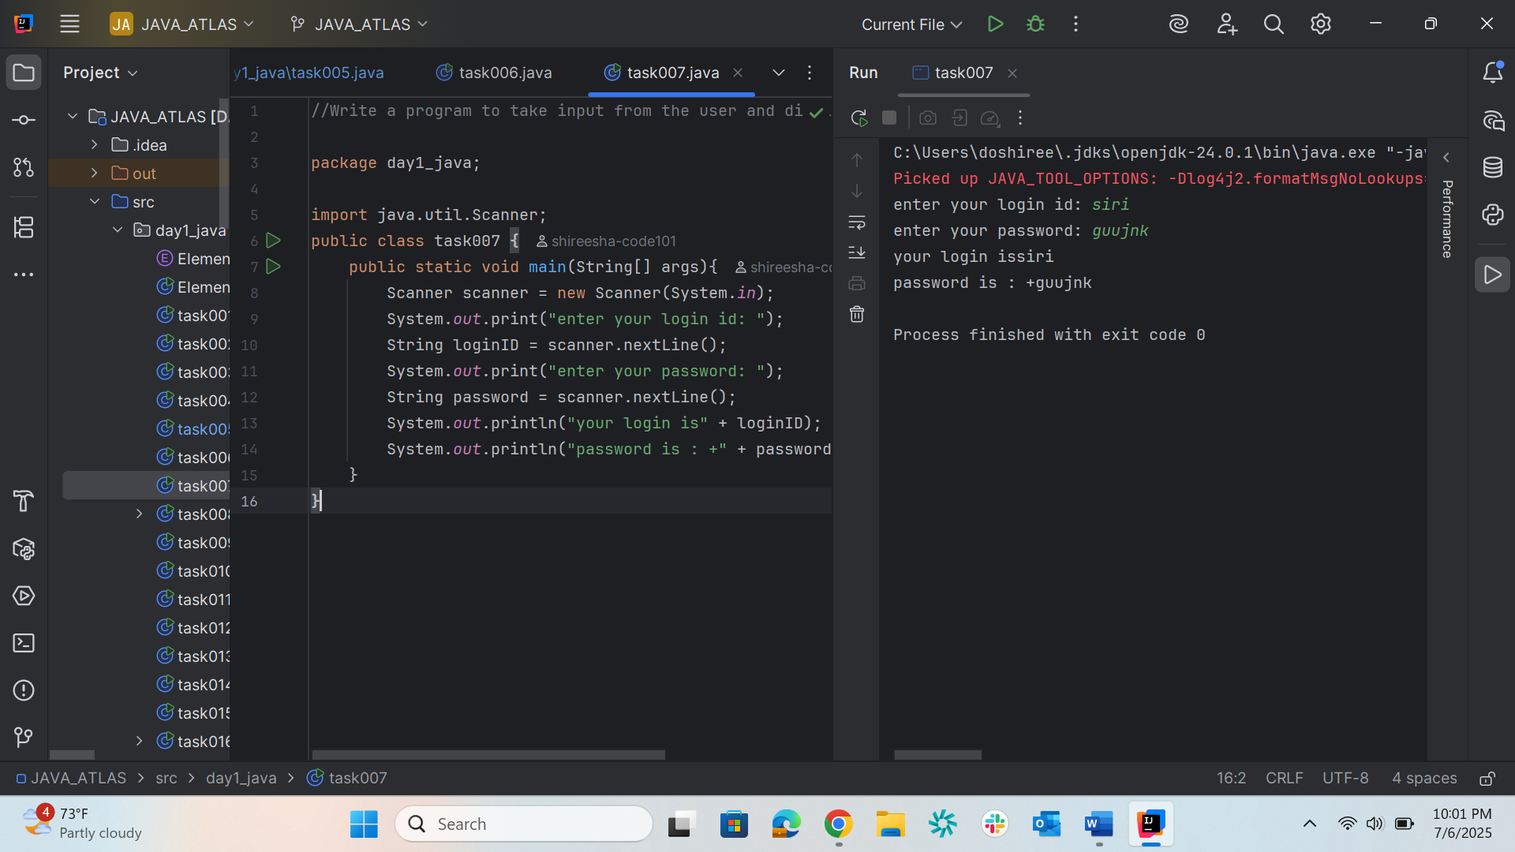

/*Write a program to create a class named Customer
Call the customer class in Task008 class using an object.
*/
Task008
package day1_java;
public class task008 {
public static void main(String[] args) {
Customer cobj = new Customer();
cobj.accept();
cobj.display();
}
}
class Customer {
void accept() {
System.out.println("accept customer called");
}
void display() {
System.out.println("display customer called");
}
}

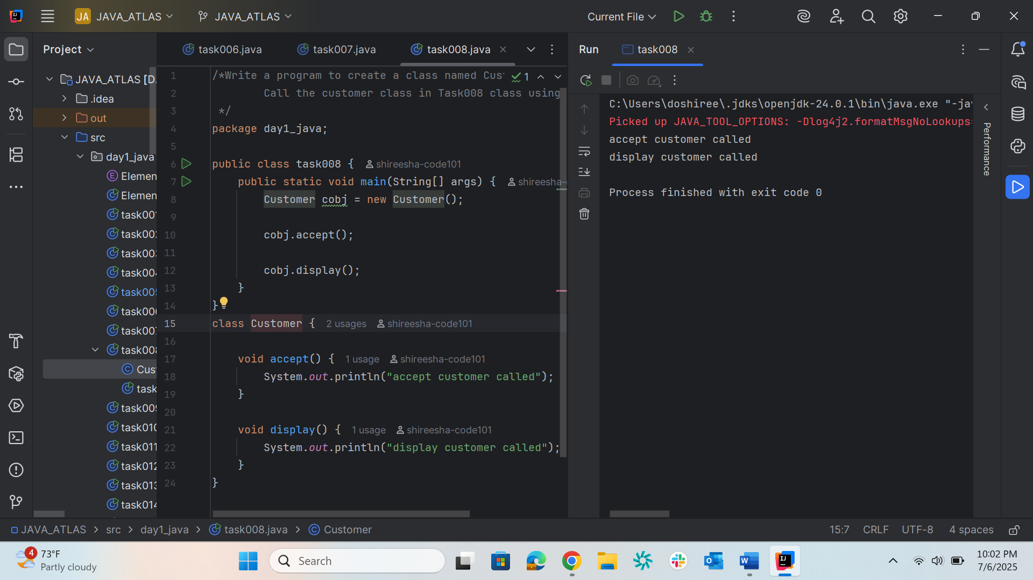

//Wap to check the greater of 2 numbers
Task009
package day1_java;
import java.util.Scanner;
public class task009 {
public static void main(String[] args) {
Scanner scanner = new Scanner(System.in);
System.out.print("enter the first number: ");
int num1 = scanner.nextInt();
System.out.print("enter the second number: ");
int num2 = scanner.nextInt();
if(num1 > num2)
{
System.out.println("num1 is greater :" + num1);
}
else
{
System.out.println("num2 is greater :" + num2);
}
}
}
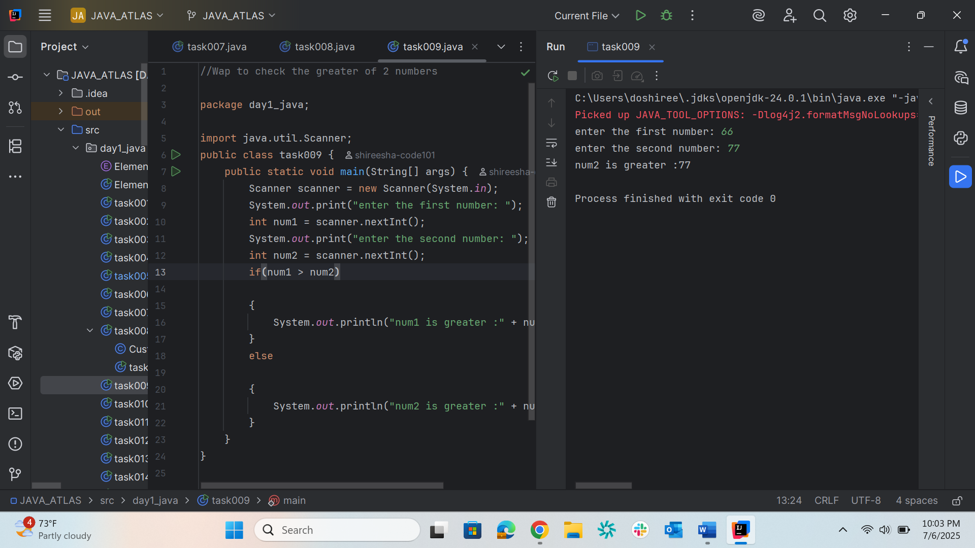

/*Wap to check greater of 3 numbers
Hint 👍
Use elseif*/
Task010
package day1_java;
import java.util.Scanner;
public class task010 {
public static void main(String[] args) {
Scanner scanner = new Scanner(System.in);
System.out.print("enter the first number: ");
int num1 = scanner.nextInt();
System.out.print("enter the second number: ");
int num2 = scanner.nextInt();
System.out.print("enter the third number: ");
int num3 = scanner.nextInt();
if(num1 >= num2 && num1 >= num3)
{
System.out.println("num1 is greater :" + num1);
}
else if(num2 >= num1 && num2 >= num3)
{
System.out.println("num2 is greater :" + num2);
}
else
{
System.out.println("num3 is greater: " + num3);
}
}
}
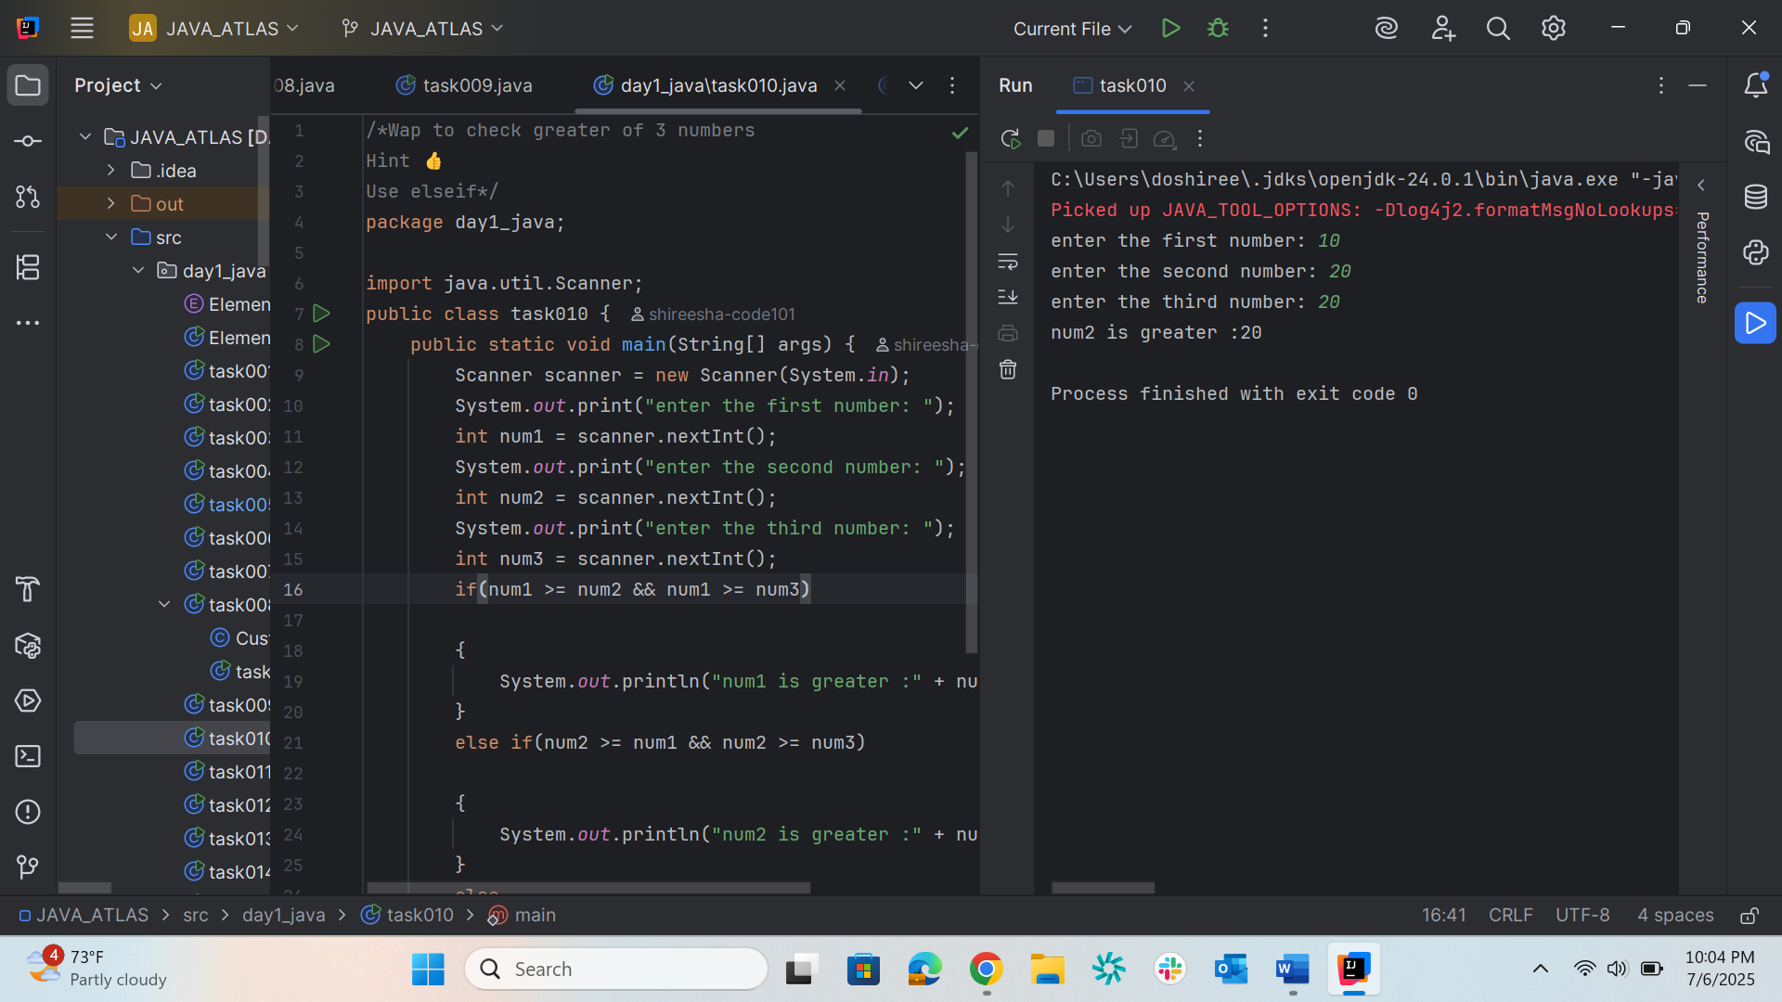

/*Wap to check if week days
1 ===> sunday
2 ===> monday
So on
8 and above ===> invalid input
*/
Task011
package day1_java;
import java.util.Scanner;
public class task011{
public static void main(String[] args){
Scanner scanner = new Scanner(System.in);
System.out.print("enter a number :");
int day = scanner.nextInt();
switch(day)
{
case 1:
System.out.println("sunday");
break;
case 2:
System.out.println("monday");
break;
case 3:
System.out.println("tuesday");
break;
case 4:
System.out.println("wednesday");
break;
case 5:
System.out.println("thursday");
break;
case 6:
System.out.println("friday");
break;
case 7:
System.out.println("saturday");
break;
default:
System.out.println("invalid input");
}
}
}
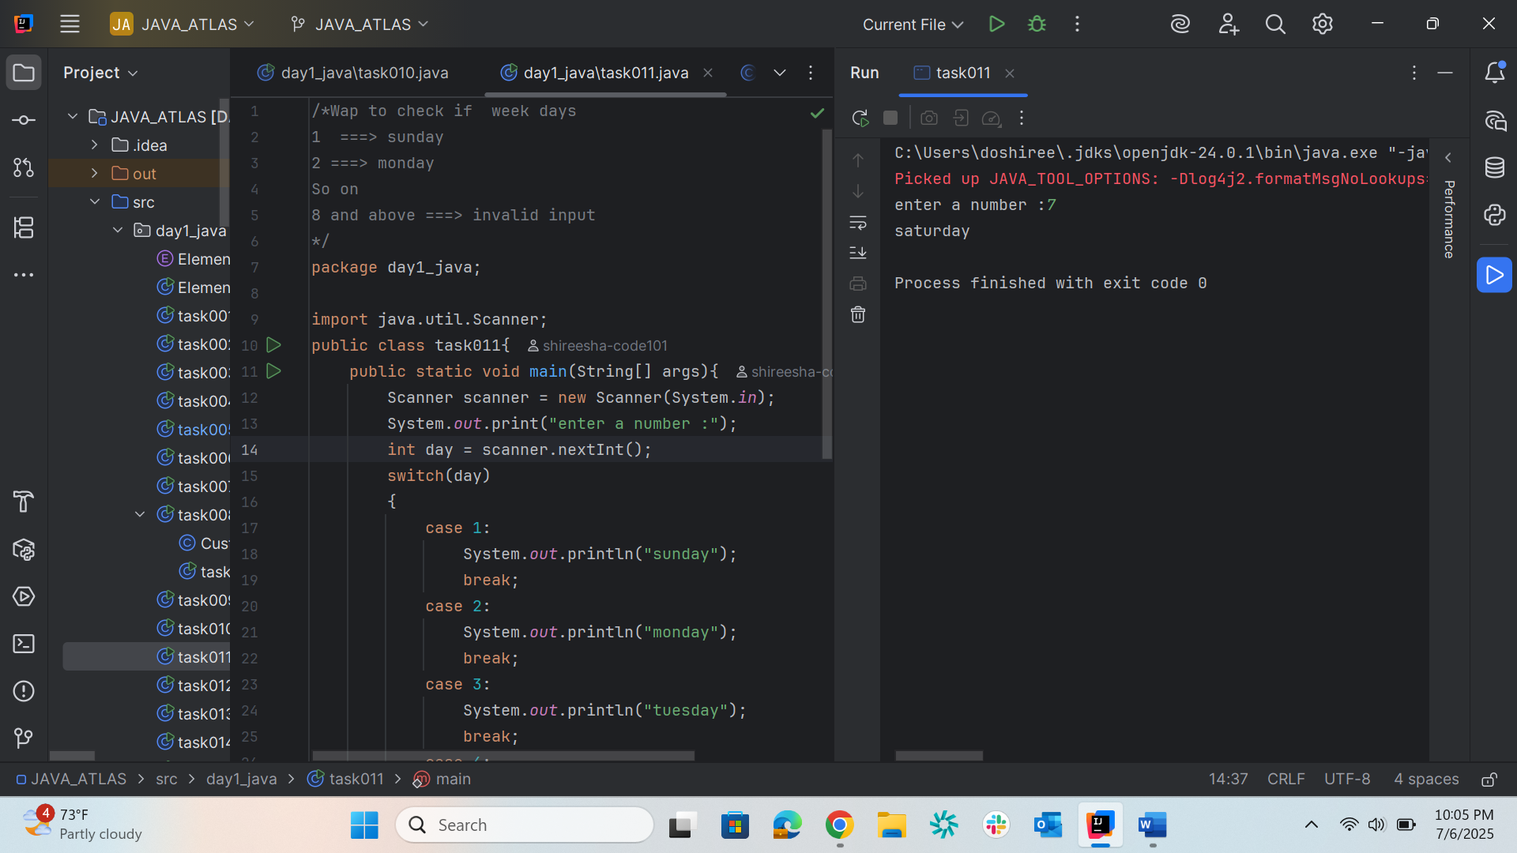

/*Wap to check loginid and password validation
Hint use while loop */
package day1_java;
task012
import java.util.Scanner;
public class task012 {
public static void main(String[] args) {
Scanner sc = new Scanner(System.in);
String correctLoginId = "Shireesha";
String correctPwd = "12345867";
int count = 0;
while (true) {
System.out.println("Enter your login ID:");
String loginId = sc.nextLine();
System.out.println("Enter your password:");
String pwd = sc.nextLine();
if (loginId.equals(correctLoginId) && pwd.equals(correctPwd)) {
count++;
System.out.println("You have logged in " + count + " times.");
} else {
System.out.println("Invalid login ID or password.");
}
System.out.println("Do you want to try again? (yes/no):");
String response = sc.nextLine();
if (!response.equalsIgnoreCase("yes"))
{
break;
}
}
System.out.println("Thank you for using the login system.");
}
}
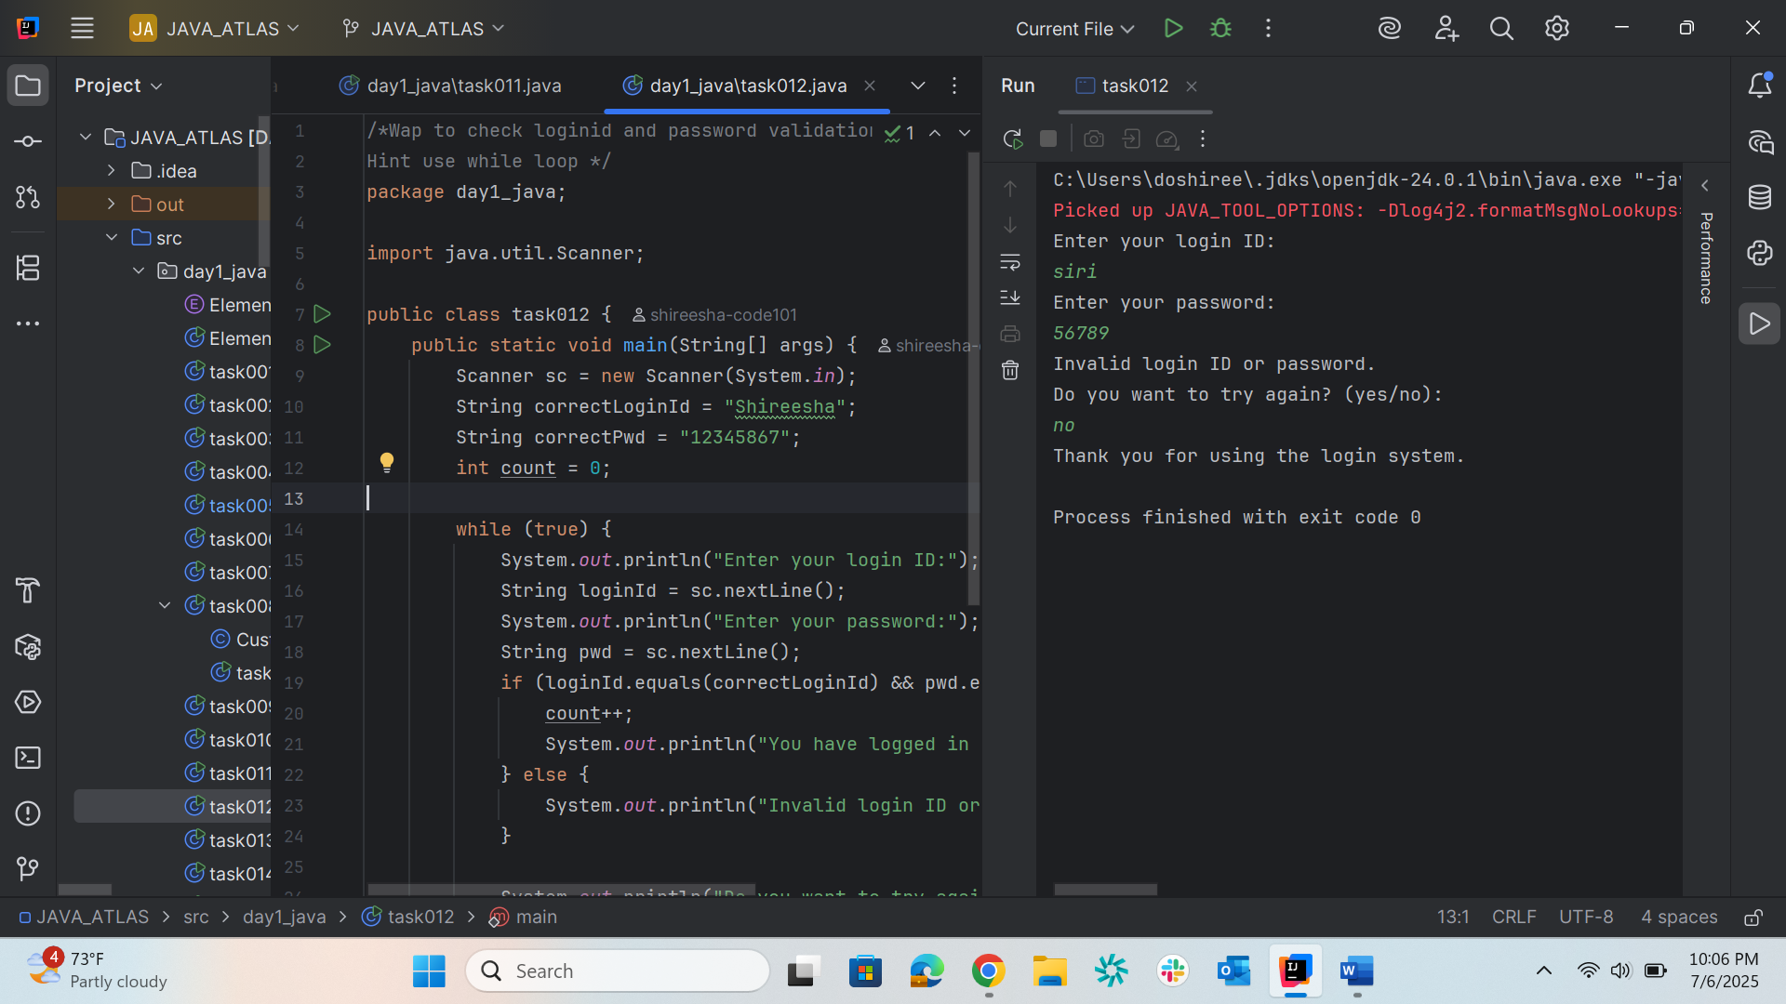
/*Wap to display numbers from 10 to 1 .. skip 7 and 5.*/
Task013
package day1_java;
public class task013 {
public static void main(String[] args){
for(int i=10;i>0;i--){
if(i==7||i==5){
continue;
}
System.out.println(i);
}
}
}
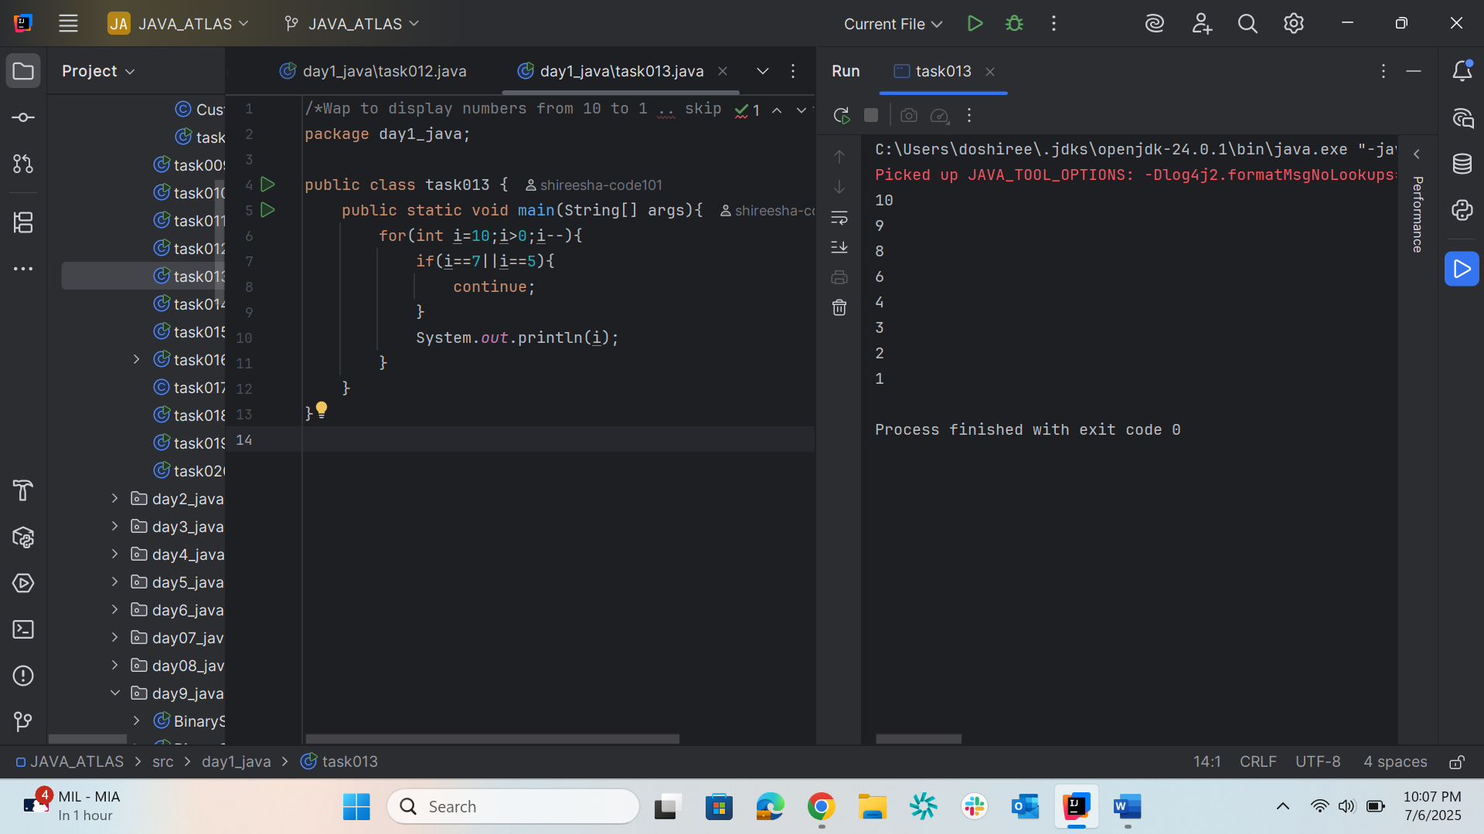

Task014
package day1_java;
import java.util.Arrays; // Import for Arrays.toString()
public class task014 {
public static void main(String[] args) {
// Initialize char array and print it
char[] arr = {'a', 'e', 'i', 'o', 'u'};
System.out.println(arr); // Outputs: aeiou
// Initialize String array
String[] names = {"Meena", "Tina", "Veena", "heena"};
System.out.println(names[0]); // Outputs: Meena
// Modify an element
names[1] = "Reena";
System.out.println(names[1]); // Outputs: Reena
// Print the array length
System.out.println("Length of names array: " + names.length); // Outputs: 4
// Safely access the last element instead of the invalid index 4
System.out.println("Last element in names: " + names[names.length - 1]); // Outputs: heena
// Optionally, print the entire array in a neat format
System.out.println("All names: " + Arrays.toString(names));
}
}
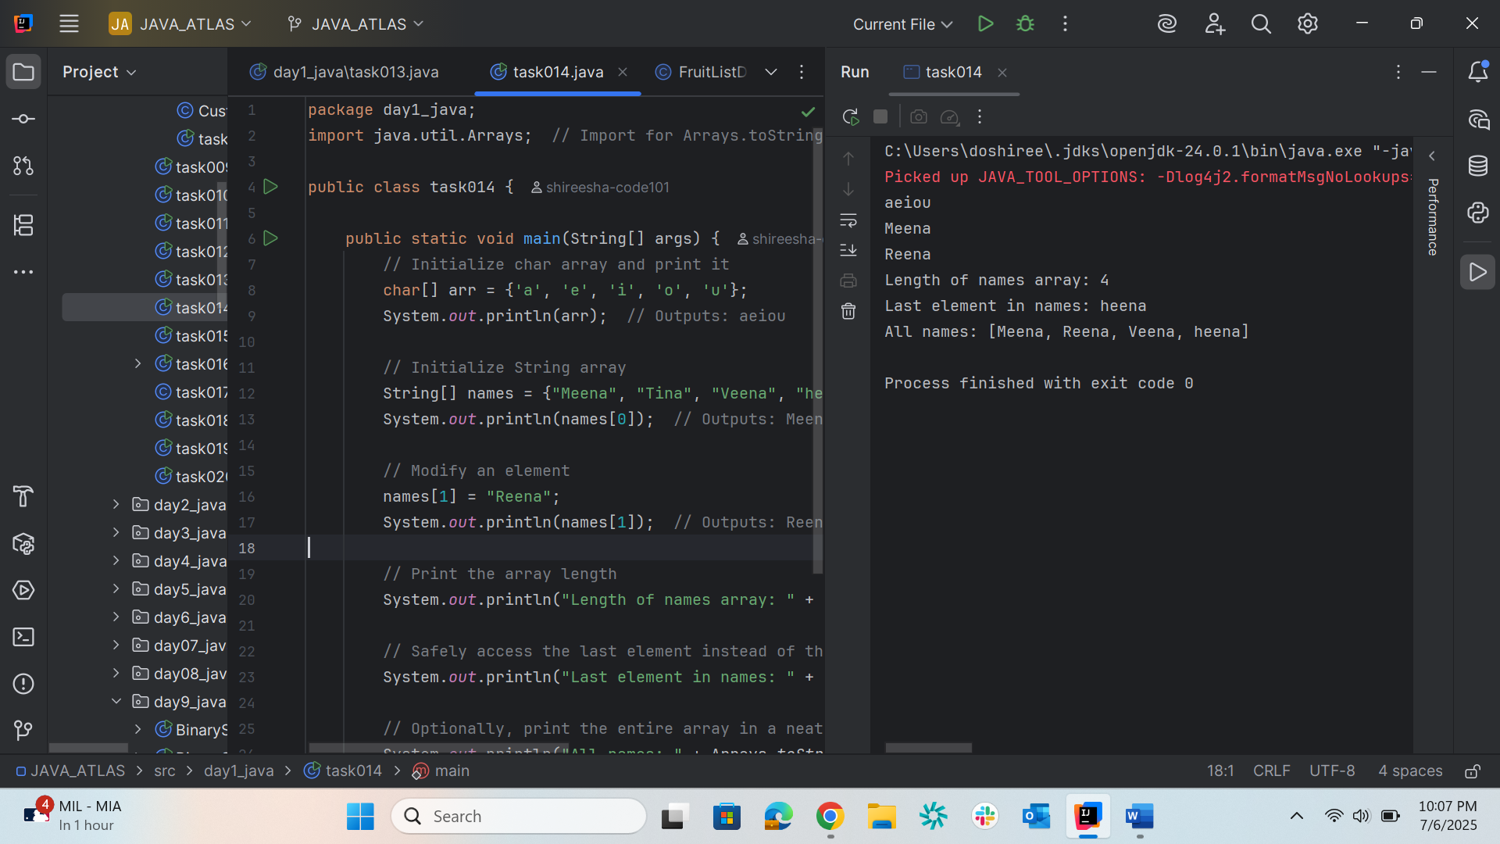

Task015
package day1_java;
public class task015
{
public static void main(String[] args) {
String str1 = "Java Strings ";
String str2 = str1;
String str3 = "are easy to learn ";
char[] ch = { 'S', 't', 'r', 'i', 'n', 'g' };
String str4 = new String(ch);
System.out.println(str1 + "\n" + str2 + "\n" + str3 + "\n" + str4);
}
}

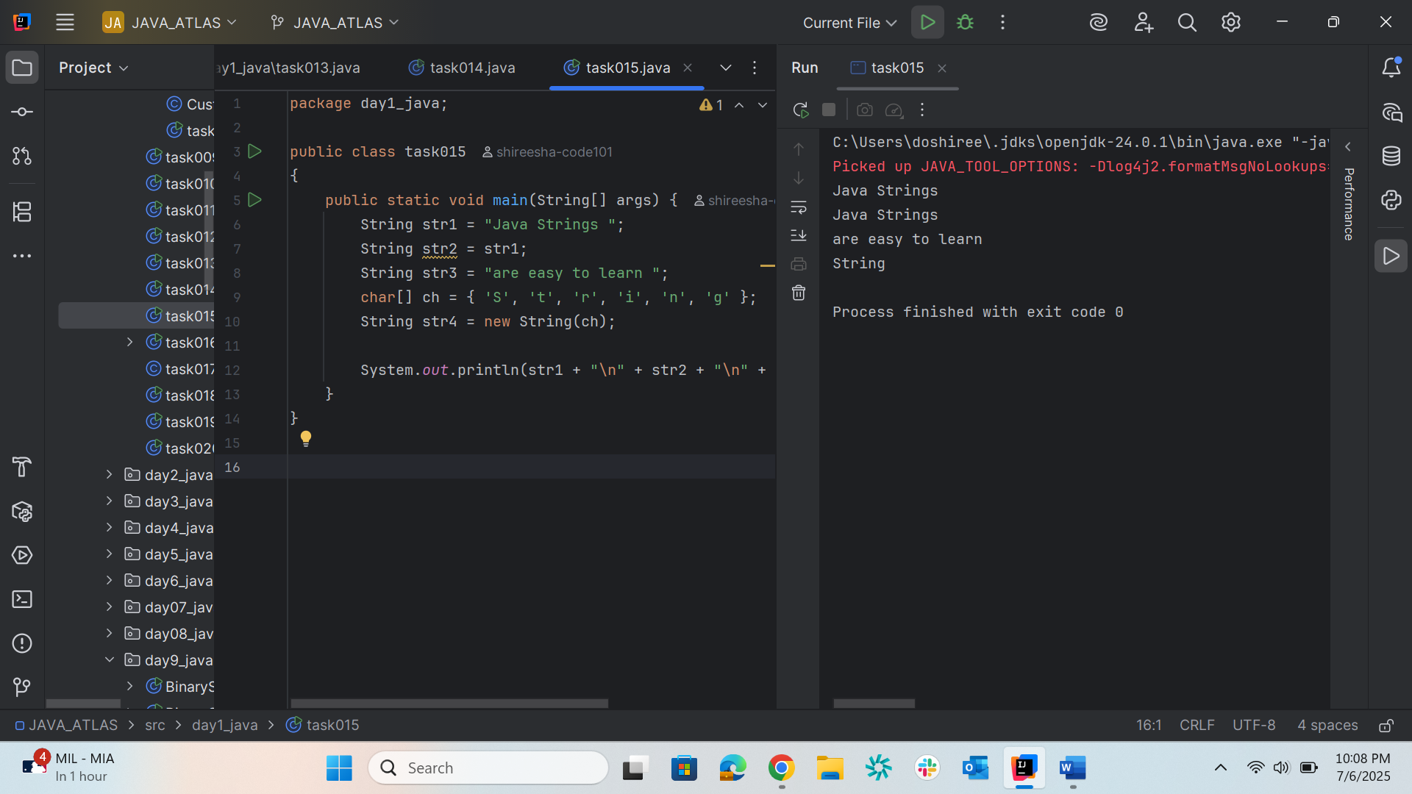
Task016
package day1_java;
enum color {
red, blue, green, yellow
}
public class task016{
public static void main(String[] args) {
color c1 = color.yellow;
System.out.println(c1); // prints: yellow
}
}
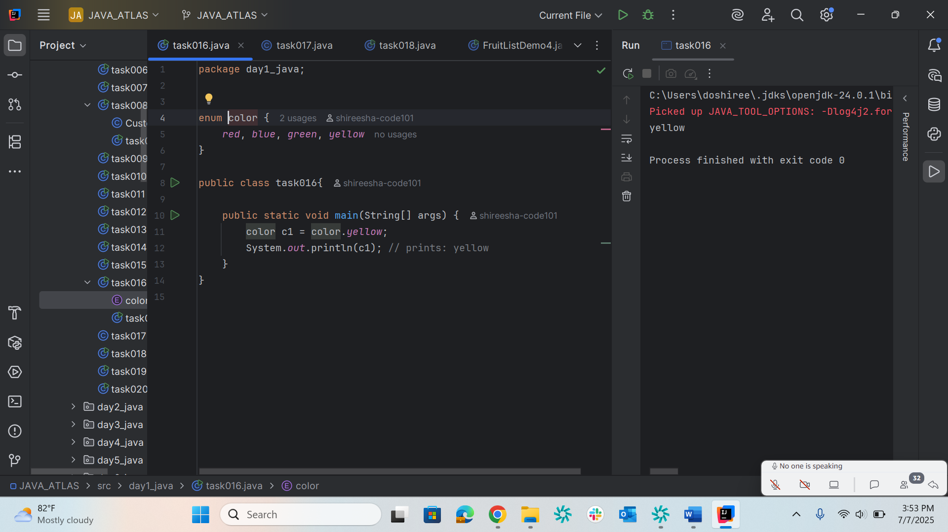
Task017
package day1_java;
public class task017 {
private String name; // private field – encapsulation
// Getter (accessor)
public String getName() {
return name;
}
// Setter (mutator)
public void setName(String newName) {
this.name = newName;
}
}
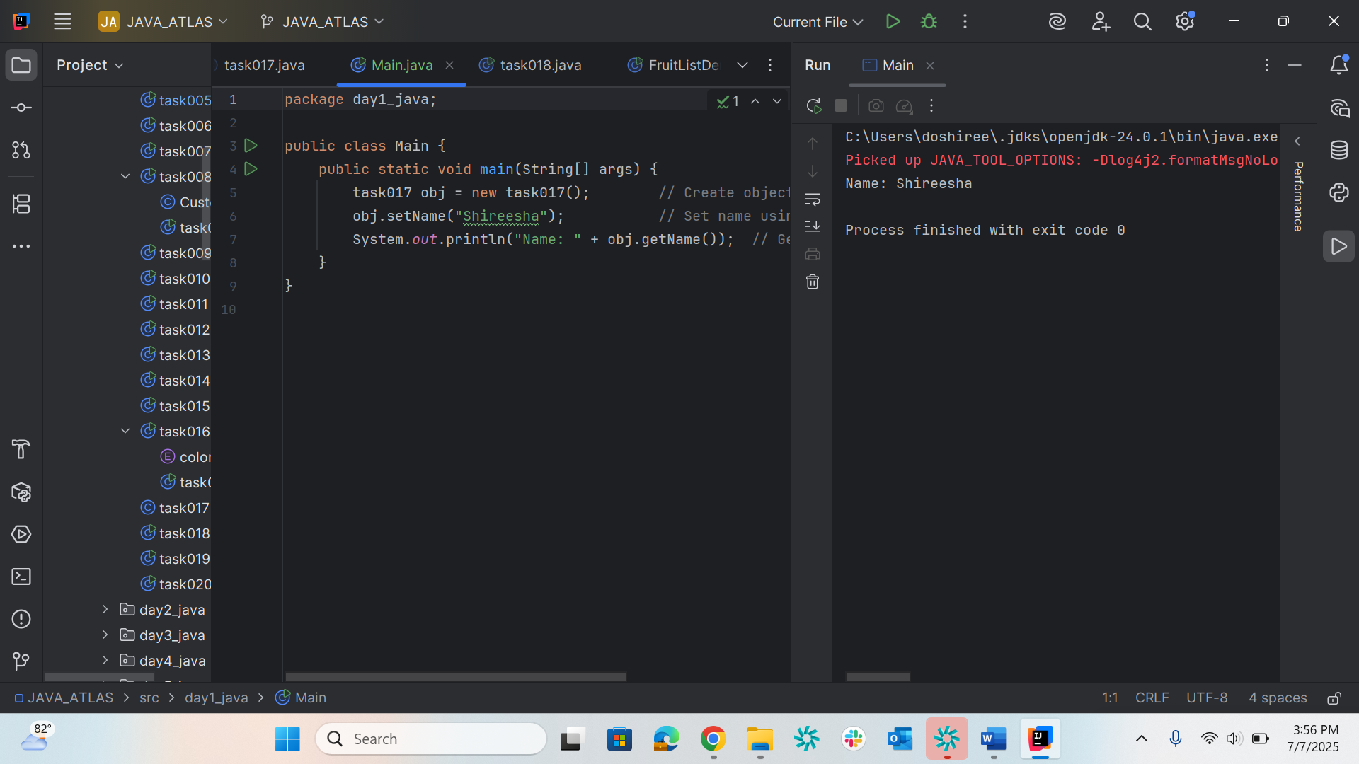
Task018
package day1_java;
public class task018{
public static void main(String[] args) {
task017 myObj = new task017(); // Instantiate a new Person object
myObj.setName("John"); // Use the setter to assign a name
System.out.println(myObj.getName()); // Use the getter to retrieve and print the name
}
}

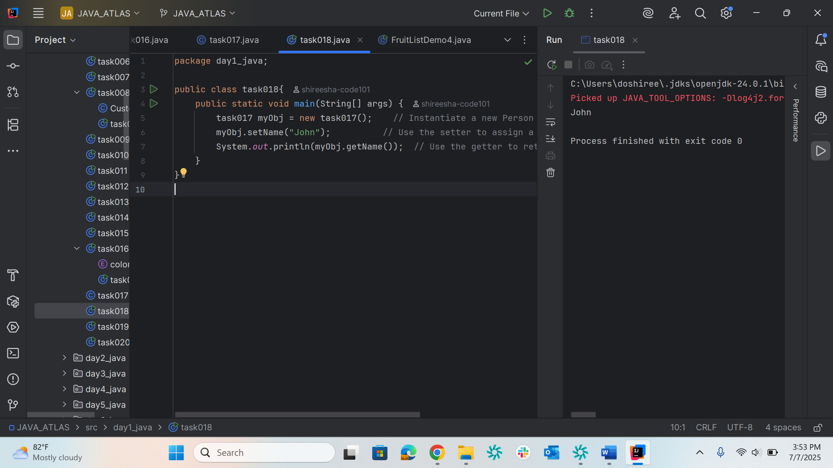

Task019
package day1_java;
public class task019 {
public static void main(String[] args) {
System.out.println("Find by label 'Helium': " + Element.valueOfLabel("Helium"));
System.out.println("Find by atomic number 10: " + Element.valueOfAtomicNumber(10));
System.out.println("Find by atomic weight 1.008f: " + Element.valueOfAtomicWeight(1.008f));
}
}
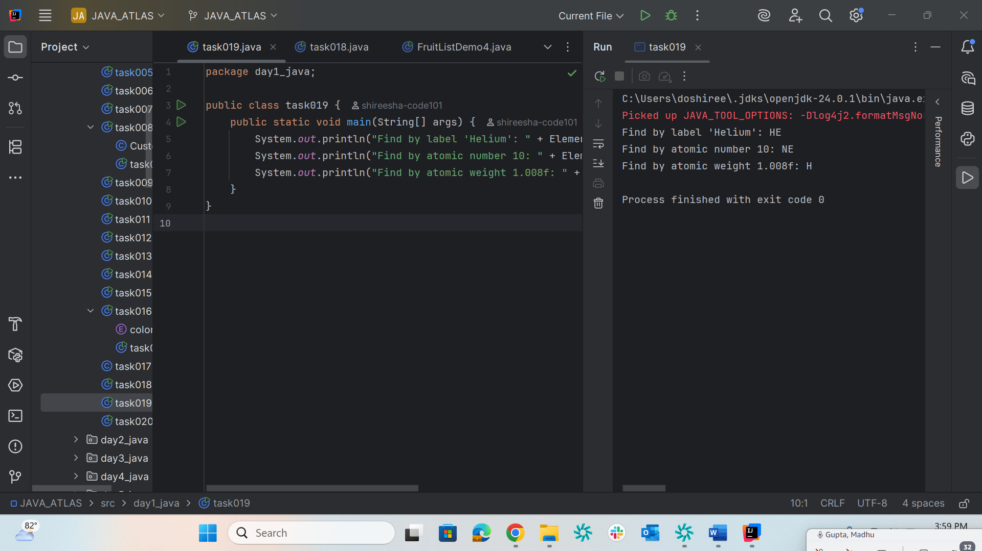
Task020
package day1_java;
public class task020 {
public static void main(String[] args) {
// Replace with your own name letters
char[] Name = {'A', 'l', 'i', 'c', 'e'};
// Print the array (as a String)
System.out.println(Name);
// Determine the length of the name
int n = Name.length;
System.out.println("There are " + n + " letters in my name");
// Print each letter using a classic for loop
System.out.print("Classic for loop: ");
for (int i = 0; i < n; i++) {
System.out.print(Name[i] + " ");
}
System.out.println();
// Print each letter using enhanced for loop
System.out.print("Enhanced for-each loop: ");
for (char ch : Name) {
System.out.print(ch + " ");
}
System.out.println();
}
}

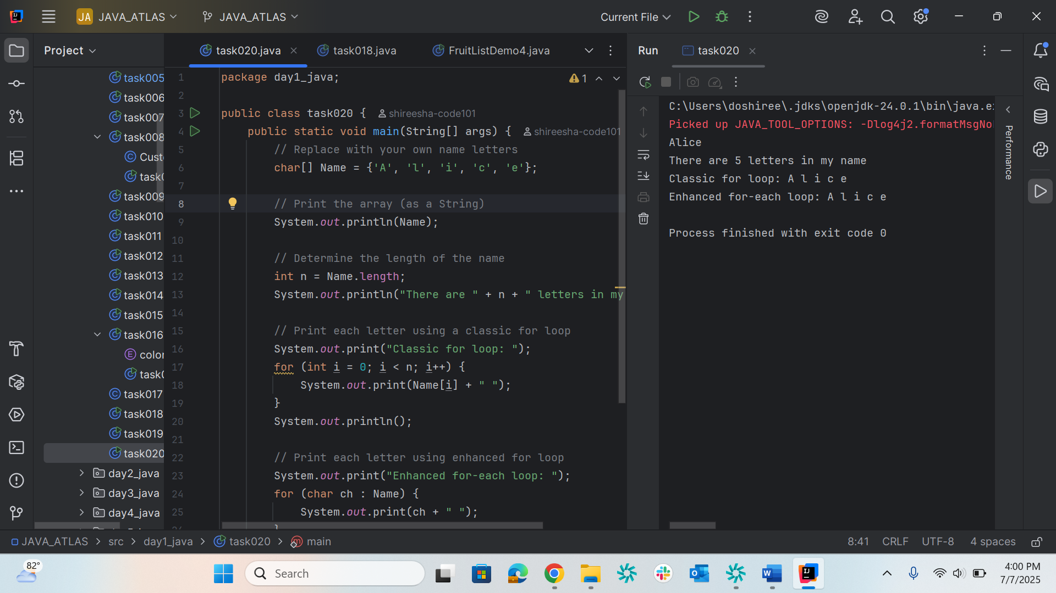
Task021
package day1_java;
import java.util.HashMap;
import java.util.Map;
public enum Element {
H("Hydrogen", 1, 1.008f),
HE("Helium", 2, 4.0026f),
NE("Neon", 10, 20.180f);
// ...add other elements as needed
private static final Map<String, Element> BY_LABEL = new HashMap<>();
private static final Map<Integer, Element> BY_ATOMIC_NUMBER = new HashMap<>();
private static final Map<Float, Element> BY_ATOMIC_WEIGHT = new HashMap<>();
static {
for (Element e : values()) {
BY_LABEL.put(e.label, e);
BY_ATOMIC_NUMBER.put(e.atomicNumber, e);
BY_ATOMIC_WEIGHT.put(e.atomicWeight, e);
}
}
public final String label;
public final int atomicNumber;
public final float atomicWeight;
Element(String label, int atomicNumber, float atomicWeight) {
this.label = label;
this.atomicNumber = atomicNumber;
this.atomicWeight = atomicWeight;
}
public static Element valueOfLabel(String label) {
return BY_LABEL.get(label);
}
public static Element valueOfAtomicNumber(int number) {
return BY_ATOMIC_NUMBER.get(number);
}
public static Element valueOfAtomicWeight(float weight) {
return BY_ATOMIC_WEIGHT.get(weight);
}
}
package day1_java;
public class ElementDemo {
public static void main(String[] args) {
System.out.println("Find by label 'Helium': " + Element.valueOfLabel("Helium"));
System.out.println("Find by atomic number 10: " + Element.valueOfAtomicNumber(10));
System.out.println("Find by atomic weight 1.008f: " + Element.valueOfAtomicWeight(1.008f));
}
}

