Day10_java
Task 1,2,3
package day9_java;
class TreeNode {
int value;
TreeNode left, right;
TreeNode(int item) {
value = item;
left = right = null;
}
}
class BinarySearchTreeOp {
TreeNode root;
void insert(int value) { // 10
root = insertVal(root, value); //root = null
}
TreeNode insertVal(TreeNode node, int value) { // null, 10 //
if (node == null) {
node = new TreeNode(value);
return node;
}
if (value < node.value) {
node.left = insertVal(node.left, value);
} else if (value > node.value) {
node.right = insertVal(node.right, value);
}
return node;
}
void inorder() {
inorderVal(root);
}
void inorderVal(TreeNode node) {
if (node != null) {
inorderVal(node.left);
System.out.print(node.value + " ");
inorderVal(node.right);
}
}
}
public class BinarySearchTree {
public static void main(String[] args) {
BinarySearchTreeOp bstobj = new BinarySearchTreeOp();
bstobj.insert(100);
bstobj.insert(50);
bstobj.insert(400);
bstobj.insert(70);
bstobj.insert(5);
System.out.println("here is the code for in order traversal of Binary search tree ");
bstobj.inorder();
}
}
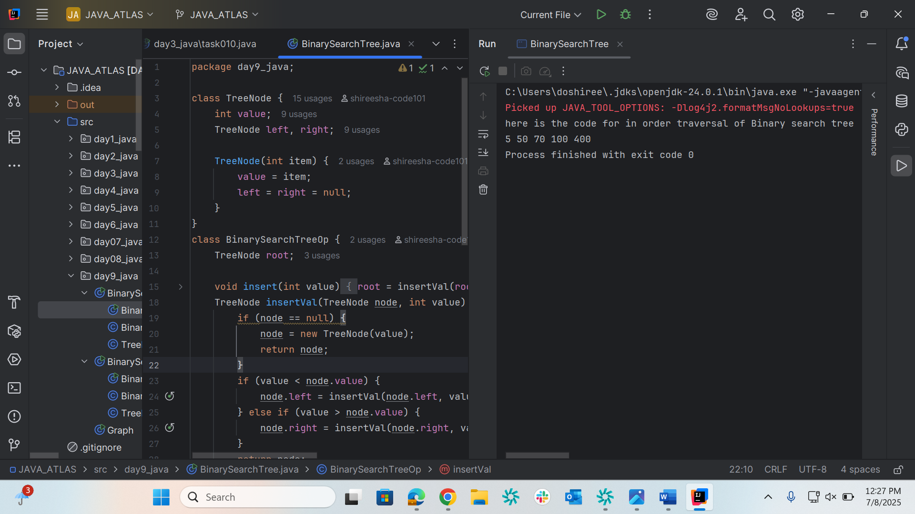

Task004
package day9_java;
class TreeNode1 {
int value;
TreeNode left, right;
TreeNode1(int value) {
this.value = value;
left = right = null;
}
}
class BinarySearchTreeOperations {
TreeNode root;
int i = 0;
// Constructor
public BinarySearchTreeOperations() {
this.root = null;
}
// Insert operations
void insert(int value) {
root = insertVal(root, value);
}
TreeNode insertVal(TreeNode node, int value) {
if (node == null) {
node = new TreeNode(value);
return node;
}
if (value < node.value) {
node.left = insertVal(node.left, value);
} else if (value > node.value) {
node.right = insertVal(node.right, value);
}
return node;
}
// Search operation
public TreeNode search(int key) {
TreeNode current = root;
while (current != null) {
if (key == current.value) {
return current;
} else if (key < current.value) {
current = current.left;
} else {
current = current.right;
}
}
return null;
}
// Traversal operations
void inorder() {
inorderVal(root);
}
void inorderVal(TreeNode node) {
if (node != null) {
inorderVal(node.left);
System.out.println(node.left + " " + node.value + " " + node.right + "===> " + i++);
inorderVal(node.right);
}
}
}
public class BinarySearchTreeOp02 {
public static void main(String[] args) {
BinarySearchTreeOperations bst = new BinarySearchTreeOperations();
// Insert operations
bst.insert(10);
bst.insert(50);
bst.insert(400);
bst.insert(70);
bst.insert(5);
// Inorder traversal
System.out.println("Inorder traversal of Binary Search Tree:");
bst.inorder();
// Search operations
int searchKey = 70;
TreeNode result = bst.search(searchKey);
if (result != null) {
System.out.println("\nFound " + searchKey + " in the tree");
} else {
System.out.println("\n" + searchKey + " not found in the tree");
}
}
}
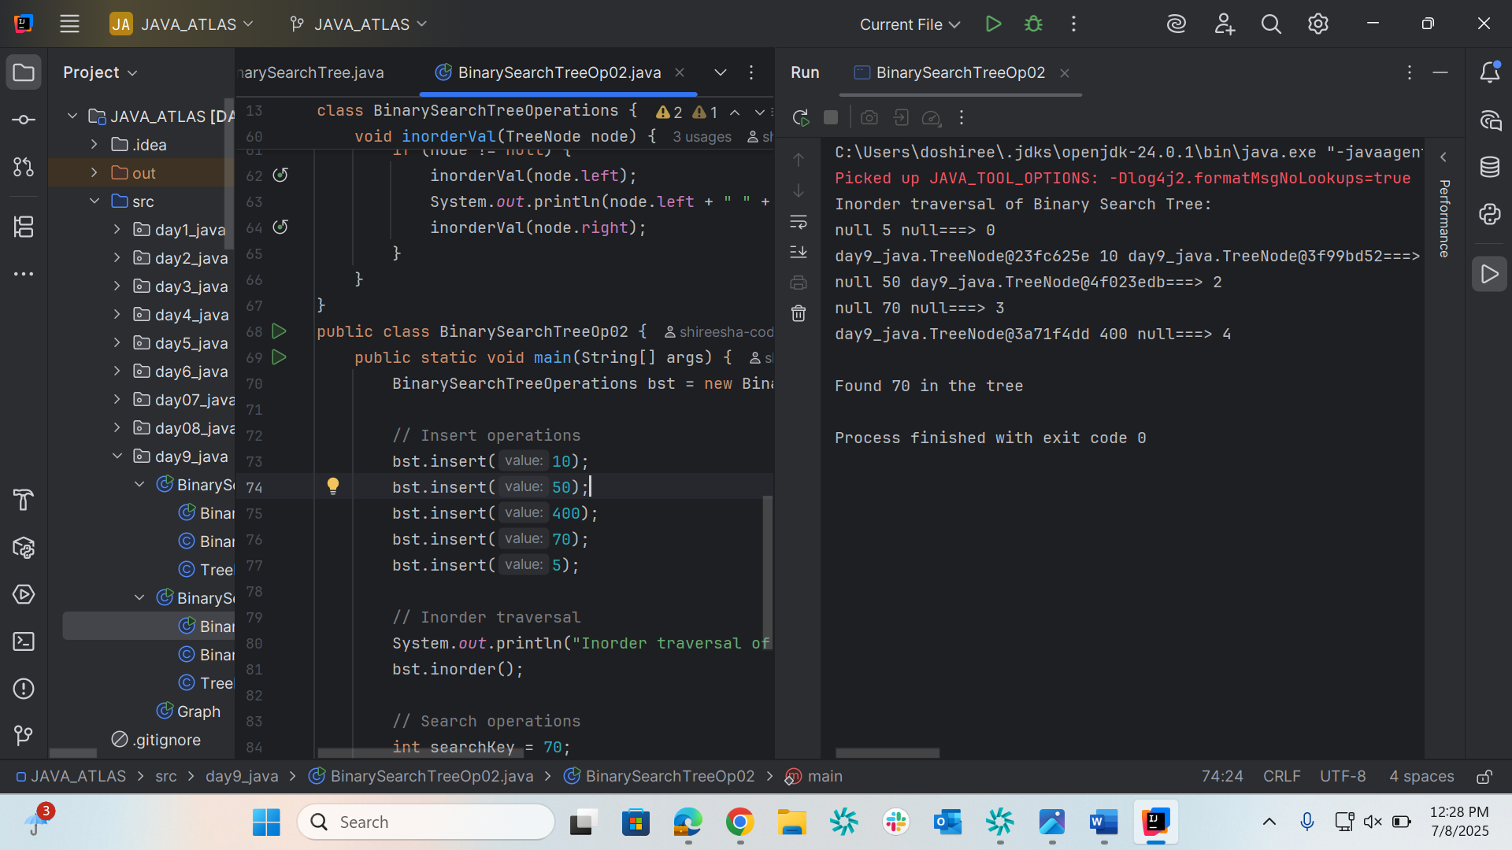

Graph
package day9_java;
class Graph {
class Edge {
int src;
int dest;
}
int vertices;
int edges;
Edge[] edge;
Graph(int vertices, int edges) {
this.vertices = vertices;
this.edges = edges;
edge = new Edge[edges];
for(int i = 0; i < edges; i++) {
edge[i] = new Edge();
}
}
public static void main(String[] args) {
int noVertices = 5;
int noEdges = 8;
Graph first = new Graph(noVertices, noEdges);
first.edge[0].src = 1;
first.edge[0].dest = 2;
first.edge[1].src = 1;
first.edge[1].dest = 3;
first.edge[2].src = 1;
first.edge[2].dest = 4;
first.edge[3].src = 2;
first.edge[3].dest = 4;
first.edge[4].src = 2;
first.edge[4].dest = 5;
first.edge[5].src = 3;
first.edge[5].dest = 4;
first.edge[6].src = 3;
first.edge[6].dest = 5;
first.edge[7].src = 4;
first.edge[7].dest = 5;
for(int i =0; i < noEdges; i++) {
System.out.println(first.edge[i].src+ " - " + first.edge[i].dest);
}
}
}
