Day9_java
Task001
package day3_java;
public class task001 {
public static void main(String[] args) {
int[] myNumbers = {1, 2, 3};
System.out.println(myNumbers[10]);
}
}
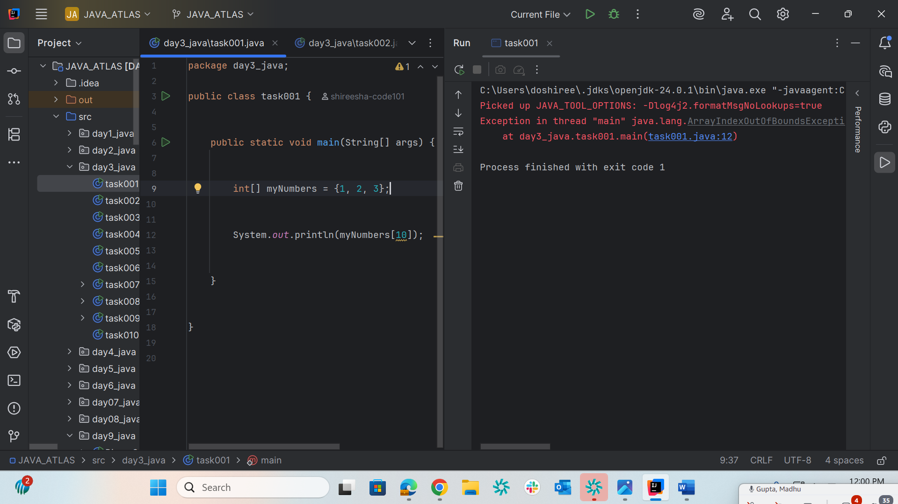

Task002
package day3_java;
public class task002 {
public static void main(String[] args) {
try {
int[] myNumbers = {1, 2, 3};
System.out.println(myNumbers[10]);
} catch (Exception e) {
// Catch block with the corrected variable 'e'
System.out.println("Something went wrong: " + e.getMessage());
}
}
}
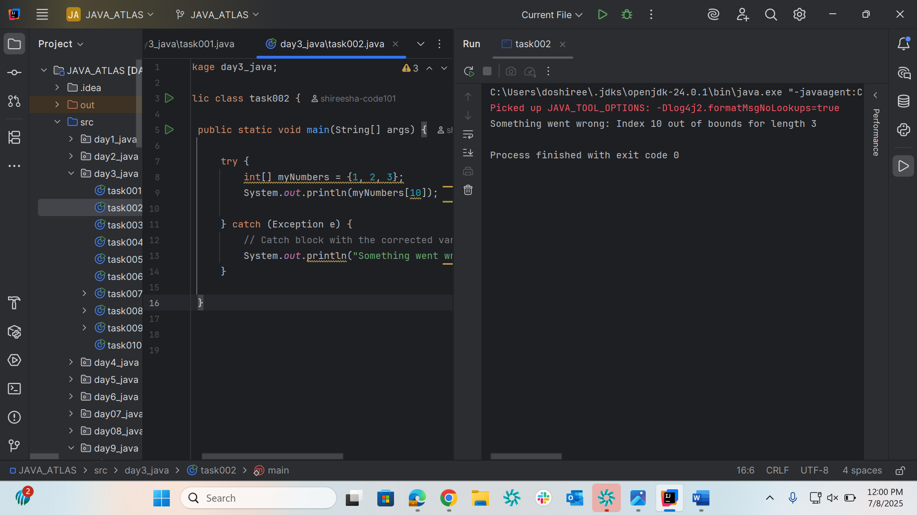

Task003
package day3_java;
public class task003 {
public static void main(String[] args) {
try {
int[] myNumbers = {1, 2, 3}
System.out.println(myNumbers[10])
} catch (Exception e) {
System.out.println("Something went wrong.");
} finally {
System.out.println("I'm from finally block.");
}
}
}
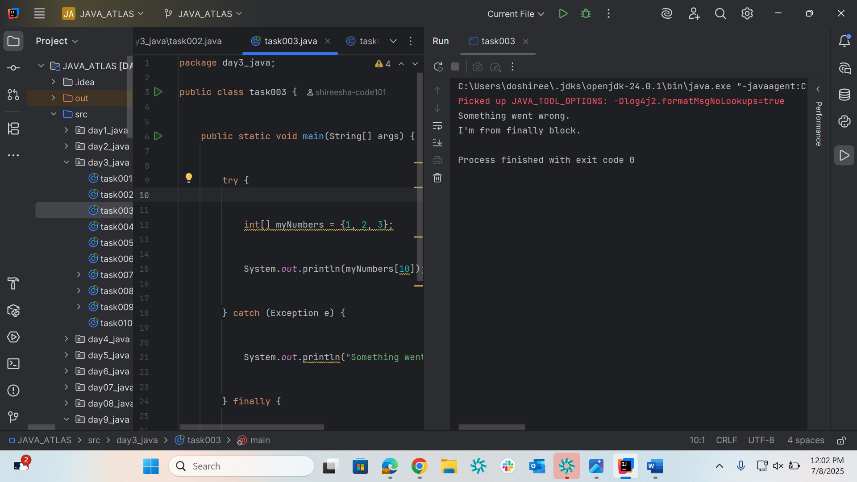

Task004
package day3_java;
public class task004 {
public static void main(String[] args) {
try {
int[] myNumbers = {1, 2, 3};
// Accessing the valid index 2
System.out.println(myNumbers[2]);
} catch (Exception e) {
System.out.println("Something went wrong.");
} finally {
System.out.println("I'm from finally block.");
}
}
}
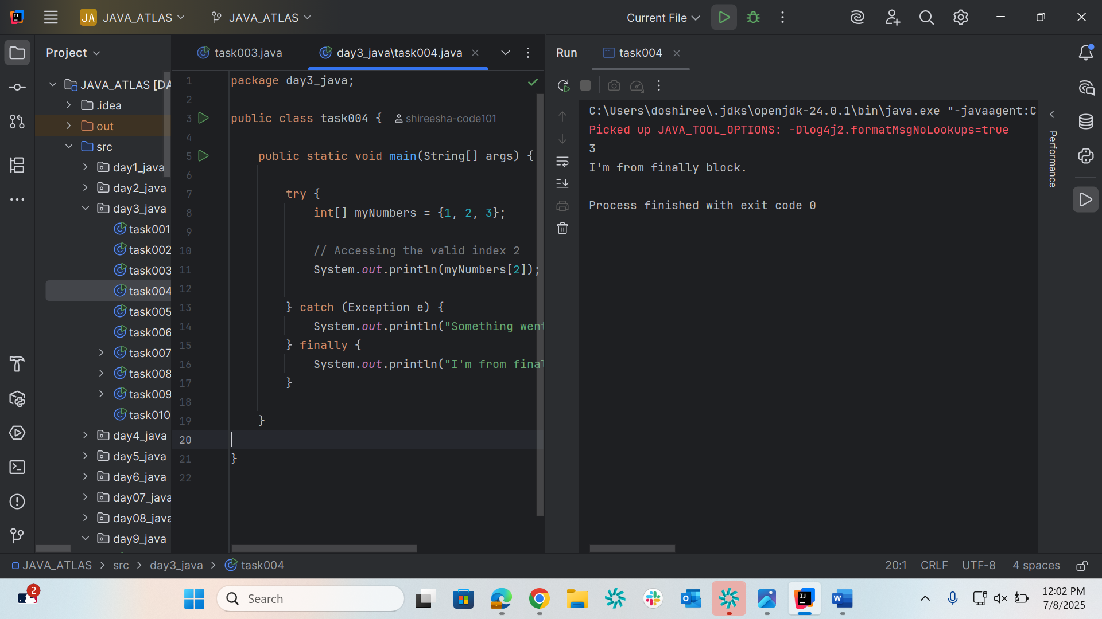

Task005
package day3_java;
public class task005 {
public static void main(String args[]) {
try {
int a[] = new int[2];
int b = 0;
int c = 1/b;
System.out.println("Access element three :" + a[3]);
}
catch (ArithmeticException e) {
System.out.println("ArithmeticException thrown :" + e);
}
catch (ArrayIndexOutOfBoundsException e) {
System.out.println("ArrayIndexOutOfBoundsException thrown :" + e);
}catch (Exception e) {
System.out.println("Exception thrown :" + e);
}
System.out.println("Out of the block");
}
}
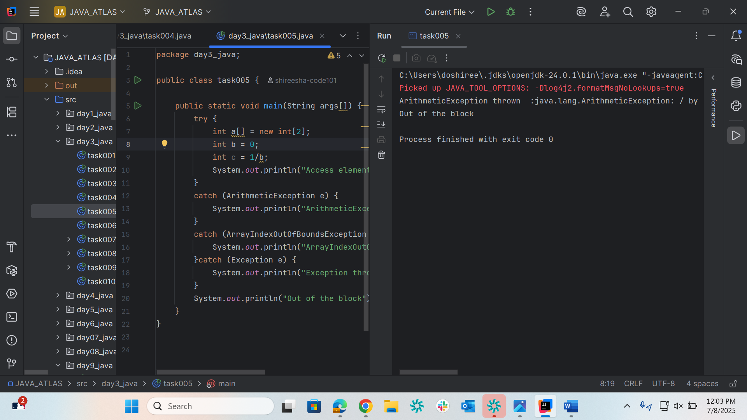

Task006
package day3_java;
public class task006 {
public static void main(String args[]) {
try {
int a[] = new int[2];
System.out.println("Access element three :" + a[2]); // try with a[0] or a[1] ===> and check if control goes to inner try block..
try {
int b = 0;
int c = 1/b;
}catch(Exception e) {
System.out.println("Exception thrown: " + e);
}
System.out.println("Access element three :" + a[3]);
}
catch (ArrayIndexOutOfBoundsException e) {
System.out.println("Exception thrown: " + e);
}
System.out.println("Out of the block");
}
}

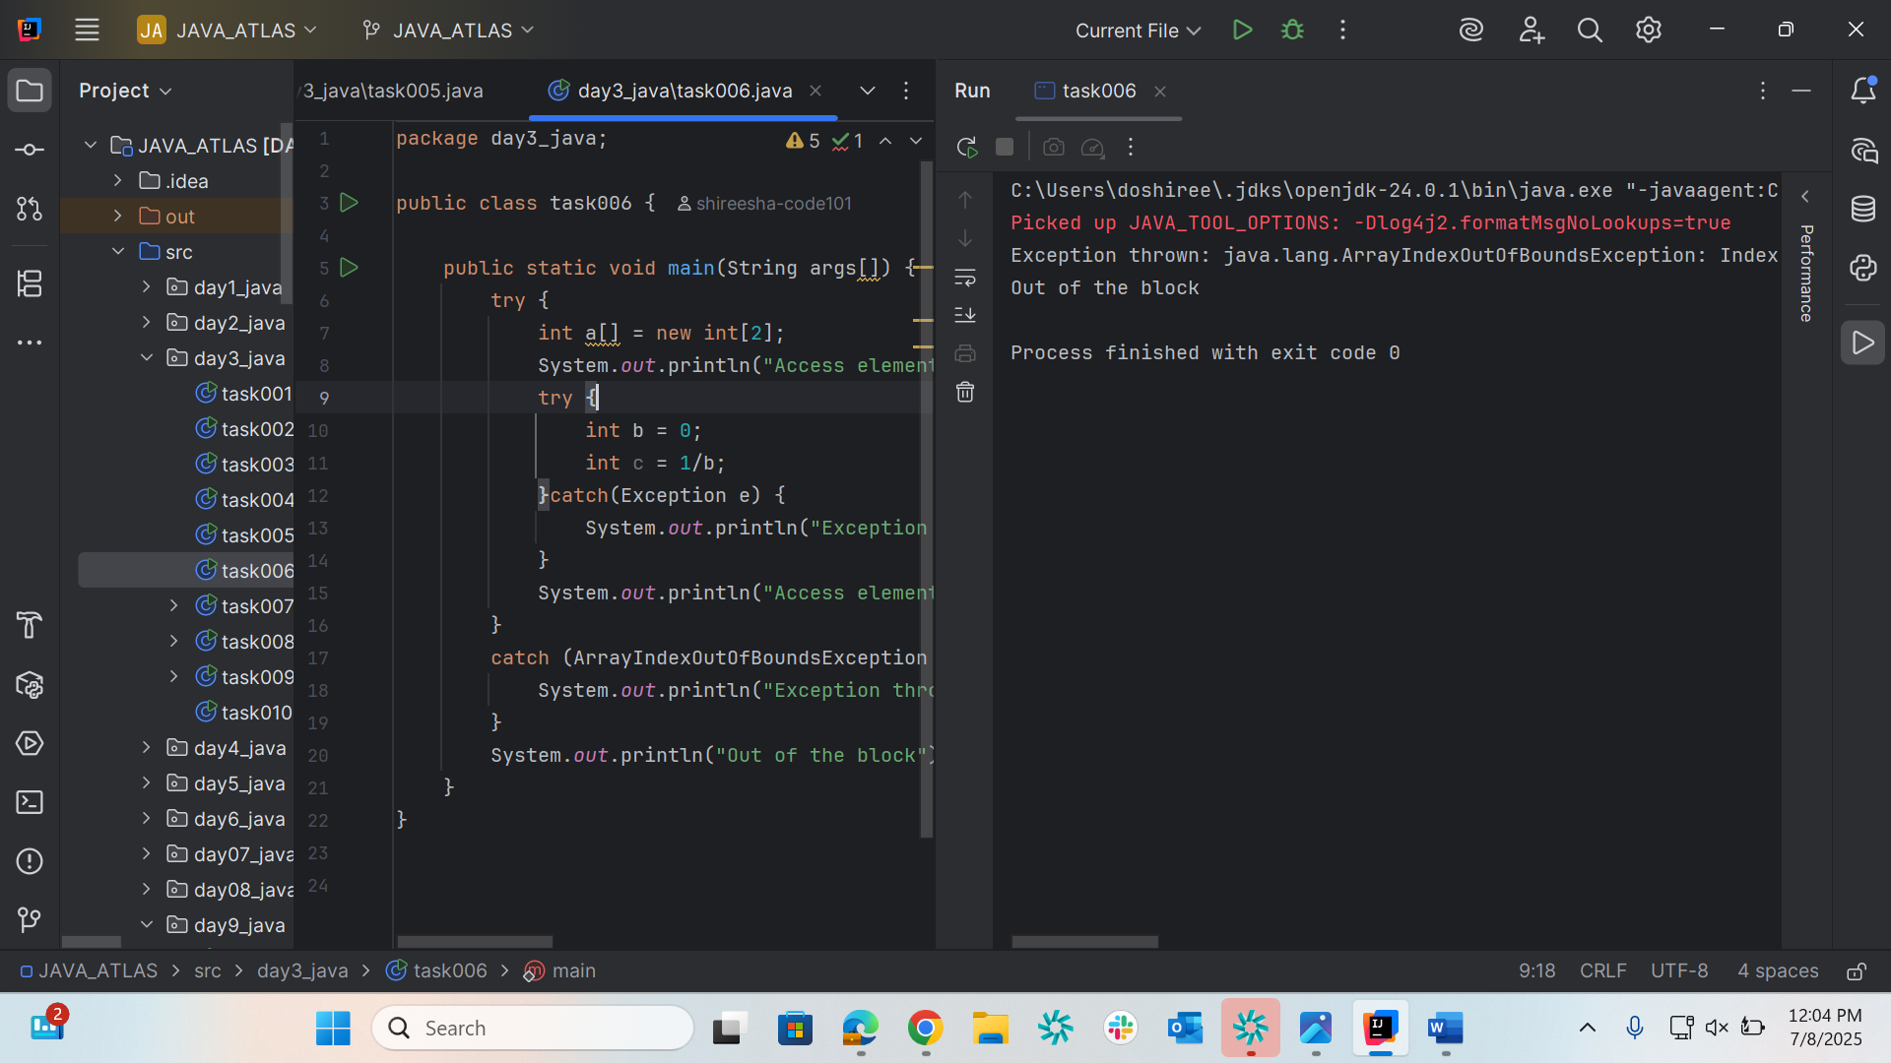

Task007
package day3_java;
class MyClass {
static void fun() throws IllegalAccessException
{
System.out.println("Inside fun(). ");
throw new IllegalAccessException("demo exception by fun method");
}
public static void main(String args[])
{
try {
fun();
}
catch (IllegalAccessException e) {
System.out.println("Caught in main." + e.getMessage());
}
}
}
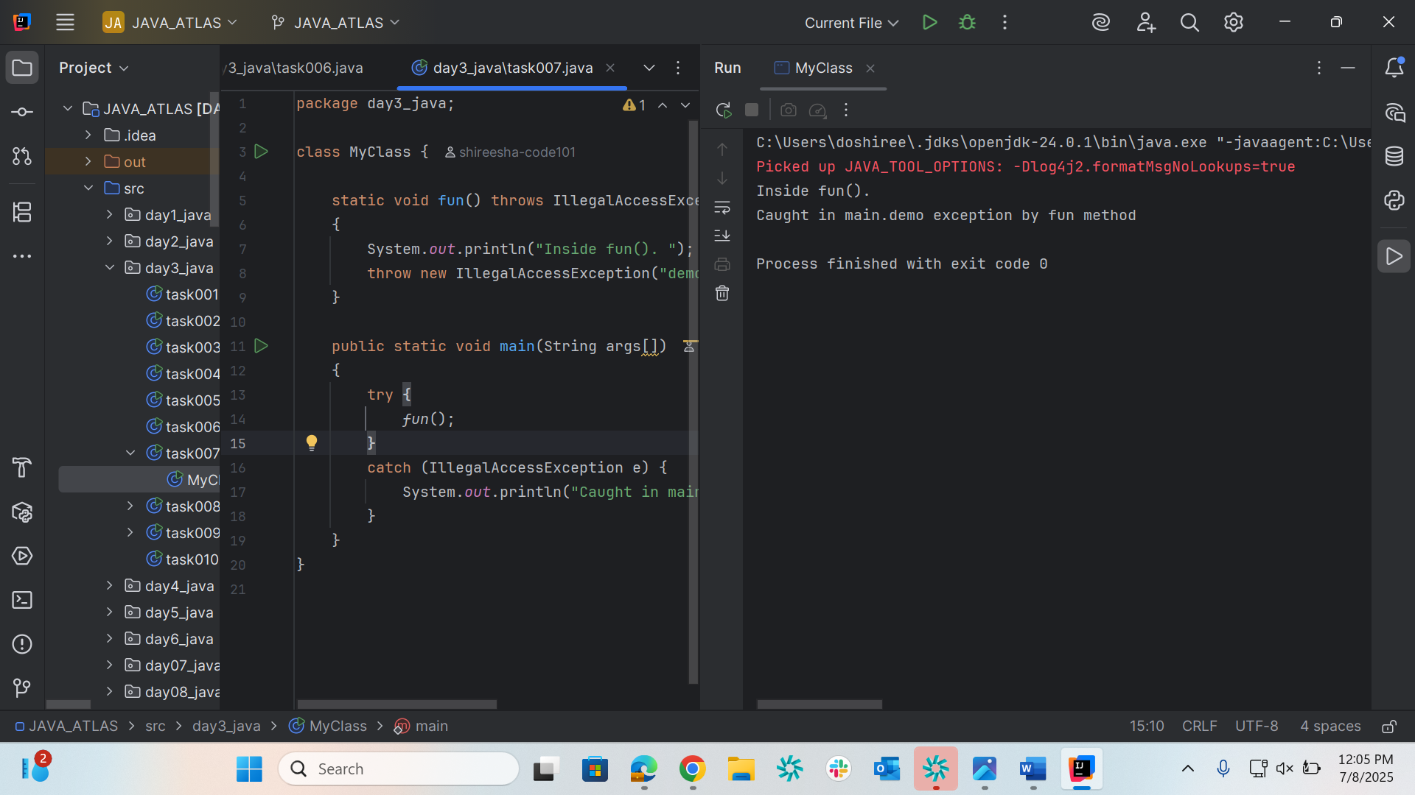

Task008
package day3_java;
// A Class that represents user-defined exception
class MyException extends Exception { // exception is a predefined class – parent class for MyException
public MyException(String m) {
//inr age ====> scan in put ===> if clock if age <0 ==? Throw an exception
super(m); // calling the parent class constructor with parameters
}
}
// A Class that uses the above MyException
public class task008{
public static void main(String args[]) {
try {
// Throw an object of user-defined exception
throw new MyException("This is a custom exception");
}
catch (MyException ex) {
System.out.println("Caught");
System.out.println(ex.getMessage());
}
}
}
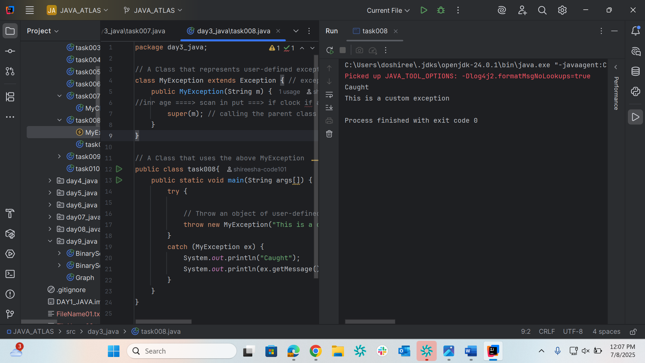

Task009
package day3_java;
import java.util.ArrayList;
class Main {
public static void main (String[] args) {
// Creating an ArrayList
ArrayList<Integer> a = new ArrayList<Integer>();
// Adding Element in ArrayList
a.add(1);
a.add(2);
a.add(3);
// Printing ArrayList
System.out.println(a);
}
}
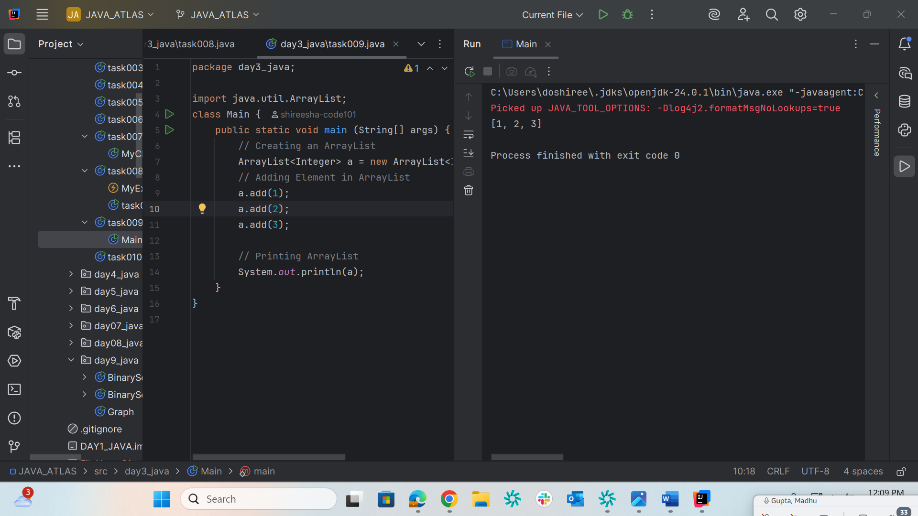

Task010
package day3_java;
import java.util.*;
class task010 {
public static void main(String args[]){
ArrayList<String> al = new ArrayList<>();
al.add("Prasunamba");
al.add("Meher");
System.out.println("Original List : "+al);
al.add(1, "Hello");
System.out.println("After Adding element at index 1 : "+ al);
al.remove(0);
System.out.println("Element removed from index 0 : "+ al);
al.remove("Prasunamba");
System.out.println("Element Prasunamba removed : "+ al);
al.set(0, "K");
System.out.println("List after updation of value : "+al);
}
}
