Task 1
package day4_java;

class RunnableDemo implements Runnable{
private Thread t;
private String threadName;
RunnableDemo ( String name){
threadName = name;
System.out.println("Creating " + threadName );
}
public void run() {
System.out.println("Running " + threadName );
try {
for(int i = 4; i > 0; i--) {
System.out.println("Thread: " + threadName + ", " + i);
// Let the thread sleep for a while.
Thread.sleep(50);
}
} catch (InterruptedException e) {
System.out.println("Thread " + threadName + " interrupted.");
}
System.out.println("Thread " + threadName + " exiting.");
}
public void Thstart () {
System.out.println("Starting " + threadName );
if (t == null) {
t = new Thread (this, threadName);
t.start ();
}
}
}
public class task001 {
public static void main(String args[]) {
RunnableDemo T1 = new RunnableDemo ( "Thread-1");
T1.Thstart();
RunnableDemo T2 = new RunnableDemo ( "Thread-2");
T2.Thstart();
}
}
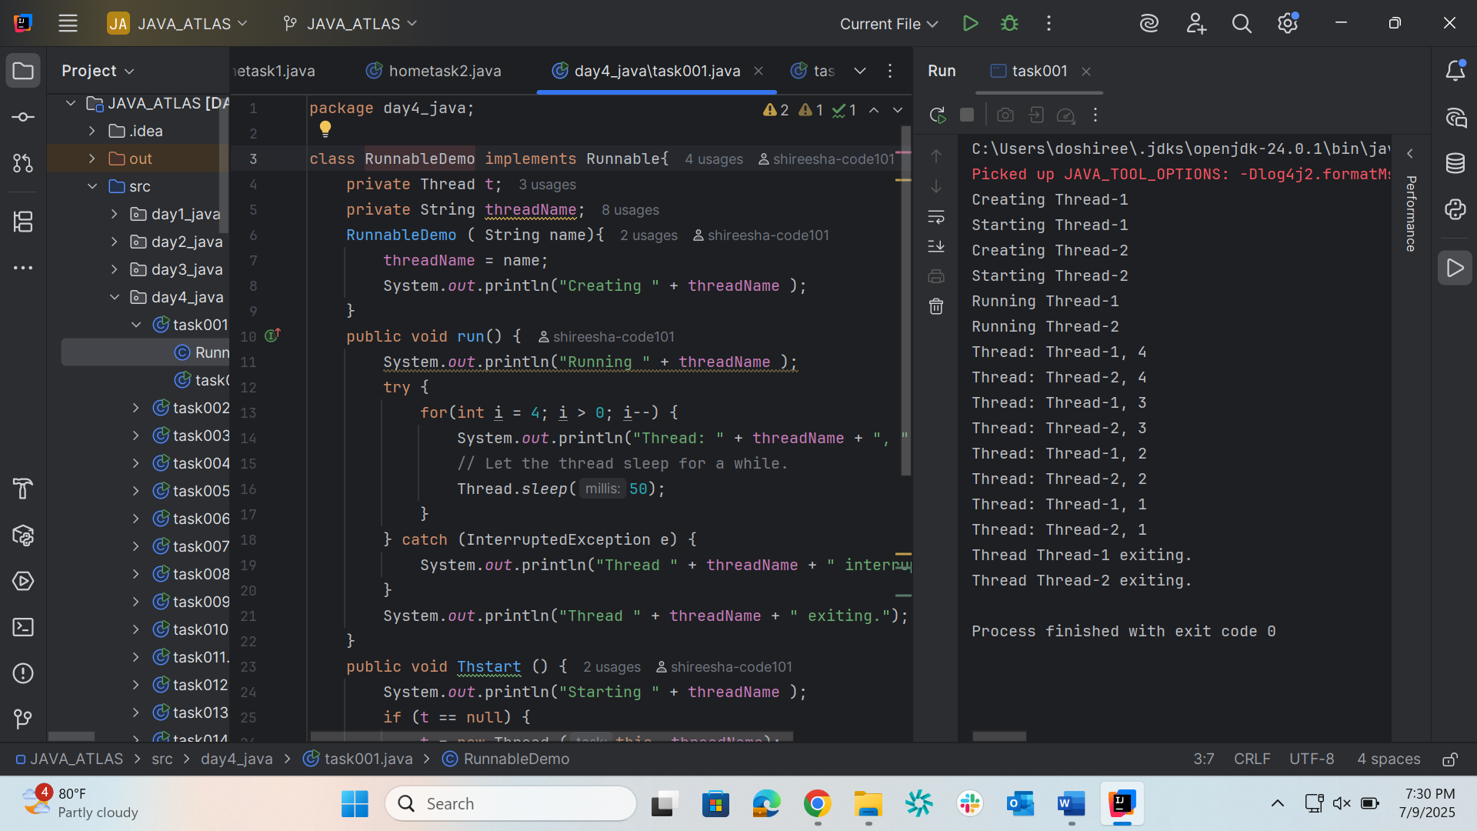

Task 2
package day4_java;

class ThreadDemo extends Thread {
private Thread t;
private String threadName;
ThreadDemo( String name){
threadName = name;
System.out.println("Creating " + threadName );
}
public void run() {
System.out.println("Running " + threadName );
try {
for(int i = 4; i > 0; i--) {
System.out.println("Thread: " + threadName + ", " + i);
// Let the thread sleep for a while.
Thread.sleep(50);
}
} catch (InterruptedException e) {
System.out.println("Thread " + threadName + " interrupted.");
}
System.out.println("Thread " + threadName + " exiting.");
}
public void Thstart () {
System.out.println("Starting " + threadName );
if (t == null) {
t = new Thread (this, threadName);
t.start ();
}
}
}
public class task002 {
public static void main(String args[]) {
ThreadDemo T1 = new ThreadDemo( "Thread-1");
T1.Thstart();
ThreadDemo T2 = new ThreadDemo( "Thread-2");
T2.Thstart();
}
}
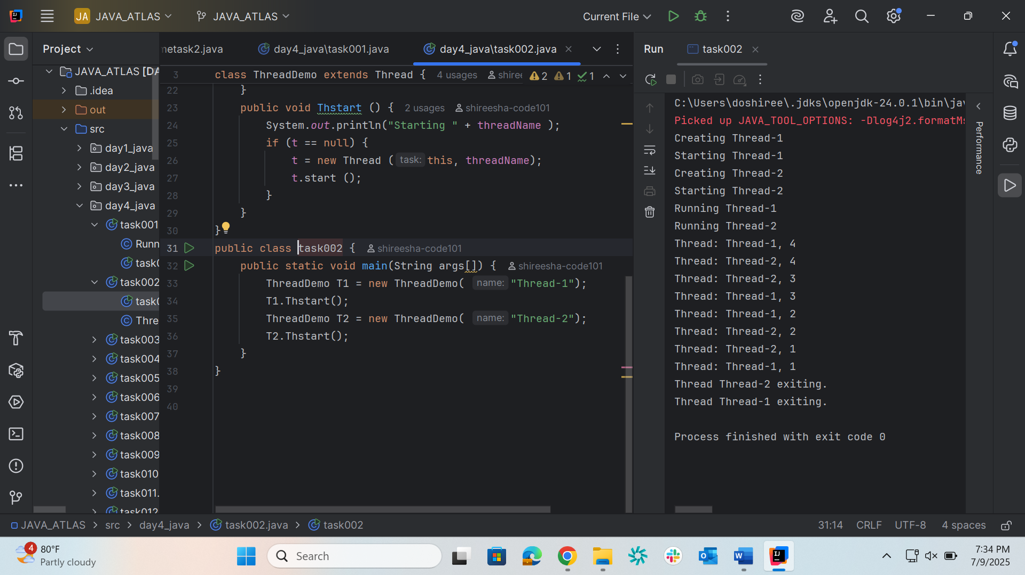

Task 3
package day4_java;

class Counter {
private int count = 0;

public void increment() {
count++;
}

public int getCount() {
return count;
}
}

class ThreadDemo1 extends Thread {
Counter counter;

ThreadDemo1(Counter counter) {
this.counter = counter;
}

public void run() {
for (int i = 0; i < 10; i++) {
counter.increment();
}
}
}

public class task003 {
public static void main(String[] args) {
Counter counter = new Counter();
ThreadDemo1 t1 = new ThreadDemo1(counter);
ThreadDemo1 t2 = new ThreadDemo1(counter);

t1.start();
t2.start();

try {
t1.join();
t2.join();
} catch (InterruptedException e) {
e.printStackTrace();
}

System.out.println("Final count: " + counter.getCount());
}
}

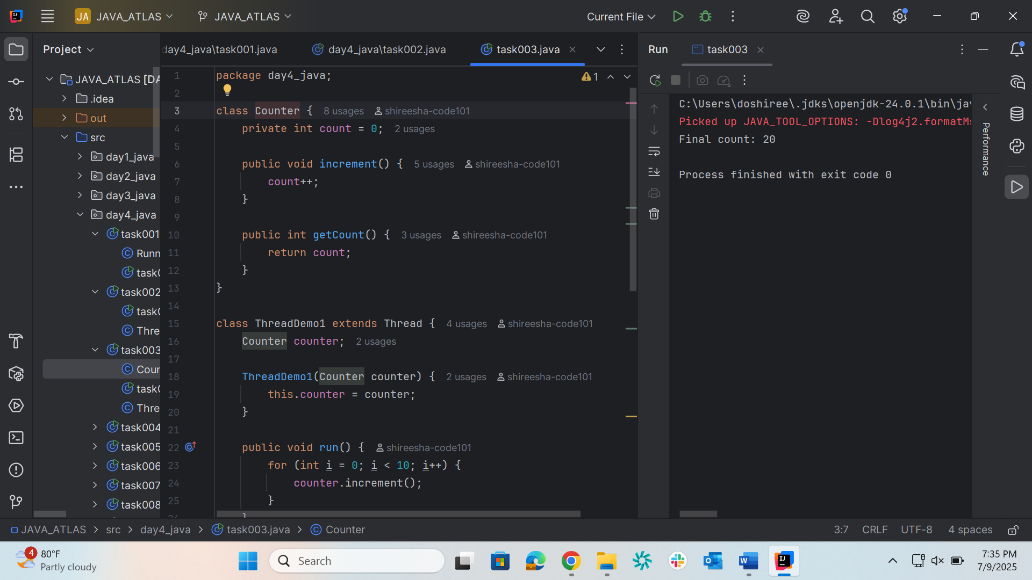

Task 4
package day4_java;

// Counter.java
class Counter1 {
private int count = 0;

// Thread-safe increment method
public synchronized void increment() {
count++;
}

// Getter method
public int getCount() {
return count;
}
}

// Main.java
public class task004 {
public static void main(String[] args) throws InterruptedException {
Counter1 counter = new Counter1();

// Thread 1: increments counter 1000 times
Thread t1 = new Thread(() -> {
for (int i = 0; i < 1000; i++) {
counter.increment();
}
});

// Thread 2: increments counter 1000 times
Thread t2 = new Thread(() -> {
for (int i = 0; i < 1000; i++) {
counter.increment();
}
});

// Start both threads
t1.start();
t2.start();

// Wait for both threads to finish
t1.join();
t2.join();

// Output the final count (should be 2000)
System.out.println("Final Count: " + counter.getCount());
}
}
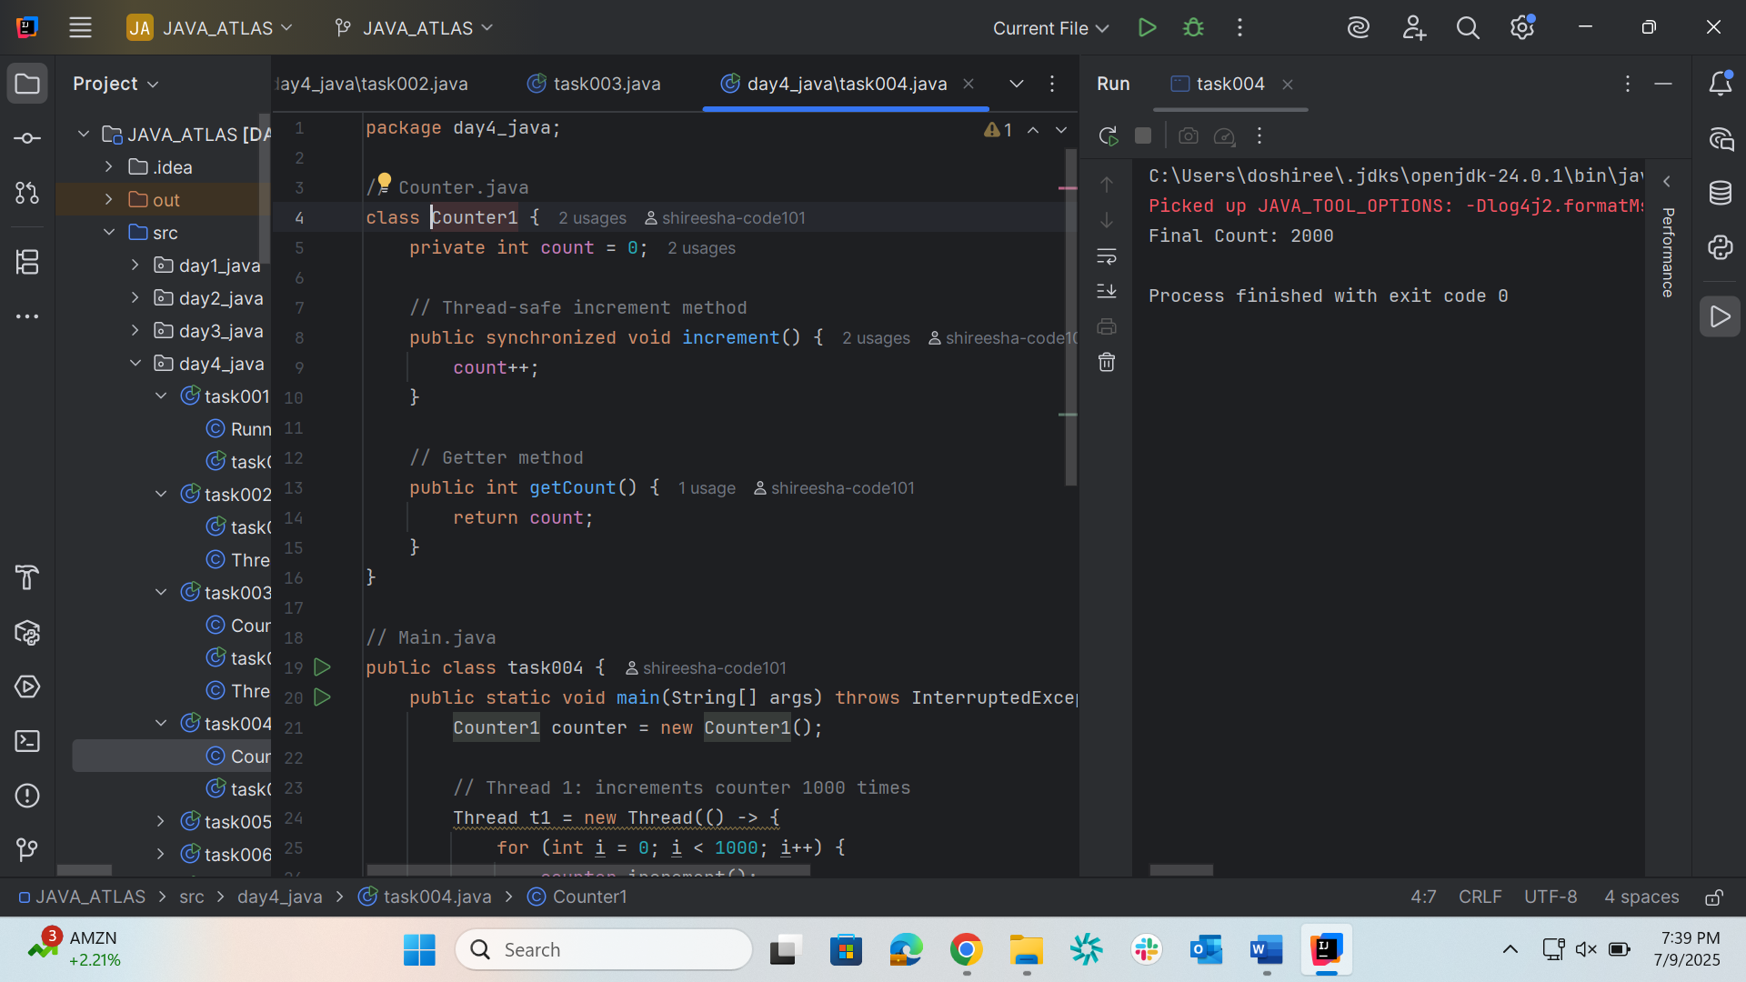

Task 5
package day4_java;

// Counter.java
class Counter2 {
private int count = 0;

// Only the critical section is synchronized
public void increment() {
synchronized (this) {
count++;
}
}

// No synchronization here; safe in this simple case
public int getCount() {
return count;
}
}

// Main.java
public class task005 {
public static void main(String[] args) throws InterruptedException {
Counter counter = new Counter();

// Thread 1
Thread t1 = new Thread(() -> {
for (int i = 0; i < 1000; i++) {
counter.increment();
}
});

// Thread 2
Thread t2 = new Thread(() -> {
for (int i = 0; i < 1000; i++) {
counter.increment();
}
});

// Start the threads
t1.start();
t2.start();

// Wait for both threads to finish
t1.join();
t2.join();

// Print the final count
System.out.println("Final Count: " + counter.getCount());
}
}
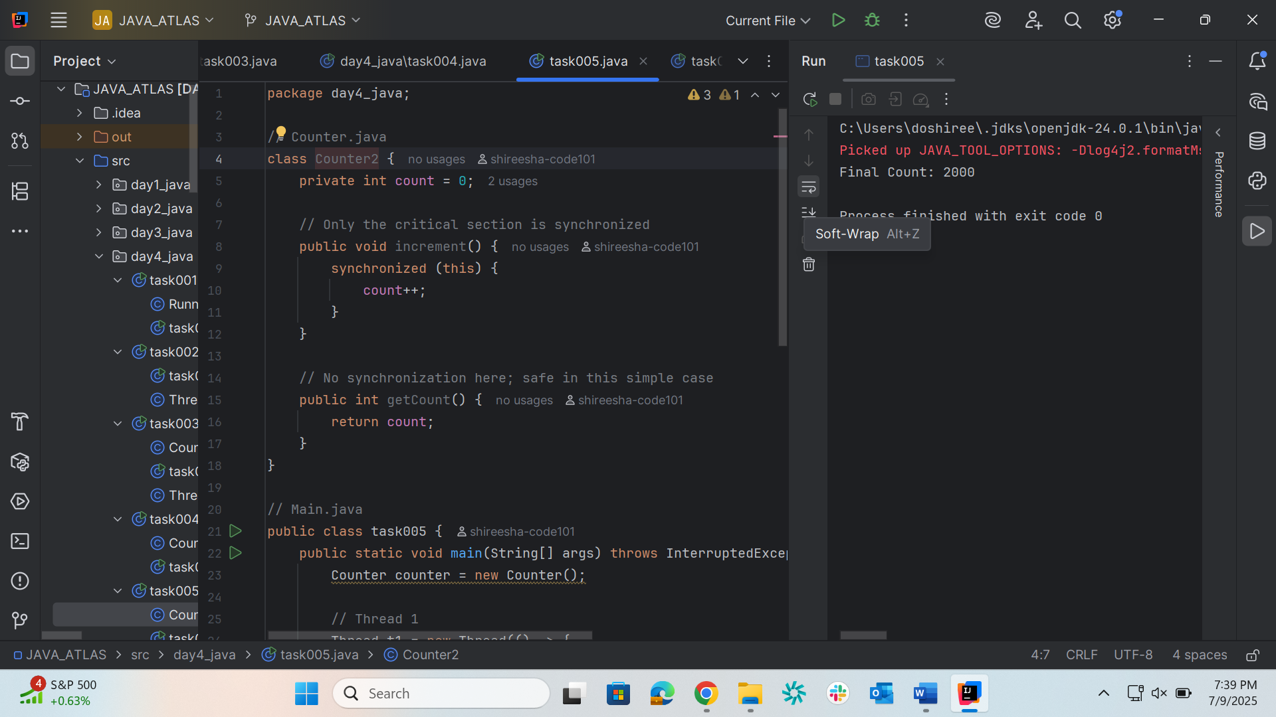
Task 6
package day4_java;

class Counter3 {
private static int count = 0; // Shared among all instances (or no instances)

public static synchronized void increment() {
count++; // Thread-safe increment
}

public static int getCount() {
return count;
}
}
public class task006 {
public static void main(String[] args) throws InterruptedException {

Thread t1 = new Thread(() -> {
for (int i = 0; i < 1000; i++) {
Counter3.increment();
}
});

Thread t2 = new Thread(() -> {
for (int i = 0; i < 1000; i++) {
Counter3.increment();
}
});

t1.start();
t2.start();

t1.join();
t2.join();

System.out.println("Final Count: " + Counter3.getCount()); // Expected: 2000
}
}

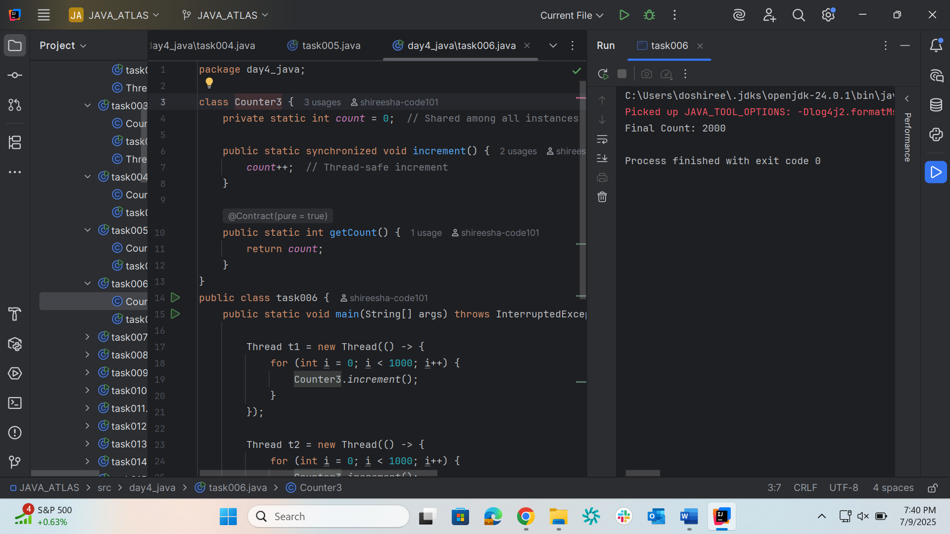

Task 7
package day4_java;
import java.util.concurrent.locks.Lock;
import java.util.concurrent.locks.ReentrantLock;

class Counter4 {
private int count = 0;
private final Lock lock = new ReentrantLock();

public void increment() {
lock.lock(); // Acquire the lock
try {
count++; // Critical section
} finally {
lock.unlock(); // Always release the lock
}
}

public int getCount() {
return count;
}
}

public class task007 {
public static void main(String[] args) throws InterruptedException {
Counter counter = new Counter();

Thread t1 = new Thread(() -> {
for (int i = 0; i < 1000; i++) {
counter.increment();
}
});

Thread t2 = new Thread(() -> {
for (int i = 0; i < 1000; i++) {
counter.increment();
}
});

t1.start();
t2.start();

t1.join();
t2.join();

System.out.println("Final Count: " + counter.getCount()); // Expected: 2000
}
}

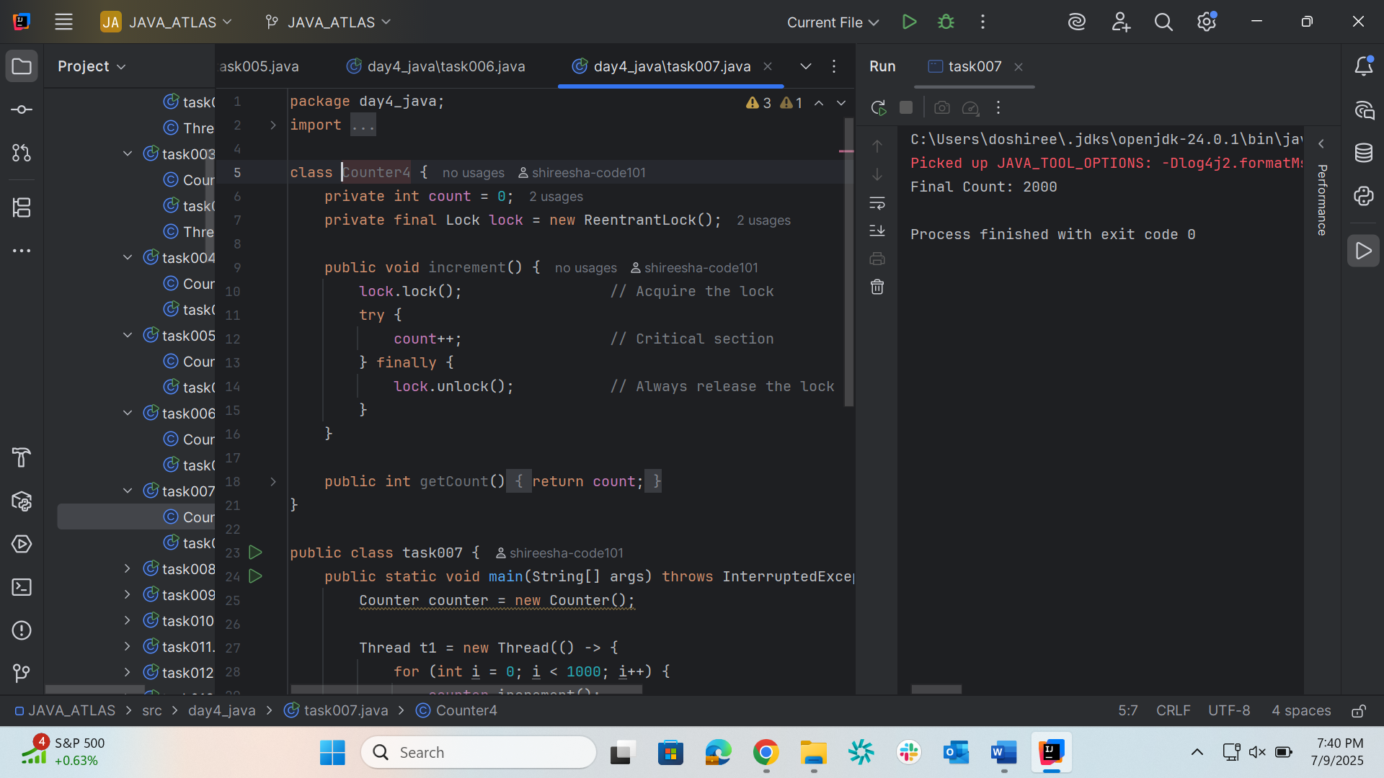

Task 8
package day4_java;

import java.util.concurrent.locks.Lock;
import java.util.concurrent.locks.ReentrantLock;
import java.util.concurrent.TimeUnit;

class Resource {
private final Lock lock = new ReentrantLock();
private final String name;

public Resource(String name) {
this.name = name;
}

public boolean tryLock() {
try {
return lock.tryLock(100, TimeUnit.MILLISECONDS);
} catch (InterruptedException e) {
return false;
}
}

public void unlock() {
lock.unlock();
}

public void use(Resource other) {
if (this.tryLock()) {
System.out.println(Thread.currentThread().getName() + " locked " + this.name);
try {
Thread.sleep(50); // simulate some work

if (other.tryLock()) {
try {
System.out.println(Thread.currentThread().getName() + " locked " + other.name);
System.out.println(Thread.currentThread().getName() + " is using " + this.name + " and " + other.name);
} finally {
other.unlock();
System.out.println(Thread.currentThread().getName() + " released " + other.name);
}
} else {
System.out.println(Thread.currentThread().getName() + " could not lock " + other.name);
}

} catch (InterruptedException e) {
Thread.currentThread().interrupt();
} finally {
this.unlock();
System.out.println(Thread.currentThread().getName() + " released " + this.name);
}
} else {
System.out.println(Thread.currentThread().getName() + " could not lock " + this.name);
}
}
}

public class task008 {
public static void main(String[] args) {
Resource r1 = new Resource("Resource-1");
Resource r2 = new Resource("Resource-2");

Thread t1 = new Thread(() -> r1.use(r2), "Thread-1");
Thread t2 = new Thread(() -> r2.use(r1), "Thread-2");

t1.start();
t2.start();
}
}

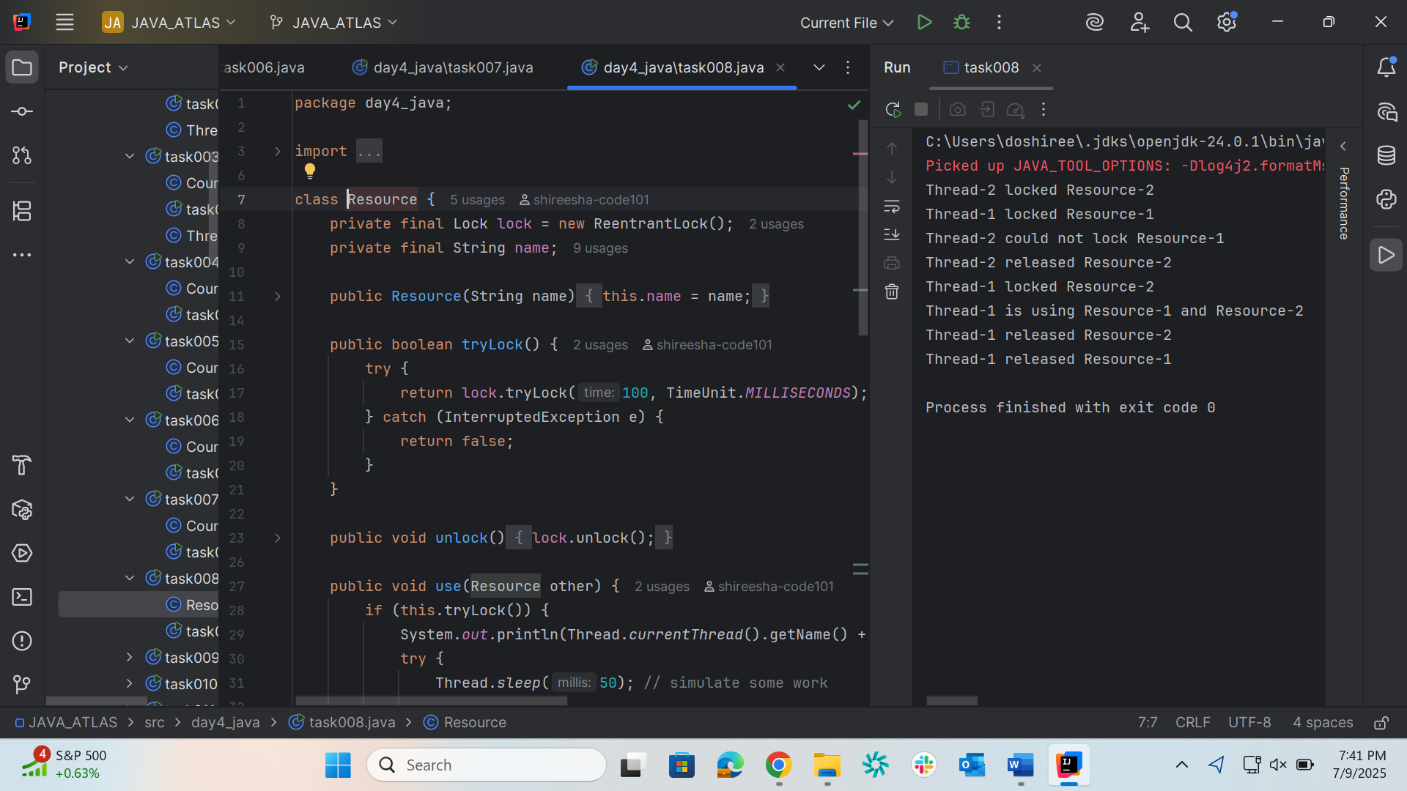

Task 9
package day4_java;

class SharedResource {
private boolean ready = false;

synchronized void produce() {
try {
while (ready) {
wait();
}
System.out.println("Producing...");
ready = true;
notify();
} catch (InterruptedException e) {
e.printStackTrace();
}
}

synchronized void consume() {
try {
while (!ready) {
wait();
}
System.out.println("Consuming...");
ready = false;
notify();
} catch (InterruptedException e) {
e.printStackTrace();
}
}
}

public class task009 {
public static void main(String[] args) {
SharedResource resource = new SharedResource();

Thread producer = new Thread(resource::produce);
Thread consumer = new Thread(resource::consume);

producer.start();
consumer.start();
}
}

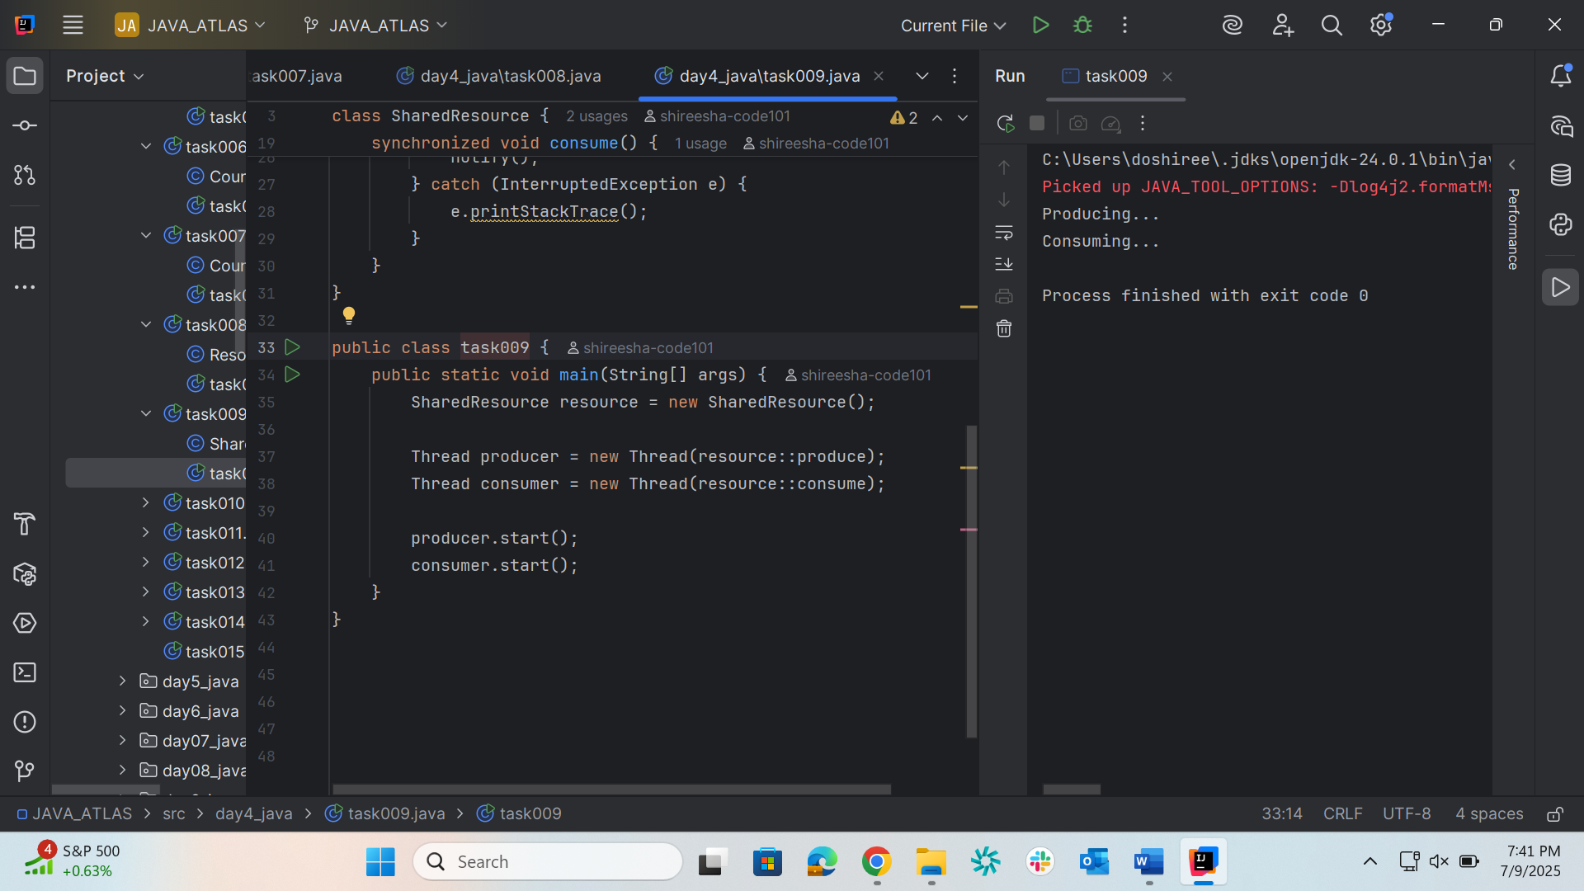

Task 10
package day4_java;

import java.util.stream.*;
class DoubleColonOp {
public static void main(String[] args) {
Stream<String> stream
= Stream.of("Hello", "My",
"name", "is",
"Prasunamba",
".MK");

stream.forEach(System.out::println);
}
}
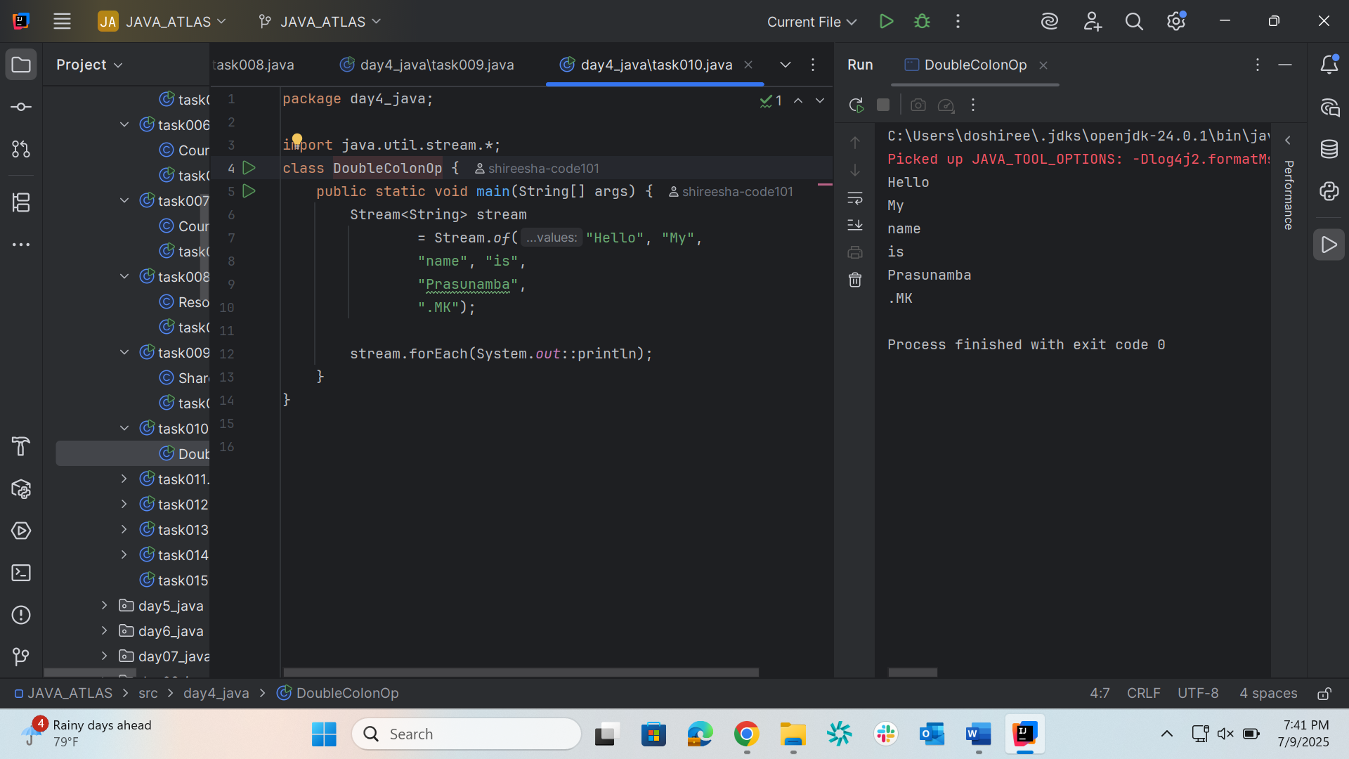

Task 11
package day4_java;

class InterruptibleThread extends Thread {
public void run() {
try {
while (!Thread.currentThread().isInterrupted()) {
System.out.println("Thread is running");
Thread.sleep(100);
}
} catch (InterruptedException e) {
System.out.println("Thread was interrupted");
}
}
}

public class task011 {
public static void main(String[] args) {
InterruptibleThread thread = new InterruptibleThread();
thread.start();

try {
Thread.sleep(500);
thread.interrupt();
} catch (InterruptedException e) {
e.printStackTrace();
}
}
}
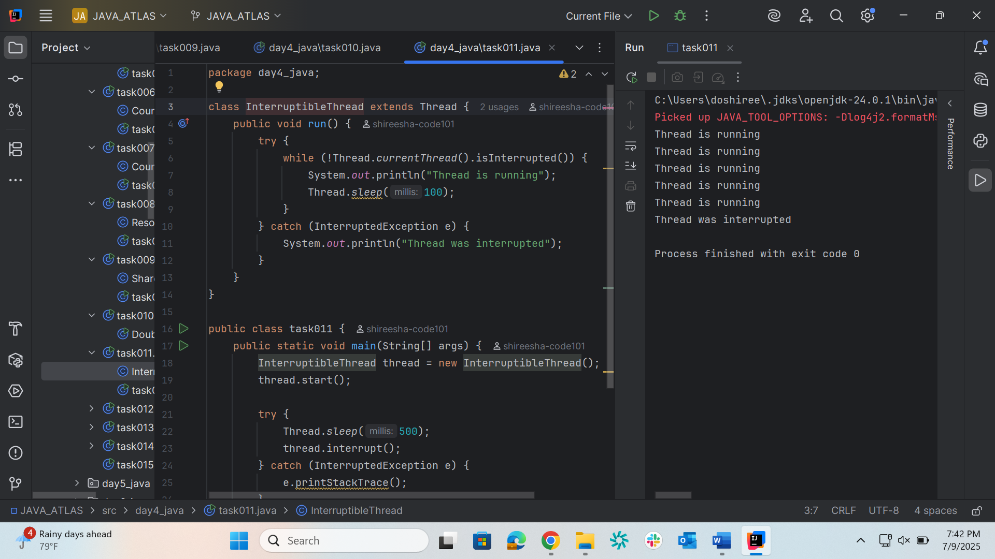

Task 12
package day4_java;

class Test extends Thread{
public void run(){
System.out.println("thread started.");
}
}

public class task012 {
public static void main(String args[]){

Test t1 = new Test();
t1.run();
}
}
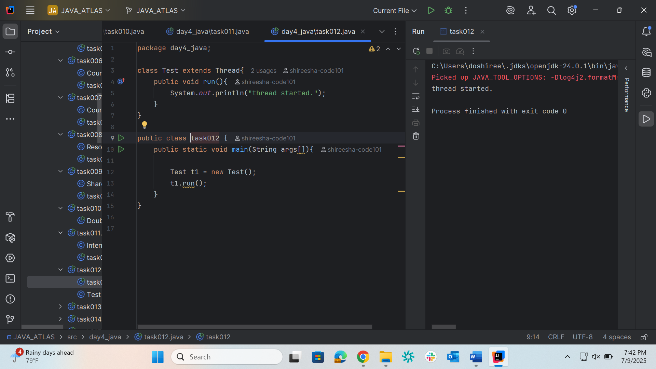

Task 13
package day4_java;

// MyRunnable.java
class MyRunnable implements Runnable {
@Override
public void run() {
System.out.println("Code executed in a new thread via Runnable.");
}
}

// MyThread.java
class MyThread extends Thread {
@Override
public void run() {
System.out.println("Code executed in a new thread via Thread extension.");
}
}

// Main.java
public class task013{
public static void main(String[] args) {
// Using Runnable interface
Thread thread1 = new Thread(new MyRunnable());
thread1.start();

// Using Thread class extension
MyThread thread2 = new MyThread();
thread2.start();
}
}

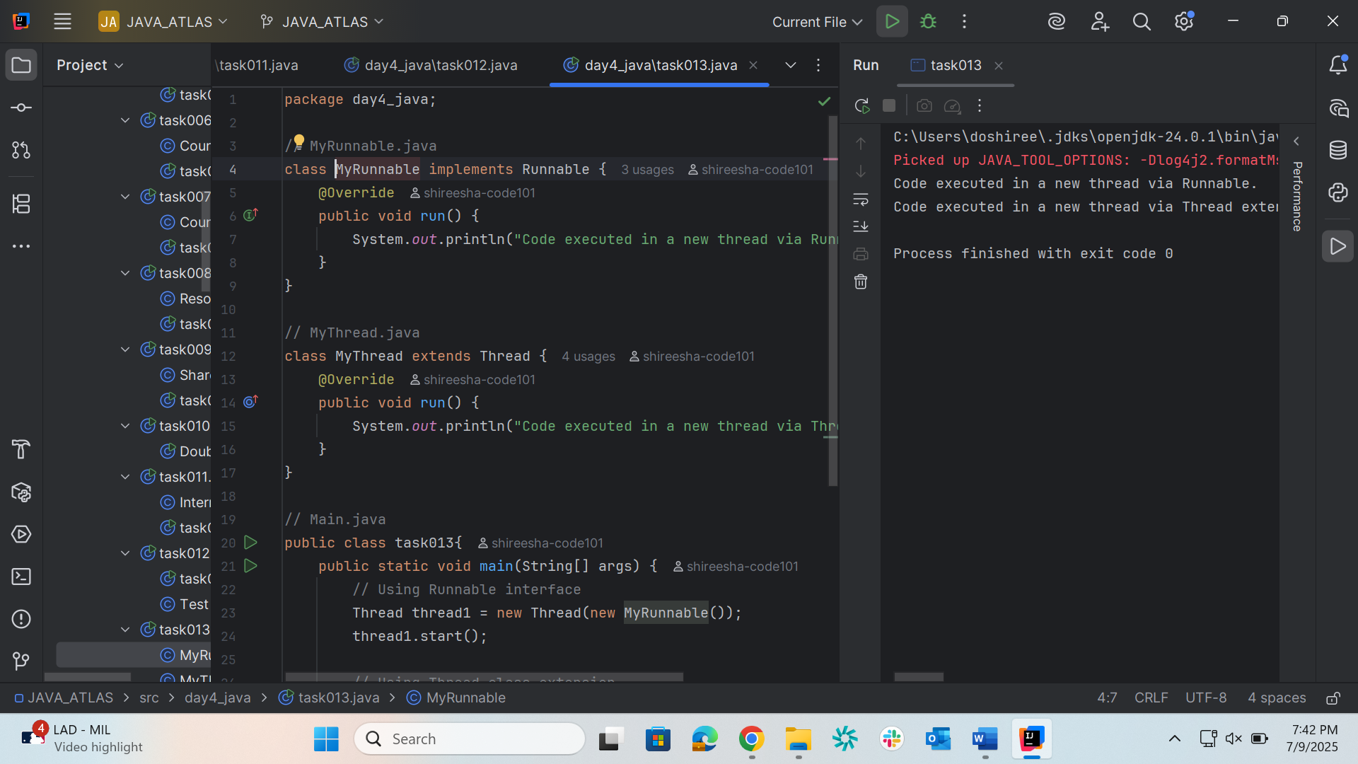

Task 14
package day4_java;

// MyRunnable.java
class MyRunnable1 implements Runnable {
@Override
public void run() {
System.out.println("Code executed in a new thread via Runnable.");
}
}

// MyThread.java
class MyThread1 extends Thread {
@Override
public void run() {
System.out.println("Code executed in a new thread via Thread extension.");
}
}

// task19.java
public class task014 {
public static void main(String[] args) {
MyRunnable runnableInstance = new MyRunnable(); // Runnable instance
MyThread threadInstance = new MyThread(); // Thread subclass instance

Thread t1 = new Thread(runnableInstance); // Wrap Runnable in a Thread

t1.start(); // Starts new thread from Runnable
threadInstance.start(); // Starts new thread from Thread subclass
}
}
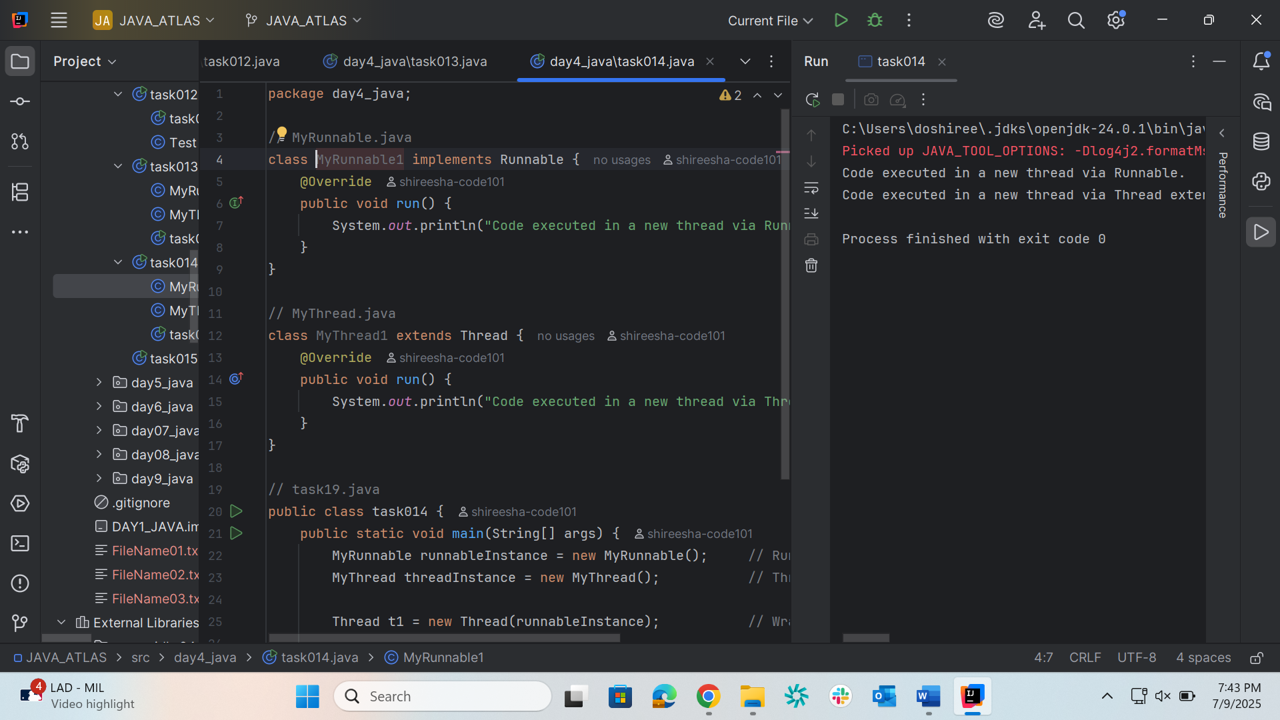

Task 15
package day4_java;

public class task015 {

public static void main(String[] args) {
method1();
}

public static void method1() {
method2();
}

public static void method2() {
method3();
}

public static void method3() {
StackTraceElement[] stackTrace = Thread.currentThread().getStackTrace();

System.out.println("Thread Stack Trace:");
// Iterate through the StackTraceElement array and print details
for (StackTraceElement element : stackTrace) {
System.out.println(" Class: " + element.getClassName() +
", Method: " + element.getMethodName() +
", Line: " + element.getLineNumber());
}
}
}
